**Communication, language and literacy**

**Writing:**

* Who Let the Gods Out? By Maz Evans

**Guided Reading:**

* VIPERS –linked to Aesop’s Fables

**MFL:**

* **French – Children will learn how to tell the time in French, including how to tell o’clock, half past, quarter past and to, as well as the day of the week.**

|  |
| --- |
|  |
|  |
|  |

**Mathematical Development**

**Maths:**

* **Multiplying numbers up to 4 digits by numbers up to 2 digits.**
* **Divide numbers with up to 4 digits by 1 digit numbers**
* **Using multiplication and division methods to solve problems**

**KIRF Focus:**

* **Multiples and factors**

**Physical Development**

**PE: Circuit training**

Children will learn about the effects of different types of exercise and they will take part in upper body, lower body  
and core muscle exercises. They will focus on sporting abilities such as being

a good sportsperson, taking part in respectful competition, working as a team and playing to each other’s strengths. Children will have a chance to plan  
their own circuit of exercises to develop someone’s all round fitness and will evaluate their own progress each lesson and throughout the unit.

**Personal, social and emotional development**

**PSHE:**

* Safety first – Children will consider how they can take responsibility for their own safety, through the choices they make. This unit also covers how to stand up to peer pressure, and what to do if they feel they are in danger.

**RE:**

* An overview of peace – the concept of peace is explored throughout multiple religions, drawing comparisons, and there is also a focus on how we can achieve and create peace.

**Knowledge and Understanding of the World**

**History:**

* Democracy – comparing now to in ancient times
* The Olympic games
* The Greek gods

**Geography:**

* Where was Ancient Greece?
* How has Greece changed since the Ancient Greeks?

**Year 5 Topic Overview**

**Autumn Term 2 2023**

**Ancient Greece**

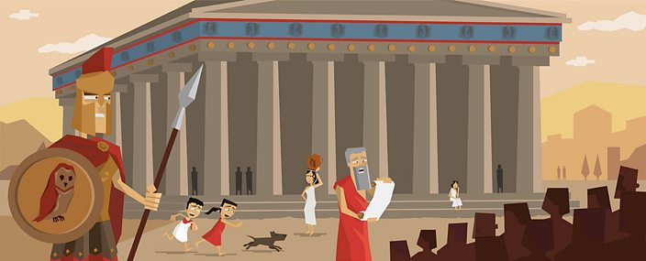

**Creative Development**

**Art:** Making Ancient Greek inspired vases out of clay

**Music:** to listen and appraise the songs ‘Three Note Bossa’ and ‘The Five Note Swing’ and develop skills and knowledge of rhythm, pitch, tempo and pulse.

**SScientific Development**

**Science: Properties and changes of materials**

* How to sort materials based on their properties
* Justify why we use different materials, based on investigations into thermal and electrical conductivity
* Disappearing vs dissolving
* How to separate mixtures through filtering, sieving, and evaporating
* Irreversible reactions

**ICT:** Online Safety - Children will learn what a digital footprint is; how to keep safe whilst playing games as well as appropriate use of social media.