Main Beliefs

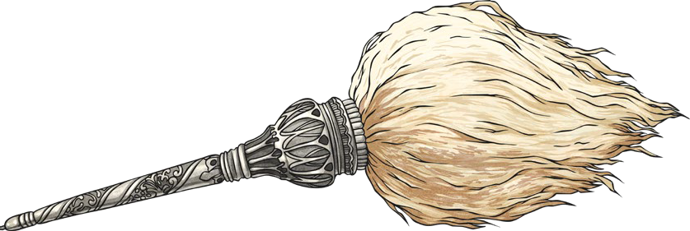
God is referred to by many names, including:
Key Vocabulary
Sikhism | One of the world’s main religions.
Sikh | Someone who follows Sikhism.
Guru | Spiritual teacher.
Guru Nanak | The founder of Sikhism.
gurdwara | A Sikh place of worship.
Guru Granth Sahib | The Sikh holy text.
sargun | The belief that God is everywhere and in everything.
nirgun | The belief that God is above and beyond everything.

Sikhs believe that:
- 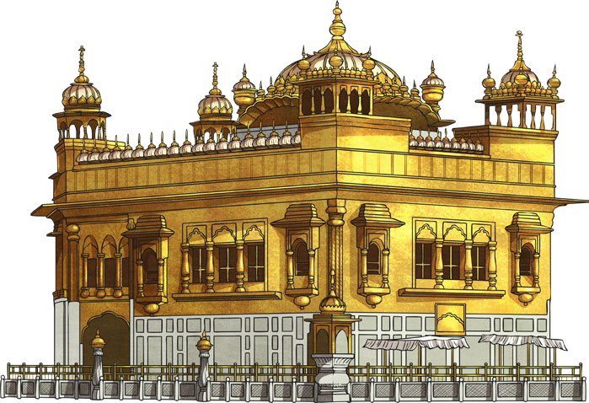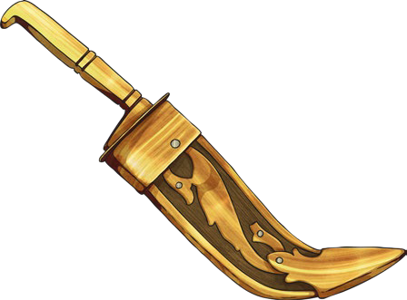there is only one God;
- God cannot be described as either male nor female;
- God is both sargun and nirgun;
- God created the world and created people to
know the difference between right and wrong;
- images of God are forbidden as is worshipping them;
- all people are equal.
Worship
Sikhs worship both in public and in private. Sikhs worship together in the gurdwara. The word gurdwara means ‘door to the Guru’.
Shoes must be removed and hair covered before entering the main prayer hall to worship. Men and women sit cross- legged on opposite sides, facing the Guru Granth Sahib.

Sri Harmandir Sahib
The Sri Harmandir Sahib is also known as the Golden Temple. It is located in Amritsar, India. Its doors open from all sides to welcome people of all faiths.

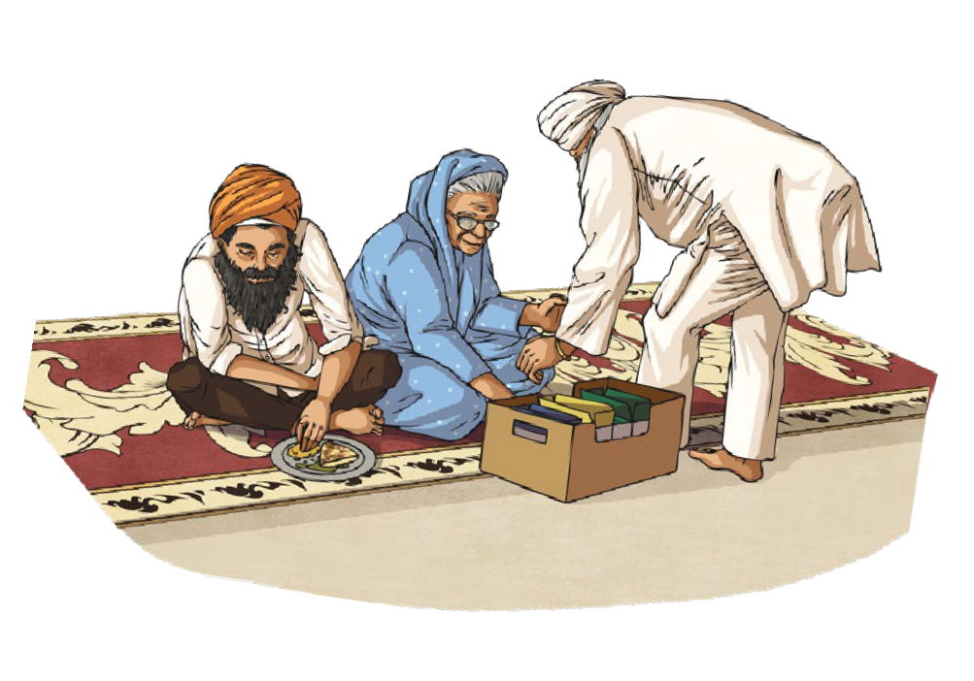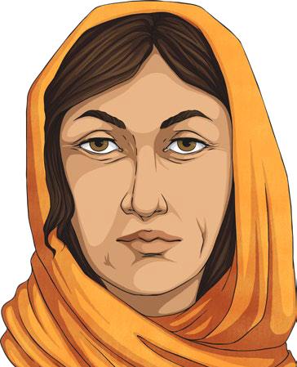
- Waheguru (Wonderful Teacher);
- Sath Nam (Eternal Reality);
- Akal Purakh (Eternal One).

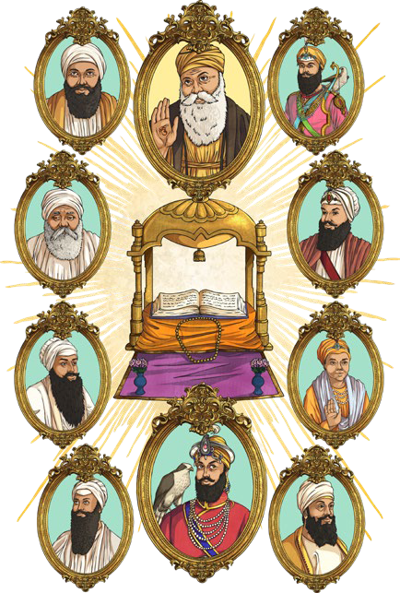
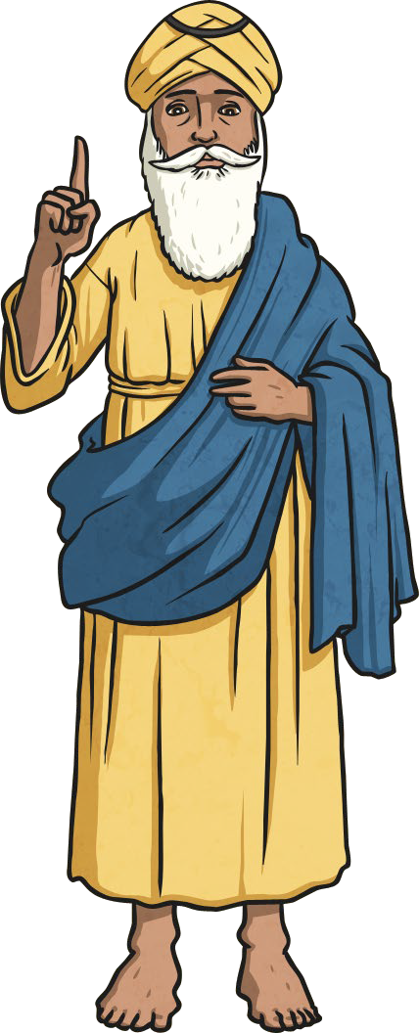
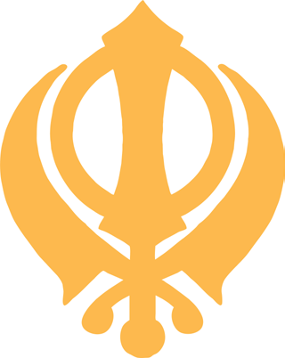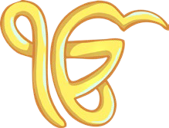
Key Vocabulary
Nam Japna | The duty of keeping God in mind at all times.
Kirt Karna | The duty of earning an honest living and avoiding crime, begging and gambling.
Vand Chhakna | The duty of giving to charity and caring for others.
shabads | Sacred hymns in the Guru Granth Sahib.

The Ten Gurus
There were ten Gurus who spread God’s message:
Guru Nanak, Guru Angad, Guru Amar Das, Guru Ram Das, Guru Arjan, Guru Hargobind, Guru Har Rai, Guru Harkrishan, Guru Tegh Bahadur and Guru Gobind Singh.

Symbols
The Khanda is the main symbol of Sikhism. The Ik Onkar means ‘there is only
one God’.

The Guru Granth Sahib | The 5 Ks
The Guru Granth Sahib is the Sikh holy book. It contains the messages of all the Gurus. It is covered by a rumala when not in use.  The chaur is made from yak’s hair. It is waved over the Guru Granth Sahib as a sign of respect. | Kesh: Sikhs leave hair uncut to show obedience to God.  Kangha: A wooden comb that helps  Sikhs to keep their hair in place.  Kara: A steel bangle that reminds  Sikhs to behave well.  Kachera: These are shorts worn as underwear.  Kirpan: A tiny sword worn by Sikhs.
The Guru Granth Sahib contains 5867 shabads, which were written by six of the ten Gurus. They are known as Gurbani (the word of the Gurus). The introduction includes the ‘Mool Mantar’, which contains all the important Sikh beliefs.

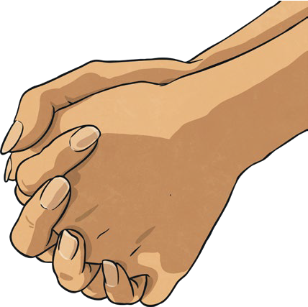
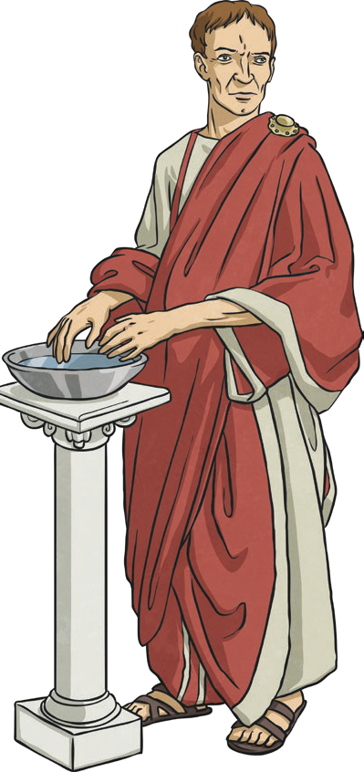
Good Friday is part of the Easter story. It was the day that Jesus was crucified on the cross. Good Friday is seen as a very important day in the Christian calendar because Christians believe that Jesus sacrificed himself for others.
Key Information
Key Vocabulary
Good Friday | The day that Jesus died on the cross.
The  Last Supper | The final meal that Jesus ate with his disciples before he died.
disciples | Jesus’ close friends and followers.
Judas | One of Jesus’ disciples.
sacrifice | Jesus giving himself up to be crucified to save humankind.
cross | The large wooden cross that Jesus was crucified on.
Pontius Pilate | The Roman governor.
betray | Being disloyal to someone.

Judas | The Last Supper | The Cross
Many priests were jealous of Jesus and wanted to see him arrested. One of Jesus’ disciples (Judas Iscariot) betrayed Jesus for 30 silver pieces.  Jesus knew this at  the Last Supper.  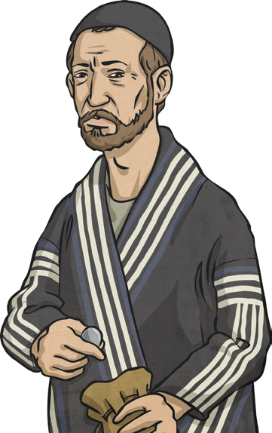 | Jesus ate his final supper with his disciples. He told them at the meal that he knew one of them had already planned to betray him.  Jesus picked up some bread and told the disciples: “This is my body. Take it and eat it and remember me.” He picked up the wine and said: “This  is my blood. Drink it and remember me.”  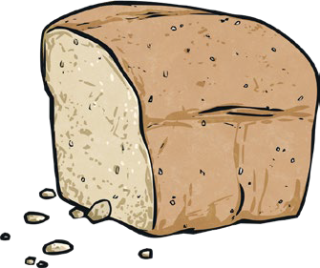 | Jewish leaders found Jesus guilty of calling himself the Son of God. Jesus was taken to Pontius Pilate for a punishment. The chief priests convinced the people that Jesus must die. When Pontius  Pilate asked what he should do with Jesus, they shouted,  “Crucify him!”  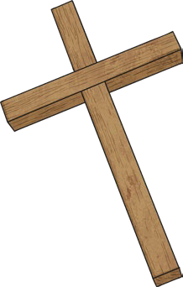

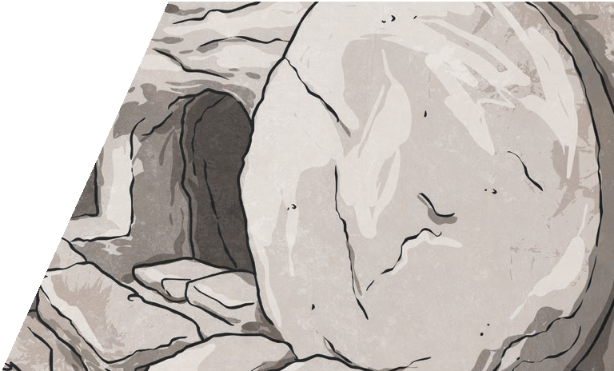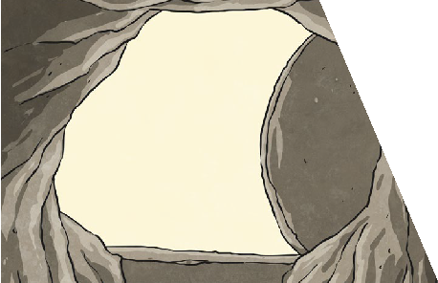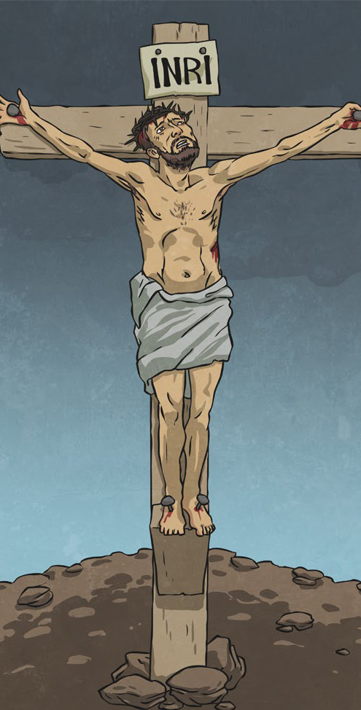
After Jesus died on the cross, he was taken down from the cross and laid in a tomb by his friends. They rolled a large stone
in front of the entrance of the tomb.
The Tomb
On the third day after Jesus’
crucifixion, the stone of the tomb had been rolled away. His body was gone from the tomb and
an angel told Mary Magdalene that Jesus had risen from the dead.
Resurrection
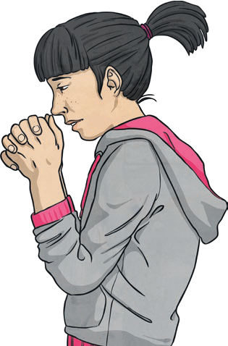
Key Vocabulary
Mary Magdalene | A friend of Jesus.
resurrection | The rising of Christ from the dead.
prayer | A way of talking to God.
crucifixion | Nailing someone to a  cross to die.
tomb | A large space for burying a body.

Sacrifice
At the Last Supper, Jesus declared the words that are now written in the Bible (John 15:13):
‘Greater love has no one than this: to lay down one’s life for one’s friends’.
Christians believe that Jesus sacrificed
himself for others.

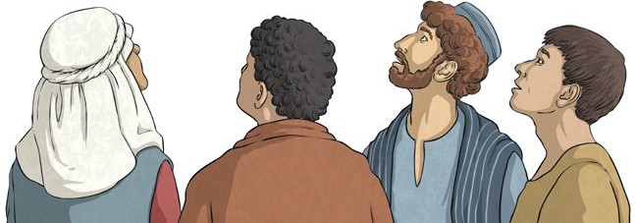

Christians believe prayers are a way of communicating with God. It is a way of offering thanks and asking for forgiveness.
Prayer
Crucifixion
A crown of thorns was put on Jesus’ head. He had to carry his own large wooden cross up a hill. At the top of the hill, Jesus was nailed to the cross, with nails through his hands and feet. Jesus was left on the cross to die.

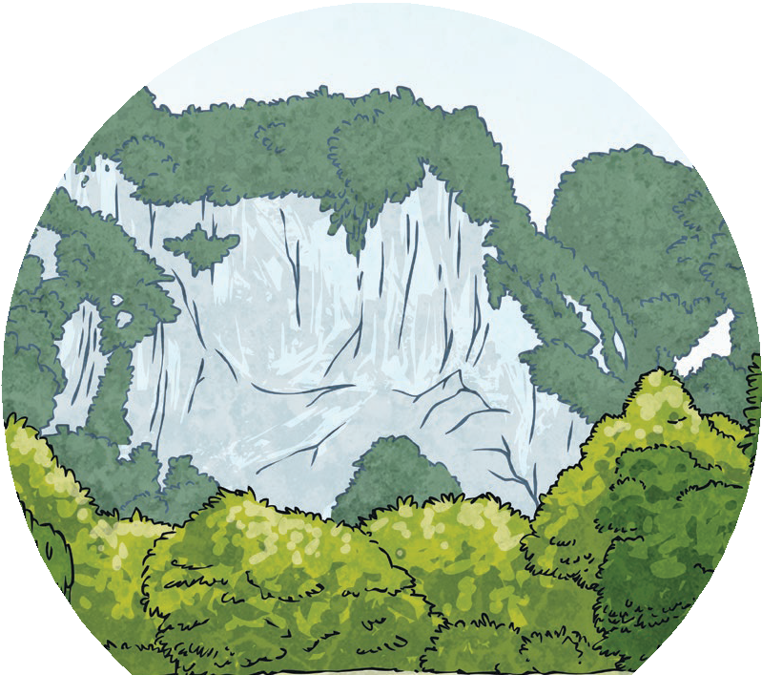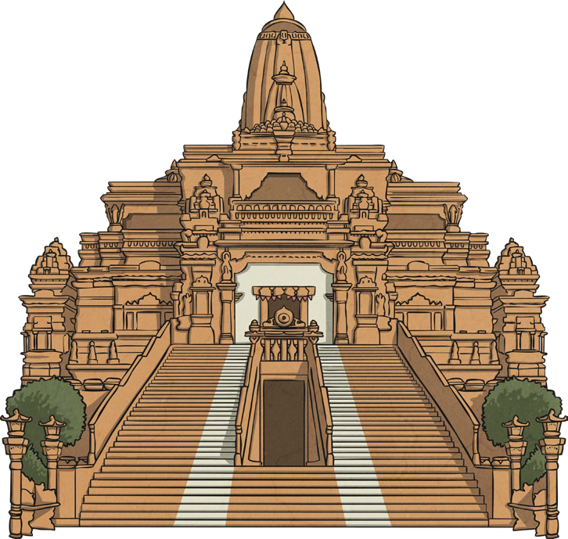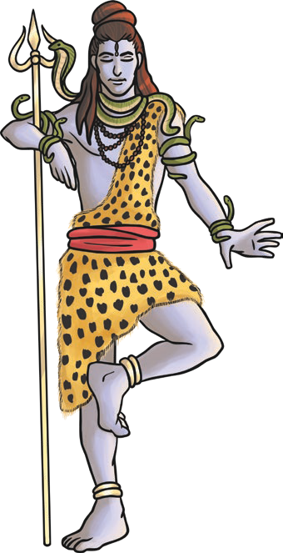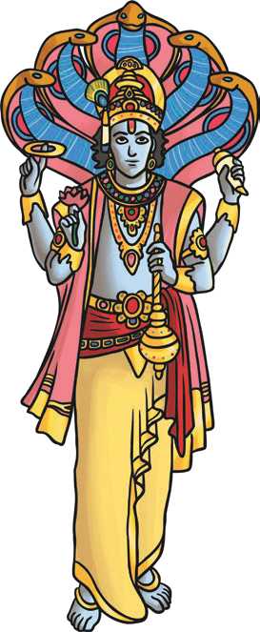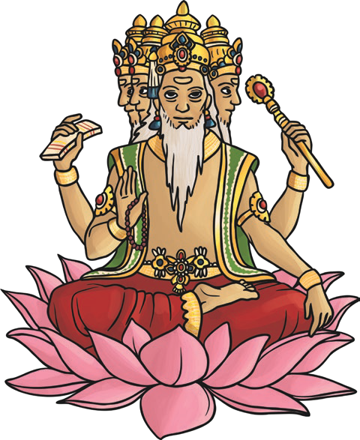
Hinduism is the oldest of the world’s religions. It is now practised all over the world but originated in South East Asia. It is a mix of different beliefs, cultures and traditions dating back over 4000 years.
Key Vocabulary
Hindu | Someone who follows Hinduism.
Vishnu | Hindu god who protects the universe.
Brahma | Hindu god of creation.
Trimurti | The three aspects of the universal supreme God.
Tridevi | The three great goddesses of Hinduism.
Brahman | Hindus recognise one God, Brahman.

Hindu Gods and Godesses
Hindus recognise one God, Brahman. The gods of Hinduism are different aspects of Brahman.
The main three aspects (Trimurti) are:
Vishnu, Brahma and Shiva
The three great goddesses (Tridevi) are:
Saraswati, Lakshmi and Shakti
Hindus can pray to different gods and goddesses for help with different needs.

Truth Is Eternal | Dharma | Reincarnation | Moksha
Hindus are encouraged to learn. | Dharma means to do the  right thing with good behaviour. | Hindus believe a soul cannot be  destroyed, so when a Hindu dies, their soul enters a new living being. | Moksha is the ultimate goal. It happens when a soul stops being reincarnated  and is reunited with Brahman.

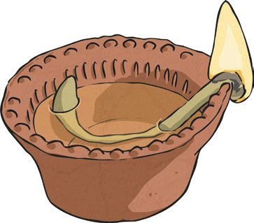
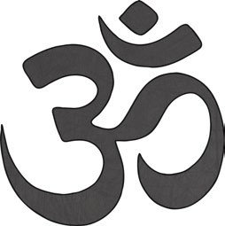
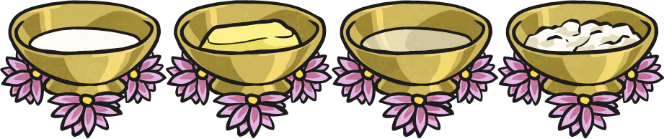
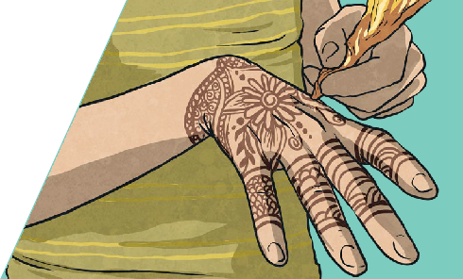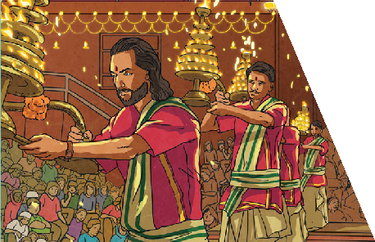

Holi is the ‘festival of colours’ and marks the be- ginning of spring with bonfires and lots of sing- ing and dancing. Old rubbish is burnt to mark
a fresh start and colour is thrown on people.
Special Festivals

Diwali is the ‘festival of lights’ and is celebrated in late autumn. Diwali celebrates good’s victory over evil with lots of lights around homes. Fire-
works, presents and new clothes are used to celebrate.
Hindus can worship at home or in a mandir.
In a mandir, Hindus can perform puja.

Some mandirs are very tall buildings. Hindus believe it brings them closer to heaven.

In a mandir, there are shrines and lots of murtis for different gods. Offerings of flowers are brought to the murtis.
Special Places for Hindus
There are holy scriptures in Hinduism. The scriptures support Hindus in their life and guide prayer.
Shruti texts are knowledge from gods. Smriti were written by Hindu spiritual leaders.
Key Vocabulary
mandir | A special place for Hindus  to worship.
puja | Act of worship for Hindus.
murtis | Special statues or images of  Hindu gods and goddesses.
shrine | A holy place to pray.
Shruti | Hindu holy scriptures which contain the four Vedas.
Smriti | Hindu holy scriptures which contain legends, myths  and history.
Vedas | Ancient Hindu text.

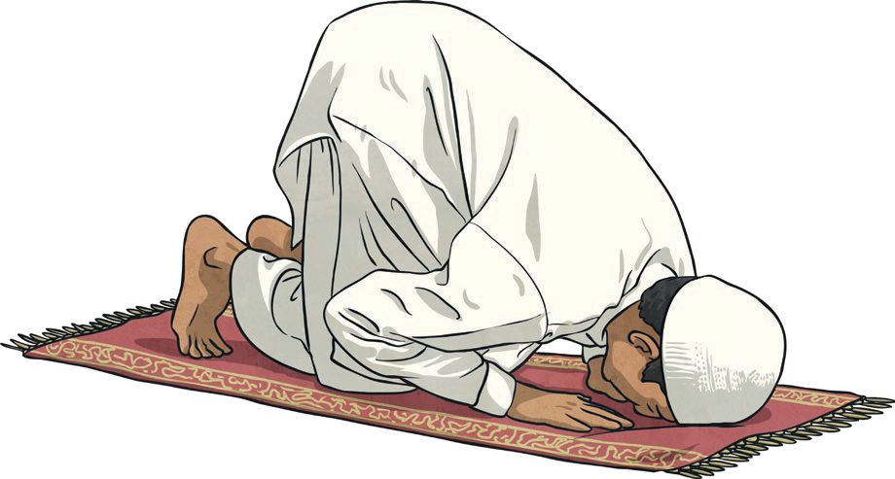
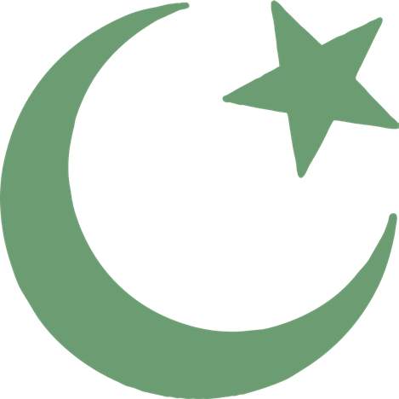
The Six Main Beliefs | The Five Pillars of Islam
- Belief in Allah as the one and only God.  - Belief in angels.  - Belief in the holy books.  - Belief in the prophets and that Muhammad was the final prophet.  - Belief in the Day of Judgement (the day when Allah decides if a person goes to heaven or hell).  - Belief in predestination (the belief that Allah has already planned out what will happen). | As well as the six main beliefs, there are Five Pillars of Islam.  Shahadah: Muslims say a declaration of faith.  Salah: Muslims pray five times a day. Before prayer, they must wash themselves and then face Mecca whilst praying.  Zakat: Muslims must donate to charities.  Sawm: Muslims fast for one month during a time called Ramadan.  Hajj: Muslims have to travel to Mecca once in their lifetime, if they can afford to.

Key Vocabulary
Islam | Islam is the second most popular religion in the world.
Muslim | A follower of the religion of Islam.
Allah | The Arabic name that  Muslims use for God.
Five Pillars of Islam | The five things that Muslims are expected to do.
Prophets | Special messengers sent from Allah.
Muhammad | The last prophet and the key prophet in Islam.

Key Beliefs
Muslims believe that there is only one God called Allah. They believe Allah is the only ruler of the universe. The word ‘Islam’ means submission and obedience to Allah.

Muhammad is so highly respected by Muslims that they will say “peace be upon him” after his name is spoken.

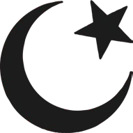
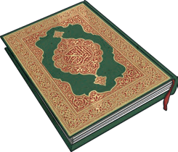
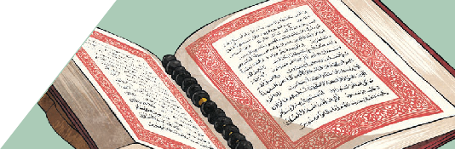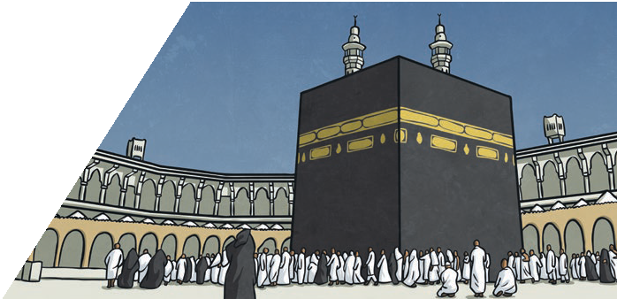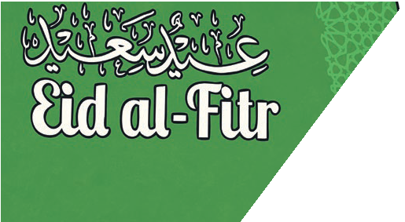
The Muslim holy book is called the Qur’an. Muslims believe that it is a record of the exact words that Allah said.
The Qur’an
Mecca is an important place to Muslims. It is where Muhammad was born and the direction that Muslims face when they pray five times a day. Muslims are expected to make a pilgrimage to Mecca once in their lifetime.
Mecca
The main Muslim festivals are: Ramadan, Eid-al-Fitr, Eid-al-Adha,
Dhu al-Hijja. During Ramadan, Muslims try to give up bad habits
and become better Muslims by praying more.
Muslim Festivals
Key Vocabulary
Mecca | Mecca is an important place to Muslims. It is where Muhammad was born. Muslims face Mecca to pray and try to visit it sometime during their lives.
Hajj | The name Muslims give to the special pilgrimage to Mecca.
The Qur’an | The holy book of Islam.
Ramadan | A Muslim festival where Muslims fast during the daylight and only eat after the sun has set.
fast | A period of time when  Muslims do not eat.
mosque | Muslim place of worship.
pilgrimage | A journey to a special place of religious meaning.

Place of Worship
The Muslim place of worship is called a mosque. Services are held in mosques every day. The most important service for Muslims is on a Friday.
Mosques often have a domed roof. There are no images of people or animals in mosques. They are decorated with patterns and words from the Qur’an.
Muslims take off their shoes before going into the mosque and wash before they pray. Muslims pray kneeling on the floor on a prayer mat. The wall of the mosque which faces Mecca is called the qibla wall. It has an empty arch to show the direction of Mecca.

Symbol of Islam
There is no official symbol of Islam, but the star and crescent symbol
is the symbol most commonly associated
with Islam.

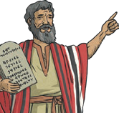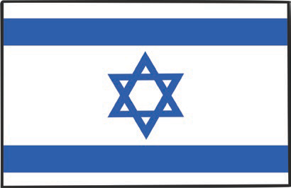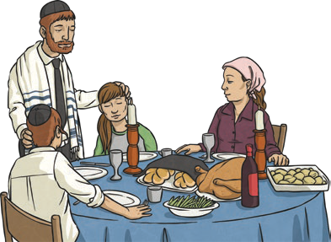
Jews believe in one God. They also try to live by the Ten Commandments.
They include using God’s name with respect, remembering the Sabbath, respecting your parents and not lying
or stealing.
Jews believe God gave the
Ten Commandments to Moses.
Main Beliefs
Judaism began around 4000 years ago in the Middle East. Jerusalem is a place where many Jews go to on pilgrimage.
Judaism
The Sabbath lasts from sundown on Friday to sundown on Saturday. Jews celebrate as a family. They enjoy
a special meal with prayers and songs.
The Sabbath
Jewish people go to a synagogue to worship. Men and women sit separately in some synagogues. The most important part of the synagogue is the Ark. This is where the Torah is kept. The Torah is treated with great respect. Jews are not allowed to touch it.
Special Places for Jews
Hebrew is a special language for Jews. Jews believe God gave the Ten Commandments
to Moses in Hebrew. The Torah is written in Hebrew and Jews learn to read it.
Hebrew
Key Vocabulary
Ten Commandments | Ten important life rules for Jews given to Moses by God.
the Sabbath | The holy day for Jews.
pilgrimage | A special religious journey.
synagogue | Place of worship for Jewish people.
rabbi | Jewish religious leader and teacher.
Ark | The place where the Torah  is kept in a synagogue.
Torah | The Jewish holy book.
Hebrew | A language used by Jewish people.

Key Vocabulary
Hannukah menorah | A special lamp with nine candles that’s lit by Jews during Hanukkah.
fast | To not eat or drink for a period of time.
barmitzvah | A ceremony to show a Jewish boy has become an adult. It happens when a boy is 13 years old.
batmitzvah | A ceremony to show a Jewish girl has become an adult. It happens when a girl is 12 years old.

Jewish Symbols
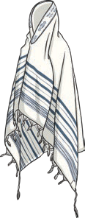 | 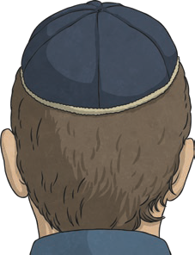 | 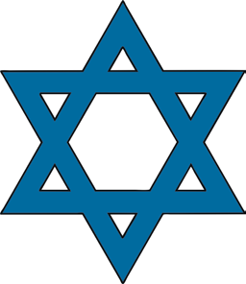
A tallit is a special prayer shawl used by Jewish men to pray. | A kippah is a special cap worn by Jewish men and boys to show respect to God. | The Star of David is the symbol of the Jewish community.

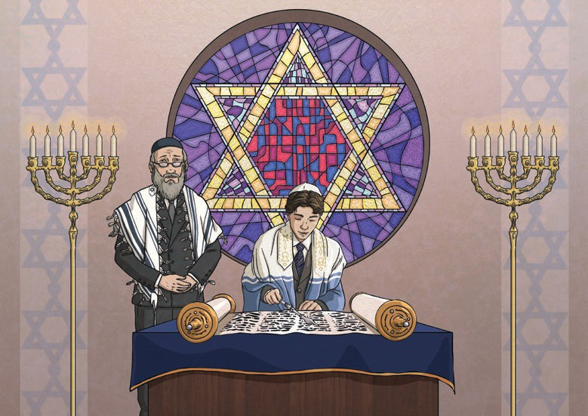
Key Vocabulary
Yom Kippur is when Jews fast, reflect on the previous year and pray for God’s forgiveness.
Hanukkah is the ‘festival of lights’ when Jews light a Hannukah menorah
dedicated to God.
Passover is when Jews remember being led out of slavery by Moses.
Barmitzvah and batmitzvah are important celebrations for Jewish families.

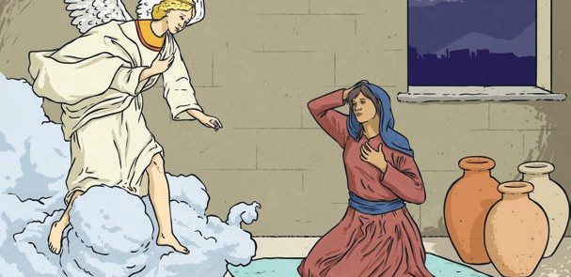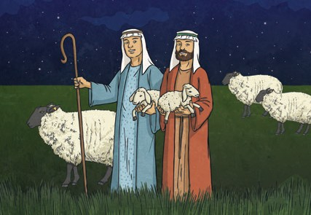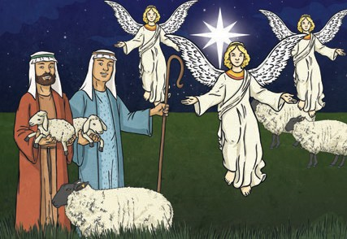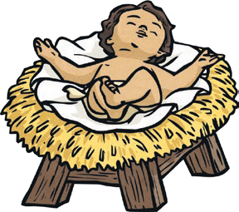
Mary was engaged to be married to Joseph. An angel, called the angel Gabriel, visited Mary at her home in Nazareth to tell her that she was going to have a special baby. The angel said that the baby would be God’s son and that she should call him Jesus.
The Angel’s Visit
Shepherds watching over their sheep on a hillside near Bethlehem were surprised when an angel appeared.
The Shepherds
The angel told them that a special baby had been born and that he would be a saviour to the people. Then the sky was filled with angels singing.
The Saviour
Mary and Joseph were offered a stable to stay in. This is where Mary had her baby. She named him Jesus and he slept in a manger.
A Place to Stay
Joseph and Mary (who was pregnant) had to travel to Bethlehem for the census. It was a long and tiring journey. When they got there, they found that all of the inns were full.
Key Vocabulary
nativity | The story from the Bible about the birth of Jesus.
Nazareth | The city where Mary and Joseph lived.
Pregnant | Expecting a baby.
Bethlehem | The town where Jesus was born, sometimes known as The City of David.
census | A formal count of all the people who live in a particular place. The Roman census  required couples to travel to the  husband’s place of birth.
inn | A house where travellers can stay.
manger | A long trough used to feed horses or cattle.
saviour | Someone who saves others from harm or bad deeds.  Christians refer to Jesus Christ  as their saviour.
worship | The feeling or act of showing respect, loyalty or love.

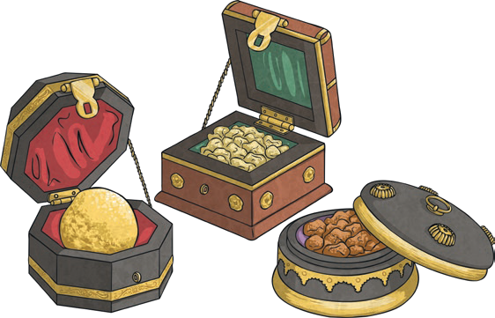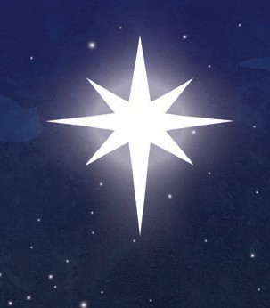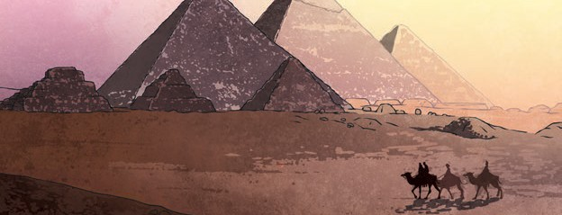
The wise men had a dream telling them not to let King Herod know where to find Jesus. King Herod gave orders that all
baby boys in Bethlehem should be killed.
The wise men found Jesus in the stable. They worshipped him and gave him gifts
of gold, frankincense and myrrh.
The Wise Men
Some astrologers noticed a new star in the sky. They knew it meant a great ruler had been born so they decided to follow it.
Joseph had a dream in which an angel told him to save Jesus by taking him and Mary to Egypt. They stayed there for many years.
Escape to Egypt
The wise men visited the palace in Jerusalem, as they expected the new ruler to be a royal baby.
King Herod was not pleased to hear of a new ruler. He asked the wise men to let him know where they found Jesus.
King Herod
The shepherds went to visit baby Jesus in the stable. When they found him, they knelt down and worshipped him. They told Mary and Joseph about the angel’s visit and that Jesus would be the saviour of the world.
The Shepherds Visit Jesus
astrologer | Someone who studies the position and movement of the stars and interprets these as having an influence on  humans. The astrologers in the nativity are also known as the wise men or kings.
Jerusalem | The holy city in Western Asia, where King Herod’s Palace was located.
King Herod | The city where King Herod lived.
frankincense | An expensive tree sap that is burned during worship. It was given to show that Jesus was divine (came from God).
myrrh | A type of resin (sticky substance) produced by certain trees. It is often linked to death and was given to show the human suffering that Jesus would experience.

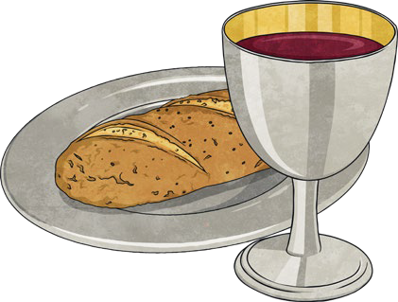
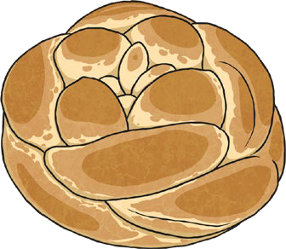
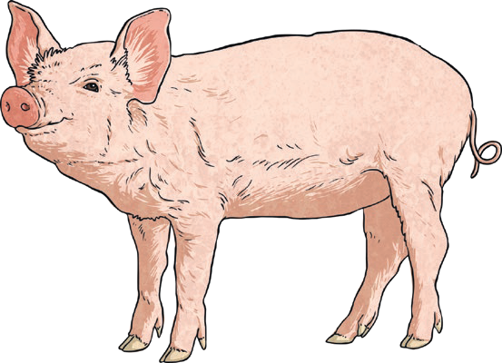
Key Vocabulary
sustenance | The food and drink that keeps us alive.
community | A group of people that live in the same place or have interests or beliefs in common.
kosher | Food that meets the requirements of Jewish rules and can be eaten.
Jewish people | People who follow the religion of Judaism.
poultry | Flesh from birds such as: chicken, duck, goose, turkey. Some kinds of poultry are kosher.
parve | Fruit, vegetables, honey and grains are  considered kosher. They are called parve foods. These can be eaten with either dairy or meat.

Kosher Food
Jewish people believe the laws of kosher come from God. The laws say Jewish people must eat kosher food. Dairy and eggs are kosher if they come from a kosher animal. Meat and dairy must be eaten separately. Kosher foods must be prepared in a particular way.

Kosher Food | Non-Kosher Food
Beef Poultry Fish  (with fins and scales) Lamb | Pork Shellfish

Bread and Wine | Shabbat | Dates
During a Christian church service, adults take a sip of wine and eat some bread to remember when Jesus shared these with his disciples and asked them to remember him. The bread symbolises the body of Jesus and the wine symbolises his blood. | Jewish people eat a Shabbat meal on Fridays. Challah bread is eaten, candles are  lit, songs are sung and special words are recited. | When a Muslim baby is born, date juice is rubbed on their gums, so that the first experience the baby has is a sweet one.

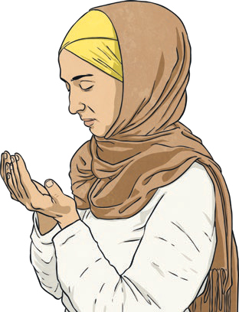
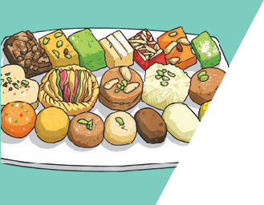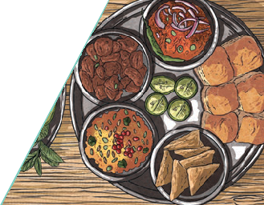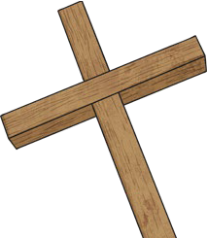

Diwali is one of the most important Hindu festivals. During Diwali, special food is eaten. Hindu women often meet to make sweets, which
are then given as gifts.
Diwali
During Ramadan, Muslims fast during daylight hours. Before sunrise, Muslims get up and share a meal (suhoor) with family and friends. After sunset, they share a special iftar meal.
Pregnant women, young children or people who are unwell are not expected to fast.
Ramadan

Lent is a time when many Christians abstain from eating particular foods. Lent lasts for around six weeks and leads up to Easter.
Christians do this to remember Jesus’ sacrifice.
Lent
Why Do People Fast?
People fast because it makes them feel closer to their
god or gods.
It allows them to focus on other things such as praying. Fasting brings communities together.
Key Vocabulary
abstain | To stop doing something.
sacrifice | To give up something important to you, for the sake of something or someone else.
fast | Not eating or drinking for a particular length of time.
Islam | One of the main world religions. Followers of Islam are Muslims.
Sawm | This is fasting. Sawm is one of the five pillars of Islam.
Ramadan | The holiest month in the  Islamic calendar.
Diwali | The Hindu festival of lights.

The Seder Plate
The Seder plate, during the Jewish festival of Passover, contains special foods that symbolise different parts of the passover story.

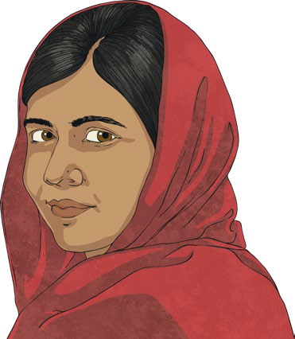
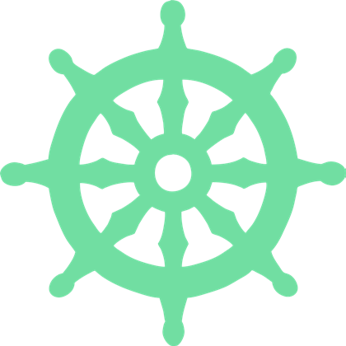
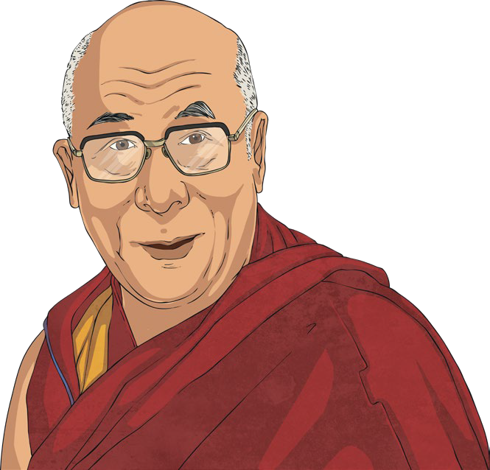

“Let us remember: One child, one teacher, one book, one pen can change the world.” Malala Yousafzai
Key Vocabulary
faith | A strong belief, usually in a religion.
Muslim | Someone who follows the religion Islam.
Taliban | A terrorist group from Afghanistan.
campaigned | Actions that are planned to achieve a particular result, e.g. a change  in the law.
inspired | To feel excited, enthused or encouraged by someone or something.
monastery | Where monks live, spending their time praying and thinking about god.
Buddhist | Someone who follows the religion Buddhism.

Faith and Beliefs
People’s faith and beliefs can help them overcome challenging times in their lives. It can have an effect on how they live their lives and inspire their work. There are many ‘People of Faith’ whose experiences have inspired others.

Malala Yousafzai | The Dalai Lama
Malala Yousafzai, a young Muslim girl, is famous because she stood up for what she believed.  When the Taliban banned education for girls  over the age of eight, Malala campaigned for education for all, but was shot by the  Taliban because of this. She recovered and has continued to campaign. | The Dalai Lama was born in Tibet.  He lived in a monastery and is a Buddhist. When the Chinese  government invaded Tibet, people who protested were killed.  The Dalai Lama had to leave Tibet and move to India for his own safety. He campaigns for the Tibetan people to be free to rule themselves. He also spreads  the Buddhist message.

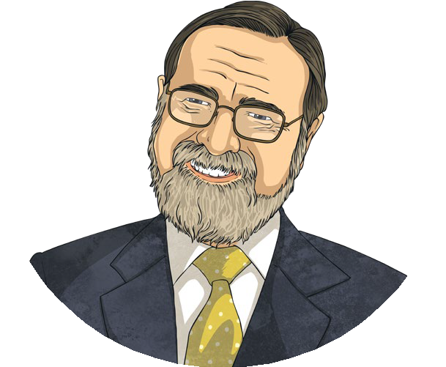
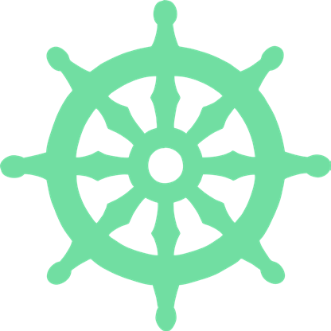
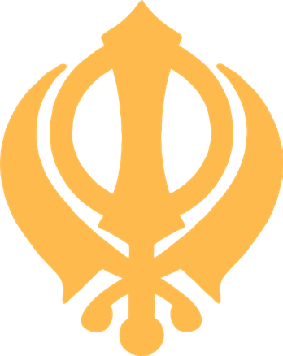
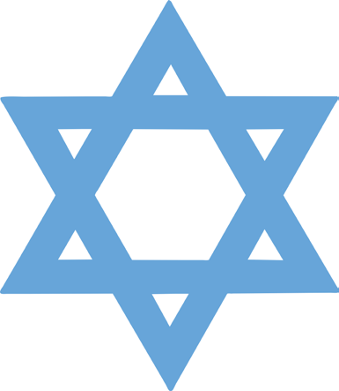
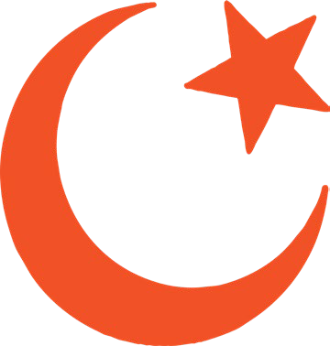
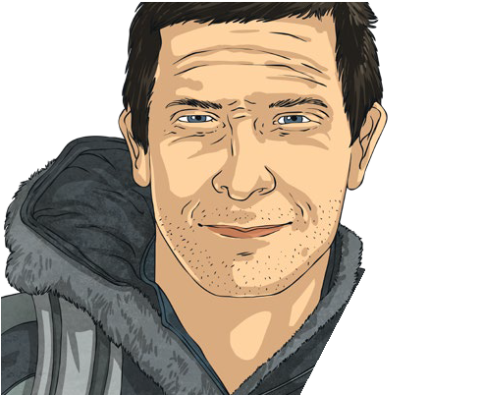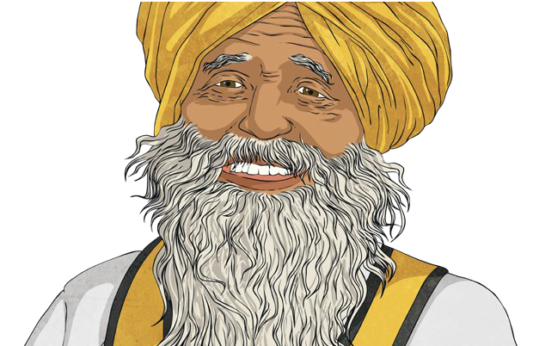
Bear Grylls is a British adventurer. He is a
Christian and says it is his faith that has helped him overcome lots of difficulties.
He says that his Christian faith inspired him to take on new challenges.
Bear Grylls
Fauja Singh is a retired British marathon runner. He began running seriously again at the age of 89 to overcome his sadness at losing his family. He is
a Sikh and has said that his faith has helped him
through difficult times.
Fauja Singh
Key Vocabulary
Rabbi | A Jewish scholar who is an expert in Jewish law.
Jewish | Someone who follows the religion of Judaism.
Sikh | Someone who follows the religion of Sikhism.
Christian | Someone who follows the religion of Christianity.
overcome | To succeed in dealing with a problem or difficulty.

Rabbi Lord Jonathan Sacks
Rabbi Lord Jonathan Sacks has been a Member of Parliament since 2009. He is Jewish and has encouraged people from different religions to talk to each other and respect each other’s differences.

“We have to learn to speak to those we do not hope to convert, but with whom we wish to live.”

Inspiration
People can become inspired by:
- Someone they know;
- Someone they consider to be a hero from the past or present;
- Someone who has had an impact on the world or others;
- An important cause.

Key Vocabulary
Buddha | The teacher and creator of Buddhism.
Meditate | When Buddhists close their eyes and  breathe deeply, trying to empty their minds of thoughts.
Enlightenment | Breaking the Buddhist cycle of rebirth and reaching Nirvana.
Eightfold Path | The rules laid out by Buddha which will lead to Nirvana.
Dharmachakra | ‘The Wheel of Dharma’.
Nirvana | Perfect peace with no suffering.

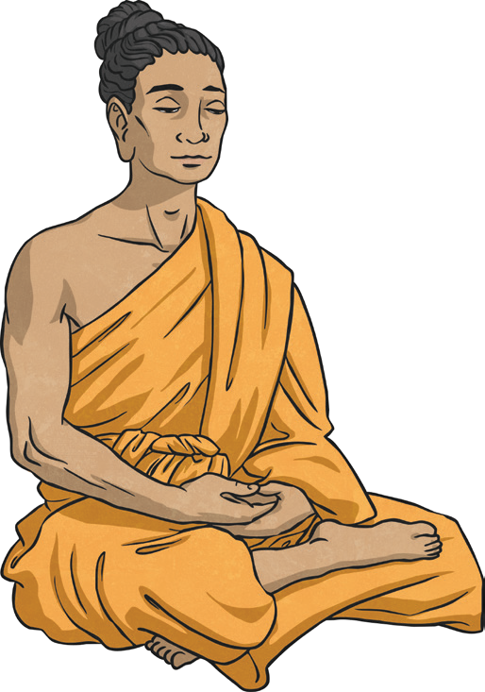
Buddhists live by five rules:
- Never take the life of a living creature.
- Do not steal.
- Be faithful to your partner.
- Do not lie.
- Do not drink alcohol.

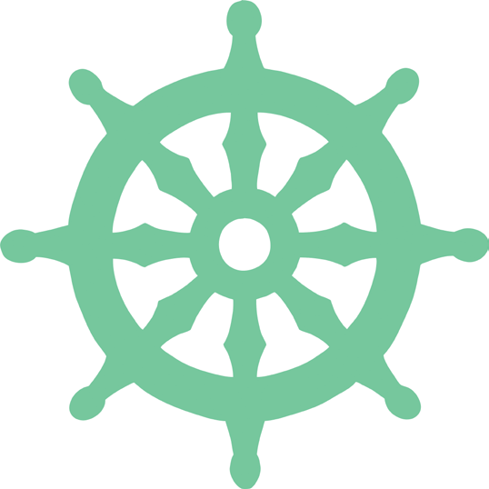
Buddhism originated in Northeast India and now has followers from all over the world. The Dharmachakra is a
The Buddha
There are no gods in Buddhism. It was created by a man called Siddhartha Gautama, who was born into a noble family. He lived a sheltered early life, but when he was older he went out into the world and saw that sickness, age and death
come to everyone. After seeing this, Gautama meditated and found the answer to life. This made him the Buddha. This was called enlightenment and the Buddha decided to teach others how to reach it.

symbol used in Buddhism.

Dukkha | Samudaya | Nirodha | Magga
Everyone suffers in life. | The cause of suffering is a craving for things and wanting to control things. | To end the suffering, life must be lived one day at a time.  You must also let go of cravings. | To end the suffering for good, people must follow the Eightfold Path created by Buddha.

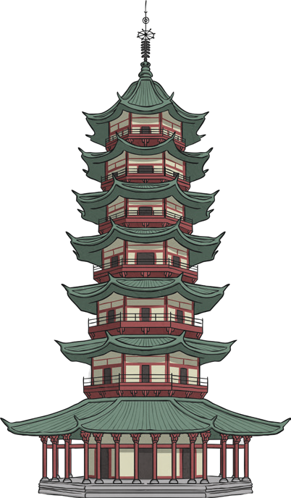
Special Shrines
Buddhists can worship from home or at a temple, which are built in a variety of shapes. Buddhists worship by sitting on the floor, making sure their feet face away from any image of Buddha. Their head and body face the image of Buddha. This is called puja. Buddhists chant to show their love for Buddha and make offerings of flowers and incense at shrines.

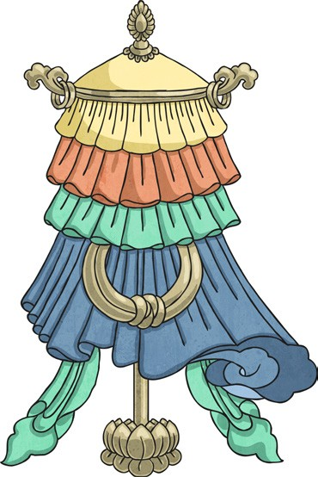
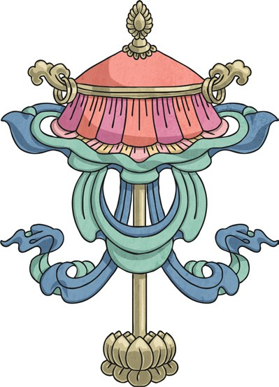
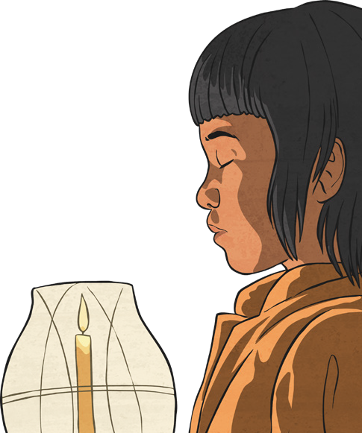
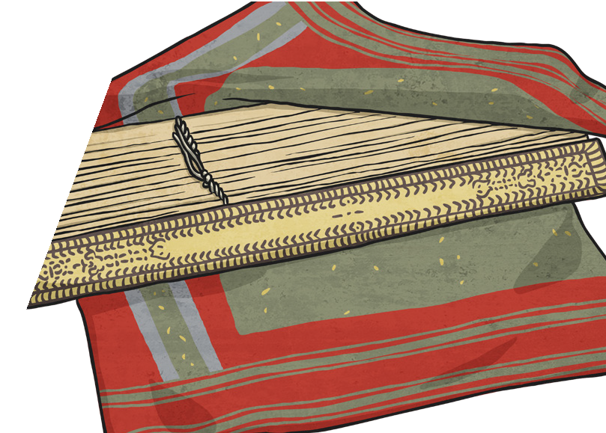Wesak is an important Buddhist festival celebrating the Buddha’s birthday.

When the Buddha died, people thought it would be a good idea to write down what Buddha said and thought. 500 Buddhist Monks met
to check the content of his teachings. The teachings were then passed down by word of mouth for around 400 years, before being written down.
Holy Books

The Buddhist teachings are called ‘Pali Canon’ and the ‘Sanskrit Canon’.
Key Vocabulary
puja | The Buddhist act of worship.
shrine | A special place that is linked with a holy object or person
Wesak | Important Buddhist festival when Buddhists try to clear their minds of negative thoughts.
Dhvaja | Buddhist symbol meaning ‘spiritual victory’, often popular with warriors.
Chattra | Buddhist symbol meaning ‘parasol’, a protection from suffering.

Chattra Dhvaja

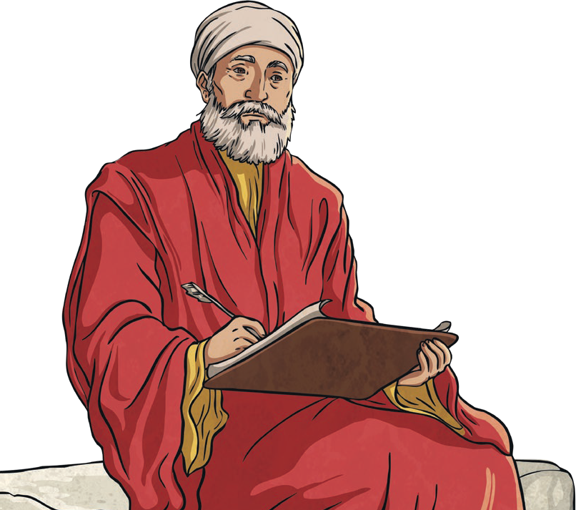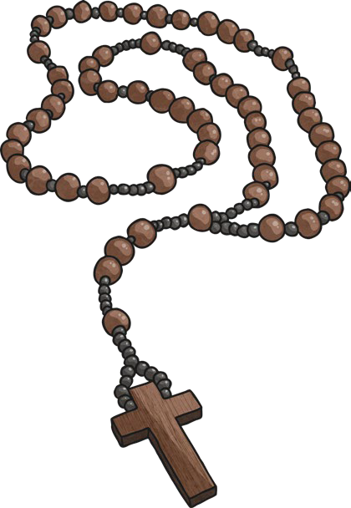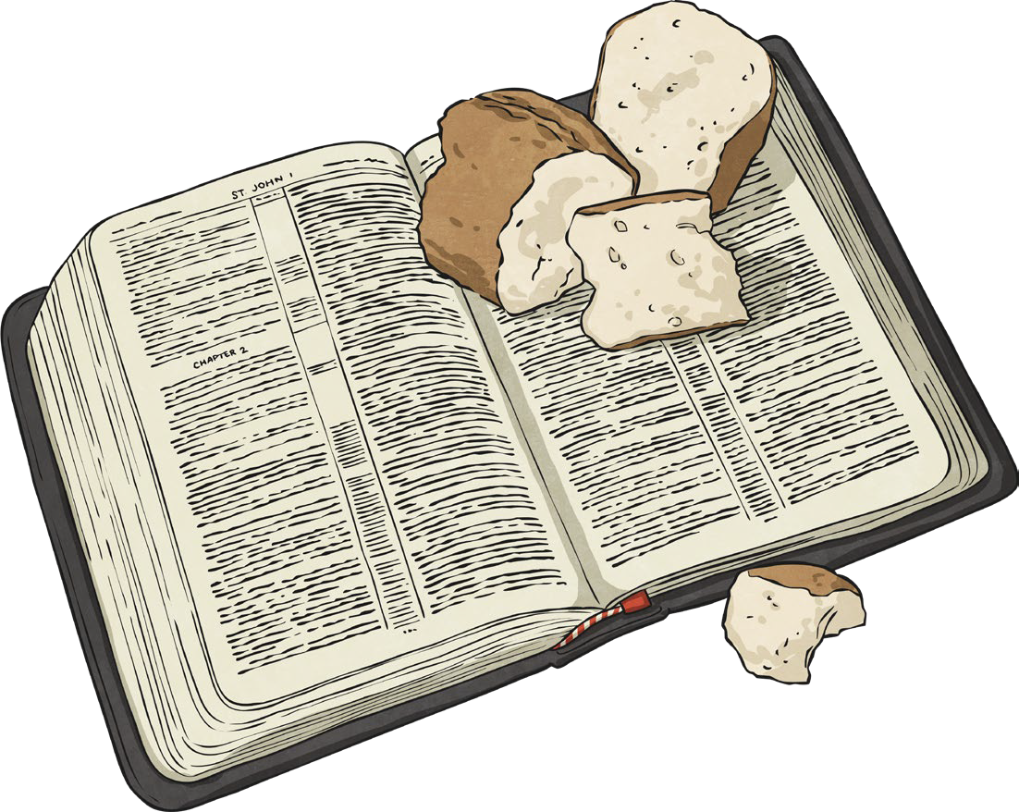
When Was the Bible Written? | The Old Testament | The New Testament
The Bible was written over a period of 1500 years. It contains 66 books, written by around 40 authors. The authors of the Bible were inspired by God to write their ideas down.  It is split into two parts: the Old Testament and the New Testament. | The Old Testament contains stories and writings from before the birth of Jesus. The first five books of the Old Testament (the books of Moses) are also sacred texts to Jewish people. | The New Testament is about the life and teachings of Jesus and his followers.  The final book in the Bible is a prophecy about how Jesus will return one day.

Key Vocabulary
sacred | Very holy and special.
Christians | People who follow the religion of Christianity.
Bible | The holy book followed by  Christians.
revelation | The Christian belief that God reveals himself to people through words  or actions.
Jewish | People who follow the religion of Judaism.

A Sacred Text
The Bible is a sacred book for
Christians.
It is treated with respect by those who use it. Christians believe that the words in the Bible are important and were revealed by God. This is known as revelation. The Bible has been translated into more than 600 languages.

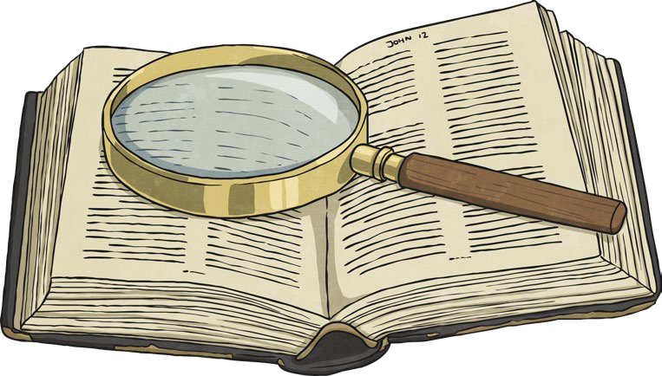
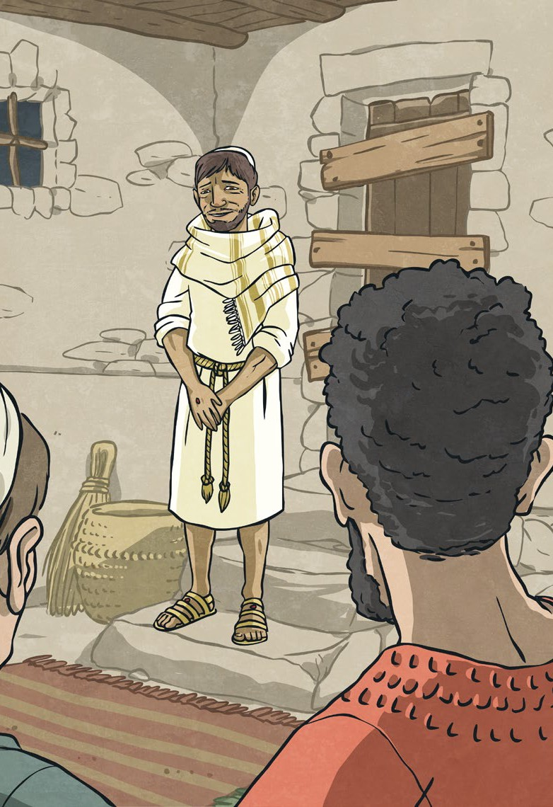
Parables | How Do Christians Use the Bible?
When Jesus wanted to teach a particular lesson to a crowd of people, he would often tell them parables.  Jesus told parables so people could remember and understand what he had taught them. | Christians read the Bible because it contains rules and advice from God. They may talk to other Christians about what it means to them.  Some Christians study the Bible. This means that they read and think about it in detail, to gain a better understanding of God.

Key Vocabulary
psalms | Poems and songs recorded  in the Bible.
parables | A story told by Jesus, to teach a particular lesson.
proverbs | Wise sayings recorded in  the Bible.
Gospels | Four books in the New Testament that tell us about Jesus’ life, from his birth up to his death and resurrection.
prophecy | A message given by God, that is delivered to his people by a specially chosen person (a prophet).

What’s in the Bible?
The Bible contains lots of different types of texts. There are:
- psalms;
- proverbs;
- letters;
- laws;
- histories;
- prophecies;
- parables.

The Gospels
The four gospel
writers are: Matthew; Mark; Luke;
John.
Different versions of the same story can be found in the gospels.

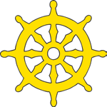
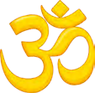
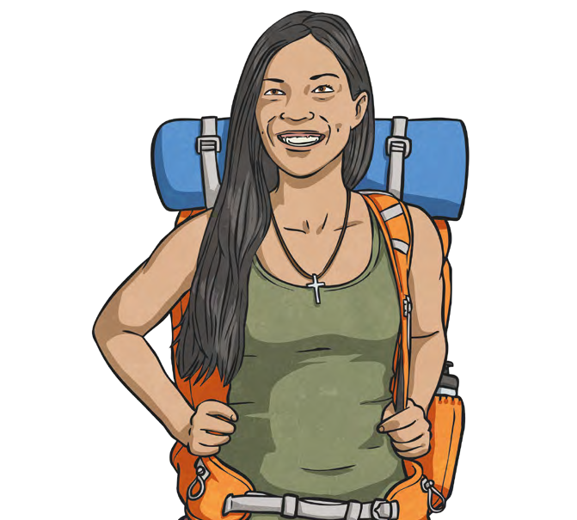
A pilgrimage is a special journey to a place that is important for religious reasons. Different religions have different special places that pilgrimages are made to. All places of pilgrimage are considered to be sacred and holy and they can be places where miracles have taken place.
What Is a Pilgrimage?
Key Vocabulary
pilgrimage | A journey to a special place that is important for religious  reasons. A person who goes on a pilgrimage is called a pilgrim.
Christianity | One of the world’s main religions. Followers are called Christians.
Buddhism | The religion followed by Buddhists.
Hinduism | The religion followed by Hindus.
holy | Something or somewhere that is dedicated to or associated with God or a religious purpose.
miracle | Something extraordinary and positive that is believed to happen because of another power, such as a god.
sacred | Something that is connected with God or a god.

Buddhist Pilgrimages | Christian Pilgrimages | Hindu Pilgrimages
Pilgrimages are very important in Buddhism. The most important Buddhist pilgrimage sites are called the ‘Eight Great Places’. They are:  Rajgir, Bodh Gaya, Sarnath, Vaishali, Sankassa, Kusinara, Shravasti and Lumbini. Four of these are believed to be where miracles took place.  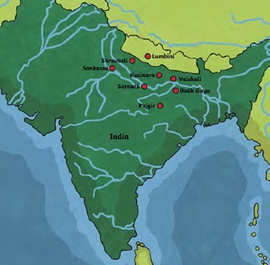 | There are different views on pilgrimage in Christianity. For some Christians,  going on pilgrimage is important, whereas others do not believe it is that important. Christians who go on pilgrimages visit places that are in the New Testament in the Bible,  or are linked with saints or miracles. Pilgrimages include Lourdes in France and Bethlehem.  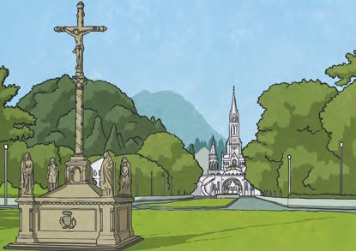 | Pilgrimage is an important part of Hinduism. Hindus go on pilgrimages to several places, including temples and mountains.  Once every 12 years, millions of people share in ritual bathing at the Kumbh Mela festival. This is held where the waters  of the Ganges and Yamuna rivers combine. The River Ganges is the holiest river for Hindus.  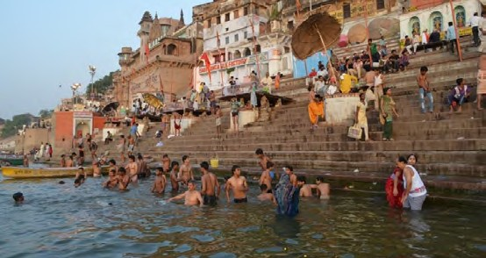

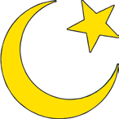
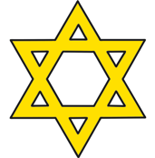
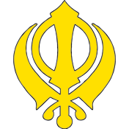
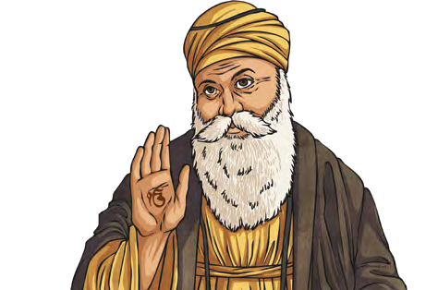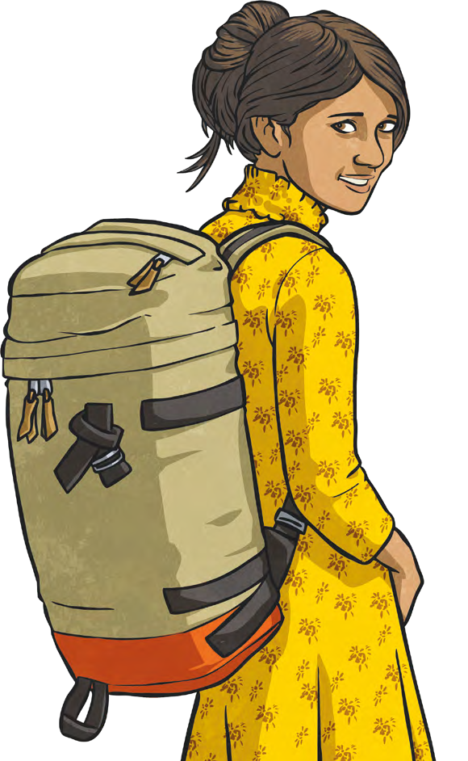
Muslim Pilgrimages | Jewish Pilgrimages | Sikhism and Pilgrimages
In Islam pilgrimage | In the past, it used to be | Pilgrimage is not
is important. All three | the duty for all followers | compulsory for Sikhs so
types of Muslims (Sunni, | of Judaism to pilgrimage | many choose not to go and
Shia and Sufi) take | to Jerusalem three times a | spend the money they could
pilgrimages. Each group | year during specific festivals. | have spent on a pilgrimage
of Muslims has its own | It is no longer a duty, but | to help others. Sikh gurus,
pilgrimages but they | Jews still go on pilgrimage | such as Guru Nanak, have
all believe in a special | to Jerusalem as it is their | said that spiritual wisdom
pilgrimage called Hajj. | holiest city. Jews go to | and “God’s name is the real
All Muslims try to go | pilgrimage at the Western | pilgrimage place”.
once in their life, as | Wall (or Wailing Wall) as it | If Sikhs do choose to go on
this is the fifth pillar of | is the last site of a destroyed | a pilgrimage, they visit the
Islam. For Hajj, Muslims | Jewish temple. Jews pray | ‘Golden Temple’ in India. It
travel across the world | at the wall and write | is the most famous place of
to visit Mecca. | messages to God. | worship for Sikhs.
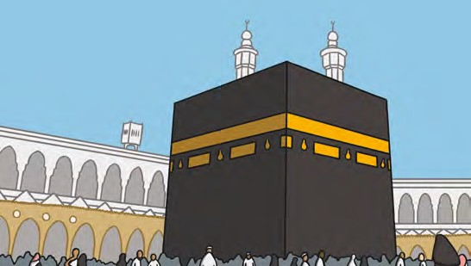 | 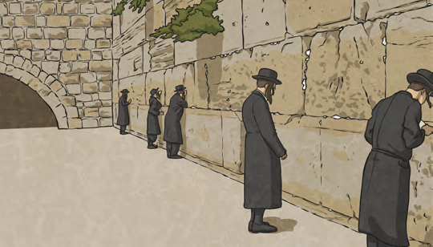

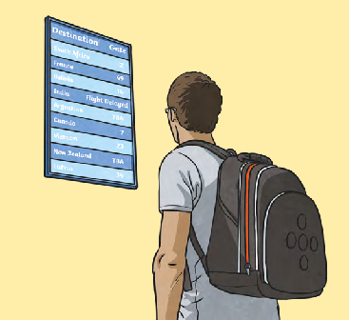
Key Vocabulary
Islam | Islam is the second most popular religion in the world. Muslims are followers of Islam.
Judaism | The religion followed by Jews.
Sikhism | The religion followed by Sikhs.
guru | A religious teacher or leader in the Hindu or Sikh religions.

Although going on a pilgrimage is important to many different religions, this is not true with every religion. Some Sikhs go on pilgrimages but many do not as it is not seen as a compulsory part of Sikhism.
Are Pilgrimages Important To All Religions?

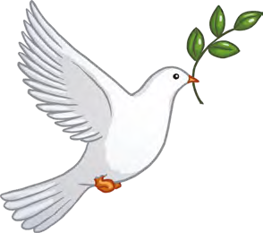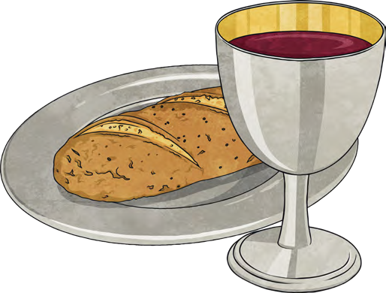
The Son of God | The Trinity | The Ten Commandments
Christians believe that Jesus was the son of God and that he came to Earth to teach people about God’s message. Jesus is also known as Jesus Christ, Jesus of Nazareth, The Good Shepherd, Lamb of God, Light of the World, and Bread of Life. | Christians believe in the Trinity. There is one God, but He is three separate people: Father, Son and Holy Spirit. The Holy Spirit is sometimes known as the Holy Ghost.  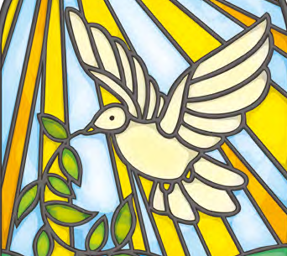 | These ten rules were given by God. They can be found in the Old Testament.  Christians try to live their lives by following the Ten Commandments.  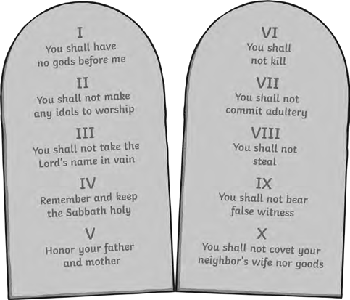

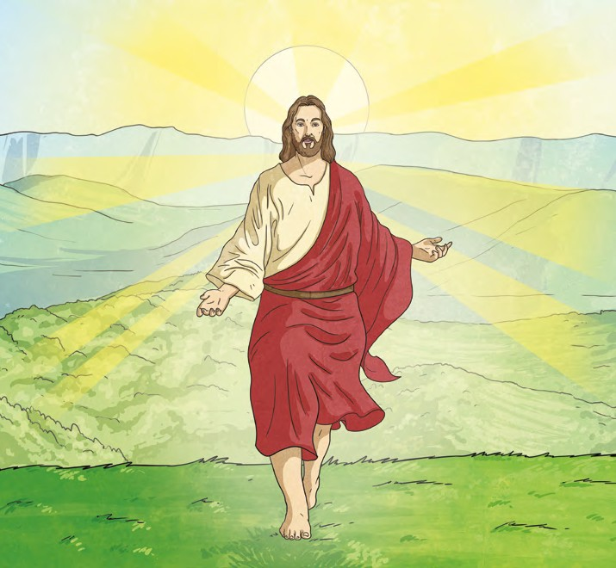
Key Vocabulary
Christianity | The religion followed by Christians.
Judaism | The religion followed by Jews.
Jesus | The founder of  Christianity.
Ten Commandments | Ten rules given by God for people to live by.
The Trinity | The three separate forms that God is known by.
Old Testament | The first (and biggest) part of the Bible, written before Jesus was born.

Christianity is one of the five main world religions. It began after the death of Jesus.
Jesus was born a Jew and Christianity originally developed as part of Judaism.
There are a number of symbols associated with
Christianity:
Christianity
The words ‘Christian’ and ‘Christianity’ come from the name, ‘Jesus Christ.’

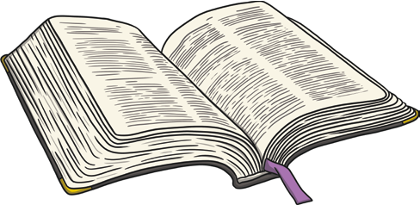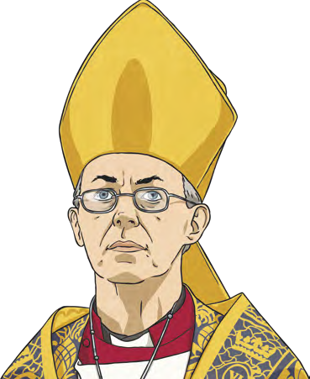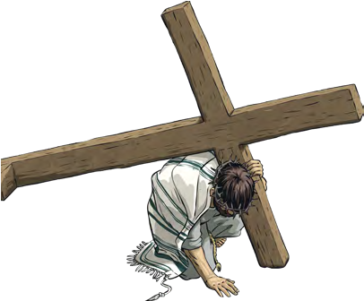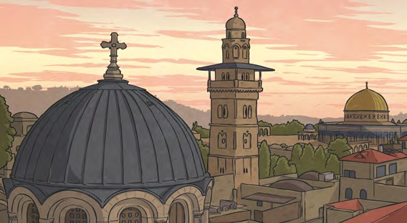
The Christian holy book is the Bible.
It has two parts: the Old Testament and the New Testament. There are over 66 books within the Bible, which include letters, laws, poems and stories.
The Bible
Another denomination of Christianity is the Anglican church. This group also includes the Church of England. The Archbishop of Canterbury is the most senior bishop of the Church of England. Canterbury is where the first church was built in England.
The Anglican Church
Easter and Christmas are important Christian festivals. Christmas celebrates Jesus’ birth and
Easter celebrates Jesus’ death and resurrection.Christians believe that Jesus died for their sins and that one day he will come again. During Lent, Christians remember Jesus’ time fasting and praying in the desert.
Festivals
Some Christians pilgrimage to holy places, such as Jerusalem (where Jesus died), Bethlehem (where Jesus was born) and Nazareth (where Jesus grew up).
Special Places
Catholics may pilgrimage to Lourdes, in France, where miracles were said to have occurred, or Rome, in Italy, where the Pope (the head of the Catholic church) lives.
Key Vocabulary
pilgrimage | A journey to visit a religious site.
Catholic | A member of the Roman Catholic church – a denomination (group) of Christianity.
miracles | Amazing events that occur, but cannot be explained.
resurrection | When Jesus rose from the dead.
Lent | The 40 days leading up to Easter. Christians often give something up for Lent.
fasting | To fast is to not eat or drink for a particular length of time.
New Testament | The second part of the Bible, which was written after Jesus was born.

Progression of Skills
 | LKS2
Beliefs and teachings (from various religions) | Children can describe the key beliefs and teachings of the religions studied, making some comparisons between religions. Children expand on their knowledge of world religions from KS1.  Children can:  - describe the key teachings and beliefs of a religion;  - begin to compare the main festivals of world religions;  - refer to religious figures and holy books.
Rituals, ceremonies and lifestyles (from various religions) | Moving on from KS1, children look at the concepts of belonging, identity and meaning. Children understand what belonging to a religion might look like, through practices and rituals, and what it might involve. Children begin to discuss and present thoughtfully their own and others’ views. Children also explore pilgrimages as a part of a religious life.  Children can:  - identify religious artefacts and how they are involved in daily practices and rituals;  - describe religious buildings and how they are used;  - explain religious ceremonies and rituals and their importance for people’s lives and sense of belonging.
How beliefs are expressed | Children explore the expression of beliefs through books, scriptures, art and other important means of communication. Children then move on to exploring a range of beliefs, symbols and actions to express meaning. Children can explain the meaning of religious stories and sources of wisdom and the traditions from which they come.  Children can:  - begin to identify religious symbolism in different forms of art and communication;  - looking at holy texts and stories, explain meaning in a story;  - express their beliefs in different forms, with respect for others’ beliefs and comparing beliefs.
Time to reflect and personal growth | Children further explore how an appreciation of religion plays an important role in the lives of some people. They make links to expressing identity and belonging, including links to communities they may belong to. They notice and respond sensitively to different views.  Children can:  - understand that personal experiences and feelings can influence their attitudes and actions;  - offer suggestions about why religious and non-religious leaders and followers have acted the way they have;  - ask questions that have no agreed answers, and offer suggestions as answers to those questions;  - understand that there are similarities and differences between people and respect those differences.
Values (in your own life and others lives) | Children develop their appreciation of the ways in which people’s values are an important aspect of their lives. They make links to responsibility and citizenship and choices they make affecting their lives. Children begin to understand the concept of shared values and how a community can use shared values.  Children can:  - make informed choices and understand the consequences of choices;  - describe how shared values in a community can affect behaviour and outcomes;  - discuss and give opinions on morals and values, including their own.

