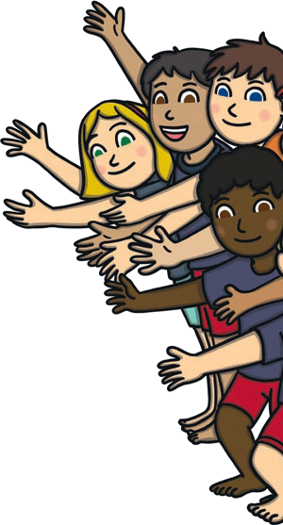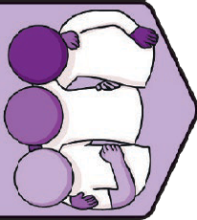
Key Vocabulary
team | A group of people working together.
achieve | To complete or do well at a task or goal.
mindset | Our attitude towards something.
compliment | Something nice we say to someone else.
kindness | Being friendly, generous and considering the feelings of others.
empathy | Being able to understand and share the feelings of others.
belonging | When we feel part of a group.
listen | Hearing and concentrating on what someone is saying.
conflict | An argument or disagreement between two or more people.
respect | A way of treating or thinking about someone that shows they are important and they are valued.
considerate | Thinking of others and how they might feel.
polite | Speaking with good manners and respect.
bullying | Doing something repeatedly to hurt someone’s body or feelings on purpose.
teasing | Making fun of or playing tricks on someone.

Relationships | TEAM Key Knowledge Team
A team is a group of people
who work together to achieve something. Working as a team can help us to feel good because we are contributing to something.

Team Skills
There are certain skills that help us to work as part of a team. Some of these are: listening, talking, showing respect,
PSHE and Citizenship | TEAM
kindness and empathy. This means we can think about how the other people in our team might feel about things. When we work as a team, we can do things that we are not able to do on our own.

Positive Mindset
If we have a positive mindset about our learning, we can make sure we continue to try when things get tricky. By having a positive learning mindset, we can try new
things when a task is feeling difficult, learn from our experiences and see challenges as opportunities to learn and improve.

Unkind Behaviour
Unkind behaviour can cause uncomfortable emotions. There are different types of behaviour that might cause people to feel uncomfortable emotions. These include joking, teasing and bullying. If we know about or experience any unkind behaviour,
it is important to speak to a trusted adult straight away.

Listening
It might help us to listen if we look at the person who is talking, if our hands and feet are calm and still, and if we are not talking at the same time.
Listening to others helps us to work as part of a team. Listening to other people helps us to learn from, understand and show respect to people around us.

Key Learning Point: Kindness and Respect Ways to show respect to others:
- listen;
- speak politely;
- use kind words and actions;
- 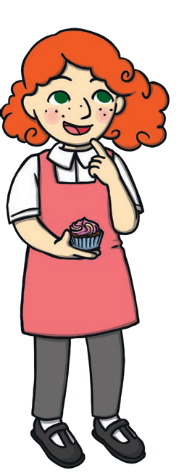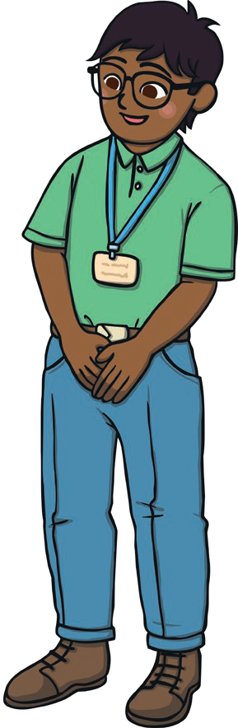understand people have different opinions;
- value each other’s strengths;
- give people the time they need to do things.

Ways to show kindness to others:
- smile;
- help others;
- ask someone how they are;
- tidy up;
- say please and thank you;
- share;
- welcome others.

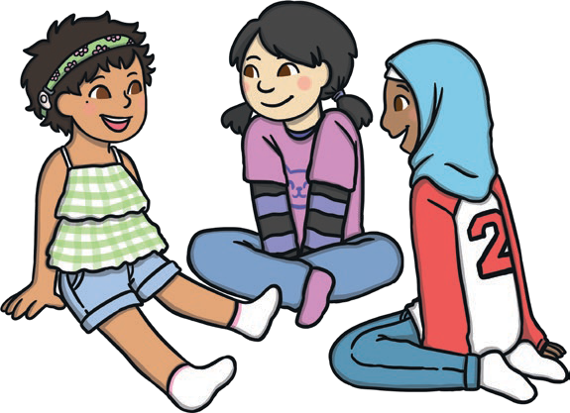
twinkl.com

To look at all the planning resources linked to the KS1 TEAM planning, click here
This resource is fully in line with the Learning Outcomes and Core Themes outlined in the PSHE Association Programme of Study.

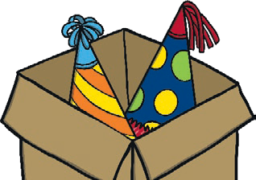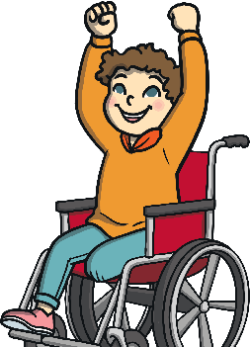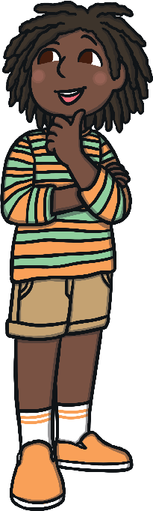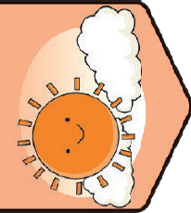
Key Vocabulary
positive | Looking for the good in a situation rather than focusing on the bad.
happy | A comfortable feeling we get when we are enjoying what we are doing.
challenge | Something we may find tricky but that we can work to do well at.
emotions | The way we feel about things that are happening.
thoughts | Ideas we have inside our mind.
choices | Options we have about what to do.
consequences | Things that happen as a result of something else.
decisions | Choices we make when offered options.
persevere | To keep on trying.
resilience | To keep trying when we find something difficult.
achieve | To complete or do well at a task or goal.
mindset | Our attitude towards something.
thankful | A feeling we get when we are grateful for and appreciate something.
mindful | Focusing on and being aware of something.  Focusing on what we are doing now, how we are feeling and giving our minds time to relax.

Health and Wellbeing | Think Positive | KS1 Key Knowledge

Positive Thinking
When we think positively, we look for the good in a situation. This can help us feel better about things and help improve our mood.
PSHE and Citizenship | Think Positive

Making Good Choices
We each have lots of decisions
to make each and every day. This could be about what we
have for breakfast, what we
wear or who we play with. By making good choices such as eating a balance of different foods, getting enough sleep, playing outside and spending time with friends and family, we can help our minds and bodies stay healthy and happy.

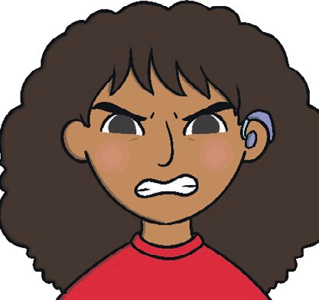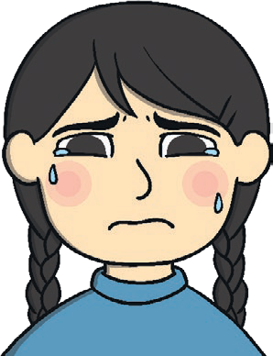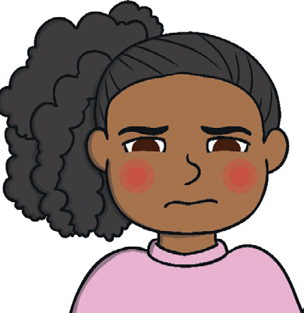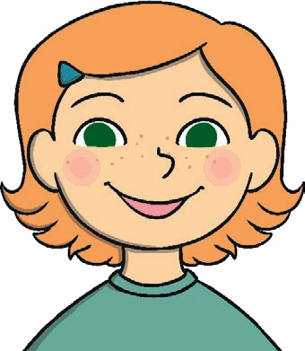Positive Mindset
twinkl.com
If we have a positive mindset about our learning, it means we look for new ways to tackle challenges and that we see learning experiences as exciting. It means not being afraid to fail and to keep on trying, giving our learning our very best effort. People with a positive mindset about their learning will persevere and show resilience.

Managing Uncomfortable Emotions
We all experience lots of different emotions and this is OK. It can be helpful to have some strategies to manage our feelings which we might find uncomfortable. If we feel uncomfortable emotions it can help to talk to someone we trust, take deep breaths, think of things we enjoy doing, find someone we enjoy spending time with or do an activity we enjoy.

Being Thankful
Being thankful and appreciating what we have helps us to feel happy. By focusing on what we have and being grateful for this, we focus on the positives and help our minds to feel good.
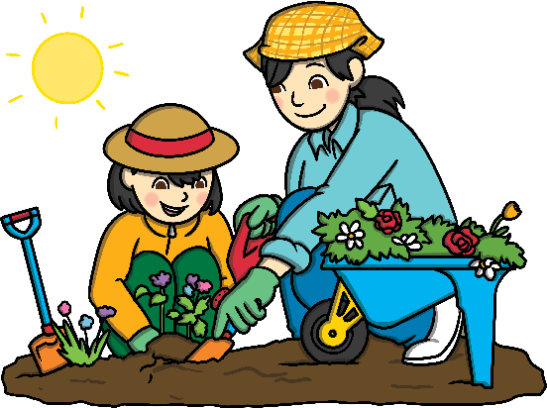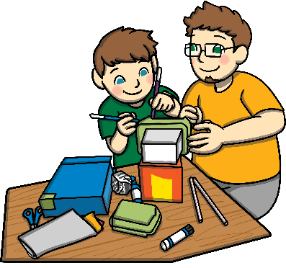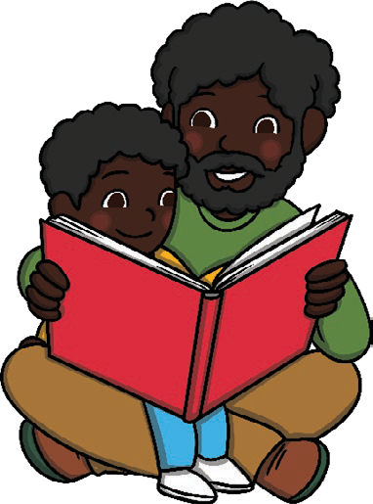

Being Mindful
When we practise mindfulness we focus on our bodies and minds and what we are doi and feeling right now. This gives our minds a chance to be calm and to relax. This can h us to understand our feelings and manage our emotions. We can be mindful by focusin on our breathing, thinking about what we can see, feel and hear right now, going for a peaceful walk outside, focusing on the taste and feel of the food we are eating, listening some calming music, looking carefully at things around us and noticing detail in them o concentrating on a calm activity we enjoy.
ng
elp g

to r

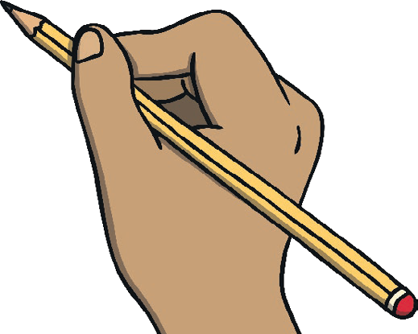Key Learning Points:
Helping Our Bodies and Minds to Feel Good:
To help our minds and bodies feel good we can:
- play outside;
- do things we enjoy;
- spend time with family and friends;
- eat a balanced diet;
- get enough sleep;
- think of things we are
thankful for;
- enjoy some calm or mi
ndful
activities.

Having a Positive Mindset for Learning: There are lots of ways we can help ourselves approach tasks with a positive mindset. This way we can see challenges as exciting and help ourselves try new strategies to achieve our goals. It can help if we remember positive words and phrases:
- I can do this!
- If I keep trying I will succeed.
- Is there another way I could complete this challenge?
- Are there resources that can help me?
- Is there someone who I can talk to about this challenge?
- I am going to try my best!

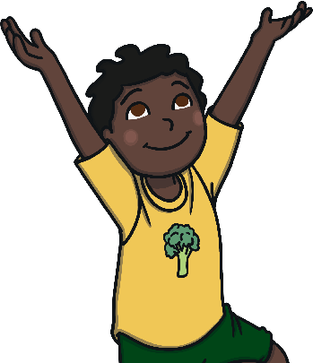
twinkl.com

To look at all the planning resources linked to the KS1 Think Positive planning, click here
This resource is fully in line with the Learning Outcomes and Core Themes outlined in the PSHE Association Programme of Study.

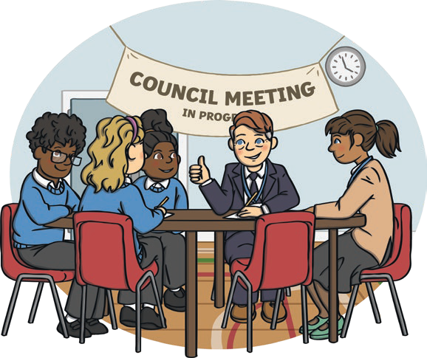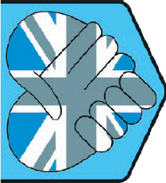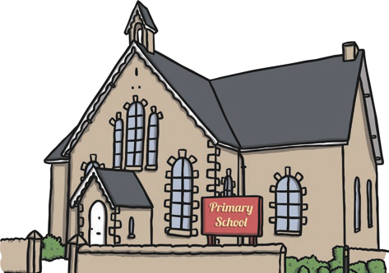
hings.
nd
Key Vocabulary
community: | A group of people who live or work together in the same place, or who like to do the same kind of things.
belonging: | Feeling that we are part of a group.
respect: | A way of treating or thinking about someone that shows they are important and they are valued.
listen: | Hearing and concentrating on what someone is saying.
behaviour: | Our actions.
choice: | Options we have about what to do.
consequence: | Things that happen as a result of something else.
neighbours: | People who live and work in our local community.
neighbourhood: | The area near and around where we live.
responsibilities: | Tasks that we do to contribute or things we are in charge of.
environment: | The world around us, including the land, sea, sky, plants, animals and people. Environments can be natural or built.
multicultural: | A group of people from many different cultures.
diverse: | Made up of lots of different t
culture: | The food, clothes, language a traditions people enjoy.

Living in the Wider World | Diverse Britain | KS1
Key Knowledge
My School Community In our school community we are kind, caring and helpful to each other and we follow school rules. We treat
PSHE and Citizenship | Living in the Wider World
everyone and everything with
respect, share our resources
and help to keep our space
tidy. This helps our school community to be a safe and happy place.

My School Community
In our school community we are kind, caring and helpful to each other and we follow school rules. We treat everyone and everything with respect, share our resources and help to keep our space tidy. This helps our school community to be a safe and happy place.

Being a Good Neighbour
We can be good neighbours by thinking about what other people need to feel happy. We can show respect to others, look after the environment, smile and
help people.

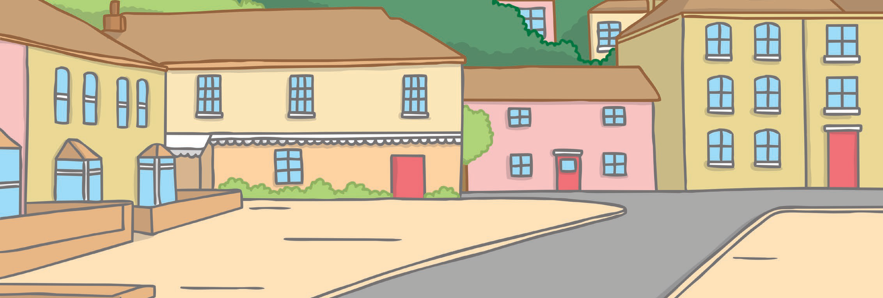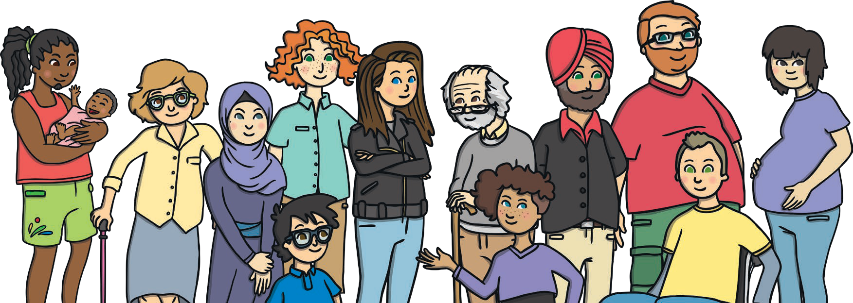Looking After Our Neighbourhood
twinkl.com
To look after our neighbourhood, we need to look after the natural and built environment that is local to us. People have the right to live somewhere clean and safe, where they can be healthy. We have a responsibility to look after our neighbourhood to help make sure all people and other living things have a comfortable home.

Living in Britain
Britain is multicultural. There are many different cultures and traditions. This will mean there are many similarities and differences between people, places and experiences. These differences are what makes the world an exciting place and they should be celebrated.

British People
The United Kingdom of Great Britain and Northern Ireland and other British Isles are multicultural nations. People come from many different backgrounds. They wear many different types of clothes, eat many different foods, speak many different languages and enjoy doing lots of different things. We all have the right to live as we choose and this must be respected.
We can show respect by smiling, being friendly and learning from each other.

Feeling Proud of Our Country
There are lots of things that make our country special. These include the people, places, cultures and traditions. We can all help to keep our country special by respecting and valuing our differences and looking after the environment.

Key Learning Points:
Respecting Our Differences: There are many ways we are similar to and different from people around us.
Everyone deserves to feel respected and valued and to have every opportunity to be and achieve all they can. To help show everyone kindness and respect, we can:
- smile at others;
- speak kindly;
- show care;
- ask questions;
- respect people’s choices;
- learn from each other.

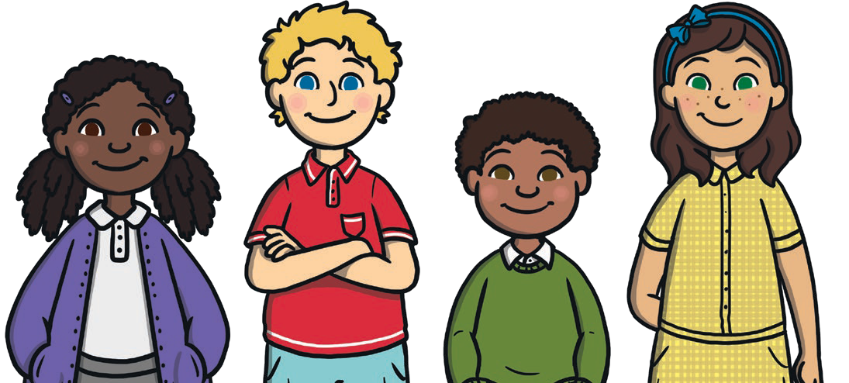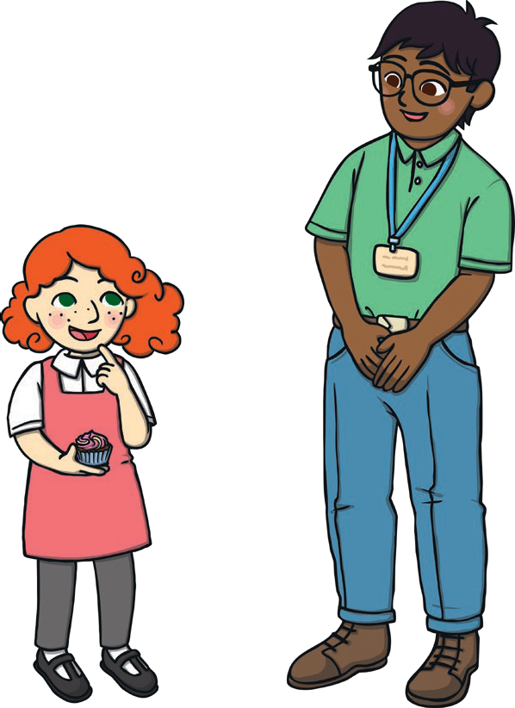
twinkl.com

To look at all the planning resources linked to the KS1 Diverse Britain planning, click here

This resource is fully in line with the Learning Outcomes and Core Themes outlined in the PSHE Association Programme of Study.

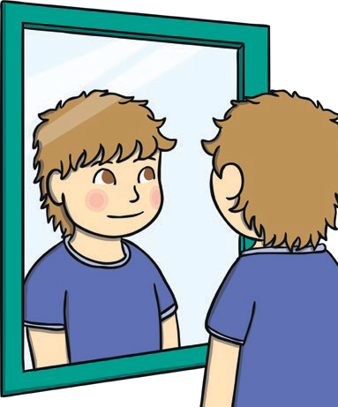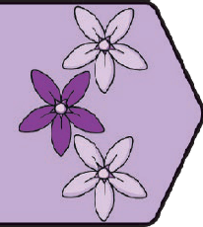
Relationships | Be Yourself | KS1 Key Knowledge
Key Vocabulary
special qualities | Things about us that make us different from others.
kind | To be friendly, considerate and generous to others.
feelings | Emotions we experience about things that are happening.
unique | Something that is special and unlike anything else.
happy | A comfortable feeling we get when we are enjoying what we are doing.
calm | To feel settled. A time of no strong emotions.
content | To feel comfortable with how things are.
change | When something becomes different.
care | The way we feel towards people we love.  To provide things people need.
trusted adult | Adults who we know we can talk to about anything that worries us.
polite | Speaking with good manners and respect.
respect | A way of treating or thinking about someone that shows they are important and they are valued.

Things That Make Us Special
We are all special and unique. This is exciting! There are lots of ways we are different from other people and this is something to be proud
of. These might be things we like, things we are good at or things we are interested in. Feeling good about the ways we are unique is a way we can be kind to ourselves.
PSHE and Citizenship | Be Yourself

Talking About Our Feelings
By talking about how we feel, we can get help if we are worried, understand someone else’s point of view about a situation and learn from people we care about. We all experience lots of different feelings. We might feel happy, sad, angry, calm, lonely, excited or lots of other feelings too. Some of these will feel comfortable and some may feel uncomfortable. Every feeling is OK. If we are worried about anything at all or feel uncomfortable emotions, it is very important to talk to a trusted adult.

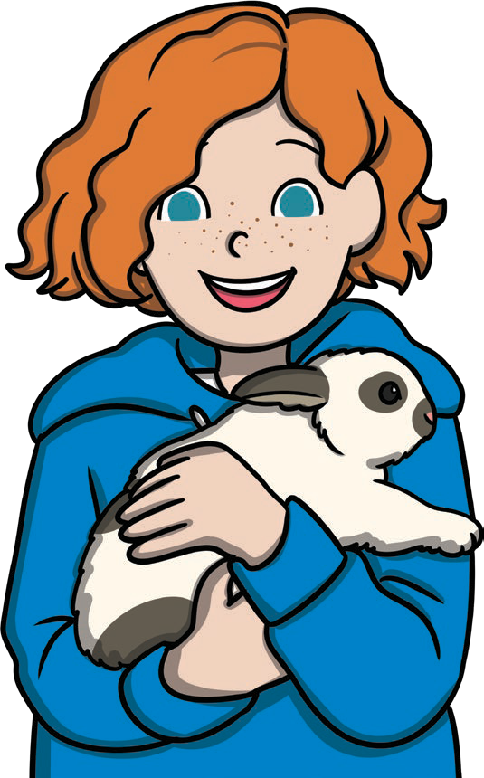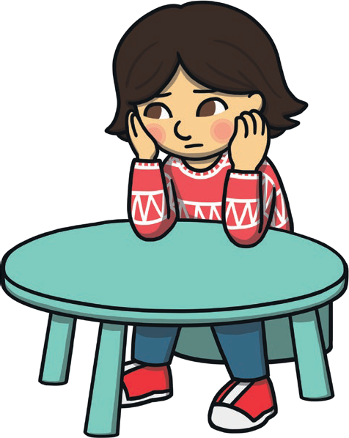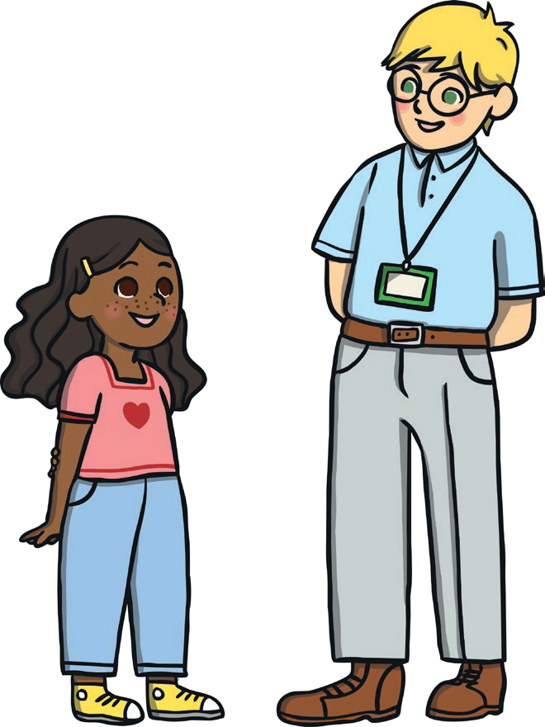Feeling Happy
twinkl.com
When we feel happy it is often because we are pleased with something. This may be when we are doing things we enjoy or
when we are with people we enjoy spending time with. Because we are all different, different things will make us happy.
Managing Our Uncomfortable Feelings We all feel lots of different
emotions. Some will be comfortable and some will be uncomfortable and this is OK. It can be helpful to know some ways to help ourselves cope with uncomfortable emotions. We could cry to let our feelings out, exercise to help our mood, listen to music to help ourselves feel calm or express our emotions, talk to someone we trust to get help and breathe calmly to focus on the present.

Coping with Change
There are lots of changes we might face, some may be small and some may be big. Sometimes change
can be exciting or sometimes it can make us feel worried or sad. Some ways we can help ourselves cope with change are to talk to trusted adults, or write down or draw pictures of happy memories or things we are looking forward to.

Sharing Our Feelings
Talking to people we trust about how we feel can help us to feel valued and get help if we need it. We are all equally
important so our thoughts and feelings are equally important as well. When we share our feelings with others, it is important to speak kindly, calmly and with respect.
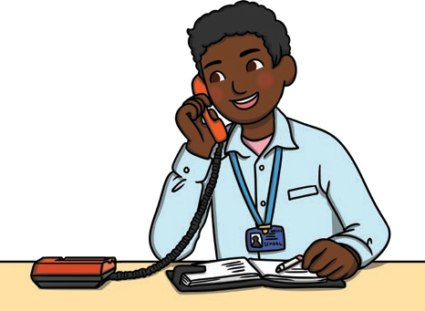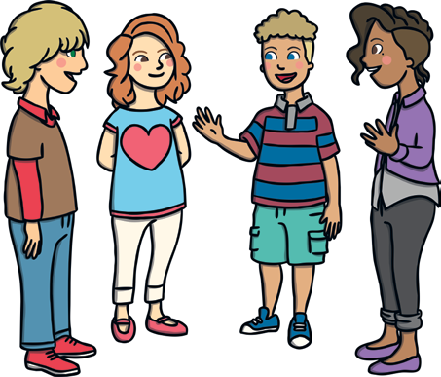

Key Learning Points:
Coping with Our Feelings and Emotions: We all experience lots of emotions and some may feel comfortable while others feel uncomfortable. There are lots of ways we can express our emotions or help ourselves to understand what we are feeling. These things can help:
- Listening to music;
- Taking slow, deep breaths and focusing on how this feels;
- Getting active and exercising;
- Spending time with people who are special to us;
- 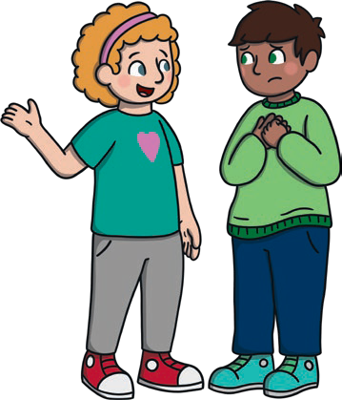Talking to people we trust;
- Spending time doing activities we enjoy.
Being Kind to Ourselves: It is important to be kind to ourselves and feel good about ourselves. We are special and unique and
deserve to feel valued and loved. Reminding ourselves how special we are and of the many things we do well can help us show respect and care for ourselves and to feel good.

twinkl.com
To look at all the planning resources linked to the KS1 Be Yourself planning, click here
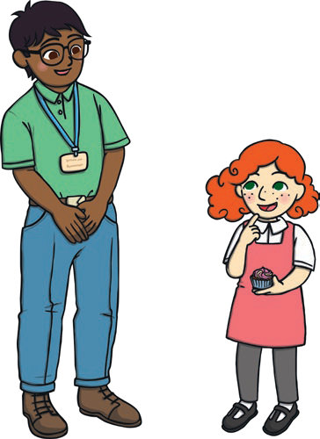This resource is fully in line with the Learning Outcomes and Core Themes outlined in the PSHE Association Programme of Study.

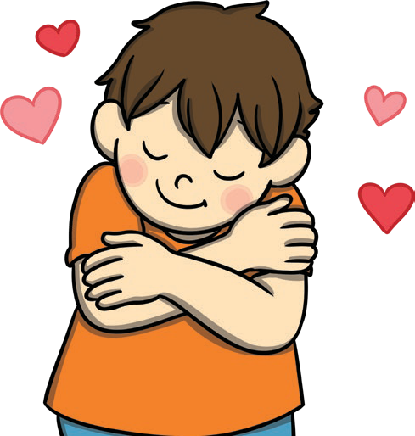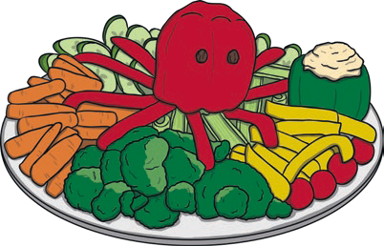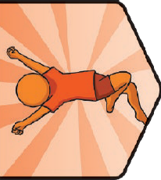
Health and Wellbeing | It’s My Body | KS1 Key Knowledge
Key Vocabulary
consent | To give permission or agree to something.
choice | Options we have about what to do.
exercise | Physical activity that helps our bodies and minds to stay healthy.
permission | Allow something to happen.
hygiene | Keeping ourselves clean to stay healthy and well.
risk | A chance something may be dangerous or cause harm.
safe | Being protected from harm or danger.
unsafe | Something that is not safe.
danger | Something that could cause harm.
comfortable | Something that we feel is OK or that helps us to feel settled.
uncomfortable | Something that we feel isn’t OK or that makes us feel unsettled.
trusted adult | Adults who we know we can talk to about anything that worries us.
rules | Instructions we need to follow to stay safe.
consequence | Things that happen as a result of something else.

My Body My Choice
It is up to us what happens to our body. No one has the right to hurt our body or feelings. It is
important to ask permission or consent before
we hug or hold
someone’s hand. This is how we should expect to be treated and how we should treat others.
PSHE and Citizenship | It’s My Body

A Healthy Balance
To keep our bodies and minds healthy, we can eat a balance of different foods, make sure we do lots of physical activity and exercise and get enough relaxing time and sleep. All these things will help our bodies and minds feel good and have enough energy for all we want to do.

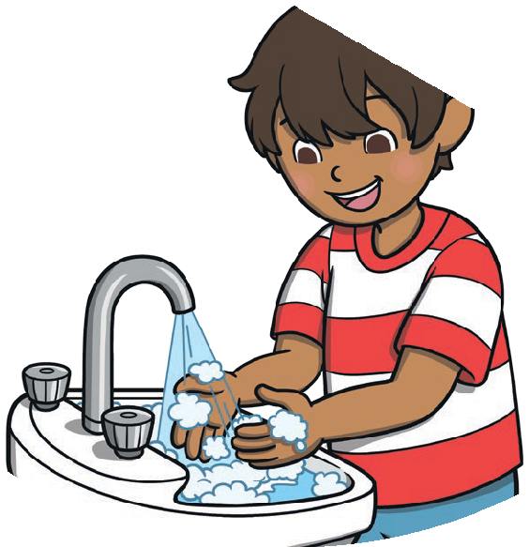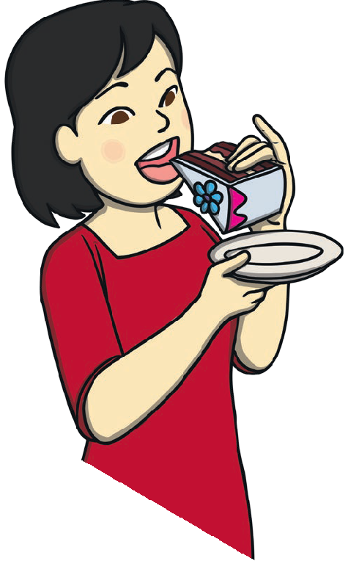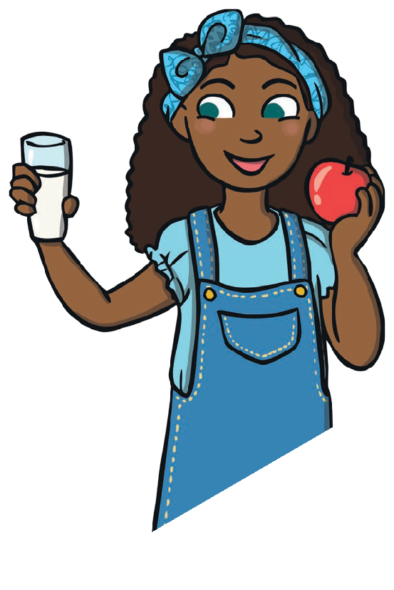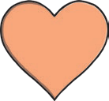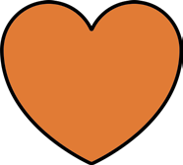A Balance of Different Foods
twinkl.com
To help our bodies and minds stay healthy, it is important that we eat a lot of different
kinds of foods. These can include foods from different food
groups. This balance looks different for everyone
and we must respect people’s choices.

Keeping Ourselves Clean We can make choices about our personal hygiene. There are parts of our body that need to be washed twice a day or more, these
include our teeth and hands. There are other parts of our body that
need to be washed every day. These include our face, private parts, armpits, feet and neck. Other
parts of our body can be washed less often, like our hair.

What Can We Eat?
It is important that we only eat things that are safe. We must
never eat or drink products that are not food or drink
and we should only take medicine that is meant for us. We mustn’t
eat plants or flowers that are growing in the wild as there is a risk they might be poisonous. If anyone offers us food to share, we should always
check with a trusted adult to see that it
is suitable. If we are worried about anything
at all, speak to a trusted adult straight away. Tell a
trusted adult immediately if you have eaten or drunk something
and are not sure it was safe.

Our Reactions to Others
Our bodies belong to us. No one should choose to hurt our feelings or our body. If someone does something that we do not like we have a choice about how we react. It is important to explain how they are making us feel. Using a calm and firm voice, we can explain that we do not like the way we have been treated. People will listen to us and respect this.
If it is a big problem that makes us feel uncomfortable it is important to tell a trusted adult straight away.

Key Learning Points:
Looking After Our Bodies and Minds: There are lots of things we can do to keep our bodies and minds healthy. We can:
- spend time doing active things we enjoy;
- spend time doing calming, quiet activities to help our minds rest;
- spend time with family and friends;
- eat a wide variety of foods to create a
balanced diet;
- spend time outside;
- drink lots of water;
- get enough sleep.
Our Bodies are Our Own: No one should make us feel uncomfortable about anything they do to us. If someone has touched our body in a way that we don’t like, it is very important we:
- tell them to stop it because we don’t like it;
- run to a trusted adult;
- tell them what has happened.

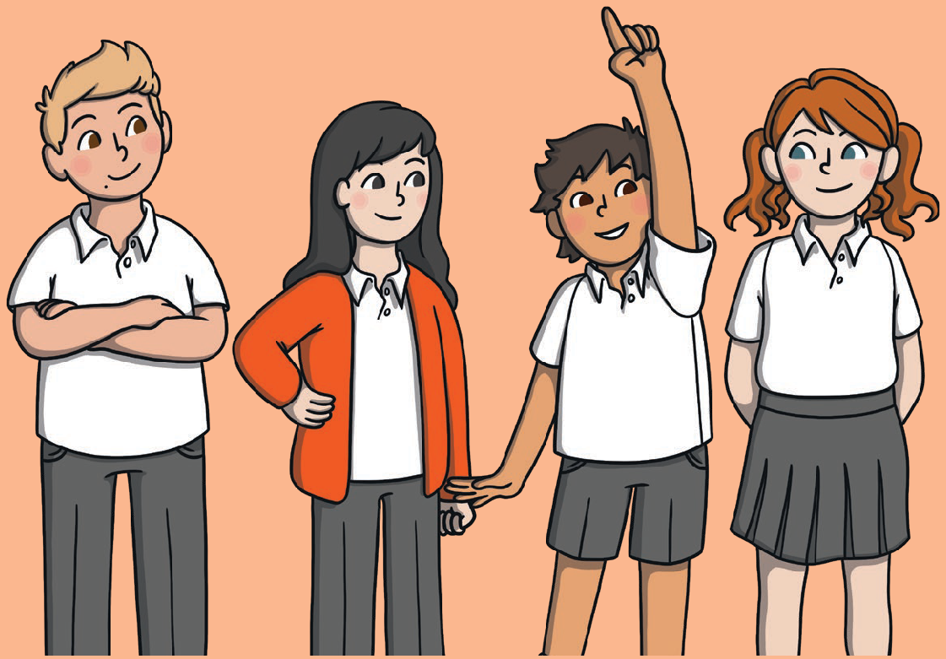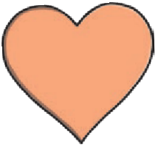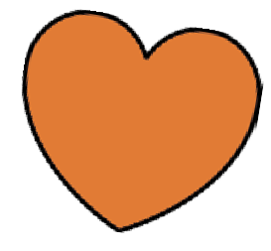
twinkl.com
To look at all the planning resources linked to the KS1 It’s My Body planning, click here
This resource is fully in line with the Learning Outcomes and Core Themes outlined in the PSHE Association Programme of Study.

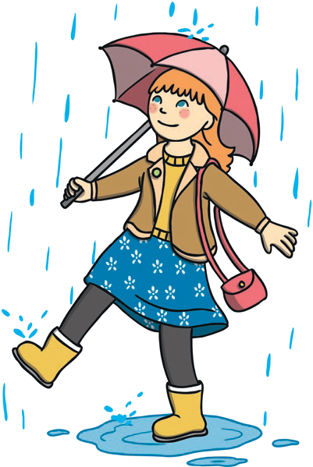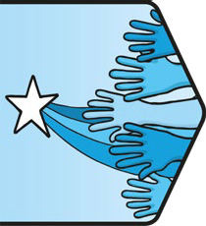
Key Vocabulary
aspire | To hope to achieve something.
achieve | To do something successfully.
ambitions | Things we would like to do or achieve.
value | To feel that something is important.
responsibilities | Tasks that we do to contribute or things we are in charge of.
strength | Something we are good at.
skill | A talent we work at.
stereotype | Assuming a group of people will behave in the same way because of a shared characteristic.
qualities | Special things about ourselves and others.
self-esteem | The way we feel about ourselves.
confidence | Feeling good about ourselves or something we are doing.
challenge | Something that may be difficult or needs to be worked on.
resilience | Trying again when we have found something difficult.
goal | Something we can work towards.
qualification Learning we have completed, that enables us to try something new.

Living in the Wider World | Aiming High Key Knowledge

Star Qualities
Our star qualities are the things that make us special. Focusing on our star qualities is important because it helps us to feel comfortable emotions
and improves our self-esteem. We are all unique and special and knowing what qualities we have helps us to celebrate that.
PSHE and Citizenship | Aiming High

Positive Learning Attitude Our learning attitude is all about how we feel towards our learning. If we have a positive learning attitude, we
will look at new challenges
as exciting and see our mistakes as learning opportunities. It is about being hopeful and looking for ways to achieve.

Aspirations for the Future
Our aspirations for the future are our ideas about what we would like to do or be when we are older. This might include the job we want to do, the people we want to spend our time with or the journeys we want to go on.

Equal Opportunities
When we are thinking about what we want to aspire to and achieve, it is very important that everyone feels they have the opportunity to do their best. To do this, we must all be given equal chances and have the same access to these opportunities.

Personal Goals
Our personal goals are areas we want to work on and achieve. We might be able to identify steps we can take to achieve these goals and things we can do to help ourselves.

Managing Our Feelings About Change When we know things are going to be different, it can feel a little unsettling. There are things we can do to help us manage these feelings.
We can name and accept our feelings, we can think of happy times we have had and we can think of things we are looking forward to.

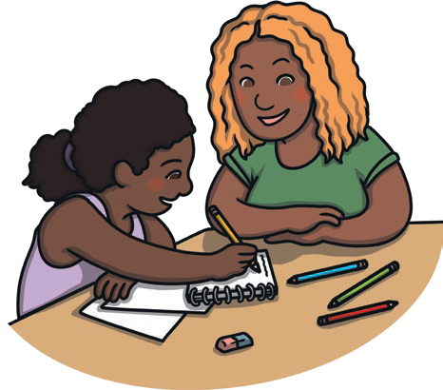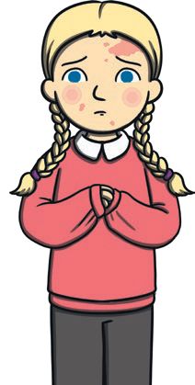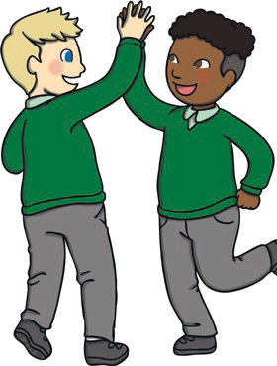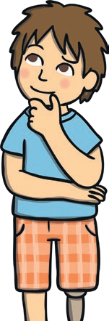
twinkl.com

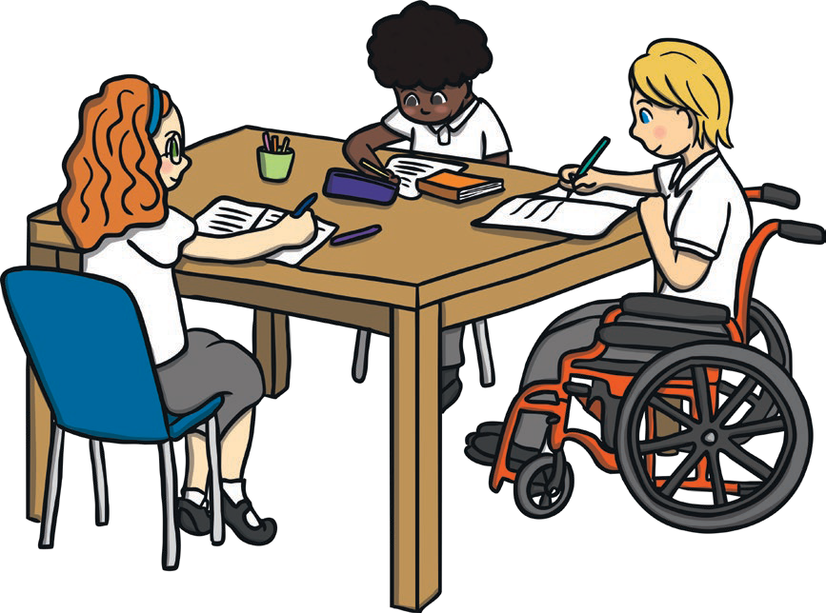Key Learning Point: Having a Positive Learning Attitude
Self-talk to help a positive learning attitude:
- I want to try my best with this learning task;
- If I keep trying, I will improve;
- By learning from my mistakes, I can get better;
- This is a new challenge for me and I like learning new things;
- I can’t do this yet, but I will.
To look at all the planning resources linked to the KS1 Aiming High planning, click here
This resource is fully in line with the Learning Outcomes and Core Themes outlined in the PSHE Association Programme of Study.

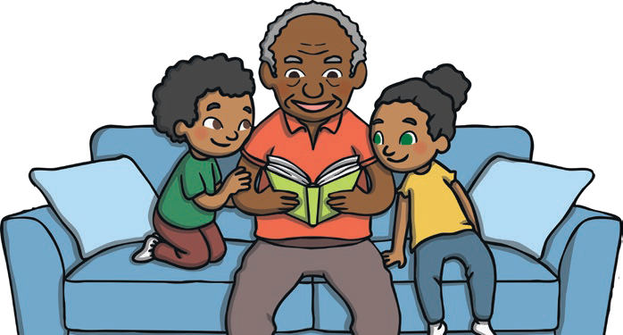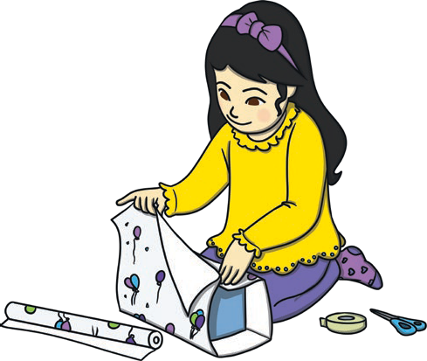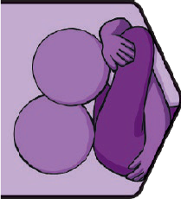
Relationships | VIPs Key Knowledge
Key Vocabulary
VIPs | Very Important Persons. These will be different for everyone, but will include family and friends. They are people who we care about and trust, who help us  to feel safe and who we enjoy spending time with.
special people | Someone who we feel close to and  care about.
care | The way we feel towards people we love. To provide things people need.
kind | To be friendly, considerate and generous to others.
help | To give someone a hand to do something.
trust | To feel someone is reliable.
love | The emotion we feel for people who are  special to us.
safe | Being protected from danger or harm.
similarities | Ways we are the same.
differences | Ways we are not the same.
cooperate | To work together to achieve something.
friends | People who we like a lot and know well.

Our Special People
We all have people who are special to us. These will be different for everyone, but will include our family and our friends. These are people who we care about and who care about us. They help us to feel loved, safe, healthy and happy.

Showing We Care
PSHE and Citizenship | VIPs
We can show our special people we care for them in many ways. We can be kind to them and help them. We know our special people care for us if they make us
feel safe, make us feel respected and show we can trust them.

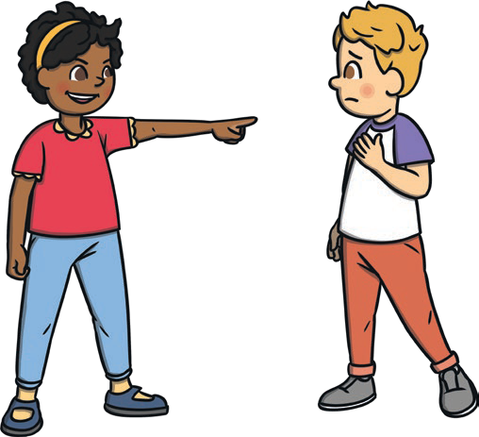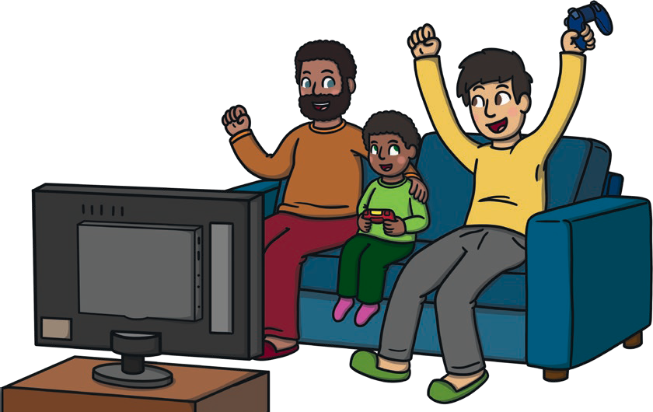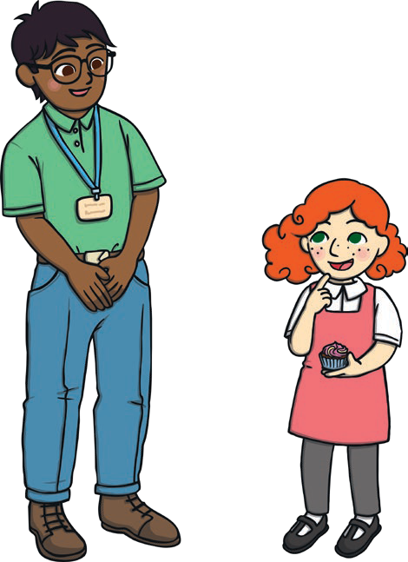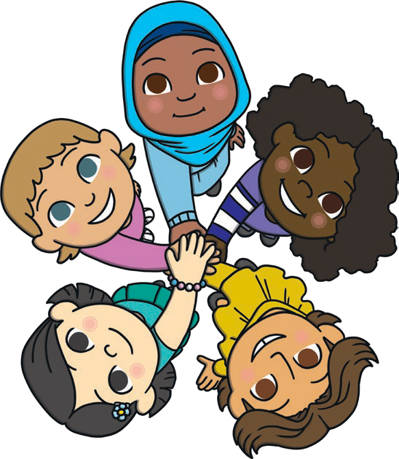Families
twinkl.com
We all belong to a family group and these may be big or small. Our family is a group of people who are special to us. Our family groups will all be slightly different and this is something to
be celebrated.

Trusted Adult
Our trusted adults are adults who are special to us and whom we know we can talk to. It is important we have trusted adults that we know will be there for us and who will help us if we are worried or concerned about anything.
Falling Out with Others Falling out happens when two or more people have a disagreement. It can make us feel sad, worried or angry. It is important to speak about our feelings and find ways to move forward and solve the problem. We might take some time to calm down, count
to 10 and take deep breaths and use kind words and calm voices to explain how we feel and what might help.

Working Together
When we cooperate with others, we can achieve wonderful things. When we cooperate,
we need to listen to each other, share jobs that need to be done, help each other and listen to how we are each feeling.

Key Learning Points:
Qualities in a Good Friend: There are lots of things that make friendships special. These are some qualities that good friends have:
- Being a good listener;
- Being caring;
- Being helpful;
- Showing kindness;
- Being trustworthy;
- Being honest.

Feelings of a Healthy Relationship: Every relationship is different but there are certain feelings we should get from a positive relationship. Positive relationships should help us to feel:
- safe;
- happy;
- loved;
- cared for;
- healthy.

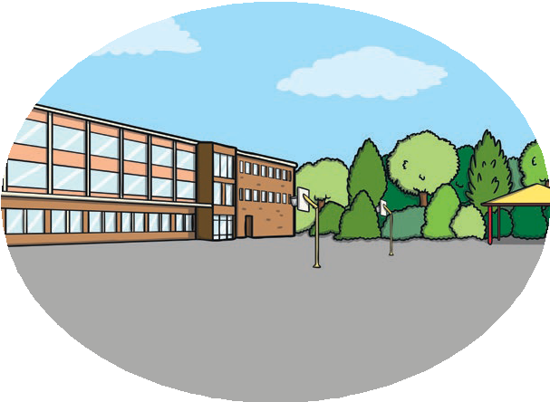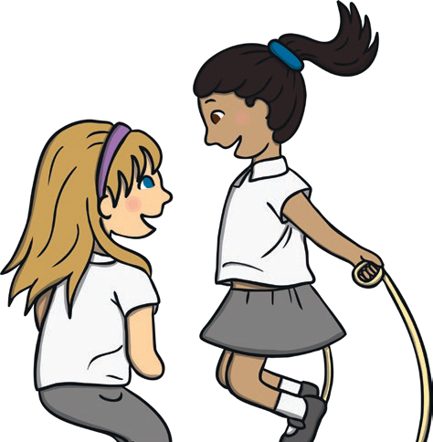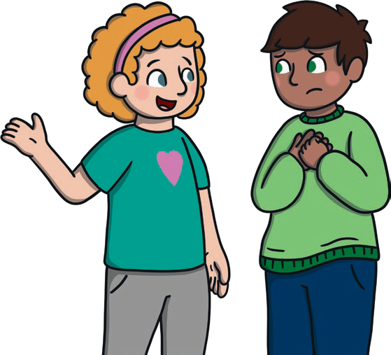
twinkl.com

To look at all the planning resources linked to the KS1 VIPs planning, click here

This resource is fully in line with the Learning Outcomes and Core Themes outlined in the PSHE Association Programme of Study.

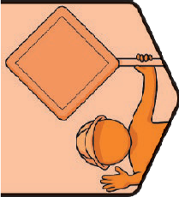
Key Vocabulary
danger: | Something that could cause harm.
unsafe: | Something that is not safe.
safe: | Being protected from harm and danger.
hurt: | To be injured.
rules: | Instructions we need to follow to stay safe.
trusted adults: | Adults who we know we can talk to about anything that worries us.
hazard: | Something which could be dangerous or cause harm.
Green Cross Code: | A set of instructions to help pedestrians stay safe around roads.
stranger: | Someone we don’t know well or at all.
risk: | A chance something may be dangerous or cause harm.
Internet: | A system that enables computers and other devices to send each other  information. We can use devices to find and share information on the Internet, communicate with others, watch videos and listen to music.
personal information: | Our full name, our date of birth, our address, our telephone number, the name of our school.

Health and Wellbeing | Safety First | KS1 Key Knowledge

Safety in the Home
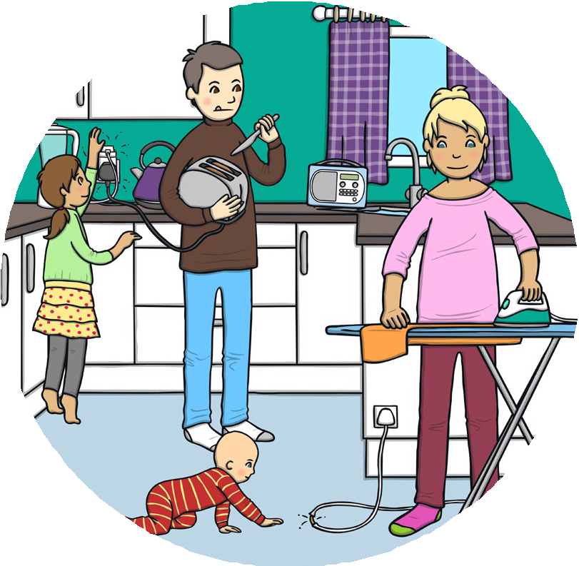We can use our rules to stay safe in our homes. This means not touching things that are hot or sharp, putting things away so people don’t trip over them, not touching electronic power sockets and only using agreed electrical appliances with a trusted adult. Only use age-appropriate online games or apps that have been agreed with a trusted adult and always avoid touching any chemical products in and around
PSHE and Citizenship | VIPs
our homes.

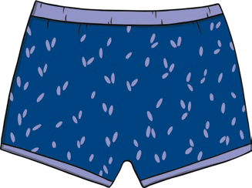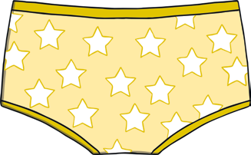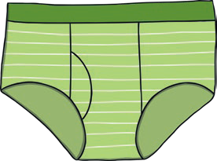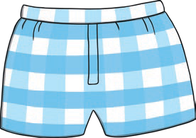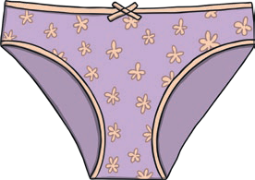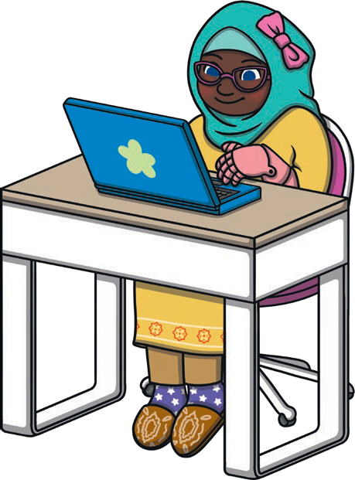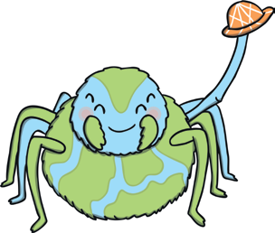Staying Safe When Out and About
twinkl.com
When we are out and about there are lots of things we can do to stay safe. We can stay near our trusted adult, play in a space that we know is safe, talk to our trusted adult if we are worried or frightened, cross the road with our trusted adult and follow their instructions to stay safe. It is important that we wear clothes that are right for the weather, wear a seat belt if we travel in a car and follow sun-safety rules by wearing suncream and a hat, drinking water and staying in the shade if it is hot and sunny.

Online Safety
To stay safe when using the Internet we need to only play age-appropriate games that we have agreed with a trusted adult and ask permission before we play. We must keep all our personal information private, we must tell a trusted adult if anything we see
makes us worried or uncomfortable and we must never share pictures of ourselves or agree to meet up with someone we have met online.

Staying Safe Around Strangers
We don’t talk to people we don’t know. If something happens that makes us feel uncomfortable we can shout, run to find a trusted adult and tell them what has happened. Safer strangers can also help. These are people whose job it is to keep others safe. This includes police officers, doctors, paramedics and firefighters.
Safer strangers often wear a uniform, a name badge or both.

The Underwear Rule
Our bodies belong to us. No one has the right to touch our body without our permission and there are certain parts of our body which are only for us and are always private. The parts of our bodies that are covered with our underwear are private. If anyone tries to do anything to our body that we don’t like, it
is important to say ‘no’ loudly and tell a trusted adult
straight away.

People Who Help Us
There are lots of people who can help us to stay safe. If we are at home or school, the adults who help to keep us safe will be our family or our adults at school. If we need help when we are out and about, we can speak to a trusted adult or a safer stranger about what has happened and how we feel. Safer strangers wear uniforms or name badges and it is their job to help keep people safe.

Key Learning Points
Safety Rules: There are lots of rules to help us stay safe. We have rules to help us stay safe at school, at home, when we are playing inside and when we are out and about. It is important we all know the rules that can help us to stay safe.

Getting Help: If anything makes us feel uncomfortable or unsafe, it is very important we get the help of a trusted adult straight away. We can shout, run and tell the trusted adult what has happened and they will help us.

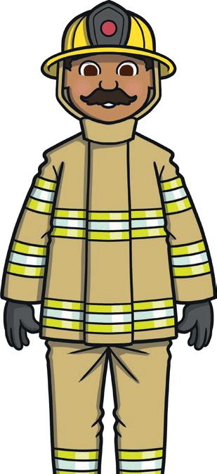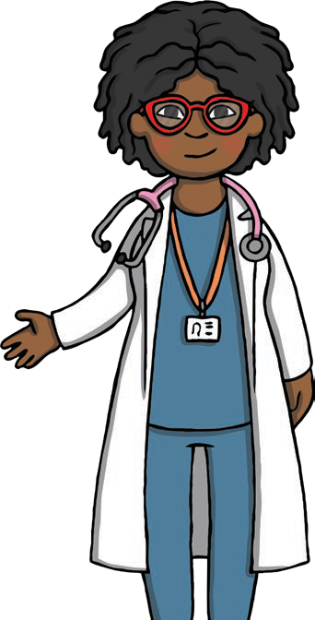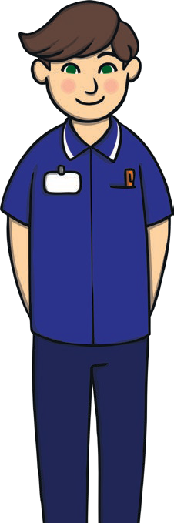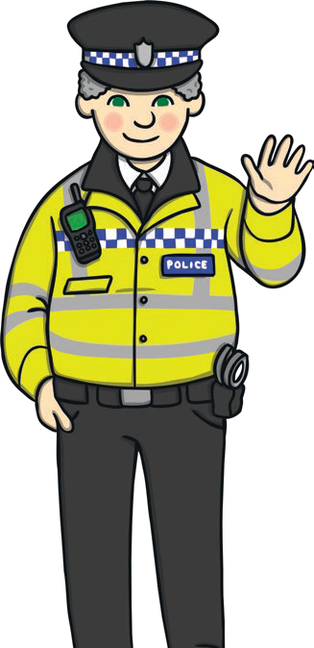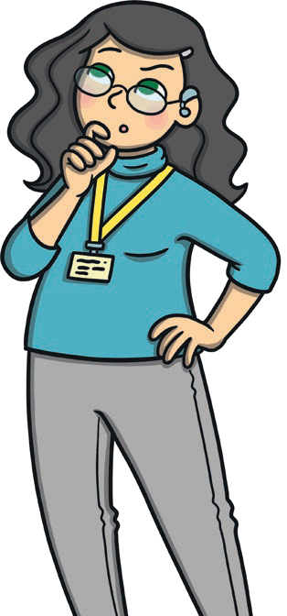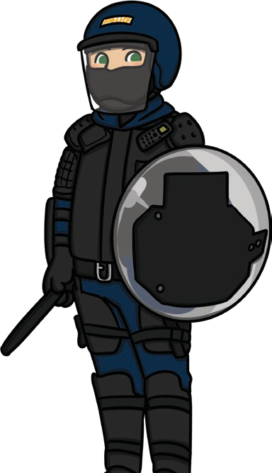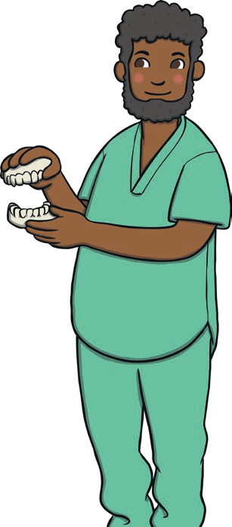
twinkl.com
To look at all the planning resources linked to the KS1 Safety First planning, click here
This resource is fully in line with the Learning Outcomes and Core Themes outlined in the PSHE Association Programme of Study.

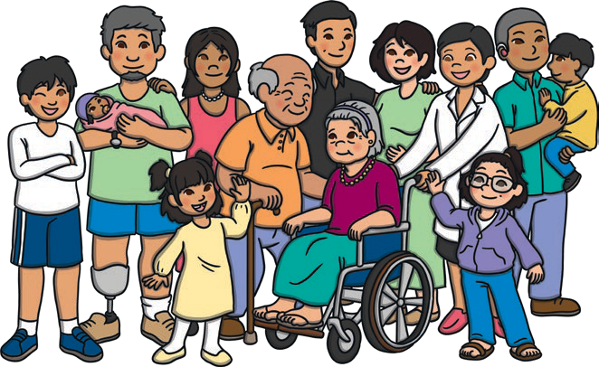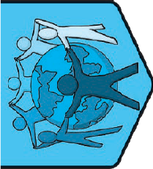
Key Vocabulary
trust: | To feel someone is reliable.
safe: | Being protected from harm and danger.
family: | People we are close to who are special to us. They help us feel loved and cared for.
similar: | To be like something else or the same in certain ways.
different: | To not be the same in certain ways.
special people: | Someone we trust and care about who makes us feel  safe and loved and takes care of us and our feelings.
home: | The place we live. Somewhere we feel safe, happy and healthy.
environment: | The surroundings in which people live. Environments can be natural or built.
natural resources: | Substances or objects that are created naturally and don’t need to be made by people.
protect: | To look after something.
choice: | Options we have about what to do.
harm: | To cause damage to something.
respect: | A way of treating or thinking about someone that shows they are important and they are valued.
care: | The way we feel towards people we love.  To provide things people need.

Living in the Wider World | One World | KS1
Key Knowledge
Caring for Our Families Family life around the world may look similar to or different from our own, but families have some very
PSHE and Citizenship | Living in the Wider World
special things in common; the
love and care they show to
each other. There are lots of ways we can show we care for our families. We can show kindness, help out, spend time together, ask how they are feeling and support each other when times are difficult.

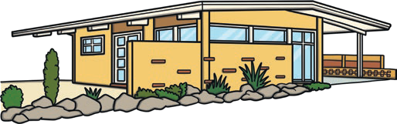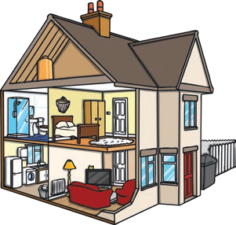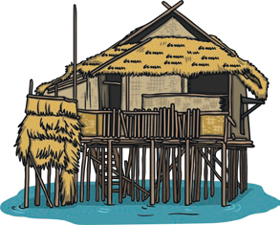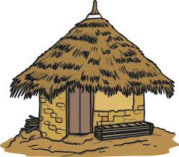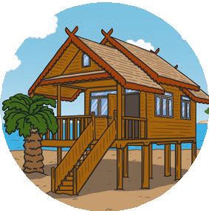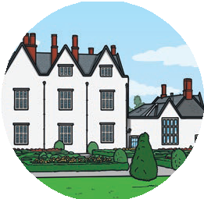Our Homes
Around the world, children live in many different types of homes. They may look different to each other and be built from different materials. Children may have different things inside their homes and may enjoy doing different things when they are at home.
Homes around the world are also similar in some ways; they are somewhere where we should feel safe, happy and healthy.

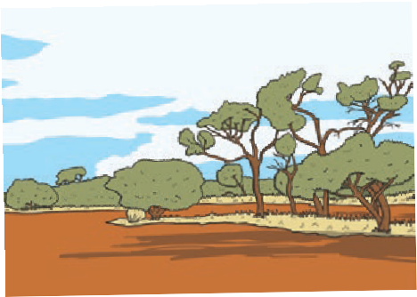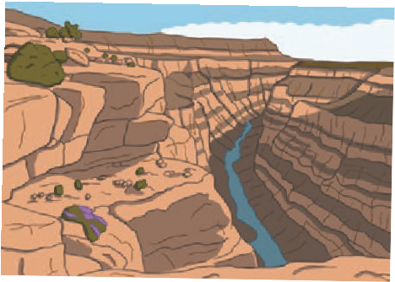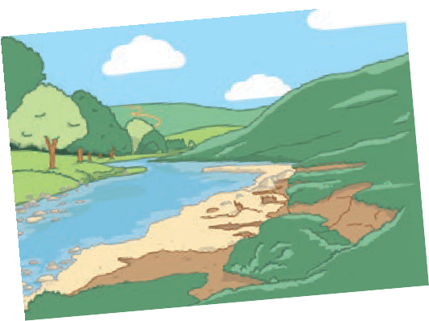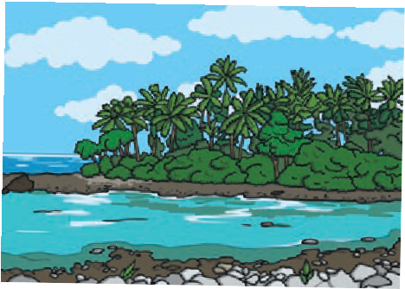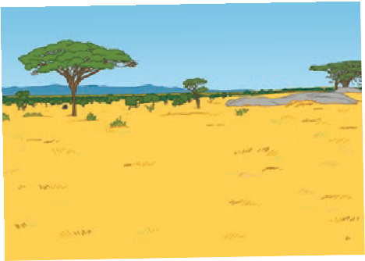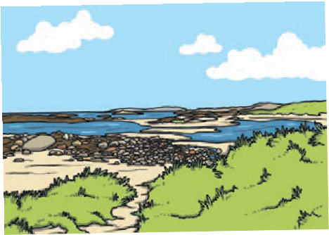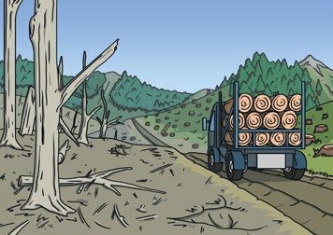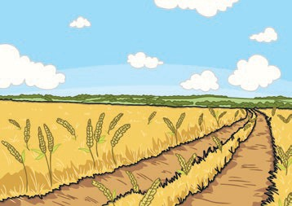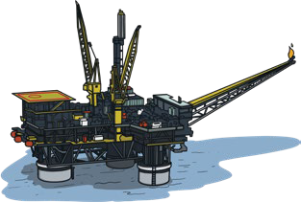How Environments Affect Us
twinkl.com
People around the world live in different environments. The environment someone lives in will affect how they live their life, the clothes they wear, the things they do, how they travel around and many more things as well. By learning about the different environments people live in, we can show value and respect and think about how we can help to meet the needs of people around the world.

Schools Around the World
There will be ways that schools around the world will be similar to ours and different from ours. All children have the right to go to school and learn. By learning about children from other countries, we can understand what life is like around the world.

Using Natural Resources
There are many natural resources on our amazing planet Earth. These can be used to help us live and enjoy our lives. It is important we use them with respect to protect them for the future as well.

Protecting Our Planet
There are so many amazing things about our wonderful world. By thinking about what we can do to protect our planet, we can look after all the things about it that we love. We can make choices to protect the planet by recycling waste, putting litter in the bin and saving natural resources.

Key Learning Points:
Caring for People Around the World: There are many ways we can care for people around the world:
- we can learn about the lives of people in different
countries;
- we can show kindness and respect to people whose lives are different from ours;
- we can respect people’s right to choose how they live;
- we can think about how we can help people around the world have their needs met;
- we can show love and care to people who are special to us.
Caring for Our Wonderful World: There are many ways we can care for and protect our planet:
- we can recycle waste;
- we can take things we have used and finished with to charity shops;
- we can put litter in the bin to avoid pollution;
- we can turn off lights when we leave a room;
- we can turn off the tap when we are brushing our teeth.

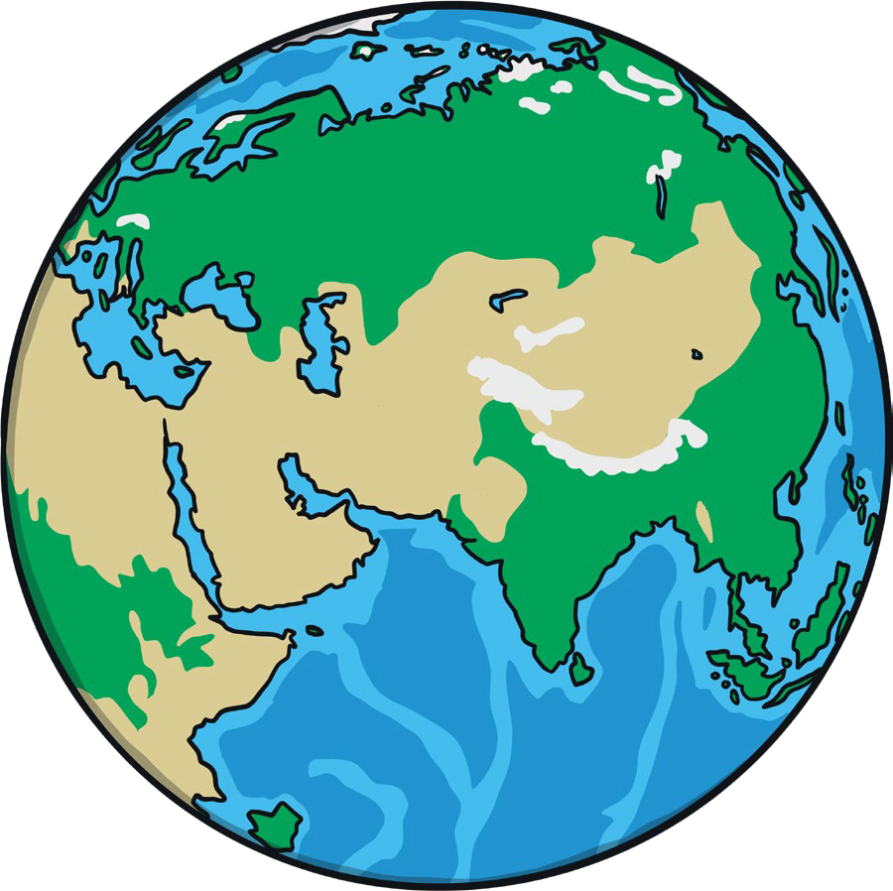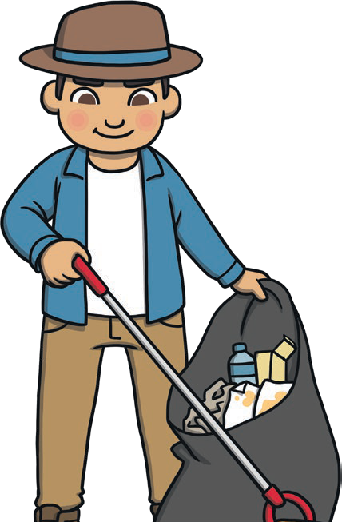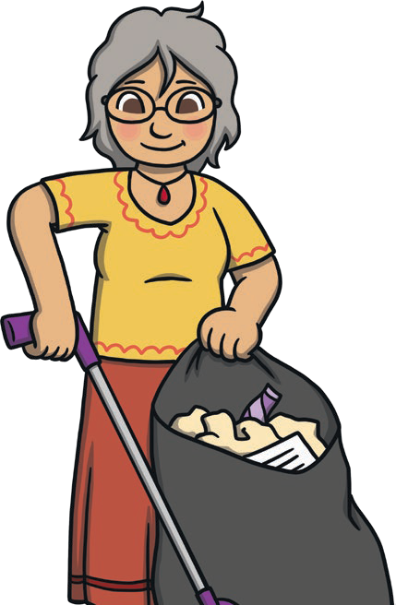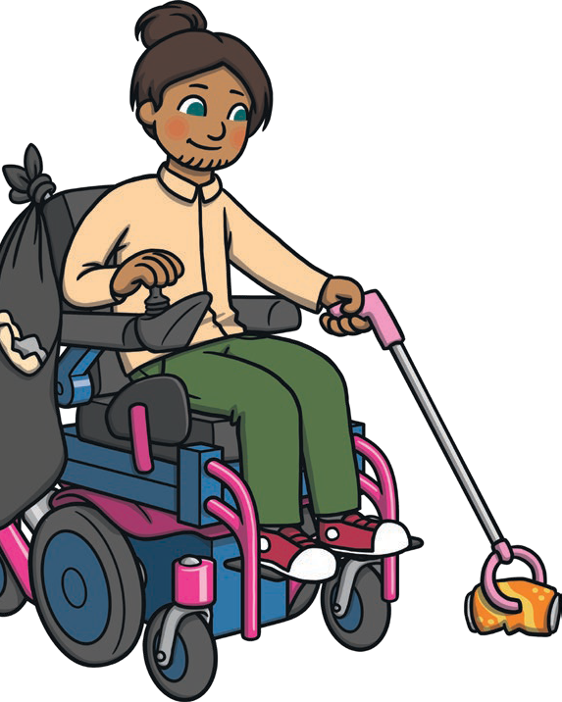
twinkl.com

To look at all the planning resources linked to the KS1 One World planning, click here

This resource is fully in line with the Learning Outcomes and Core Themes outlined in the PSHE Association Programme of Study.

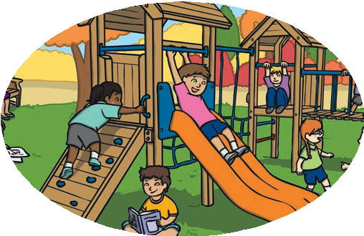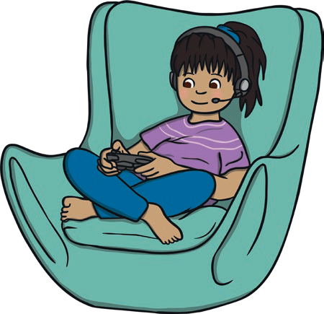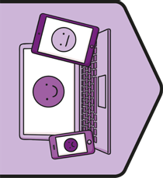
Key Vocabulary
Internet | A system that enables computers  and other devices to send each other information. We can use devices to find and share information on the Internet, communicate with others, watch videos and listen to music.
device | An electronic item which accesses the Internet.
television | An electronic device we use to watch programmes.
laptop | A portable computer.
tablet | A touch sensitive device which can access the Internet.
computer | A device which can access the Internet.
smartwatch | A watch which can access the Internet.
smartphone | A mobile phone which can access the Internet.
account | Personalised access to a website or app which you need a login name and password to use.
communicate | Talking to others and expressing ourselves.
online | Activities we do when we use the Internet.

Relationships | Digital Wellbeing Key Knowledge

My Internet Use
The Internet can help us in many ways. It can help us find information, communicate with others, do things we enjoy and control other things around our home like some stereos. It is important we use the Internet access we have in a safe and responsible way and balance the time we spend online with lots of fun activities offline as well.
PSHE and Citizenship | Digital Wellbeing

Balancing Online and Offline Activities
It is important to try to balance the time we spend on the Internet and the time we spend away from a screen. This way we can have a healthy mixture of activities in our day, enjoying the Internet for different uses and getting lots of fresh air and time with family and friends.

Staying Safe Online
There are lots of things we can do to help us to stay safe on the Internet. We can:
- choose age-appropriate apps and games with a trusted adult;
- respect age restrictions and make sure we only access websites that are appropriate for our age;
- avoid clicking links that appear on-screen;
- tell a trusted adult straight away if someone we don’t know tries to talk to us;
- tell a trusted adult if anything online makes us uncomfortable and worried;
- treat people online with kindness and respect;

offline | Activities we do when we are not using the Internet.
personal information | Information that is about us.
app | Short for ‘application’. An application for a computer or mobile phone. This might be a game or a link to a website.
website | Information on the Internet from an organisation or group.

Personal Information
This is information that is special because it is about us.
Personal information includes:

- balance our online and offline activities.

Kindness and Respect Online It is important to show kindness and respect to others
online and consider
- our full name;
- our date of birth;
- our address;
- our phone number and email;
- our school name;
- bank account details.

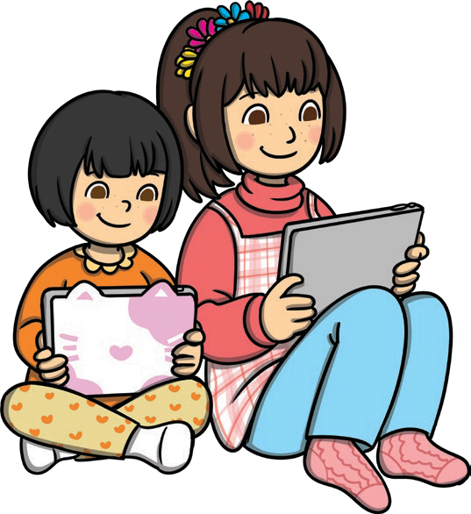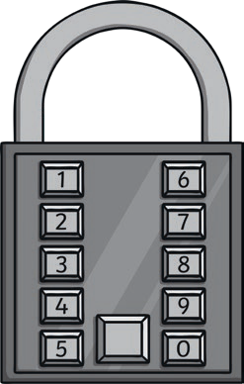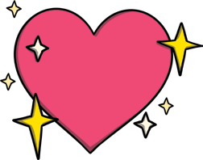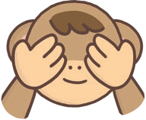how our comments or reactions might make them feel.
twinkl.com
It is very important that we don’t share
personal information with people we don’t know. This helps to keep us safe online.

Trusting the Internet
The Internet isn’t owned by anyone and people can write whatever they want. When we read information online, it is important that we use a trusted source or check a few websites we feel confident that we can rely on.

Key Learning Point: Benefits of the Internet:
The Internet can help us in many ways. We can:
- find information;
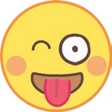
- video call people far away;
- send messages;
- 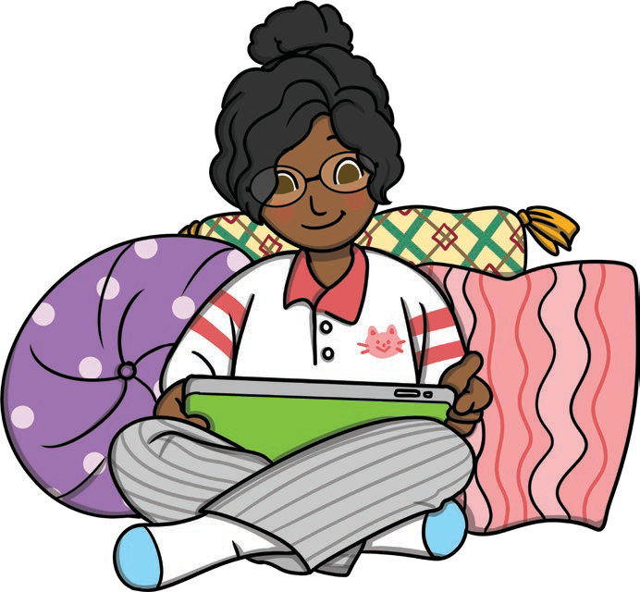research information;
- play games.

Using the Internet Safely and Responsibly:
It is important that we use the Internet safely and responsibly. This means:
- use age-appropriate websites and games;
- talk to a trusted adult and agree what websites and
apps can be used;
- keep all personal information private;
- don’t share images;
- talk to a trusted adult if anything worries or frightens us;
- think carefully about how we react to other people’s comments or news;
- show kindness and respect in our communication online.

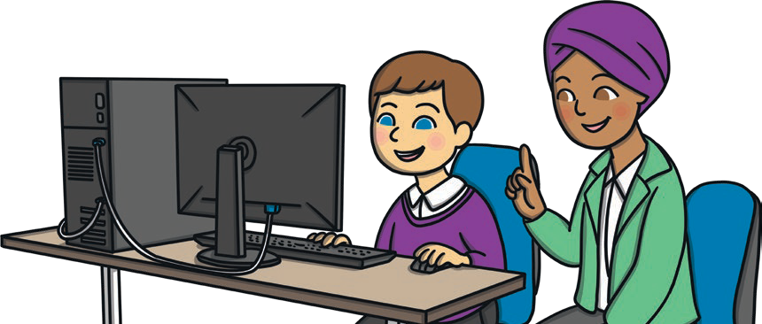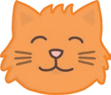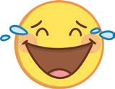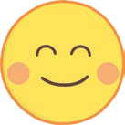
twinkl.com

To look at all the planning resources linked to the KS1 TEAM planning, click here
This resource is fully in line with the Learning Outcomes and Core Themes outlined in the PSHE Association Programme of Study.

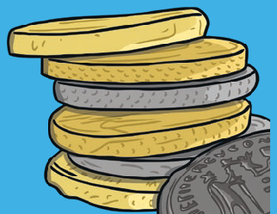
Key Vocabulary
money: | Something we use to pay for things we need.
coins: | A form of money. Coins come in values of 1p, 2p, 5p, 10p, 20p, 50p, £1 and £2.
banknotes: | A form of money. Banknotes come in values of £5, £10, £20 and £50.
debit card: | A way of paying for goods or services. The debit card is linked to our bank account and uses money from this account to pay for things.
contactless payment: | Using your debit card to pay for goods or services by tapping it onto a special machine. This can pay for amounts up to the value of £100.
online payment: | Paying for goods or services on the Internet.
wages: | The amount of money you get paid for doing your job.
salary: | The amount of money paid over a year for doing a job.
bank account: | Somewhere to keep money safe.
receipt: | A record of what has been spent and when.
want: | Something we would like to have.
need: | Something we need to be safe, healthy and well.

Living in the Wider World | Money Matters | KS1
Key Knowledge

Different Ways to Pay
When we pay for goods or services we use money and there are lots of ways to pay. We can use coins, banknotes, a debit card or online payment.
PSHE and Citizenship | Living in the Wider World
Sometimes, people choose to use coins and banknotes for smaller amounts and debit cards for bigger amounts.
We need to use online payments when we are paying for anything we are buying on the Internet.

Where Money Comes From
Money can come from lots of different places but it often comes from having a job. People get paid to do a job.
This money is called their wages
and these are paid on a certain date, often each month. The amount earned throughout a year from having a job is called a salary. Getting paid is
one reason people have jobs, as well as the teamwork,
satisfaction and sense
of purpose jobs provid
e.

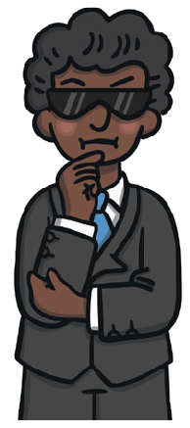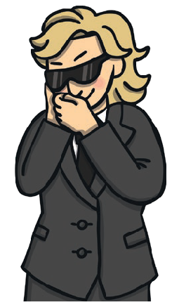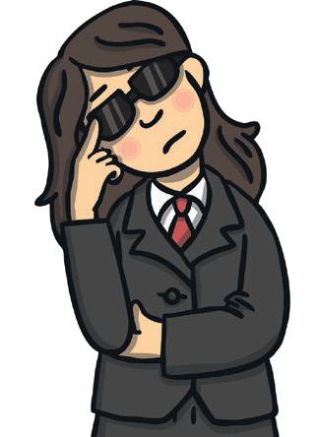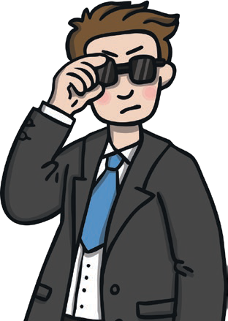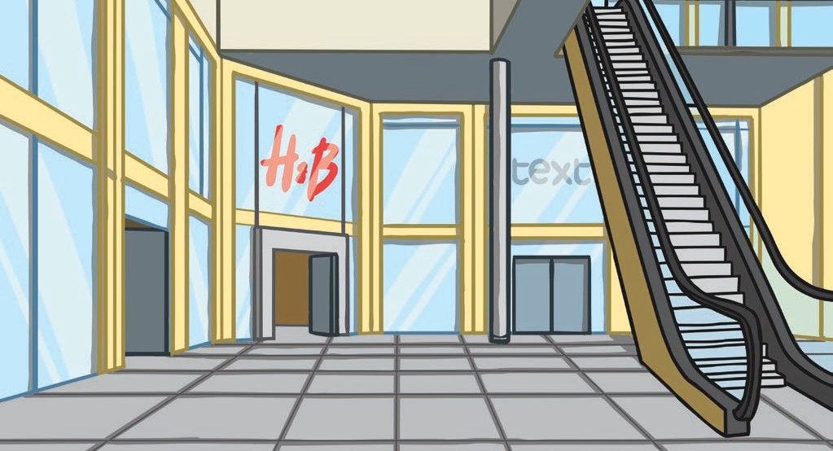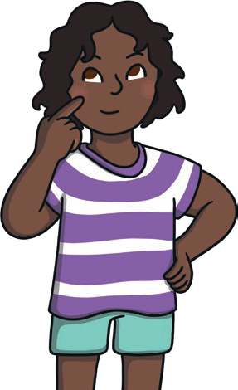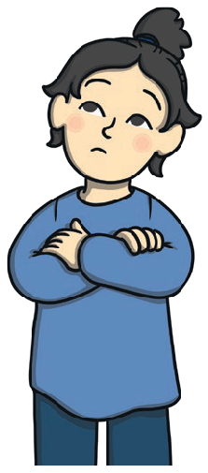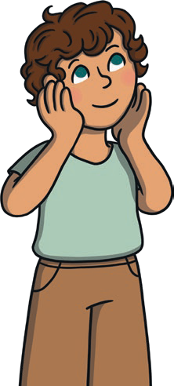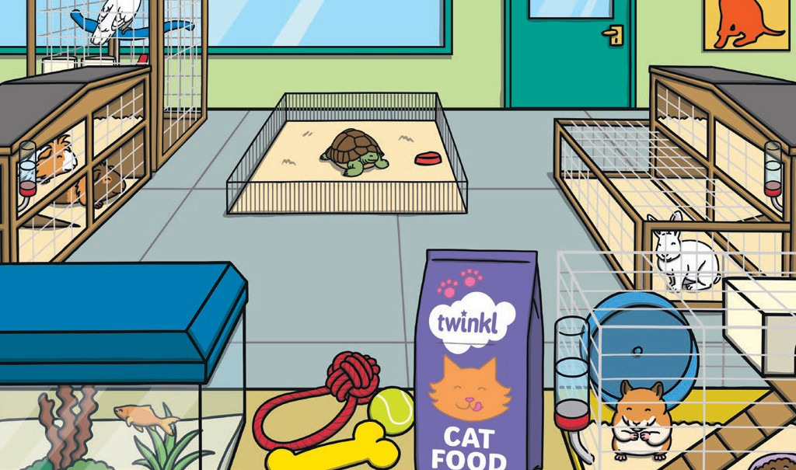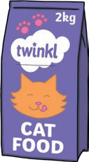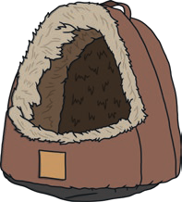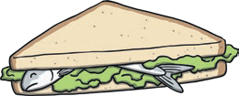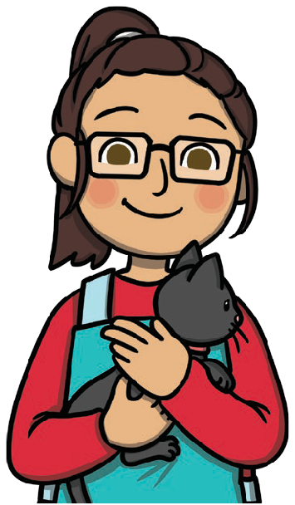Keeping Money Safe
twinkl.com
It is important to keep money safe so we can look after what we have. If we have coins or banknotes at home we might need to store them in a piggy bank. If we need to take coins, banknotes or a debit card out with us when we go shopping, we might take them in a wallet or purse. If we have larger amounts of money we can save up by opening a bank account. This is somewhere safe to store our money for when we need it.

Choices About Spending
There are lots of things that affect the choices people make about what to spend their money on. Some of these may include how much money they have at the time, what they need or trips they plan on taking. We must treat other
people’s spending choices with respect and remember people make choices based on what is right for them and their family. Receipts are one way people can keep track of what they spend.

Wants or Needs
We may choose to spend money on things we want or things we need, but it is important to understand the difference. Things we need are things that help us to be safe, healthy and well. Things we want are things we would like to have. It is important to remember that people must make choices based on what is right for them and this will be different for everyone. We must respect the spending choices people make as they will choose what is right for them and their family.

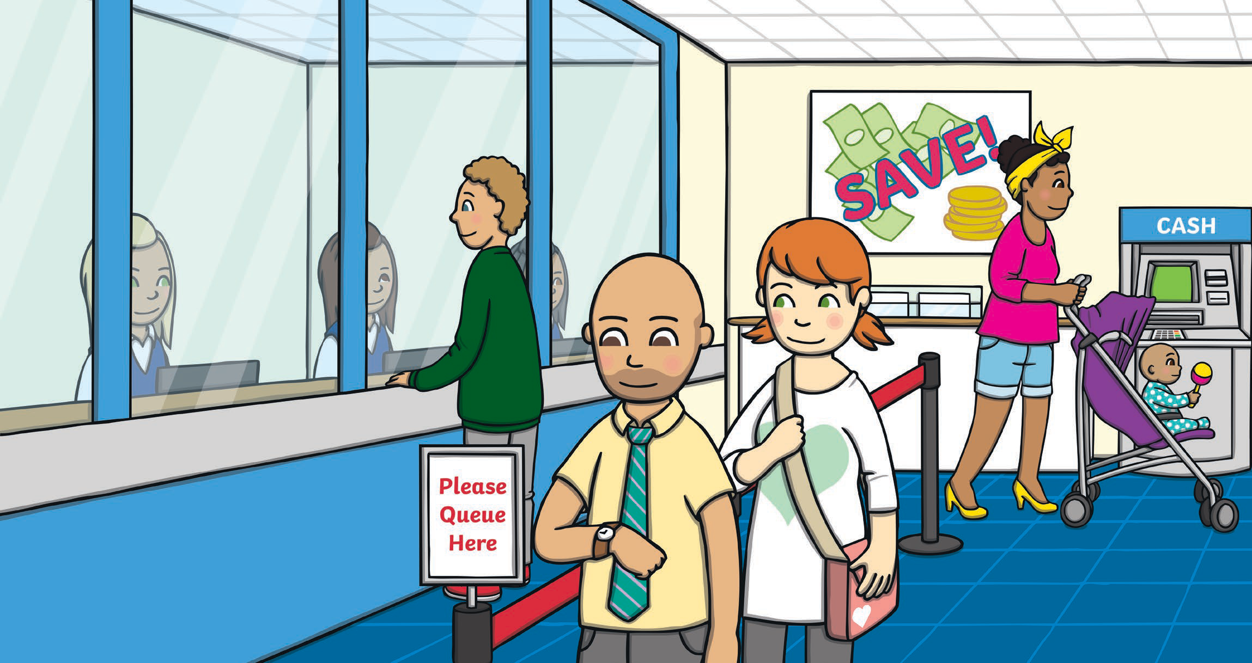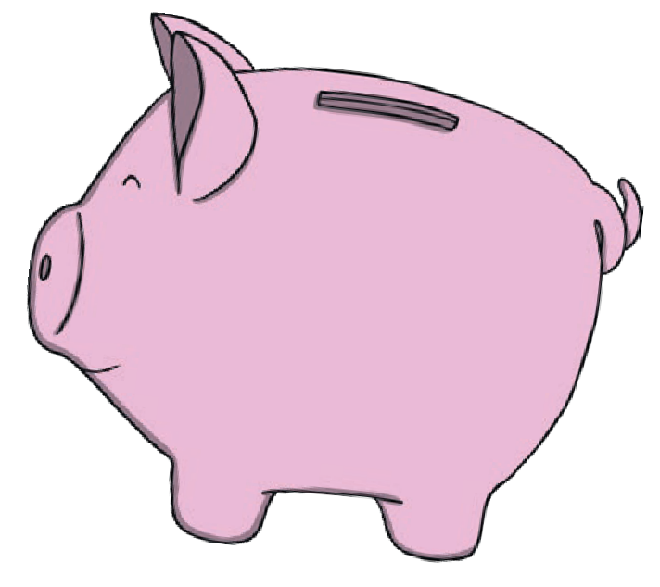Spending Money
twinkl.com
There are lots of different things we can buy with our money. It is helpful to look after our money by keeping it in a safe place at home and when we are out and about. We may make different choices to people around us and this is OK. People make choices based on what is right for them and their family and this needs to be respected.

Key Learning Points:
Money and Wellbeing: How people choose to spend their money is a personal decision. It is important to remember that the decisions people make about what to do with their money and how they spend it needs to be respected, as this will be based on what is right for them and their family. Money may
cause uncomfortable emotions if people worry about whether or not they have enough money for the things they need. If we are worried about anything at all, it is important to speak to a trusted adult about how we feel.

To look at all the planning resources linked to the KS1 Money Matters planning, click here

This resource is fully in line with the Learning Outcomes and Core Themes outlined in the PSHE Association Programme of Study.

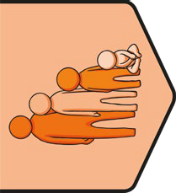
Key Vocabulary
genitals: | Parts of our body that are private. Females have genitals called a vulva and a vagina, and males have genitals called a penis and testicles.
private parts: | Parts of our body that are just for us.
similar: | To be like someone else or the same in certain ways.
different: | To not be the same in certain ways.
vulva: | Part of the female genitals.
penis: | Part of the male genitals.
vagina: | Part of the female genitals.
testicles: | Part of the male genitals.
respect: | A way of treating or thinking about someone that shows they are important and they are valued.
consent: | To give permission or agree to something.
trusted adult: | Adults who we know we can talk to about anything that worries us.
rules: | Instructions we need to follow to stay safe.
stereotype: | Thinking someone knows something about someone else based on the way they look, the way they speak, where they come from or their gender.
unique: | Something that is special and unlike anything else.
change: | When something becomes different.

Health and Wellbeing |
Growing Up | KS1 | Key Knowledge

My Body
There are lots of ways our bodies are similar to and different from people around us. Some of these similarities are body parts that we may all have. These may include backs, wrists, necks, heads, arms and legs. The genitals are an example of ways male and female bodies are different. Female bodies have genitals called a vulva and
PSHE and Citizenship | Health and Wellbeing
a vagina, and male bodies have
genitals called a penis
and testicles.
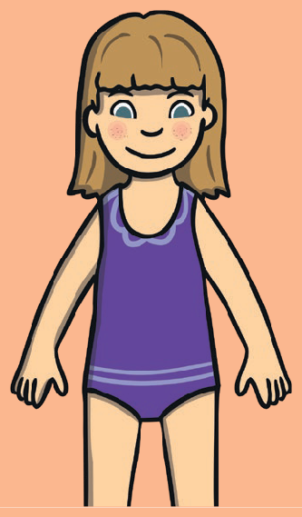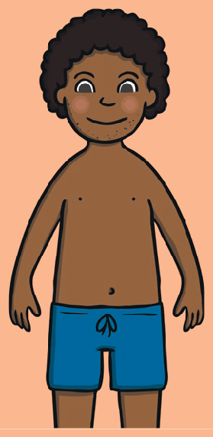
Disclaimer
This resource is designed to support teaching about biological attributes. You should consider whether this content is appropriate for all children in your class, especially chil- dren who have DSD/are intersex, or who are transgender. This resource is editable to ensure that you can adapt it to meet the needs of children in your setting.

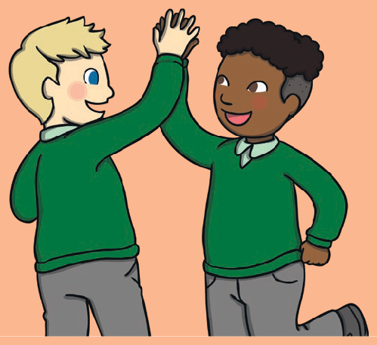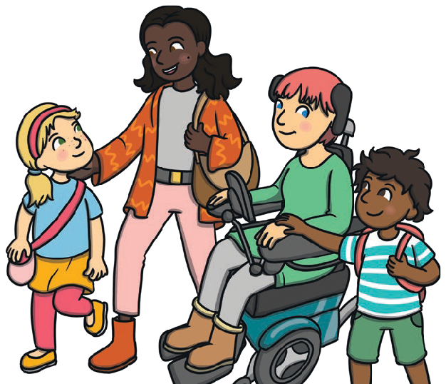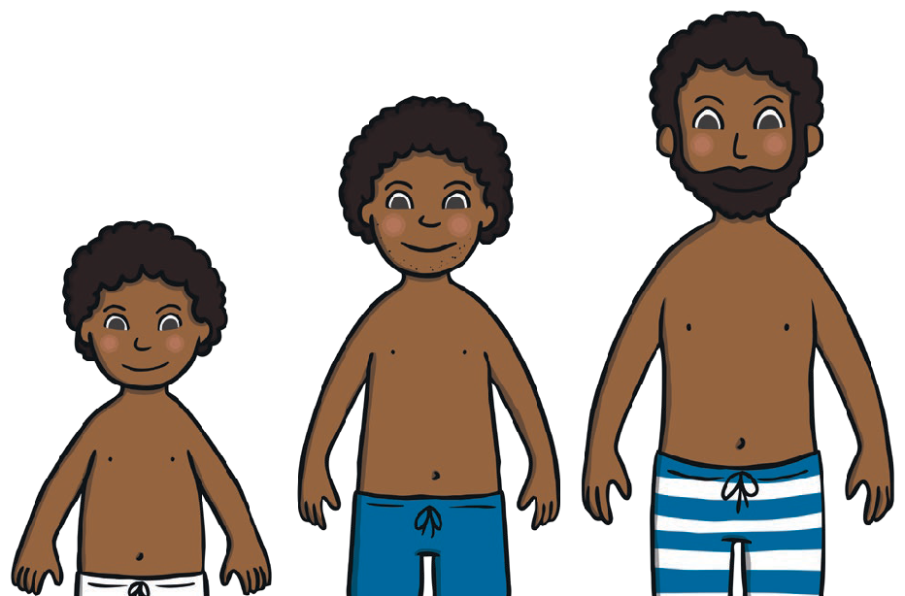Respect and Consent
twinkl.com
What happens to our bodies is up to us. Other people have the right to decide what happens to their bodies too. No one should touch someone else if this is not welcome and to find out whether or not someone is comfortable with this, their permission or consent should be asked. This shows respect for others and their decisions and we should expect people to treat us with this respect as well.

Families
Families are very important to provide love, care and safety. Our family may be similar to or different from the families of our friends. There are lots of ways we can enjoy spending time with our families, like cooking and sharing food, celebrating festivals that are important to us, relaxing and exploring. Families can support each other in difficult times as well. If anything about our family is making us worried, it is
there are
ts who
important to know other trusted adul can help us.
Similarities and Differences There are lots of ways that we are similar to and different from people around us. It is important that we value and respect these differences and don’t expect to know what people may like or dislike based on stereotypes.

Changing and Growing
As we grow older, we might notice some things that change. We will be able to do more, we may have more responsibility, our friends might change and our bodies will change. It is exciting to think about what we might want to do when we grow up. If we know something is going to change, like moving to the next class, there are things we can do to prepare for this. This way, we will feel m
ore comfortable with the change.

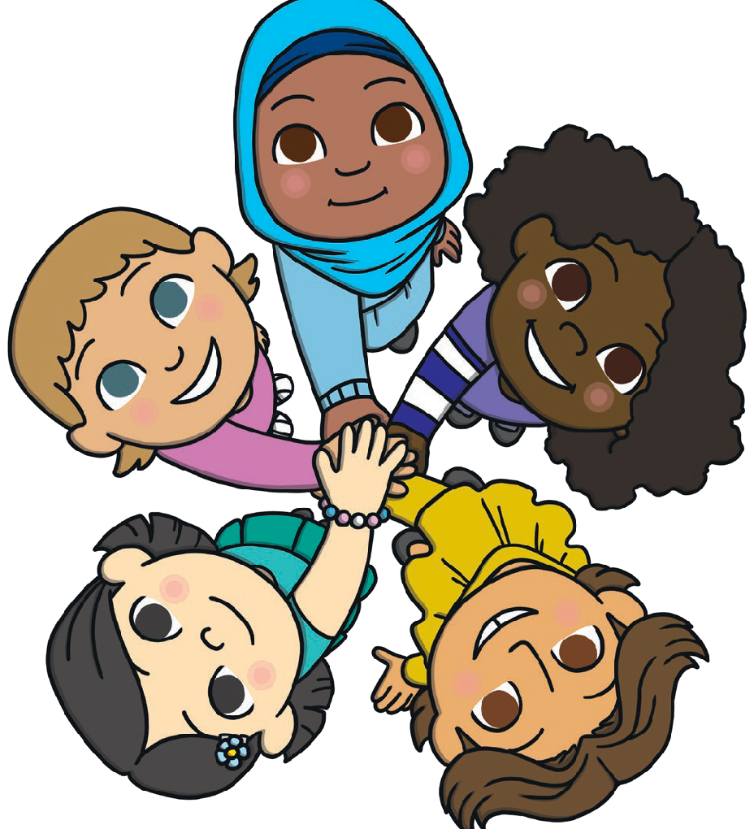Coping with Change
twinkl.com
There are many changes we might go through, some may be big and some may be small. Each of these changes can make us feel lots of different emotions. Some of these may be comfortable and some may be uncomfortable. There are lots of things we can do to help ourselves to cope with change. These include talking to family, talking to another trusted adult such as a teacher or another adult at school, talking to a friend or allowing ourselves to get used to the change over time.

Key Learning Points:
Respect and Consent: It is important to show respect to everyone as we are all equal and deserve to be healthy and happy. Our
bodies belong to us and it is important people respect our bodies through their actions as well as their words. Asking for consent before touching someone’s body is a very important way to show this respect.
Valuing Differences: As we grow and change, there are many similarities and differences we might notice between ourselves and others. These should be celebrated and valued because they are a way we can learn from each other. Learning from and enjoying the
differences between ourselves and others avoids stereotyping and values the many ways we are all unique.
To look at all the planning resources linked to the KS1 Growing Up planning, click here

This resource is fully in line with the Learning Outcomes and Core Themes outlined in the PSHE Association Programme of Study.

