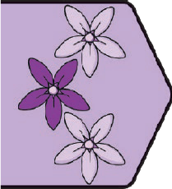
PSHE and Citizenship | Growing Up
Key Vocabulary
reproduction | When plants or animals produce young.
foetus | A baby growing inside a female’s body.
puberty | The time when children’s bodies start to develop into adults.
genitals | Parts of our body that are private. Females have genitals called a vulva and a vagina and males have a penis and testicles.
hormones | Natural chemicals within our body.
testosterone | Male sex hormone.
oestrogen | Female sex hormone.
feelings | Emotions we experience about things that are happening.
emotions | The way we feel about things that are happening.
lesbian | A woman who is attracted to other women.
gay | A man who is attracted to other men or a woman who is attracted to other women.
bisexual | A person who is attracted to both men and women.
asexual | Someone who isn’t attracted to men or women.
transgender | Someone whose gender identity (how they feel) is different from their biological sex.
egg | Eggs are made by the woman’s body. If an egg is fertilised by sperm, a baby starts to grow.
sperm | Sperm is made by the man’s body. If sperm fertilises the egg, a baby starts to grow.

twinkl.com

Key Knowledge
Human Reproduction
All living things reproduce. Reproduction means to make the same thing again. When humans reproduce, they have babies. The male body produces sperm which is stored in the testicles. The female body produces eggs which are stored in the ovaries. The ovaries are joined to the uterus by the fallopian tubes. In the female body, the egg travels along the fallopian tubes to the uterus and if it is fertilised by sperm, a baby starts to grow.
Boys and Puberty
Puberty causes some changes to happen in male bodies. These changes happen so that when we are older, if we would like to, we can become parents. Changes that happen to the male body during puberty include the Adam’s apple developing, the testes growing bigger, the penis becoming longer, wider and sometimes becoming hard (an erection), hair growing underarms, on the chest and around the penis and the body growing bigger and stronger. These changes happen because the sex hormone testosterone is produced. It can be helpful to talk to trusted adults for advice and support if you have any questions or if anything worries you.
Girls and Puberty
Puberty also causes changes to happen in the female body. These changes happen so that when we are older, if we would like to, we can become parents. Changes that happen in the female body during puberty include starting menstruation when the uterus sheds lining as an unfertilised egg is released, breasts growing, hair beginning to grow under the arms and around the genitals. These changes happen because the sex hormone oestrogen is produced. It can be helpful to talk to trusted adults for advice and support if you have any questions or if anything worries you.
Emotions
As we go through puberty, there are certain changes that happen to boys and girls. We grow taller and stronger, our hair may become greasier and we may find we sweat more, we may get spots and we might feel very strong and quickly changing emotions. Strong and changing emotions is something that happens to everyone through puberty and there are strategies that we can use to help ourselves. If we experience uncomfortable emotions very often or for a long time, it is important to speak to someone we trust.
Loving Relationships
Families can be large or small and can be made up of lots of different family members. Some family members include children, parents, siblings, step-parents, step-siblings, aunts, uncles, grandparents, cousins and carers. Families may have one parent or two and parents may live together, be married, be in a civil partnership or may live apart. Some families live together and some families live apart. There is no right or wrong grouping when it comes to families but there is something very important that they all have in common. This is the love they share for each other and the care they provide. Families help us to feel safe, cared for, loved and secure.
Where Babies Come From
When sperm fertilises an egg, a baby starts to develop inside a woman’s body. At first it is called an embryo then after eight weeks it is called a foetus.
The baby develops in the woman’s uterus over nine months. During this time it is protected by a special bag of fluid called an amniotic sac and gets all the nutrients and fluid it needs from its mother’s bloodstream through a special tube called an umbilical cord. After nine months, the baby is ready to be born and will be pushed from the mother’s body through the vagina.

twinkl.com

Key Learning Point:
Growing into Adults: There are lots of changes we go through during puberty. These changes may feel confusing at the time but they are completely normal and happen to everyone. Our changing emotions can also feel confusing but there are things we can do to help. We can:
- 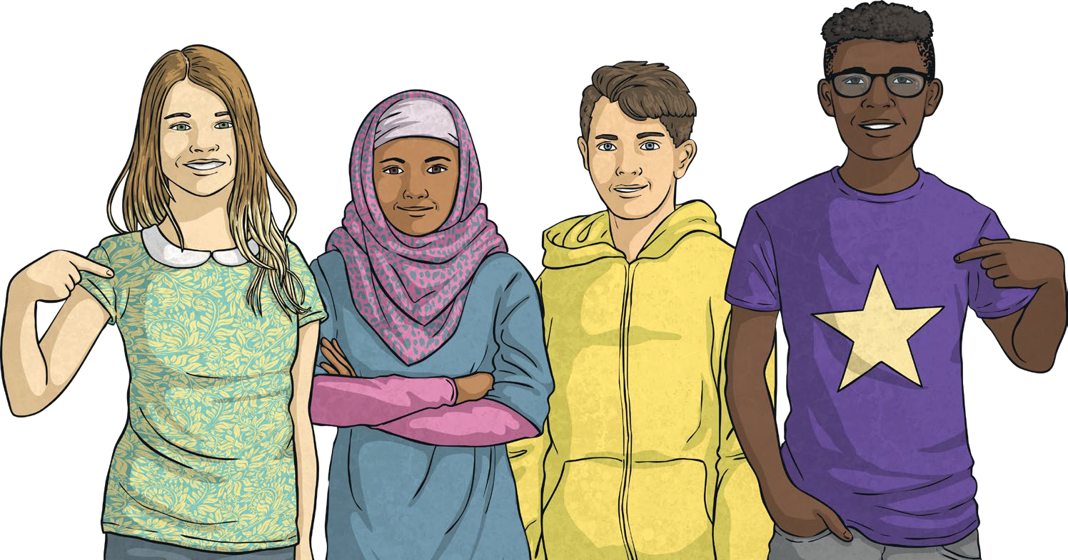have some calm, quiet time;
- do something active - exercise helps release endorphins;
- do something we enjoy;
- phone or visit a friend;
- write our feelings down;
- talk to a trusted adult;
- spend time with a pet;
- go for a walk.

To look at all the planning resources linked to the LKS2 Growing Up unit click here

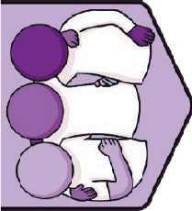
Relationships | TEAM
Key Vocabulary
change: | When something becomes different.
resilient: | Trying again and continuing to persevere when we find something difficult.
positive: | Looking for the good in a situation and things that are going well rather than focusing on areas we find difficult.
opportunities: | Chances to do things.
mindset: | Our attitude towards something and how we feel about it.
teamwork: | Skills and ways of working that will benefit the team and the people in the team.
behaviour: | Our actions. The way we behave.
facial expressions: | When a person uses their face to show how they are feeling or what they want.
body language: | Gestures, movements or mannerisms used by a person or animal to show how they are feeling.
response: | The way we react to things that are happening around us.
considerate: | Thinking of others and how they might feel.
dispute: | A disagreement.
resolve: | To find a solution to a problem.
conflict: | An argument or disagreement between two or more people.
compromise: | Finding a way of working together where two or more people adapt their behaviour, actions or choices.
responsibility: | Tasks that we do to contribute or things we are in charge of.

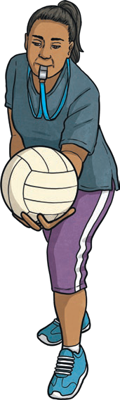Key Knowledge

Supporting Ourselves at Times of Change:
When we experience change we may feel lots of different emotions. Some of these may be comfortable and some may be uncomfortable. There are lots of things we can do to help ourselves to cope with and manage these changes. We can talk about our feelings, get enough sleep, make time for our hobbies and interests, eat well and drink enough water as well as ask any questions we have.
PSHE and Citizenship | Relationships
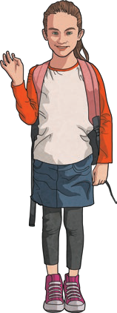Positive Team Behaviours: When people work as a team there are certain teamwork skills that can help everyone feel included and help to collaborate and achieve the goal. These include communicating well with others and
thinking about the facial expressions and body language that we use and that other people use. Successful teamwork can help
people within the team to feel supported, accepted, valued and confident as well as many other comfortable feelings. This will help teams to be resilient.
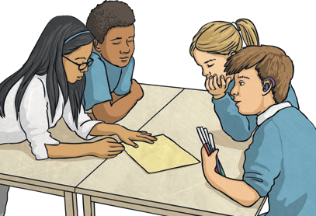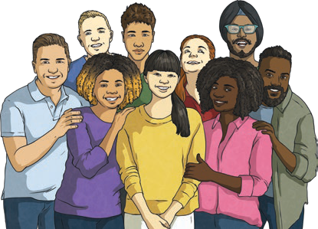

twinkl.com

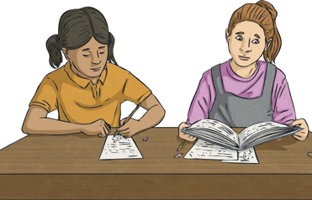Key Learning Points:

Effects of Our Actions: When we work as a team, our actions have an effect on those around us. If we use positive teamwork skills, these effects will be positive and helpful. We can listen to others, share our ideas with kind words and calm voices, help others and encourage our teammates.
- listen to each other;
- compromise when we need to;
- use kind words and calm voices;
- 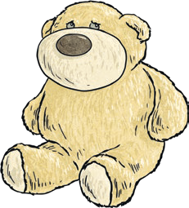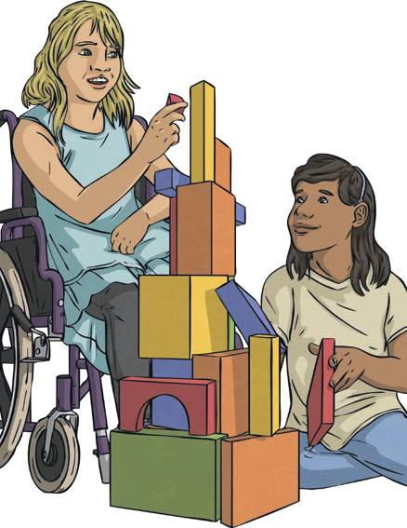explain how we feel about different situations;

Being Considerate: By understanding how to read other people’s facial expressions and body language we can understand the feelings and emotions of our teammates. This means that we can then show consideration for the feelings of others and express how we feel to those around us, allowing them to be considerate as well.
- try our best;
- help others.
If we do this, our teams can  achieve our shared goals and work collaboratively. This means people within our teams feel:

Resolving Disputes or Conflicts: Sometimes disagreements or disputes happen. When they do, there are lots of ways we can help to find a resolution. We can show empathy by thinking about how the other person feels, we can share our feelings and take turns in talking about how we feel, we can smile, we can listen to the other person, we can change or adapt our behaviour to try to find a compromise and we can be patient as these things can take time.
- 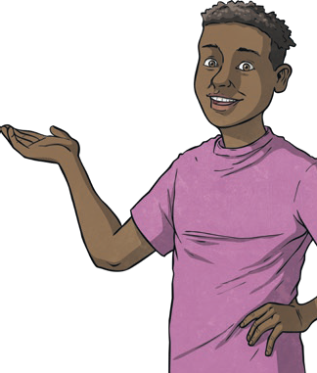listened to;
- valued;
- cared for;
- special;
- strong;
- 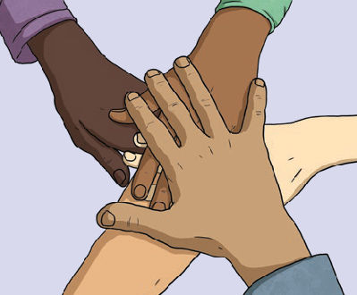confident.

Responsibilities Within Our Team: Each person within a team has responsibilities. If they each fulfil these responsibilities, all the jobs and tasks within a team get done. We have responsibilities in every team we are part of. These might include things like listening, concentrating, trying our best, following rules, helping others, looking after our bodies and minds as best we can and taking care of our belongings.
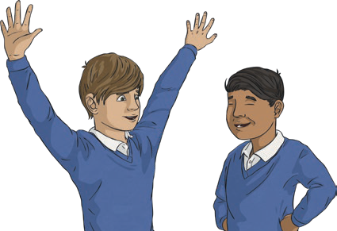
To look at all the planning resources linked to the LKS2 TEAM unit, click here

This resource is fully in line with the Learning Outcomes and Core Themes outlined in the PSHE Association Programme of Study.

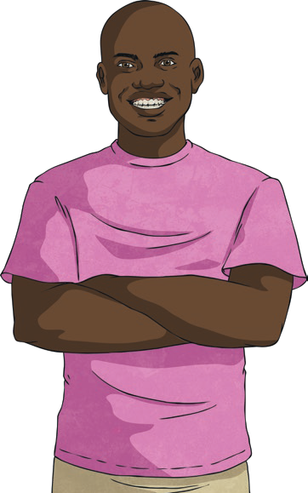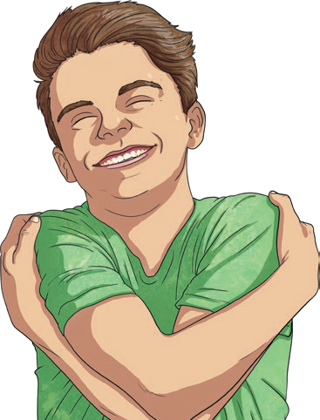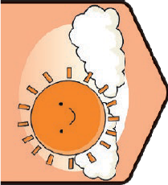
Health and Wellbeing | Think Positive
Key Vocabulary
positive attitude: | Looking for the good in a situation and things that are going well rather than focusing on areas we find difficult.
mental health: | How we are feeling and the thoughts we are having and the effect this has on the choices we make and how we behave.
change: | When something becomes different.
mindset: | Our attitude to something and how we feel about it.
mindfulness: | Focusing on the present and what we are feeling, seeing and doing right now.
strategies: | Ways we can work through or manage something.
emotions: | How we feel about things that are happening.
response: | The way we react to things that are happening around us.
challenge: | Something we may find tricky but can work to do well at.
resilience: | Trying again and continuing to persevere when we find something difficult.
flexible: | Making changes or adapting ideas when needed.

Key Knowledge
Our Happiness: Happiness is a comfortable emotion we feel when we are doing things we enjoy or when we are spending time with people we feel close to. There are lots of ways we can support our minds to feel healthy and happy.
We can relax, get enough sleep, smile and laugh, spend time with family and friends, exercise regularly, eat healthily, be fair and honest, listen to music, care for others, enjoy a hobby, work hard to achieve goals, accept ourselves and feel proud of who we are. All these things support positive mental health and wellbeing.
PSHE and Citizenship | Think Positive

Helpful and Unhelpful Thoughts: Our thoughts affect the way we feel and behave. It can be helpful to understand this so we can begin to understand why we are experiencing the emotions we are. Helpful thoughts focus on the positives in a situation or help us to cope with
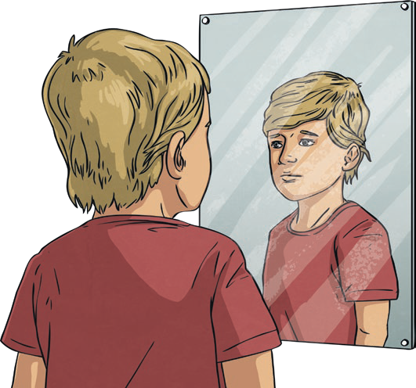
or achieve something. Unhelpful thoughts might make us worry or feel emotions that may be uncomfortable. We can help our minds think positively and try to look for the good in a situation or ways we can solve a problem or achieve something by adopting a positive mindset.

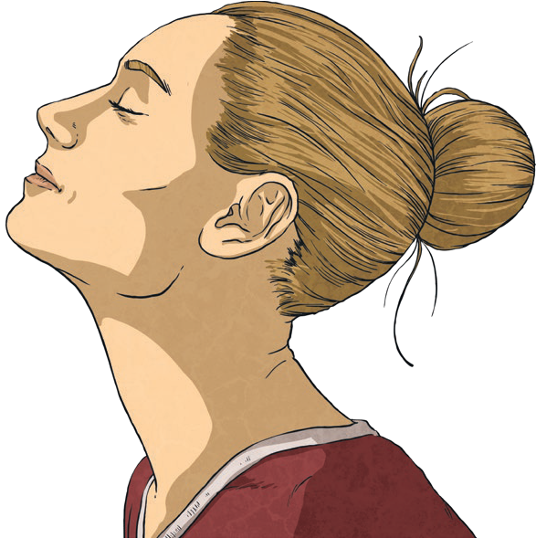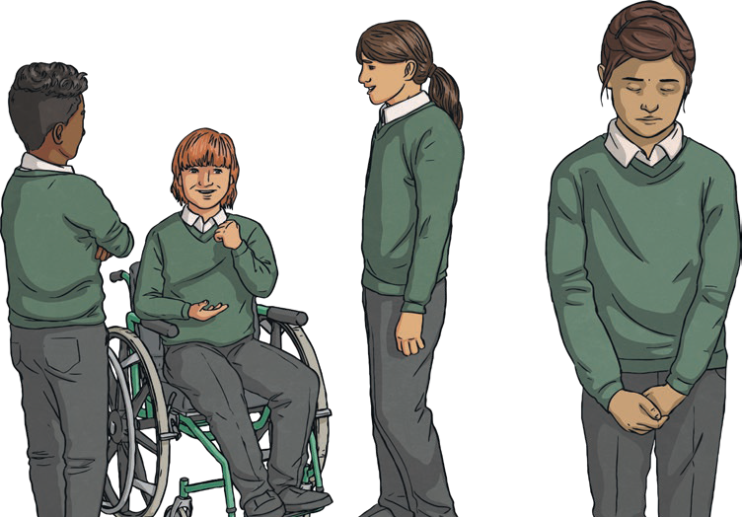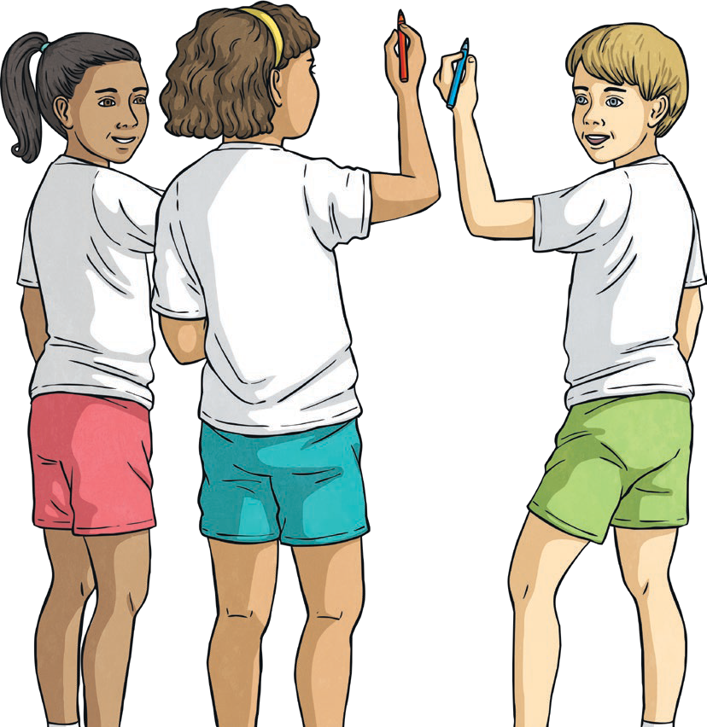Changes: Changes might be big or small. They can be planned or unexpected and the way we each feel about different sorts of changes is personal to us. What one person might see as an exciting change might make someone else worried and anxious. It is important to respect the feelings of others and show kindness when listening to their emotions. We can also help ourselves prepare for or cope with change. Different strategies will help with different scenarios of change.
twinkl.com
It may help to talk to people we feel close to, plan how we will deal with a change that we know is coming so we can be prepared, write our feelings down or focus on a hobby or an activity that we really enjoy. Some people may find it
helps to remember these feelings will pass and we will get used to the change and the new situation. It is very important
to talk to a trusted adult if we feel any uncomfortable emotions about changes that we are experiencing.
Benefits of Mindfulness: There are lots of ways mindfulness can help us. It can improve our focus and concentration, it can help us to understand and manage our bigger emotions, it can help us to build our resilience by understanding these emotions and it can help us process decisions carefully. There are ways we can bring mindfulness into our routines quickly and easily. One example of how to be mindful is to focus on our senses and what we can see, hear, smell, touch and taste. We can do this easily through almost
anything we do, for example, when we go for a walk or when we eat. We can also practise mindfulness by focusing on a hobby or activity and spending time with nature.
Positive Learning Attitude: Having a positive attitude to our learning can support our mental health and wellbeing. We can help ourselves to develop a positive attitude to learning by viewing challenges as exciting, asking questions to learn more, believing in ourselves, learning from the success of others, watching and listening carefully, learning from our mistakes, practising with determination, getting help when needed, asking questions and trying a different approach.

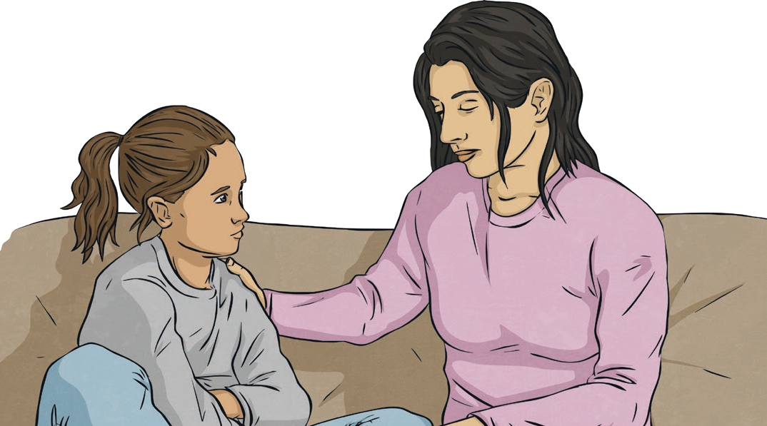Managing Uncomfortable Emotions: Every feeling or emotion is OK and we are likely to feel a large range of emotions each day. Some emotions we experience may feel uncomfortable so having some strategies to manage these can be helpful. It can help to breathe calmly and deeply or to go for a walk or get active, maybe by playing a game or going outside. We can also spend time with people we feel close to. It is very important we get help and support if we feel uncomfortable emotions too often or for too long so speaking to a trusted adult is a very good place to start.
Although we can’t choose what happens to us or even how we feel about it, we can choose how to react. Having these strategies can allow us to take time to understand our feelings and have more choices about how we behave in response to them.

Key Learning Point:
Looking After Our Mental Health and Wellbeing: Adopting a positive mindset can contribute to our self-care routine for our mental health and wellbeing. There are many other things we can do to support our mental health and wellbeing as well. These include:

- spending time with family, friends and people we feel close to;
- enjoying hobbies, crafts or other focused activities;
- getting active and playing games;
- spending time in nature;
- showing kindness to ourselves and others;
- eating a balance of different foods;
- drinking plenty of water;
- getting enough sleep;
- learning something new.
It is very helpful to understand the ways we can support our own mental health and wellbeing. If there is anything worrying
us or causing us uncomfortable emotions, it is also very important to speak to a trusted adult.

twinkl.com

To look at all the planning resources linked to the LKS2 Think Positive unit, click here

This resource is fully in line with the Learning Outcomes and Core Themes outlined in the PSHE Association Programme of Study.

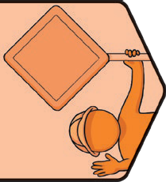
PSHE and Citizenship | One World

Key Vocabulary
similarities | Ways things or people are the same.
differences | Ways things or people are not the same.
rural | The countryside.
urban | Towns and cities.
stereotype | Assuming someone will behave in a certain way because of a certain characteristic. This could be based on the way they look, the way they speak, where they come from or their gender.
United Nations (UN) | An international organisation supporting countries to work together peacefully and create fairer, more equal societies.
discrimination | Unfair treatment of a person or group based on who they are, where they are from or how they choose to live their life.
empathy | Being able to understand and share the feelings of others.
compassion | Understanding the challenges people are facing and wanting to help.
diversity | A large variety of a similar type of thing.
resources | Things we use.
fair trade | Making sure farmers get paid fairly for their goods.
responsibility | Tasks that we do to contribute or things we are in charge of.
climate change | A long-term change in the climate of the earth caused by increasing temperatures on the planet.
charity | Organisations which raise money to support causes in need of help.

twinkl.com

Key Knowledge

Similarities and Differences - We are all different and this is something to be celebrated and appreciated. Every one of us deserves the same chances and opportunities. Sometimes these are not offered and people are treated unfairly. This leads to inequality. Inequality can be found in countries all around the world but individuals, groups and organisations are working to make life fairer for people who experience inequality. Everyone has the right to equal opportunities and to live happy, safe, healthy and fulfilling lives no matter who they are, where they live, what they look like or how they choose to live their lives.
Challenging Stereotypes - Stereotypes are overgeneralised beliefs about something. They can be harmful as they may mean that people are treated unfairly and this may affect the opportunities people feel that they have. By identifying stereotypical behaviour we can challenge these views and take small steps to work towards a more equal society.
Different Decisions - Everyone must make the decision that is right for them and their family. We need to view these differences with kindness and respect. By learning about people’s different experiences and the decisions they each have to make we can empathise with people, showing compassion and understanding. By treating people with kindness and respect we can help to create a fairer society where people are treated equally.
Fair Trading - Our world is a wonderfully diverse place and there are lots of things we can celebrate about it. Some people are treated unfairly when trading goods and this is not OK. To make trading more fair and equal, some groups and organisations are working to achieve fairer trading. This might mean that farmers are paid more for their crops, companies trading with farmers use their profits for training and equipment for the farm or that companies and farmers work together to set the price that is to be paid for the goods.
Climate Change and its Effects - The temperature of the world is rising. This is affected by human activity including intensive cattle farming, burning fossil fuels and cutting down trees that absorb carbon dioxide. This results in increased rainfall, rising sea level, changing seasons, extreme weather and shrinking sea ice and all these effects have an impact on the natural world around us. Climate change also affects farmers who produce the food we eat. This could be through droughts, floods, change in air quality caused by deforestation and extreme heat. We can all make small changes to reduce these harmful effects. We can turn off electronic equipment when we are not using it, recycle what we can, create less food waste and walk more rather than using vehicles.
Responsible Global Citizens - Being a responsible global citizen means we make choices that help others, both close to us and around the world. There are many groups, organisations and charities that work to help people around the world. Some of these work with local groups to educate the community and with governments to help make fairer laws and raise money to build facilities. Some people choose to support the work of charities, either by donating money or organising events to raise money and this is one way we can be global citizens. We can also consider what we use and try to reduce waste, recycle where possible, use reusable carrier bags when shopping and turn off electronic devices when they are not in use.

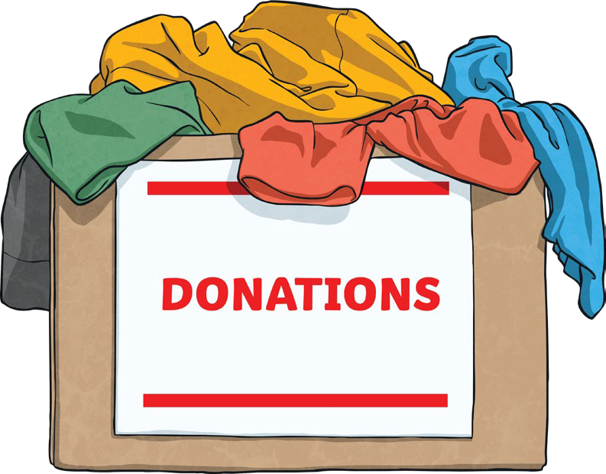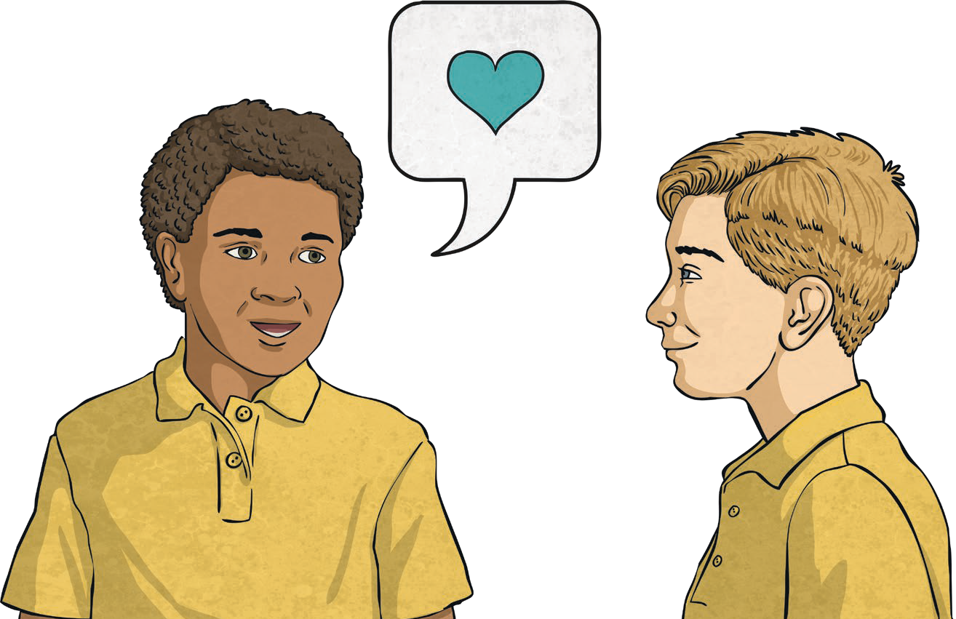
twinkl.com

Key Learning Point:

By learning about the world around us we can understand what life is like for people around the world. This can help us to live our lives with care and consideration for others, doing what we can to help create a fair and equal society. To do this we can:
- appreciate the similarities and differences between people and see these as things to be celebrated;
- challenge stereotypes and discrimination to work for a fair and equal society where everyone is valued and respected;
- respect the different decisions people make;
- be active global citizens by reducing, reusing and recycling. This could be by using reusable shopping bags, recycling our waste, taking items we no longer use to charity shops, turning off water and electrical devices that are not being used.

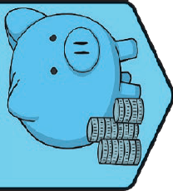
PSHE and Citizenship | Money Matters

Key Vocabulary
money | Something people use to pay for things they need.
employment | Having a job.
wages | The amount of money people get paid for doing their job.
bank account | A place to store money safely.
debit card | A small plastic card which is linked to a bank account. People can use a debit card to pay money from their  bank account.
credit card | A card which enables people to spend money that has been lent by a credit company. People can spend more  money than they have and then repay it at a later date. People pay interest for borrowing this money.
contactless payment | Paying for goods and services by tapping a debit card onto a small machine. This transfers money from the linked bank account to the business you want to pay.
online payment | Paying for goods and services on the Internet by entering the details from a debit card in a form. This transfers  money from a person’s bank account to the business they want to pay.
interest | - A fee charged for borrowing money.  - A sum of money paid by the bank into a bank account to encourage savings.
ethical spending | Spending money or buying things in a way that has no negative impact on the environment or people involved in the making of the goods.
environment | The surroundings in which people live.
priority | Things we consider important.

twinkl.com

Key Knowledge

Where The Money Goes
Money can come from many places. One way people get money is by having a job. Often, if people have a job they are paid wages. The money they earn every year from a job is called a salary. This money can be used to pay for food, household bills, travel costs and outings. When people decide what job they would like to do, the money they are paid may be one consideration but there may be other things that influence the decision as well. These include the training that is needed, the interests and skills someone has and the team someone would work with. Different jobs have different requirements. Sometimes people need to have certain qualifications, sometimes people need to have done certain training and sometimes people need interests and strengths in an area which will help them with the job.

Forms of Money
There are lots of different ways to pay for things we need or want. These include coins and notes, credit cards, debit cards, contactless payments and online payments. The way people choose to pay for what they need may be affected by the cost of the item that needs to be bought and where it is bought from. How people choose to store their money is a personal choice and it is their choice what they do with this money. We are all different so will all have different opinions on how to use our money.

Borrowing Money
Sometimes people need to borrow money and this could be for lots of different reasons. Money might need to be borrowed so people can buy food or pay household bills or to pay for university fees or to buy a house. No matter what the reason, if something is borrowed, it needs to be returned. When people pay back the borrowed money, there is also an extra fee called interest. This is an extra amount that needs to be paid when money has been borrowed. Borrowing money can have an effect on our mental wellbeing. It may cause people to feel happy and satisfied if borrowing has helped them to achieve something they have been working towards or it may cause people to worry if they feel unable to repay the money that has been borrowed. If people experience any uncomfortable emotions about money it is important that they talk to someone they trust.

Decisions About Spending
Everyone is different and because of this we will all have different priorities. What people choose to spend their money on is a personal decision that needs to be right for them, their family and their wellbeing. Some people choose to prioritise spending that avoids any negative impact on the environment. This is ethical spending. These choices might include avoiding single-use plastic, exploring fair trade options, giving items to charity shops when they no longer need them and taking reusable shopping bags when going shopping. Everyone has different spending priorities and it
is important to view the decisions of others with kindness and respect. If any decisions about spending ever worry us, it is important to speak to a trusted adult to get help.

twinkl.com

Advertisements
Many companies advertise their products to try to encourage customers to buy them. It can be helpful to understand companies are often trying to sell their goods and therefore will make a financial gain.

Spending and Recording
When people go shopping they will need to make decisions about what to buy and where to find the items depending on what they are shopping for and the reasons they are shopping. It can be helpful to record what has been spent so that people know where their money goes. Recording how money is spent can help to budget for future spending as well.

Key Learning Point:

The spending decisions people make will be as individual as they are. We are all different so will all have different priorities. It is very important we respect the decisions of others and show ourselves kindness when reflecting on our own spending choices. We can do this by:

- understanding what choices we have about how to spend our money;
- reflecting on our own priorities and spending what we feel we need to on things we consider important;
- exploring ethical spending options such as donating to charity shops and taking reusable bags when shopping;
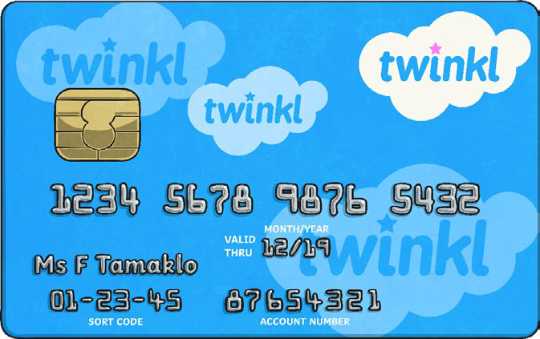
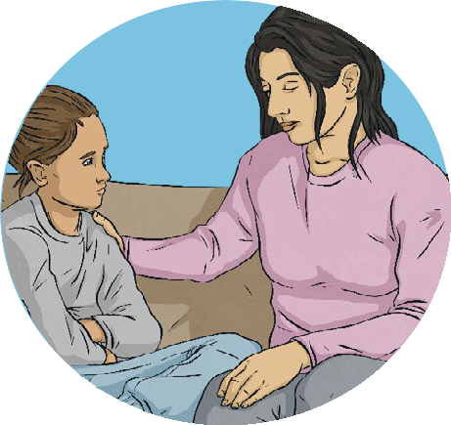
- being aware of how spending can affect our feelings and emotions;
- talking to a trusted adult if anything worries us.

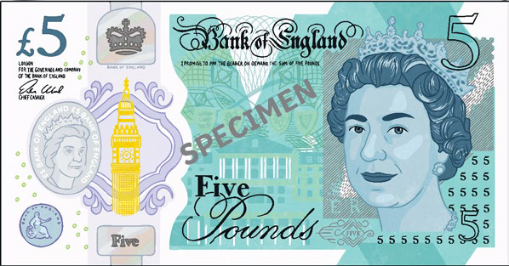

To look at all the planning resources linked to the LKS2 Money Matters unit, click here.

Health and Wellbeing | Think Positive
Key Vocabulary
positive attitude: | Looking for the good in a situation and things that are going well rather than focusing on areas we find difficult.
mental health: | How we are feeling and the thoughts we are having and the effect this has on the choices we make and how we behave.
change: | When something becomes different.
mindset: | Our attitude to something and how we feel about it.
mindfulness: | Focusing on the present and what we are feeling, seeing and doing right now.
strategies: | Ways we can work through or manage something.
emotions: | How we feel about things that are happening.
response: | The way we react to things that are happening around us.
challenge: | Something we may find tricky but can work to do well at.
resilience: | Trying again and continuing to persevere when we find something difficult.
flexible: | Making changes or adapting ideas when needed.

Key Knowledge
Our Happiness: Happiness is a comfortable emotion we feel when we are doing things we enjoy or when we are spending time with people we feel close to. There are lots of ways we can support our minds to feel healthy and happy.
We can relax, get enough sleep, smile and laugh, spend time with family and friends, exercise regularly, eat healthily, be fair and honest, listen to music, care for others, enjoy a hobby, work hard to achieve goals, accept ourselves and feel proud of who we are. All these things support positive mental health and wellbeing.
PSHE and Citizenship | Think Positive

Helpful and Unhelpful Thoughts: Our thoughts affect the way we feel and behave. It can be helpful to understand this so we can begin to understand why we are experiencing the emotions we are. Helpful thoughts focus on the positives in a situation or help us to cope with
or achieve something. Unhelpful thoughts might make us worry or feel emotions that may be uncomfortable. We can help our minds think positively and try to look for the good in a situation or ways we can solve a problem or achieve something by adopting a positive mindset.

Changes: Changes might be big or small. They can be planned or unexpected and the way we each feel about different sorts of changes is personal to us. What one person might see as an exciting change might make someone else worried and anxious. It is important to respect the feelings of others and show kindness when listening to their emotions. We can also help ourselves prepare for or cope with change. Different strategies will help with different scenarios of change.
twinkl.com
It may help to talk to people we feel close to, plan how we will deal with a change that we know is coming so we can be prepared, write our feelings down or focus on a hobby or an activity that we really enjoy. Some people may find it
helps to remember these feelings will pass and we will get used to the change and the new situation. It is very important
to talk to a trusted adult if we feel any uncomfortable emotions about changes that we are experiencing.
Benefits of Mindfulness: There are lots of ways mindfulness can help us. It can improve our focus and concentration, it can help us to understand and manage our bigger emotions, it can help us to build our resilience by understanding these emotions and it can help us process decisions carefully. There are ways we can bring mindfulness into our routines quickly and easily. One example of how to be mindful is to focus on our senses and what we can see, hear, smell, touch and taste. We can do this easily through almost
anything we do, for example, when we go for a walk or when we eat. We can also practise mindfulness by focusing on a hobby or activity and spending time with nature.
Positive Learning Attitude: Having a positive attitude to our learning can support our mental health and wellbeing. We can help ourselves to develop a positive attitude to learning by viewing challenges as exciting, asking questions to learn more, believing in ourselves, learning from the success of others, watching and listening carefully, learning from our mistakes, practising with determination, getting help when needed, asking questions and trying a different approach.

Managing Uncomfortable Emotions: Every feeling or emotion is OK and we are likely to feel a large range of emotions each day. Some emotions we experience may feel uncomfortable so having some strategies to manage these can be helpful. It can help to breathe calmly and deeply or to go for a walk or get active, maybe by playing a game or going outside. We can also spend time with people we feel close to. It is very important we get help and support if we feel uncomfortable emotions too often or for too long so speaking to a trusted adult is a very good place to start.
Although we can’t choose what happens to us or even how we feel about it, we can choose how to react. Having these strategies can allow us to take time to understand our feelings and have more choices about how we behave in response to them.

Key Learning Point:
Looking After Our Mental Health and Wellbeing: Adopting a positive mindset can contribute to our self-care routine for our mental health and wellbeing. There are many other things we can do to support our mental health and wellbeing as well. These include:

- spending time with family, friends and people we feel close to;
- enjoying hobbies, crafts or other focused activities;
- getting active and playing games;
- spending time in nature;
- showing kindness to ourselves and others;
- eating a balance of different foods;
- drinking plenty of water;
- getting enough sleep;
- learning something new.
It is very helpful to understand the ways we can support our own mental health and wellbeing. If there is anything worrying
us or causing us uncomfortable emotions, it is also very important to speak to a trusted adult.

twinkl.com

To look at all the planning resources linked to the LKS2 Think Positive unit, click here

This resource is fully in line with the Learning Outcomes and Core Themes outlined in the PSHE Association Programme of Study.

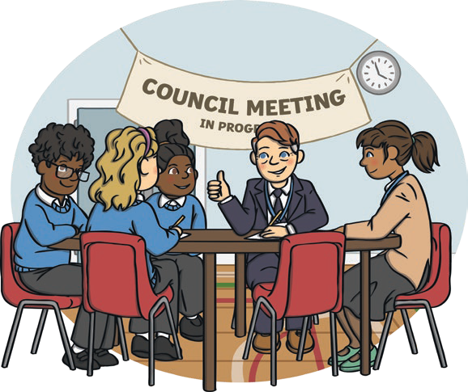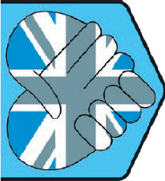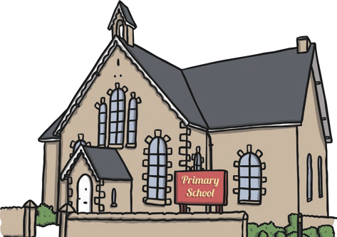
hings.
nd
Key Vocabulary
community: | A group of people who live or work together in the same place, or who like to do the same kind of things.
belonging: | Feeling that we are part of a group.
respect: | A way of treating or thinking about someone that shows they are important and they are valued.
listen: | Hearing and concentrating on what someone is saying.
behaviour: | Our actions.
choice: | Options we have about what to do.
consequence: | Things that happen as a result of something else.
neighbours: | People who live and work in our local community.
neighbourhood: | The area near and around where we live.
responsibilities: | Tasks that we do to contribute or things we are in charge of.
environment: | The world around us, including the land, sea, sky, plants, animals and people. Environments can be natural or built.
multicultural: | A group of people from many different cultures.
diverse: | Made up of lots of different t
culture: | The food, clothes, language a traditions people enjoy.

Living in the Wider World | Diverse Britain | KS1
Key Knowledge
My School Community In our school community we are kind, caring and helpful to each other and we follow school rules. We treat
PSHE and Citizenship | Living in the Wider World
everyone and everything with
respect, share our resources
and help to keep our space
tidy. This helps our school community to be a safe and happy place.

My School Community
In our school community we are kind, caring and helpful to each other and we follow school rules. We treat everyone and everything with respect, share our resources and help to keep our space tidy. This helps our school community to be a safe and happy place.

Being a Good Neighbour
We can be good neighbours by thinking about what other people need to feel happy. We can show respect to others, look after the environment, smile and
help people.

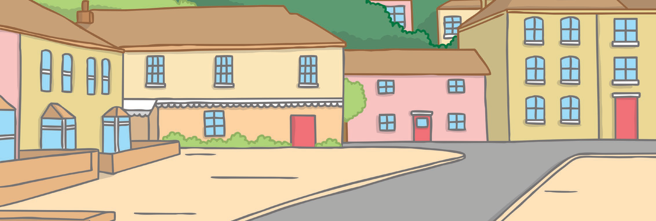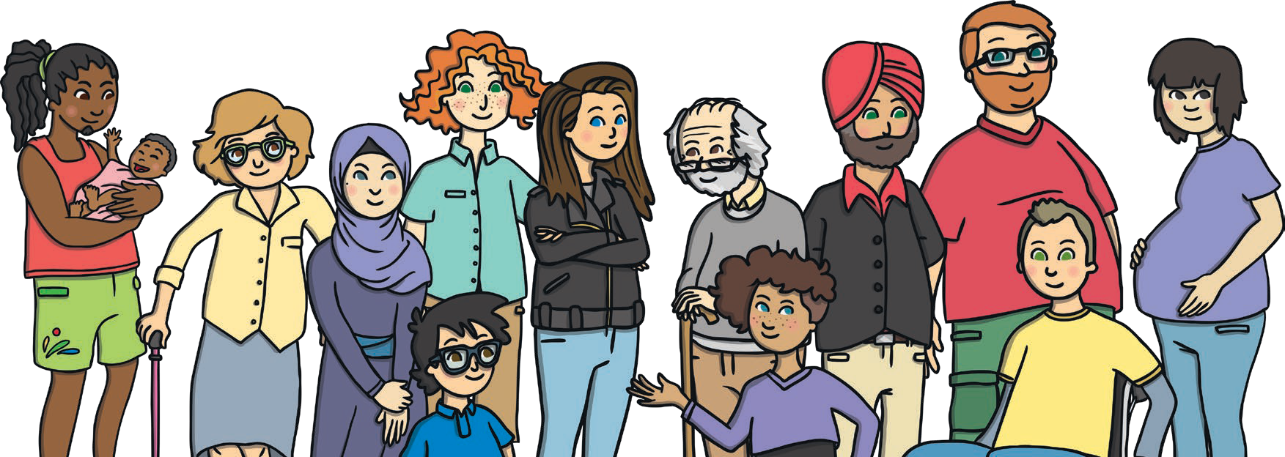Looking After Our Neighbourhood
twinkl.com
To look after our neighbourhood, we need to look after the natural and built environment that is local to us. People have the right to live somewhere clean and safe, where they can be healthy. We have a responsibility to look after our neighbourhood to help make sure all people and other living things have a comfortable home.

Living in Britain
Britain is multicultural. There are many different cultures and traditions. This will mean there are many similarities and differences between people, places and experiences. These differences are what makes the world an exciting place and they should be celebrated.

British People
The United Kingdom of Great Britain and Northern Ireland and other British Isles are multicultural nations. People come from many different backgrounds. They wear many different types of clothes, eat many different foods, speak many different languages and enjoy doing lots of different things. We all have the right to live as we choose and this must be respected.
We can show respect by smiling, being friendly and learning from each other.

Feeling Proud of Our Country
There are lots of things that make our country special. These include the people, places, cultures and traditions. We can all help to keep our country special by respecting and valuing our differences and looking after the environment.

Key Learning Points:
Respecting Our Differences: There are many ways we are similar to and different from people around us.
Everyone deserves to feel respected and valued and to have every opportunity to be and achieve all they can. To help show everyone kindness and respect, we can:
- smile at others;
- speak kindly;
- show care;
- ask questions;
- respect people’s choices;
- learn from each other.

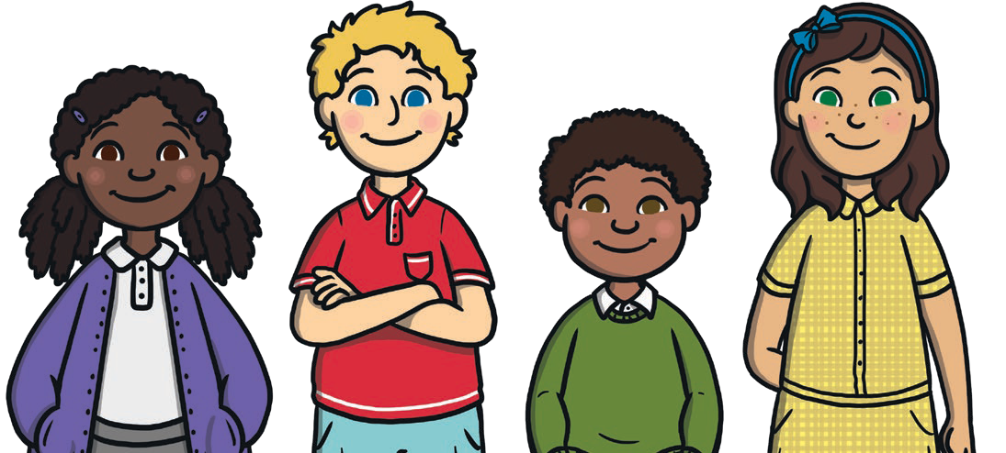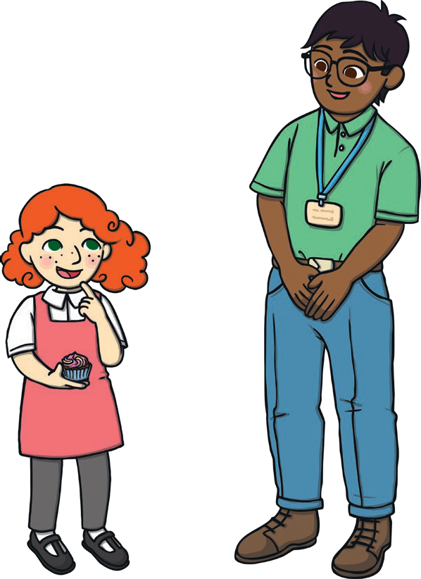
twinkl.com

To look at all the planning resources linked to the KS1 Diverse Britain planning, click here

This resource is fully in line with the Learning Outcomes and Core Themes outlined in the PSHE Association Programme of Study.

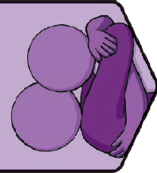
Relationships | VIPs Key Knowledge Positive Relationships
Key Vocabulary
respect: | A way of treating or thinking about someone that shows they are important and they are valued.
kindness: | Being friendly, generous and considering the feelings of others.
considerate: | Thinking of others and how they might feel.
friendships: | Relationships we have with people outside our family who we like spending time with and know well.
differences: | Ways we are not the same.
alternatives: | Different ways of doing things or another option.
options: | Choices or alternatives.
choices: | Options we have about what to do.
negotiation: | A discussion involving compromise between two or more options.
compromise: | Finding a way of working together where two or more people adapt their behaviour, actions or choices.
support network: | A group of people we can rely on to provide practical and emotional help.
bullying: | Doing something repeatedly to hurt someone’s body or feelings on purpose.
discrimination: | Unfair treatment of a person or group based on who they are, where they are from or how they choose to live their life.
prejudice: | Having an opinion without reason or experience to justify it.
equality: | The right of everyone to the same treatment and opportunity.
equity: | Providing everyone with things they need to succeed.

Positive relationships should make us
feel safe, secure, loved and cared for. We should expect to be treated with fairness, honesty and to feel valued and accepted for who we are. It is
important that we treat our VIPs in this way as well. This way our relationships
will help us to feel safe and happy. Sometimes, relationships can become unhealthy. Unhealthy relationships are where one person hurts the other, becomes angry with the other, tries to control the other or never listens to the other. If we are ever worried
PSHE and Citizenship | Relationships
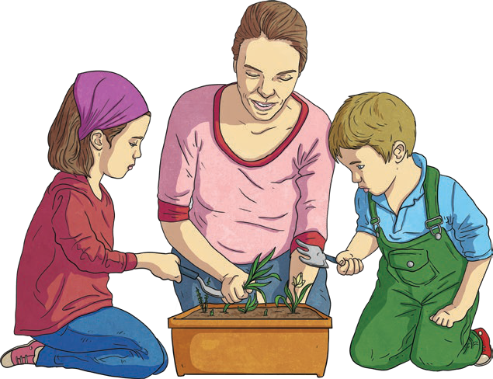a relationship we are in is becoming unhealthy, it is very important to speak to a trusted adult straight away.

Making and Keeping Our Friends: Friendships can help us to feel supported and valued and provide an opportunity for us to share our feelings and ideas. There are lots of ways we can make friends and nurture our relationships with friends we already have. Smiling, feeling confident, sharing our interests and hobbies
and showing kindness all help us to make new friends. There are many different emotions we will feel and different experiences we will have. By having lots of different friends with different interests and qualities, we will have people
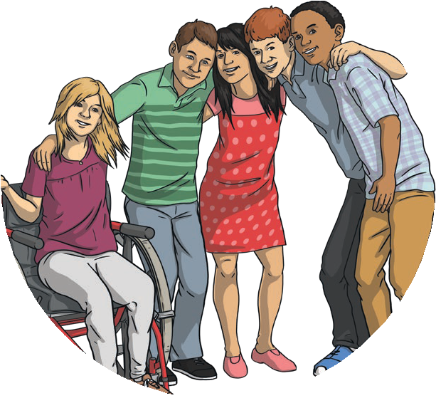to support us in lots of different scenarios. By working hard to nurture our friendships, we can help them to grow and develop. To do this, we can keep in regular contact, remember special times for them like their birthday, show interest in them and make time for them.
Healthy or Unhealthy Relationships: Positive, healthy relationships should make us feel respected and valued. Within our relationships we should feel that we are able to express how we feel and decide what we do. Our friends should also
feel confident to express how they feel, so we can each choose how to respond. Healthy relationships should not involve an imbalance of power. Instead, each person involved should feel comfortable and valued. We should also not be put in a position which makes us feel any uncomfortable emotions. This may be
through peer pressure, unwanted physical contact or by being expected to keep secrets. If anything happens that makes us feel uncomfortable emotions, it is
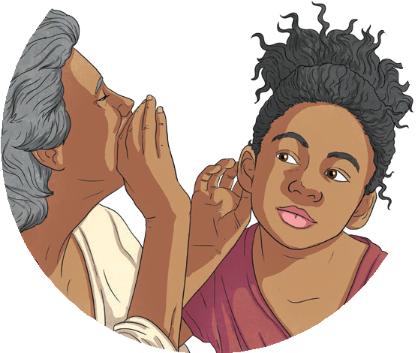important that we speak to a trusted adult straight away.

Resolving Conflict:
Every relationship has ups and downs and people sometimes disagree. This is a normal part of relationships. As
we are all different, we each have our own opinions and ideas so it is likely we will feel differently from our friends about things every now and then. It can therefore be helpful to have some
positive strategies for resolving conflicts. We might choose to use a simple game to decide how a small problem could
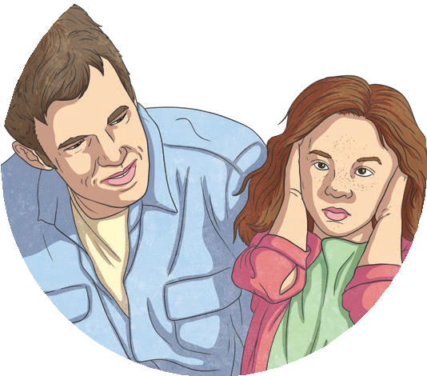be resolved, such as who should line up first. We can talk about how something makes us feel, rather than focusing on what the other person did. We can set out the steps that we think need to be made to solve a problem. If we feel like we need more support, we can get help from someone in our support network.

twinkl.com

Bullying and Hurtful Behaviour:
There are many types of bullying behaviour. These include verbal bullying, indirect bullying, cyberbullying and physical bullying. All of these forms of bullying have powerful effects on the person being bullied. They cause uncomfortable emotions, damage to self-esteem and mental health and may cause someone to avoid certain events or situations. By reaching out to get help, or reaching out to help others, we can stop bullying and spread kindness and respect.

Taking Action Against Bullying:
If we are being bullied or are worried someone else is, it is helpful to talk to our support network. A support network is a collection of healthy relationships we have with people who we know well and who we can trust. This might be our parents or carers, other family members, teachers, school staff, friends or other adults we trust. It is important to reach out and get help if anything is making us feel uncomfortable emotions.

Key Learning Points:
There are many features that are very important to healthy relationships.

These include:
- mutual respect;
- trust;
- truthfulness;
- loyalty;
- kindness;
- generosity;
- shared interests and experiences.
By making sure our relationships include these characteristics, we can be confident our relationships will help us to feel loved, safe and secure.

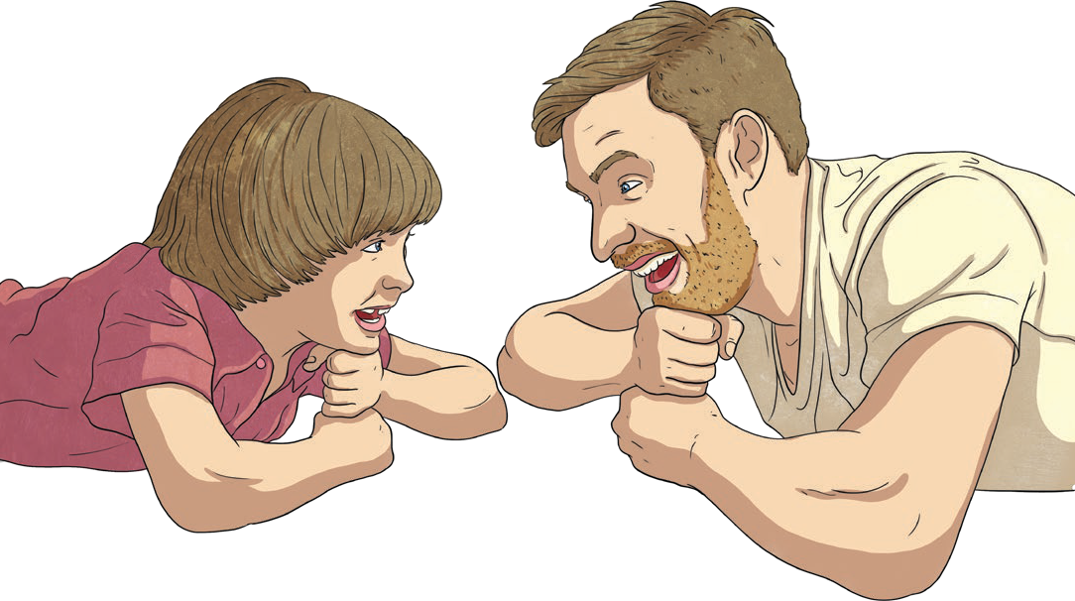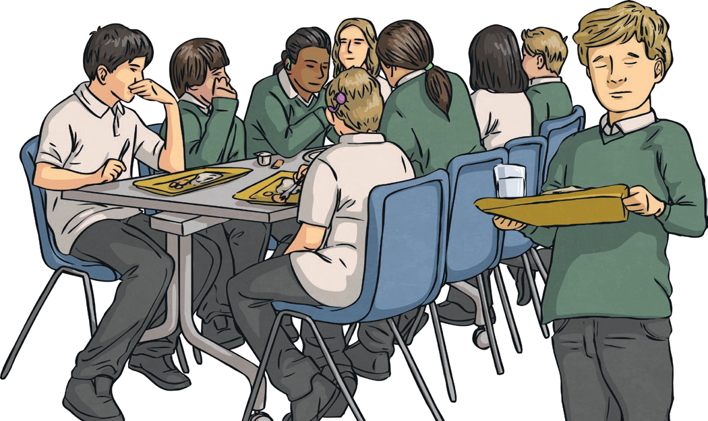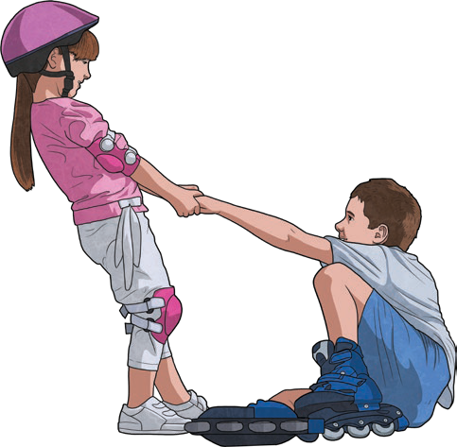
twinkl.com
To look at all the planning resources linked to the LKS2 VIPs unit click here

This resource is fully in line with the Learning Outcomes and Core Themes outlined in the PSHE Association Programme of Study.

PSHE and Citizenship | One World

Key Vocabulary
similarities | Ways things or people are the same.
differences | Ways things or people are not the same.
rural | The countryside.
urban | Towns and cities.
stereotype | Assuming someone will behave in a certain way because of a certain characteristic. This could be based on the way they look, the way they speak, where they come from or their gender.
United Nations (UN) | An international organisation supporting countries to work together peacefully and create fairer, more equal societies.
discrimination | Unfair treatment of a person or group based on who they are, where they are from or how they choose to live their life.
empathy | Being able to understand and share the feelings of others.
compassion | Understanding the challenges people are facing and wanting to help.
diversity | A large variety of a similar type of thing.
resources | Things we use.
fair trade | Making sure farmers get paid fairly for their goods.
responsibility | Tasks that we do to contribute or things we are in charge of.
climate change | A long-term change in the climate of the earth caused by increasing temperatures on the planet.
charity | Organisations which raise money to support causes in need of help.

twinkl.com

Key Knowledge

Similarities and Differences - We are all different and this is something to be celebrated and appreciated. Every one of us deserves the same chances and opportunities. Sometimes these are not offered and people are treated unfairly. This leads to inequality. Inequality can be found in countries all around the world but individuals, groups and organisations are working to make life fairer for people who experience inequality. Everyone has the right to equal opportunities and to live happy, safe, healthy and fulfilling lives no matter who they are, where they live, what they look like or how they choose to live their lives.
Challenging Stereotypes - Stereotypes are overgeneralised beliefs about something. They can be harmful as they may mean that people are treated unfairly and this may affect the opportunities people feel that they have. By identifying stereotypical behaviour we can challenge these views and take small steps to work towards a more equal society.
Different Decisions - Everyone must make the decision that is right for them and their family. We need to view these differences with kindness and respect. By learning about people’s different experiences and the decisions they each have to make we can empathise with people, showing compassion and understanding. By treating people with kindness and respect we can help to create a fairer society where people are treated equally.
Fair Trading - Our world is a wonderfully diverse place and there are lots of things we can celebrate about it. Some people are treated unfairly when trading goods and this is not OK. To make trading more fair and equal, some groups and organisations are working to achieve fairer trading. This might mean that farmers are paid more for their crops, companies trading with farmers use their profits for training and equipment for the farm or that companies and farmers work together to set the price that is to be paid for the goods.
Climate Change and its Effects - The temperature of the world is rising. This is affected by human activity including intensive cattle farming, burning fossil fuels and cutting down trees that absorb carbon dioxide. This results in increased rainfall, rising sea level, changing seasons, extreme weather and shrinking sea ice and all these effects have an impact on the natural world around us. Climate change also affects farmers who produce the food we eat. This could be through droughts, floods, change in air quality caused by deforestation and extreme heat. We can all make small changes to reduce these harmful effects. We can turn off electronic equipment when we are not using it, recycle what we can, create less food waste and walk more rather than using vehicles.
Responsible Global Citizens - Being a responsible global citizen means we make choices that help others, both close to us and around the world. There are many groups, organisations and charities that work to help people around the world. Some of these work with local groups to educate the community and with governments to help make fairer laws and raise money to build facilities. Some people choose to support the work of charities, either by donating money or organising events to raise money and this is one way we can be global citizens. We can also consider what we use and try to reduce waste, recycle where possible, use reusable carrier bags when shopping and turn off electronic devices when they are not in use.

twinkl.com

Key Learning Point:

By learning about the world around us we can understand what life is like for people around the world. This can help us to live our lives with care and consideration for others, doing what we can to help create a fair and equal society. To do this we can:
- appreciate the similarities and differences between people and see these as things to be celebrated;
- challenge stereotypes and discrimination to work for a fair and equal society where everyone is valued and respected;
- respect the different decisions people make;
- be active global citizens by reducing, reusing and recycling. This could be by using reusable shopping bags, recycling our waste, taking items we no longer use to charity shops, turning off water and electrical devices that are not being used.

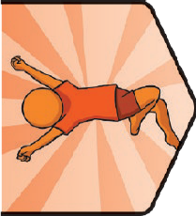
Key Knowledge
Key Vocabulary
autonomy: | The independence to make our own choices.
consent: | To give permission or agree to something.
respect: | A way of treating or thinking about someone that shows they are important and they are valued.
self-confidence: | Feeling comfortable with our own qualities,strengths and abilities.
choice: | Something we have the power to make when there is more than one possibility.
pressure: | A strong influence people feel to behave in a certain way.
inappropriate: | Not suitable for the situation or person.
drug: | A medicine or other substance which affects the body when taken. There are legal (allowed by law) and illegal (not allowed by law) drugs.
stereotype: | Assuming someone will behave in a certain way because of a certain  characteristic. This could be based on the way they look, the way they speak,  where they come from or their gender.
hygiene: | Keeping ourselves clean to stay  healthy and well.

Consent and Autonomy
We all have the power of consent and autonomy. This means we can choose what happens to our bodies and that other people need permission to touch us. Respecting ourselves means we know our bodies are precious and need to be protected from unwanted touch or harm. Other people have this right as well and can decide what happens to their bodies. It
is not OK to make anyone do something they are not comfortable doing. If anyone is worried about something that is happening that doesn’t feel right, it is important to explain the situation needs to stop and to speak to a trusted adult for help.

Exercise and Sleep
Physical activity has many benefits for our bodies and our minds. It can strengthen bones, muscles and the heart, boost immunity and energy levels, improve mood and help us to sleep better. It can also help our mental health by reducing stress, depression and anxiety levels, improving mood, brain power and self-esteem and improving social
PSHE and Citizenship | It’s My Body
connections. By making choices which help us to get enough exercise and sleep, we can help our bodies and minds feel healthy and well.

Looking After Our Bodies
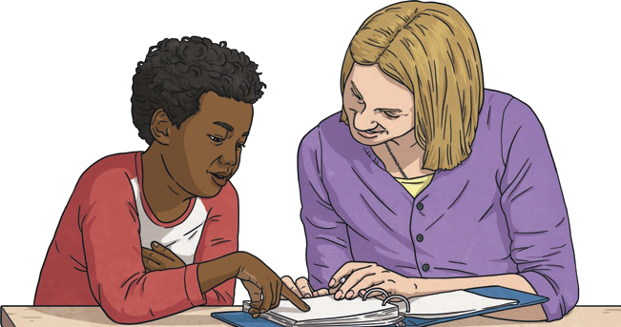
There are lots of ways we can take care of our bodies. Eating a balanced diet including a wide variety of food groups gives our body the vitamins and minerals it needs to stay healthy. Keeping ourselves clean by washing our bodies and our clothes helps us to feel fresh and hygienic. Eating breakfast gives us energy to start the day and eating foods rich in protein helps to maintain our energy levels. Looking after our teeth by brushing twice a day, flossing and visiting the dentist regularly helps maintain our oral health. Developing good bedtime routines
helps us to get enough sleep. Drinking enough water helps our bodies to stay hydrated and keeps our skin clear. Taking care in the sun by staying hydrated, sitting in the shade and covering up avoids heat and sun exposure.

twinkl.com
Key Knowledge

Harmful Substances
Substances people put into their bodies to have an effect are called drugs. Legal drugs include alcohol, tobacco, caffeine and medicines. It is important to understand the risks and rules associated with these substances so that people are able to make informed choices. It is also
important we remember it is our choice what we put into our body and that no one should make us feel pressured to do or try anything we don’t want to do or are not comfortable with.

Body Image
There are many influences around us that may affect how we see ourselves. Many of the images shown on adverts, the Internet, social media and magazines may have been altered to present an image of an unrealistic appearance. It is important to remember this
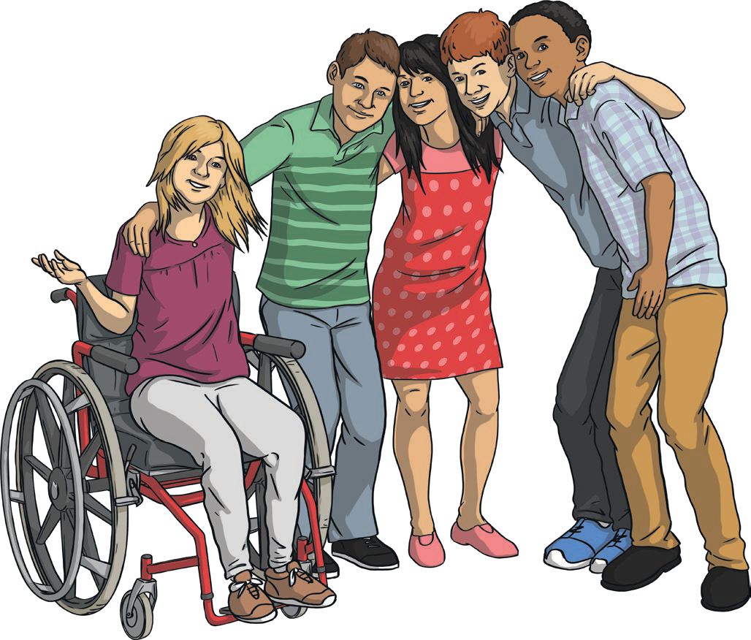
when reflecting on how we see ourselves and to make sure we value the positive qualities that we have rather than just focusing on what we look like. There are many ways we can look after our body to keep it healthy and strong and this can also help to inform our self-image.

Healthy Choices
There are lots of things we can do to keep our bodies and minds healthy and well. We can eat a balanced diet, avoid substances which would be harmful to us, drink plenty of water to stay hydrated, get enough exercise, enjoy a balance of activities,
stay safe when it is sunny by finding shade, covering up and drinking plenty of water and we can allow our minds time to be calm through relaxation
and mindfulness. It is important to make our own decisions about how we look after our bodies and not feel pressured to do anything we don’t feel is right.

Key Learning Point:
Proud to be Me
There are many choices we can make about our bodies and it’s important to remember that the decisions are ours to make. We should be able to choose options that make us feel comfortable and not be pressured by influences around us. By learning about healthy, balanced lifestyles, we can
make informed decisions that help us to stay healthy and well and feel good about ourselves.

Disclaimer
This resource is provided for informational and educational purposes only and does not constitute medical advice. If you require medical advice, you should contact a suitably qualified professional. You should not rely on the material included within this resource and Twinkl does not accept any responsibility if you do.

This resource is fully in line with the Learning Outcomes and Core Themes outlined in the PSHE Association Programme of Study
To look at all the planning resources linked to the UKS2 It’s My Body unit, click here

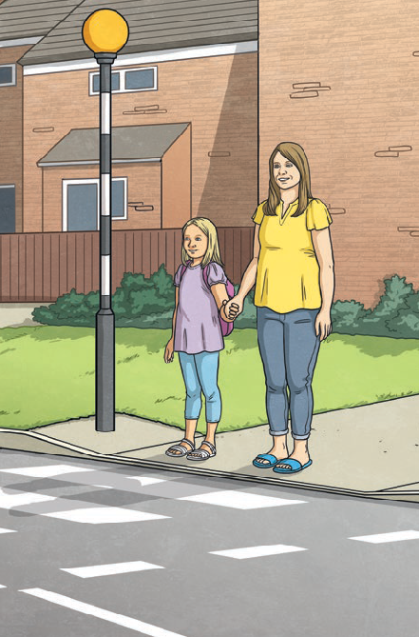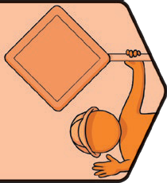
Key Vocabulary
alcohol | Alcohol is an ingredient in many adult drinks. It is illegal to buy alcoholic drinks if you are under 18 years old.
choice | Something we have the power to make when there is more than one possibility.
cigarette | A cylinder of finely cut tobacco rolled in paper for smoking. It may also contain other substances. Smoking cigarettes causes many health problems.
danger | Something which can cause harm, injury or suffering.
dare | A challenge given by someone. Dares can put pressure on someone to do something that could put them in danger.
drugs | A medicine or other substances which affect the body when taken. There are legal  (allowed by law) and illegal (not allowed by law) drugs.
e-cigarette | An electronic cigarette. Instead of smoke, the user breathes in vapour. Using an e-cigarette is often called ‘vaping’. Some dangerous chemicals have been found in them.
emergency | A serious and often dangerous situation. People in emergency situations need help straight away.
first aid | The first help given straight away to someone who is ill or injured.
hazard | Something that could cause harm or danger.

Health and Wellbeing | Safety First
Key Knowledge

Responsibilities
As we grow and become more independent, we have new opportunities and responsibilities. These include responsibilities to keep ourselves and others safe, happy and healthy. It is our responsibility to follow rules and restrictions (including age restrictions) which keep us safe and well. This includes restrictions on social media,
television programmes, films, games and online gaming.
PSHE and Citizenship | Safety First

Risks, Hazards and Danger
Hazards can cause us harm, injury or risk in the home and when we are out and about. It is important that we predict, assess and manage risk in the different situations we find ourselves in, so we can keep ourselves and others safe and out of danger. One way in which we can reduce risk and keep ourselves safe is to make sure we respond and communicate appropriately to adults we meet whom we do not know. This includes those we might meet online. If we find ourselves in a risky situation, we need to act responsibly, make safe choices and tell an adult we trust.

Pressure
Relationships and friendships can sometimes make us feel unhappy or unsafe, including those online. It is important that we tell an adult we trust and ask for help if we are in this situation. Sometimes, others put pressure on us to do things that are unsafe or that make us feel uncomfortable, including dares. We can say no and choose not to do
these things. If this is difficult, we need to ask for help from someone we trust to keep ourselves and others safe, including online.

Safety
medicine | A drug or other remedy to treat, help or prevent illness.
peer pressure | The pressure people can feel to behave in a certain way because their friends or people they spend time with expect it.
responsibility | The control we have over our actions and choices.
risk | A possibility of danger or harm.
safety | Being protected or kept safe from danger, risk or harm.
wellbeing | How comfortable, happy and healthy we feel and how able we are to cope with daily life.

There are things we can do to keep ourselves and others safe in the home, online, in the local environment and in places which are unfamiliar to us. It is important we know about these and make choices which help to protect our safety and wellbeing.

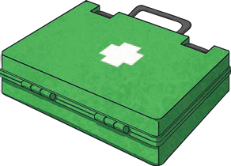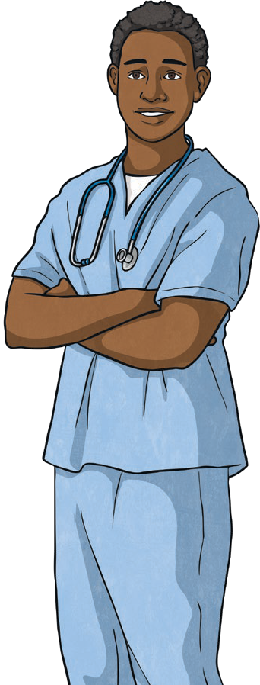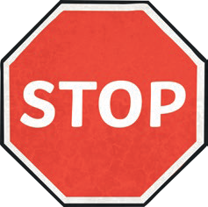Dangerous Substances
twinkl.com
It is important we take medicines correctly and use household products safely, following given instructions at all times. There are legal drugs (including medicines, alcohol, cigarettes and e-cigarettes) and illegal drugs which carry risks and can have harmful effects on the human body. Drug use can become a habit which can be difficult to break. There are laws about the use of legal drugs and some drugs are illegal to own, use and give to others. There are people and organisations that can help if people are worried about or have problems with dangerous substances.

Key Learning Point: The Primary Survey
We should follow the steps in the primary survey (with DR ABC) to help a casualty. The primary survey includes a series of checks to help the first-aider decide if there are any urgent threats to life. These checks are in order of importance. It is always best we shout for help and ask
someone to dial 999 or 112 if possible while we work through these steps.
- D is for Danger - check for hazards to assess the danger.
- R is for Response - talk to the casualty and try to get a response.
- A is for Airway - check the casualty’s airway and clear it if necessary.
- B is for Breathing - check that the casualty is breathing.
- C is for Circulation - check the casualty for bleeding.

Injuries and Emergencies
We can learn how to recognise an emergency situation and respond and react appropriately, including calling the emergency services. There are two numbers we can call to reach the emergency services: 999 and 112. After checking if it is safe to help a casualty, we should follow DR ABC (Danger, Response, Airway, Breathing and Circulation) to help us decide the best course of action.
First aid involves being one of the first people at a scene when someone is injured or ill and using techniques
for dealing with common injuries and illness.

Disclaimer
We hope you find the information on our website and resources useful. This resource is provided for informational or educational purposes only. It is intended to offer general first aid advice and is not a substitute for professional medical advice specific to your circumstances. As first aid advice is situation-specific and can change, we do not warrant that the information provided is correct or will meet your or your students’ specific health or medical require- ments. You and your students should not rely on the material included within this resource and we do not accept any responsibility if you or your students do. It is up to you to contact a suitably qualified health professional if you are concerned about your health and it is up to you to advise your students to contact a suitably qualified health professional if they are concerned about their health.

