Mill Lane Community Primary School
Forest School

Behaviour Policy

This documentation runs alongside the relevant whole school policies which can be viewed in full at http://www.mill-lane.oxon.sch.uk/website/policies/3739

Mill Lane Forest School aims to:
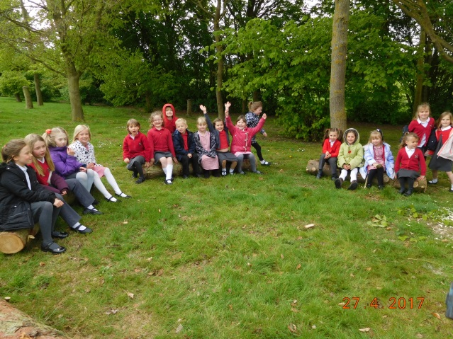
Develop children’s ability to be independent and motivated to learn whilst always maintaining a safe environment.
• Ensure children know what is expected of them, so they are free to develop their play without fear of being hurt or hindered by anyone else.
• Promote in children, an awareness, respect and care for other individuals and for the natural environment.
• Reinforce collaborative behaviour.
• Develop continuity of expectations and of approach to behaviour management both inside and outside the setting.
• Develop awareness of acceptable and responsible behaviour in an outdoor environment.
• Develop both children’s and adult’s sense of pride in their achievements. In order that these aims are achieved, expectations and standards of behaviour will be reinforced in the same way as during any other Mill Lane activity.

The role of the forest school leader is to:

• Provide a positive role model for the children and volunteers.
•Create a positive environment which encourages and reinforces caring, nurturing and acceptable behaviour towards one another, the natural environment and equipment we use.
• Promote effective relationships in which all are accepted, valued and treated equally.
• Be mindful of the need to maintain safety at all times.
• Establish clearly defined standards of behaviour while outside the setting.
• Involve staff, parents, children and outside agencies in the establishment of acceptable standards of behaviour.
• Place the needs of the children, including needs linked to their preferred learning styles, as well as social and behavioural needs at the centre of the forest school curriculum to maximise individual success and raise self-esteem.
• Give verbal praise to children demonstrating as they participate in the forest school activities

The role of the children: To the best of their ability and with or without support will:

• Listen carefully and respond to instructions and requests, especially those concerning safety.
• Develop and maintain an acceptable attitude towards one another, the environment and all equipment.

Reviewed: September 2018

Next Review: September 2019

.

