**Communication, language and literacy**

**Writing:**

* Cosmic by Frank Cottrell-Boyce – Narrative
* Spaced Out by Brain Moses and James Carter- Poetry
* A range of Non-Fiction texts - Explanation texts linked to Science and creation of their own planet

**Guided Reading:**

* VIPERS –linked to Cosmic by Frank Cottrell-Boyce

**MFL:**

* **French – Children will learn how to tell the time in French, including how to tell o’clock, half past, quarter past and to, as well as the day of the week.**

|  |
| --- |
|  |
|  |
|  |

**Mathematical Development**

**Maths:**

* **Place value to 1 million**
* **Multiples, factors**
* **Prime, square and cube numbers**
* **Multiply and divide by 10, 100, 1000**

**KIRF Focus:**

* **Rounding to the nearest 10, 100, 1,000**

**Personal, social and emotional development**

**PSHE:**

* Safety first – Children will consider how they can take responsibility for their own safety, through the choices they make. This unit also covers how to stand up to peer pressure, and what to do if they feel they are in danger.

**RE:**

* An overview of peace – the concept of peace is explored throughout multiple religions, drawing comparisons, and there is also a focus on how we can achieve and create peace.

**Knowledge and Understanding of the World**

**History:**

* History of space travel and the countries involved
* Moon landing / Apollo 11
* Roswell / Alien sightings

**Geography:**

* Location of countries involved in the Space Race

**Year Topic Overview**

**Autumn Term 2023**

**Earth and Space**

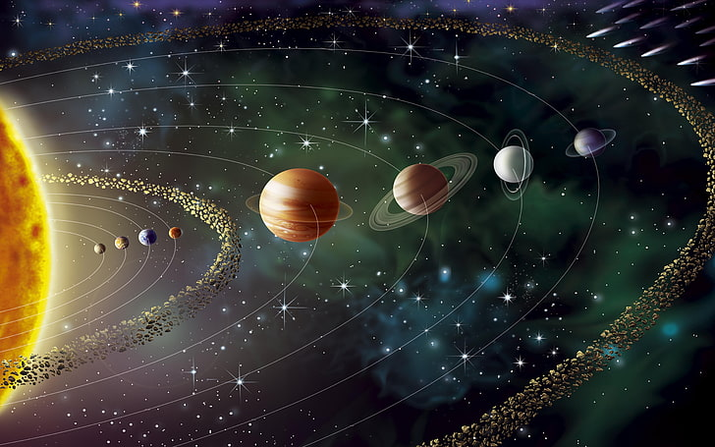

**Physical Development**

**PE: Invasion Games**

* Children will recap on the fundamental skills needed to play a range of invasion games, such as dribbling with a ball, passing and keeping possession.

**Creative Development**

**Art: I need Space – children will work towards creating their own space themed media**

**Music:** to listen and appraise the Song Happy by Pharrell Williams and develop skills and knowledge of rhythm, pitch, tempo and pulse.

**SScientific Development**

**Science: Earth and Space**

* Phases of the moon
* Order and features of the planets within the solar system
* Day & night

**ICT:** Online Safety - Children will learn what a digital footprint is; how to keep safe whilst playing games as well as appropriate use of social media.