Moving to

Secondary School

A transition workbook for Pupils in Year 6 Term 6

Name:……………………………………………………………………………………..

Introduction

Now that you are in Year 6, you will be starting to think about moving up to secondary school. This can be a very exciting time. Sometimes you might feel a little bit sad or worried. Try not to worry about anything as staff will always be there to help you.

This booklet will help you to find out about your new school.
You will probably have lots of questions that you would like to ask
about secondary school and this booklet will help to answer those.

My last day at Primary School is…………………………………………………
My first day at Secondary School is …………………………………………

Things that I have really enjoyed at Primary school:
………………………………………………………………………………………………………………………………………………………………………………………………………………………………………………………………………………………………………………………………………………………………………………………………………………………………………………………………………………………………………………………………………………………………………………………………………………………………………………………………………………………………………………………………………………………………………………………………………………………………………………………………………………………………………………………………………………………………………………………………………………….

Facts about your secondary school

What is the name of the secondary school you are going to?
……………………………………………………………………………………………………………………….

See if you can find the school website to answer these questions.

Write down the website address
………………………………………………………………………………………………………………………

What is the name of the Head teacher ?
………………………………………………………………………….

What is the school address ?
…………………………………………………………………………………………………………………………

What is the school telephone number ?..................................................

How many pupils are at the school ?........................................................

What are the specialist subjects at this school?

………………………………………………………………………………………………………………………...
What is the school badge, crest or emblem? Draw it on the next page. Write their motto if they have one too.

My School Badge

Motto:..................................................................................................

Getting to school and home again

This is often a big worry at first but you will soon get used to it. Many people have to travel further to get to secondary school. It is good to have a little practice in the summer holiday with your parents or a friend. Some people like to meet with friends at an agreed time and place to travel together each day.

How will you travel to secondary school?

Walk cycle car minibus bus taxi scooter

What time does school start?

Which door will you go in when you arrive at school?
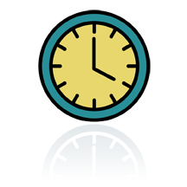
What time will you need to leave your house?

What time will you need to get up?

What time does school finish each day?

Knowing the way

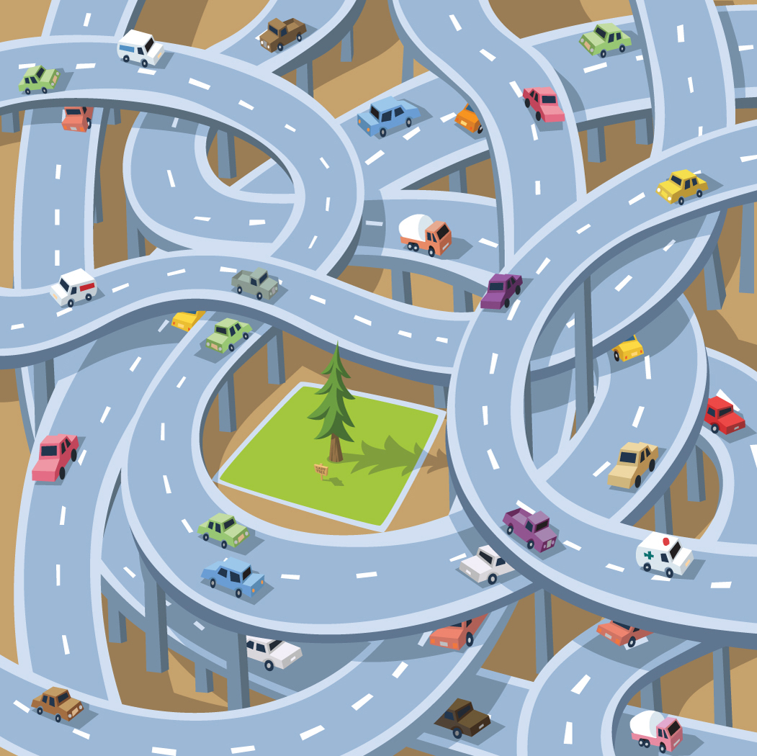
Try to write directions explaining how you will get from your house to your new school or to the bus stop. Draw a map or colour in your route on a local street map. Don’t forget to time how long this will take you and have a few practice runs in the holiday.

The school day is very busy. This is what usually happens each day



8.40-9.00am | Registration in Tutor time or Assemblies with your From Tutor  Assemblies are held twice a week  Student planners are checked every week  Uniform is checked everyday  Attendance and Behaviour are discussed
9.00-10.00 am | Period 1
10.00-11.00am | Period 2
11.00-11.20 | BREAK TIME
11.20-12.20 | Period 3
12.20-1.20 | Period 4
1..20-2.00 | LUNCH TIME
2.00-3.00 | Period 5
Home time | At 3.00 it is time to go home, or you may stay behind for some extra-curricular activities. A list of these will be provided in your form room. You may also be able to stay behind to complete homework and use the library. You may be asked to stay at school to complete work with teachers that perhaps you should have completed at another time. Buses will leave from outside school.

Same and different

Many of the things you do in primary school will be very similar in secondary school but because you are more grown up they will be slightly different. Can you guess and write down what might be different about these things in secondary school?

uniform
lunchtimes
playtimes
teacher
friends
lessons
homework
classrooms

Discuss other things that might be the same or different.

School Uniform

Cut out and stick a picture/draw the uniform that you will wear to secondary school each day (you will find this in the prospectus online)

Most secondary schools have special PE kits too.
Can you find out what you might need to wear for
different sports lessons? Stick/draw a picture of them here.

Find out if you will need to wear anything special in other lessons such as science or design technology

There will be times when you may need some help. Here’s a list of what to do if….

What if…

- I am late ---------------Go to Head Of Year and sign in, or go to reception

- I have lost something------Go to reception ( remember to name all of your belongings so that they are easy to identify)

- I feel ill---------- Tell your teacher

- I have forgotten my homework—be honest with your teacher, it’s always the best thing to do

- I have forgotten some equipment--- tell your teacher at the beginning of the lesson

Some Questions that you may have….

My Questions

Try to find the answers to your questions on the school website or make a list to discuss with your peers and staff .

Some General Questions that many people ask

How many pupils will there be in my Tutor Group?

Tutor groups average 30 students per form

How will I be rewarded at school?

Many schools operate a house point system, where students are rewarded for hard work, positive contributions and achievement. Celebration certificates, postcards and letters are also sent home

How much homework will I get?

There will be a timetable for homework so that you don’t get too much on one night. On average there will be about 1 hour.

Mobile Phones

These are not allowed to be used in school and should be switched off on arrival at school and not switched on until you have left. Your phone may be confiscated if you are caught using it outside of these times

Most secondary schools have houses.
Find out about them online

When you join Secondary school you will be told which house you are in. If you have a sibling or family in the school, you will normally be placed in the same house.

There will be house meetings and competitions which you will be able to take part in to represent your house. You will be meeting and mixing with pupils from all of the different years which means that you will know lots more people in school, which is a good thing.

You can earn House Points for your work, these are recorded and personal awards given out each term. This will all contribute to your House total.

Find out about the House System in your new Secondary School

How many houses are there?

.......................................................................

What are the names of the houses?

………………………………………………………………………………………………………………………………………………………………………………………………………………………………………………………………………………………………………………………………………………………………………………

Each house usually has a colour or emblem, find out what these are

……………………………………………………………………………………………………………………………………………………………………………………………………………………………………………………………………………………………………………….…………………….

What are the House competitions in your school?

……………………………………………………………………………………………………………………………………………………………………………………………………………………………………………….……………………………………………………………………………………

Lunchtimes

Lunchtimes are often a bit later and shorter in secondary schools.
You can take a snack and drink to school each day in your school bag to eat at break time so that you don’t get too hungry.
You can take a packed lunch or you can buy something to eat in the dinner hall or ‘canteen’, which is a bit like a café.
Most schools have a cashless system and you will use your thumb or a cash card to buy food. School will tell your adults about this before you start to make sure that you have money to spend if your adults wish you to do so.
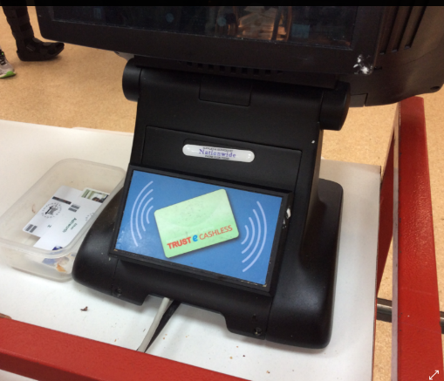
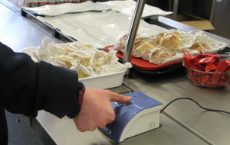

Visit the dinner hall and find out what sort of food they sell.
Different items will be available at break and lunch times.
Often there is a separate queue for Year 7 to make accessing the canteen easier for you.
You will have areas that you are allowed to eat your packed or cold lunch from the canteen. Hot lunches usually need to be eaten in the canteen.

Draw some of the food that you might choose to eat and write how much it costs.

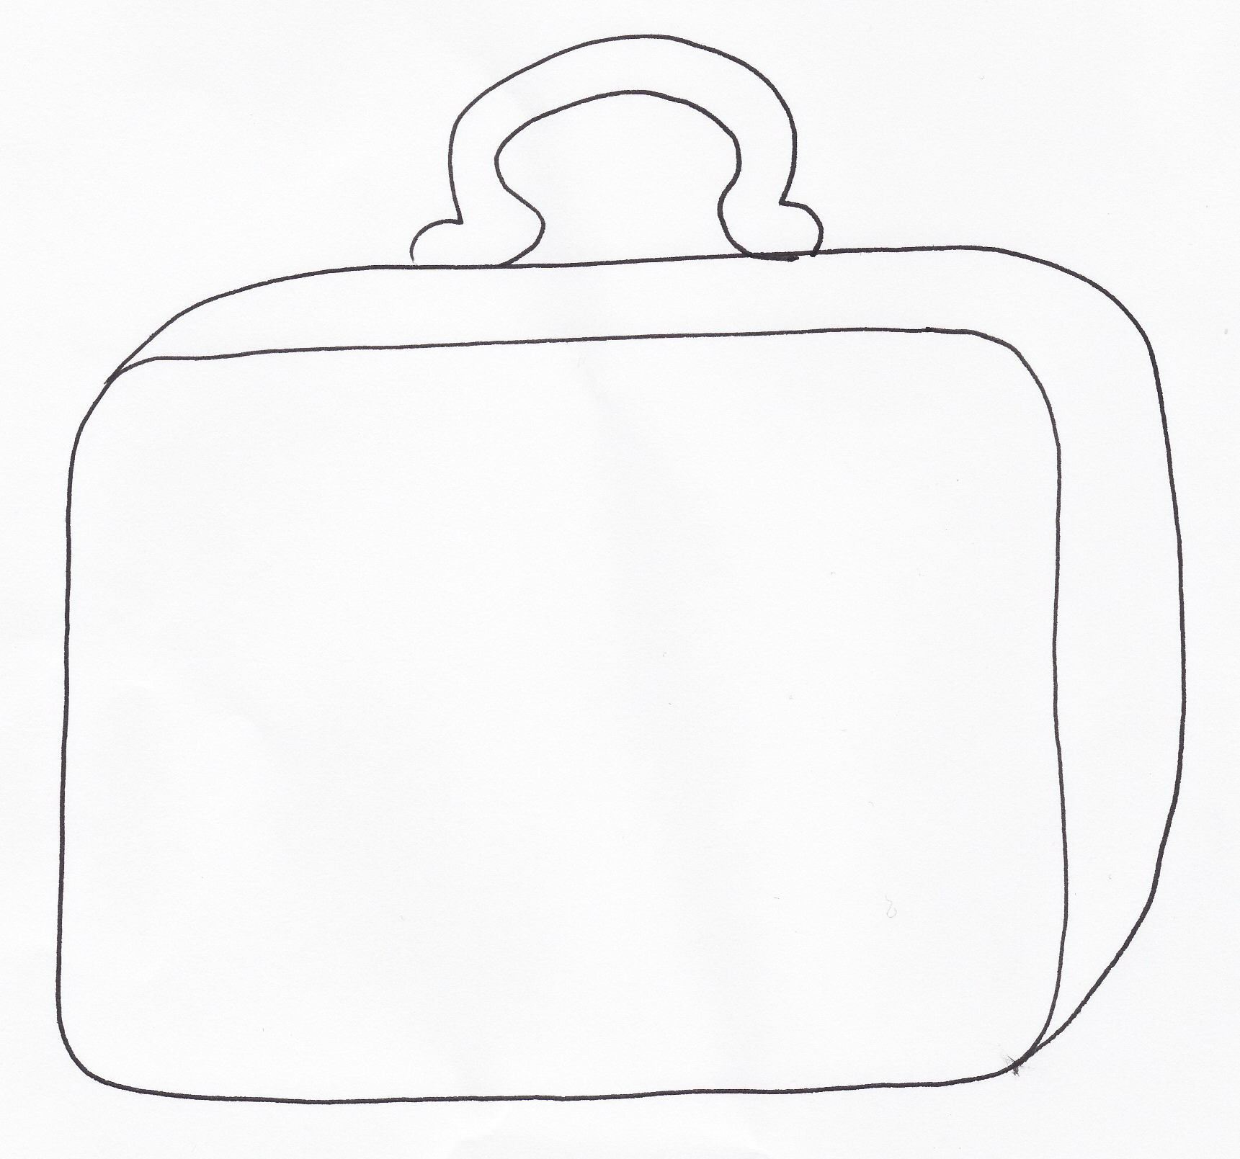

Lunch time starts at …… pm and
ends at …… pm.

The dining hall is called the ………………………………………………

Break and Lunchtimes

You will still have break and lunchtimes at Secondary School, but the timing may be different.
Think about how they will be the same and different and list some of these below.

SAME | DIFFERENT

Classrooms

At secondary school you meet in your form room or tutor group nearly every morning. This is the room that you will meet with your Form Tutor and the rest of your form for registration. Other mornings you will meet in assembly for registration.
The form room does not have a drawer or tray for you to keep your things in, or a cloakroom to hang your coats and bags because you do not stay in this same room for your lessons.
Most people carry all the things they need for the lessons that day in their school rucksack. Some schools have a locker that you can hire to keep some of your belongings in.
It is a good idea to pack your bag each night ready for the next day’s lessons so that you are not rushing in the morning and forgetting important items. There are some things that you will need in your bag everyday

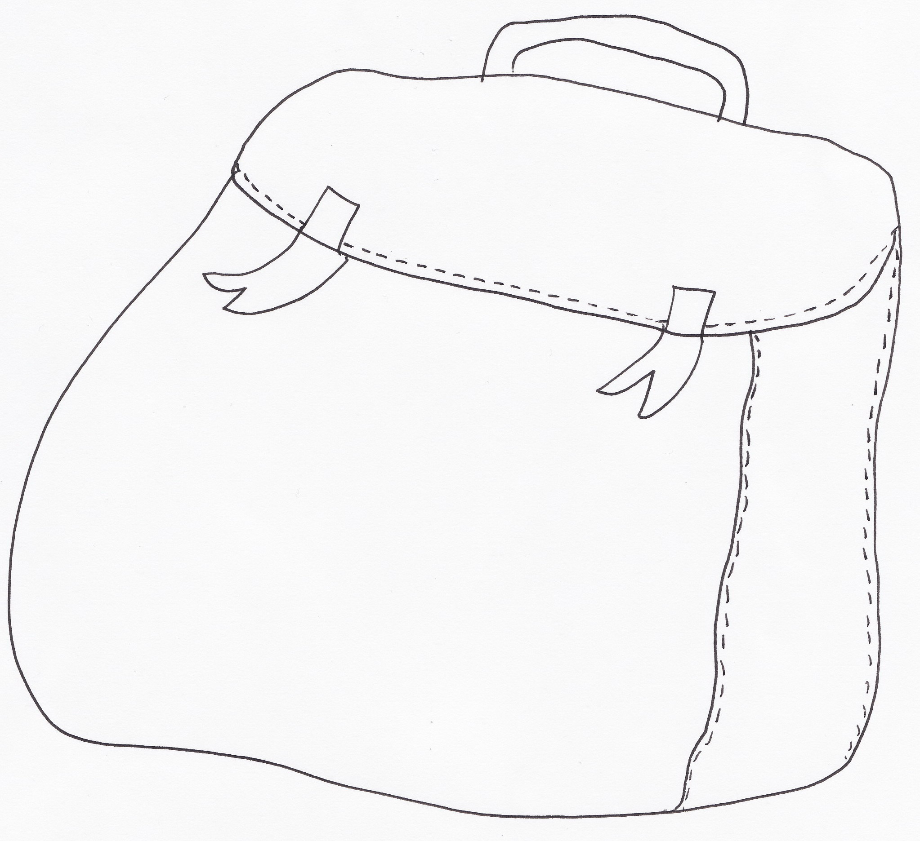

What things will you need to take to school everyday? Here is a useful checklist

Black ball point pen
Green pen
HB Pencils
Colouring Pencils
Pencil Case
Ruler
Glue Stick
Pencil Sharpener
Rubber
Calculator ( preferably Scientific)
English Dictionary (also possibly Foreign according to languages taught)
Reading Book
Student Record Book
Timetable
PE kit ( according to timetable)
Water Bottle
Packed Lunch ( if having)
Bus Pass ( if travelling by school bus)
Coat in colder weather
Mathematical equipment

Teachers

At primary school you usually have your own class teacher(s) who get to know you really well.

At secondary school you will have a form tutor instead. You meet with your form tutor every day at register times. Your form tutor will get to know you really well and usually stays the same every year. Your form (or class) will have a name, often starting with your year group number and some letters. You will probably meet your form tutor on your Transition days to your Secondary school.

At secondary school you will have different teachers to teach you each subject. Your form tutor will give you a list of their names in the first few days when you start secondary school.
Write down the names of the important staff who you will need to know on the next page. See if you can find a photograph of them on the school website

Important People

Head Teacher | Form Tutor
Head of Year | Reception Staff

Matron

Friends

If possible, your teacher will make sure that you are in a form with some of your friends when you move to secondary school. You will still be able to see your other friends at break and lunch times. You will also meet new friends from different primary schools. Everyone will probably be feeling a bit nervous at first.

What sort of things could you say to start making new friends? Write some ideas in the speech bubbles below.
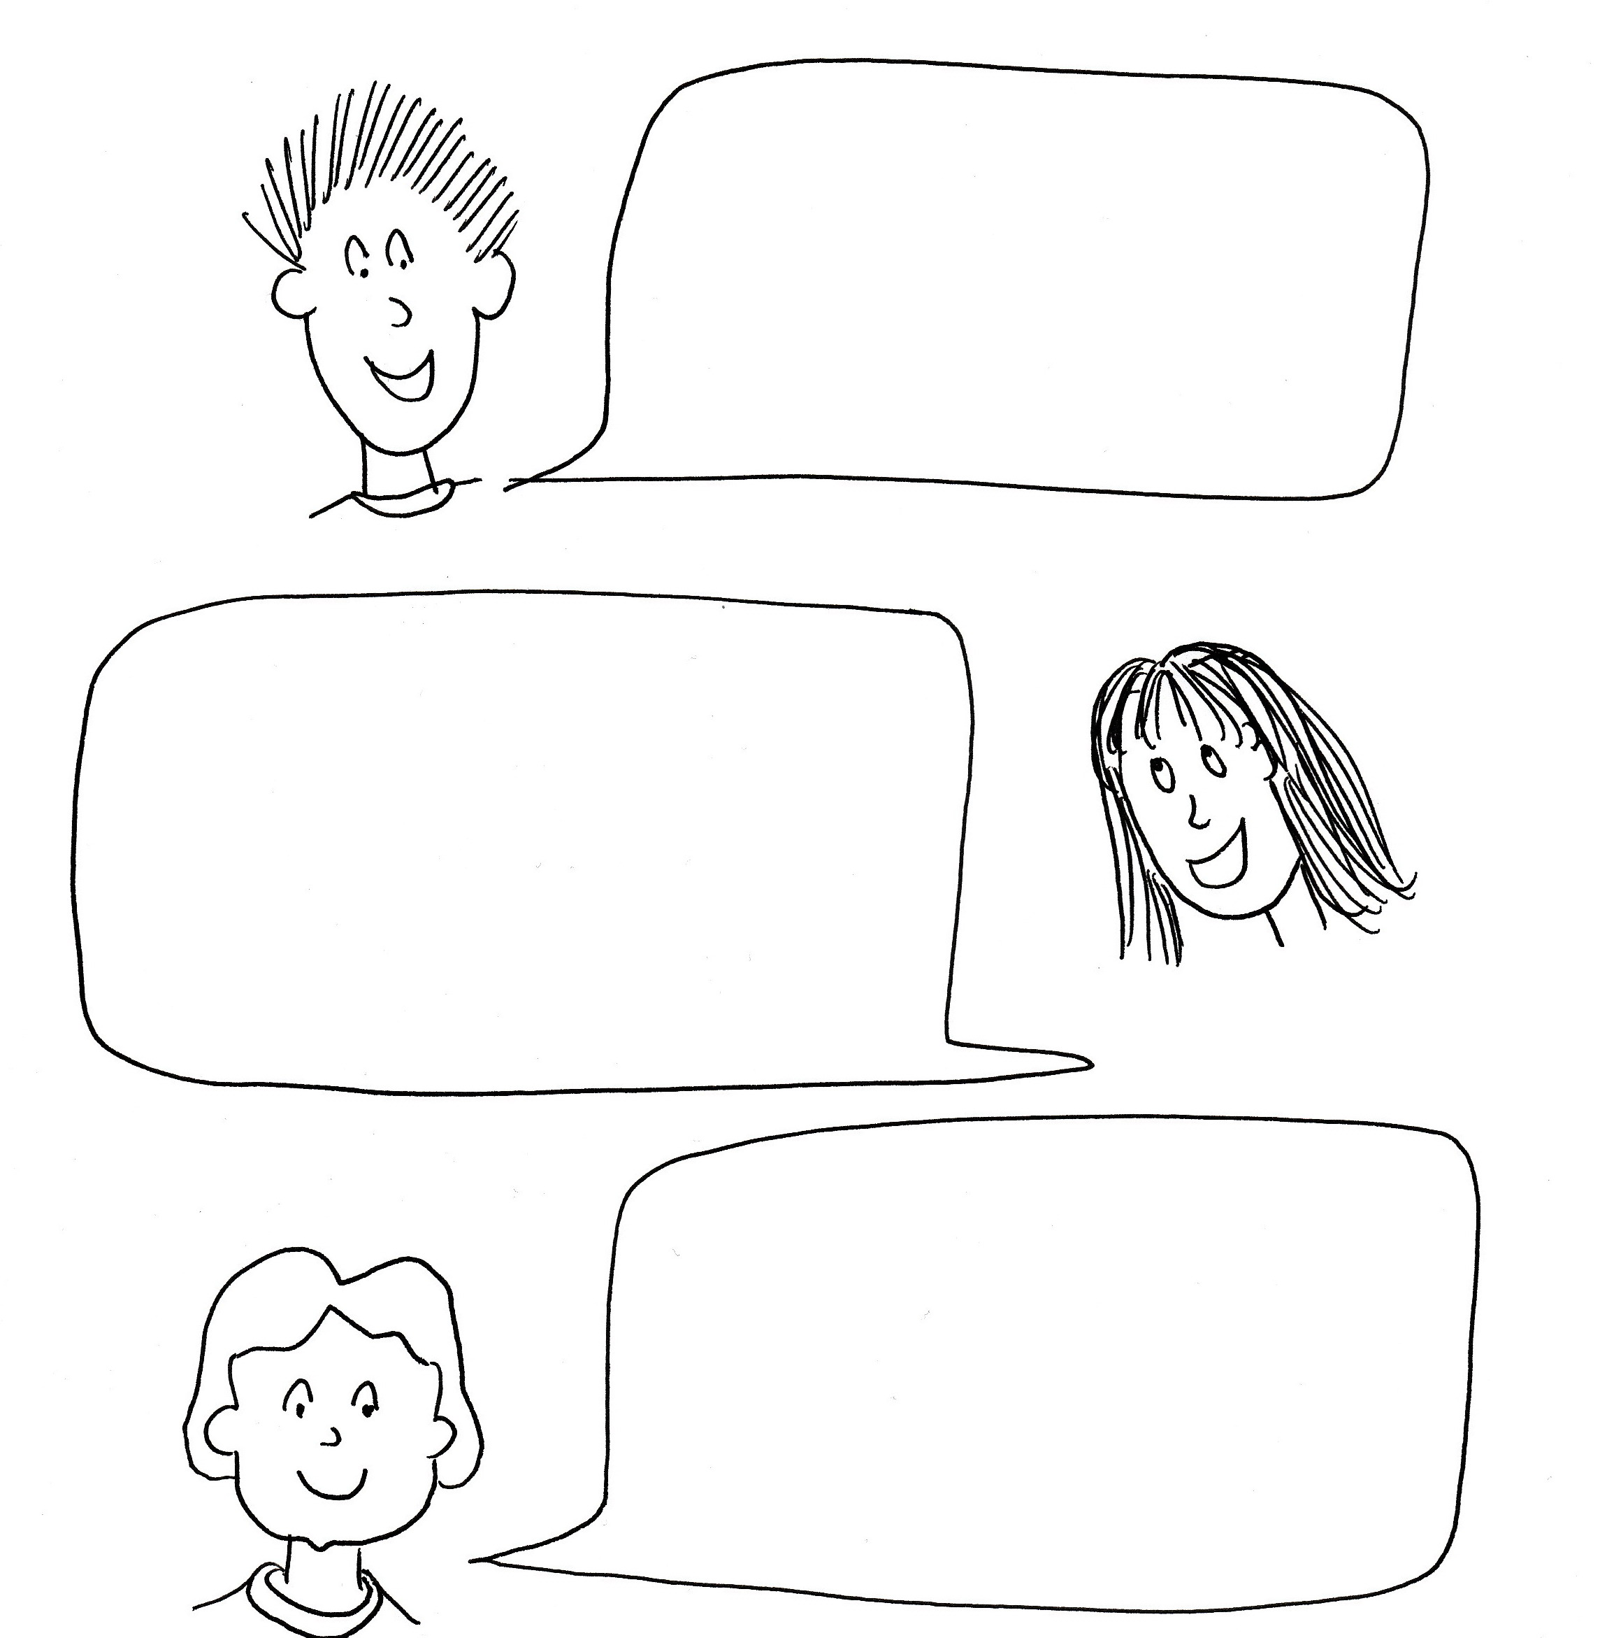
Joining In

There will be lots of different clubs and activities for you to try at secondary school.

Make a list of the sorts of things you are interested in or enjoy doing now;

- -
- -
- -
- -
- -

Find out what clubs or activities your secondary school have that would interest you and list them below.

- -
- -
- -
- -
- -

Lessons

Here are some of the lessons that you will have at Secondary School. Tick those that you think will be different to Primary School.
English |  | ICT |  | Science |  | Spanish
Maths |  | RE |  | General Studies |  | PSCHE
German |  | DT |  | French |  | History
Geography |  | Art |  | Music |  | PE
The good news is that you don’t have to do literacy and numeracy every day at secondary school! You will be given a timetable telling you which room to go to and which teacher will be teaching each lesson. You will have a 2 week timetable labelled A and B or weeks 1 and 2 .
In secondary school you usually have 5 lessons each day. They might be called periods now instead of lessons! Each period is about an hour long. You usually have period 1 and 2 then break, then period 3 and 4 then lunch and then period 5. A bell might sound at the end of each lesson. When told to do so, you then move to a different room with your group for your next lesson. Get a map of the school and a year 7 timetable. Practice finding different places and colour rooms on your map to match your lesson timetable.

My Map Of School

Homework

Your teachers will tell you what the homework is and when to hand it in. It is very important that you write it down or stick it into in your special book called a planner, student record book or an organiser. This
is a very important book and you will need to make sure that you have it in your school bag EVERY day. You must take care not to lose it because it will have lots of important information in it. Your parents will be asked to sign your planner every week and it is used for messages home too.
Most secondary schools have a homework club where you can go to do your work or get help from a teacher if you need it. Ask your form tutor about this. It will probably be a good idea for you to go to homework club every week so write it on your timetable when you get it. Getting your homework completed here will meant that you have more free time at home.
Homework club is on …………………………………………days)
at ………………………………………………………………………..(time)
in………………………………………………………..…..……….. (place)

School Rules

You will be given information about school rules. Many will be very similar to the ones you have at primary school.

It is important that you know what the rules are and what happens if you break them.

Discuss what might happen in the following situations;

- You forget to write homework in your planner and the teacher asks you why you haven’t handed it in.

- You haven’t got a pen to write with.

- You are told off for talking in class when you were trying to help someone.

- You forgot to bring your lunch money.

- You have a problem and you need to go to a quiet safe space or find someone to help you.

Write down important things that you will need to remember about your behaviour.

Exciting Times

There are many things to look forward to and feel excited about for September
Circle all of the things that you are looking forward to and add others that are personal to you:
- Making new friends
- Science experiments
- ICT lessons
- Technology
- Lunch time and after school clubs
- Learning new subjects
- Doing more of your favourite subject
- Being treated in a grown up way
- Having a bit more independence
- Having a range of different teachers
- Moving around between lessons
- Trying different sports
- Being involved in the music activities

Remember

Going to secondary school is like going on a big new adventure.

Enjoy your journey!



