Key Vocabulary
opportunities | Chances to do things.
stereotyping | Assuming someone will behave in a certain way because of a certain characteristic. This could be based on the way they look, the way they speak, where they come from or their gender.
attribute | A quality or feature someone or something has.
behaviour | Our actions. The way we behave.
growth mindset | The belief that we have the capacity to improve our talents and abilities through our effort and actions.
fixed mindset | The belief that people’s intelligence and abilities are set rather than flexible and progressive.
self-worth | How we feel about ourselves. Our successes, achievements and positive sense of self all contribute to our feelings of self-worth.
learning styles | How we experience different types of learning activities. The main learning styles are visual, audio and kinaesthetic.
failure | The sense of not achieving what we wanted to.
privilege | When people or groups get certain advantages over others.
setbacks | When something doesn’t go as we had planned.
obstacle | Something that is in the way.
motivation | The reason we do something.

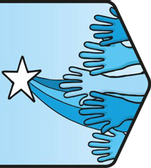
Living in the Wider World | Aiming High
Key Knowledge

Always Learning
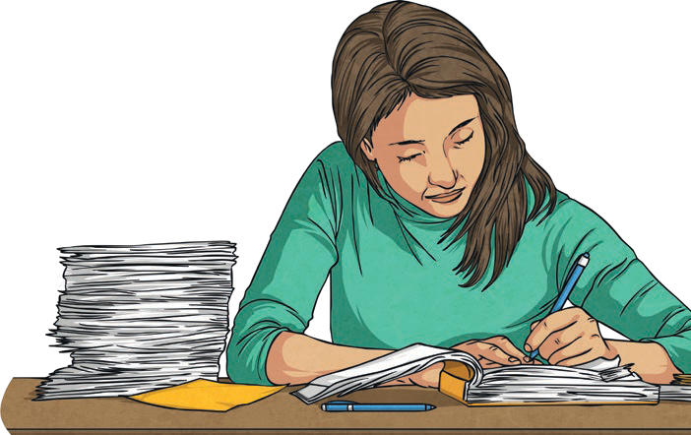
People are always learning. There may be different types of learning activities we feel we engage with more easily, such as using visuals, hearing instructions or moving around while we learn. We can all develop positive attitudes and behaviours for learning. These include watching others and seeing what go
es well, practising and llowing instructions,
t past experience, nt strategies if esn’t work, asking ng feedback on
nd
persevering, fo thinking abou trying differe something do for help, getti our progress a learning how to improve.
PSHE and Citizenship | Aiming High

Overcoming Obstacles
Sometimes, we face barriers to success. These may be in the form of things we can work to overcome, such as being frightened of making mistakes, not yet knowing how to do something or not asking for help when we need it. There are also barriers that some people face because others have the advantage of privilege. This is when people or groups are advantaged and it means that people don’t receive equal opportunities. It is important to be aware of privilege and strive to understand the different experiences people go through when working to achieve something. We can also make others aware of where we see privilege. By identifying and raising awareness of this, we can stand against unfair treatment, privilege and
unequal opportunity.

Seizing the Opportunity
There are many things we get the opportunity to do and many more that we can make opportunities for ourselves to do. It is good to take opportunities as they arise for many reasons: the opportunity might not arise again, it’s a chance to try something new, we might gain confidence from it, we might get further opportunity, we may succeed and we might gain further independence.

Future Careers
There are many different jobs available and people can choose what they do based on their interests, strengths and experience. Within most jobs, there are certain skills that can be useful that we may already be making good progress with. These include:
positivity, decision-making, teamwork, listening to others, creativity, problem-solving and presenting ideas.

Aim for Your Goal
We are each unique and because of this, we have different interests and strengths. We will also have different aims and goals that we would like to achieve. It can help to create a sense of purpose and achievement by identifying steps we can take to achieve our goals. It is important to view everyone’s personal interests and goals with kindness and respect.

Opportunities for All
Jobs and career choices should be available to anyone and are informed by the skills, interests and experience of the person applying for the position - not their gender, background or how they choose
to live their life. In the past, men and women have unfairly been paid different amounts for doing the same job and stereotypes have meant that people had certain expectations of the type of person who would do different jobs. We are working together towards a more equal society where we should expect career opportunities to be available to all and informed by our personal strengths, interests and qualifications rather than information about our characteristics.

Key Learning Point:
Career Choices
There are many career choices available to us and a variety of routes available into different jobs. This is exciting because we can find a job that appeals to our interests. It is important that people are valued in their employment because of their strengths, interests and experience and that opportunities are equally available to all. By acknowledging our strengths and allowing these to contribute to our sense of self- worth, we can support our own self-esteem. We can also identify areas we would like to improve and approach opportunities for learning with a growth mindset.

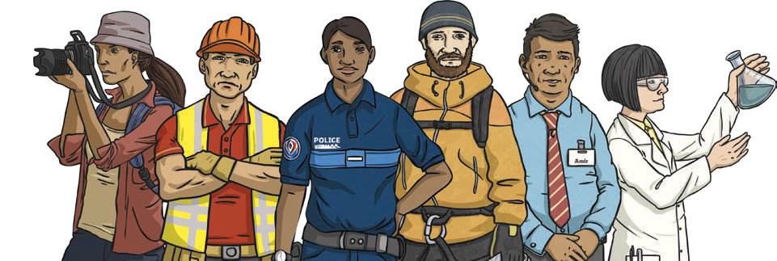
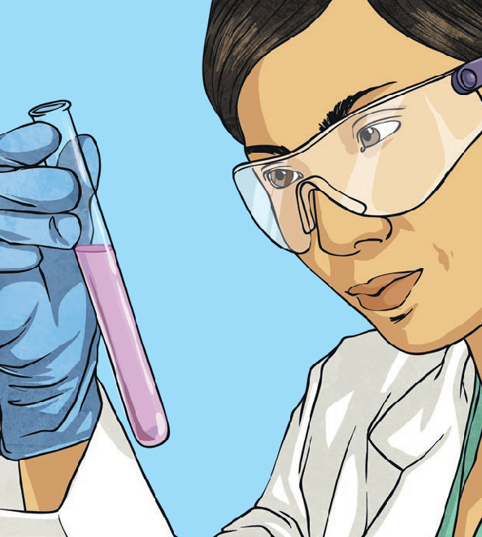
twinkl.com

To look at all the planning resources linked to the UKS2 Aiming High unit, click here.

This resource is fully in line with the Learning Outcomes and Core Themes outlined in the PSHE Association Programme of Study.

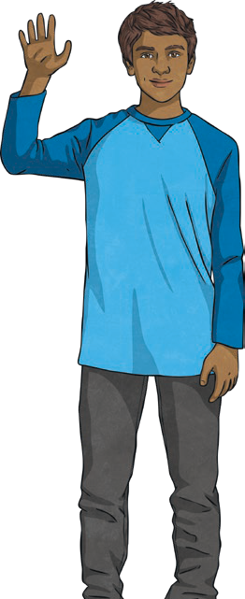
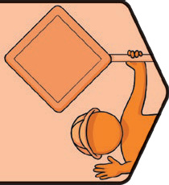
Key Vocabulary
choice: | Something we have the power to make when there is more than one possibility.
danger: | Something which can cause harm, injury or suffering.
dare: | A challenge given by someone. Dares can put pressure on someone to do something that could put them  in danger.
drugs: | A medicine or other substances which affect the body when taken. There are legal (allowed by law) and illegal (not allowed by law) drugs.
emergency: | A serious and often dangerous situation. People in  emergency situations need help straight away.
first aid: | The first help given straight away to someone who is ill or injured.
hazard: | Something that could cause harm or danger.
medicine: | A drug or other remedy to treat, help or prevent illness.
peer pressure: | The pressure people can feel to behave in a certain way because their friends or people they spend time with expect it.
responsibility | The control we have over our actions and choices.
risk: | A possibility of danger or harm.
safety: | Being protected or kept safe from danger, risk or harm.
wellbeing: | How comfortable, happy and healthy we feel and how able we are to cope with daily life.
social media: | Websites and applications where people can share images and comments and join online communities.

Health and Wellbeing | Safety First | UKS2
Key Knowledge

Responsibilities
As we grow older, we become more independent. This means it is our responsibility to help to keep ourselves and others safe. We can do this by making informed choices about how to behave and what to do.
These informed choices can help keep us physically and mentally well. We can make informed choices by thinking about past experiences, what we have been taught and what we understand to be safe.
We can then decide what we do, where we go, who we spend time with, what we eat and drink, what we watch and how we spend time online.
PSHE and Citizenship | Safety First

Managing Risk
We need to understand the hazards, risks and dangers that may be around us so we can make decisions about what we do. The risk of a hazard or a danger causing us harm can be small or large, so knowing how to assess risks and how great the risks are is very helpful. Our brain is often able
to subconsciously assess situations which we are familiar with, such as staying safe near roads, avoiding hot objects and staying with our trusted grown-ups. When a situation is new we can assess hazards, risks or dangers based on our past experience and on what we have been told by our trusted adults and support network. If we feel we are in a situation which makes us uncomfortable and carries risk of
harm or danger, it is important we stop, listen to our feelings, think about what to do and make an informed decision. It is important to get help from a trusted adult if we find ourselves in a risky situation.

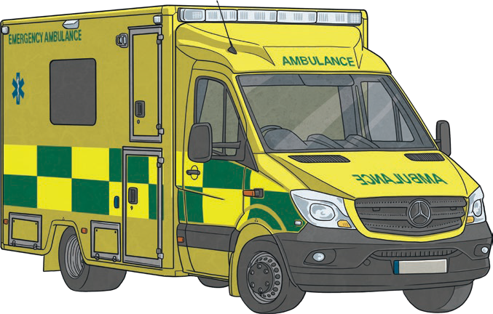
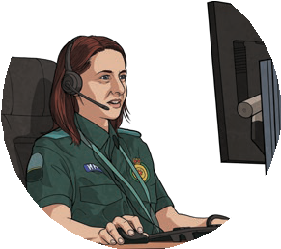
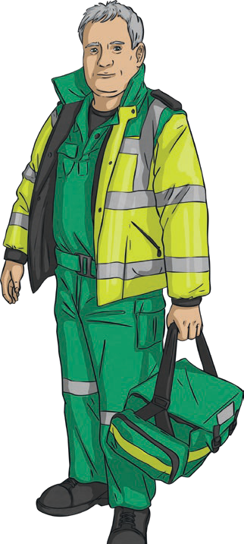
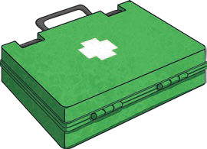
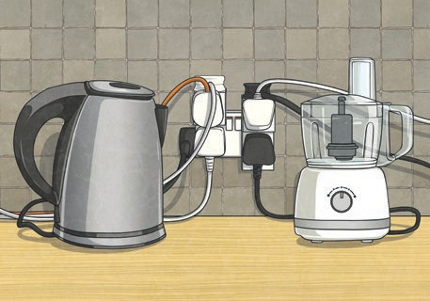
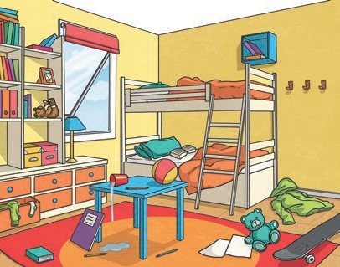
Pressure
twinkl.com
Sometimes we may feel pressure to behave in a certain way or do a certain thing. We may even be challenged to do something - this is called a dare. Relationships that make us feel pressured can make us unhappy and affect our mental health and wellbeing. Being able to identify and understand this can help. Pressure
can come from lots of places including friends, other children, advertisements, the media, social media or older children. Sometimes, people feel pressured to make choices they know are not right or not safe. This can put them in danger.
Although these situations can be difficult, it is important to remember that the brave and mature thing to do is to say no, listen to our instincts and get help from a trusted adult.

Emergencies
If someone is hurt, it is important they get the help they need quickly. This might mean getting help from a trusted adult or calling the emergency services
on 999 or 112. We can learn to recognise an emergency situation and respond appropriately. After checking if it is safe to help
a casualty, we should follow DR ABC. To do this we need to assess the danger and check for hazards, try to get a response from the casualty, check their
airways, see if they are breathing and check their circulation to see if they are bleeding. Some minor injuries can be treated through first aid.

Safety Around the Home
Around the home we can make safe choices by understanding and assessing risks. For example, many household cleaning products found in kitchens and bathrooms contain chemicals so they must be stored out of the reach of children and only be used by adults.
Medicines should always be stored safely and must only be used by the person they are prescribed for. There may be other hazards we notice as well. We can take action to remove or alter and reduce the risk of hazards we notice. This might mean we put things away, switch off electrical appliances or follow usage instructions.
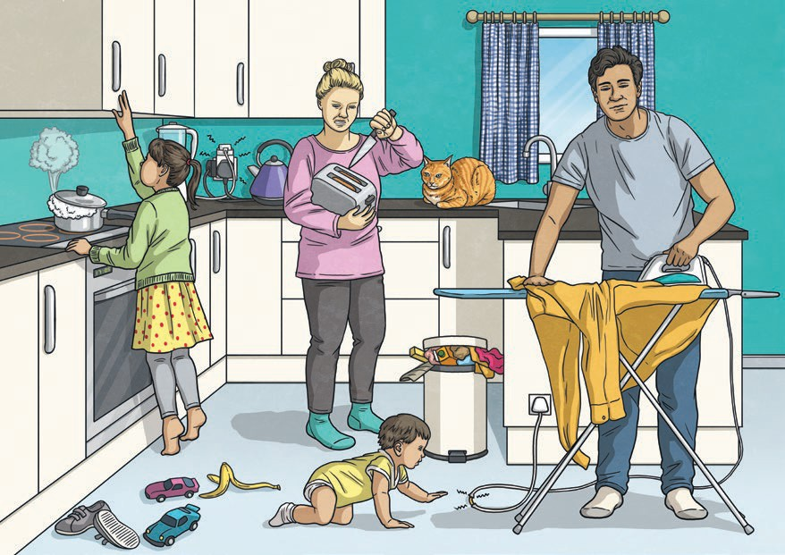

Staying Safe While Out and About
There are lots of ways we can help to keep ourselves safe when we are out and about. We can learn to assess risk and make responsible choices about how we behave. When near roads, we can walk sensibly and only cross at a safe place, taking time to think, stop, look, listen, then cross if it is safe. If we are cycling, we must always wear a helmet and cycle in the correct place on roads or footpaths. When using a railway, we can stand behind the yellow line on the platform, stand clear of closing doors, never try to get anything that has fallen on the track and instead, tell a member of station staff. If using a level crossing, we must stand clear if lights flash or alarms sound and only cross when this stops. To stay safe near water we can learn to swim, stay at a depth we can easily stand, use a floatation device if we cannot swim and understand what different colour flags mean when swimming in the sea. When spending time around water, we should walk and not run and use a lifejacket if asked to. To stay safe with fireworks, we can keep a safe distance from any display, wear gloves when holding sparklers and never return to fireworks when lit.

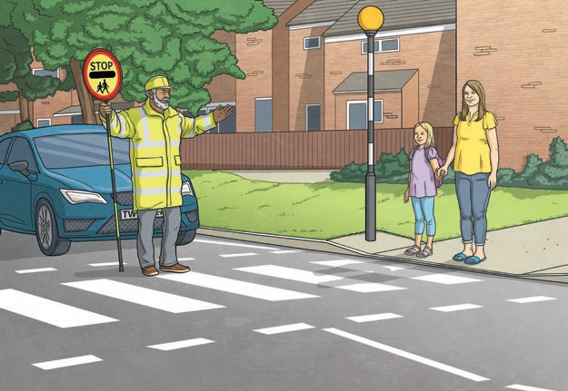 | 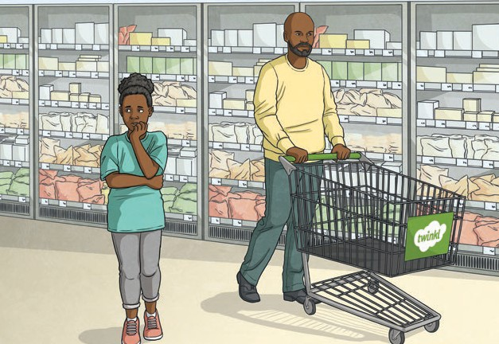

Key Learning Point: Keeping Ourselves and Others Safe
As we get older we may be given more independence. This means we can help by taking responsibility for keeping ourselves safe and making choices that help others too. To help keep everyone safe, we can:
- understand how to assess risks;
- consider whether the risks are large or small;
- identify if there is anything we can do to reduce or alter the risks we see;
- think about our past experience of this risk;
- make safe informed choices based on what we know and all we have learnt;
- get help from a trusted adult if we need.

Disclaimer
We hope you find the information on our website and resources useful. This resource is provided for informational or educational purposes only. It is intended to offer general first aid advice and is not a substitute for professional medical advice specific to your circumstances. As first aid advice is situation-specific and can change, we do not warrant that the information provided is correct or will meet your or your students’ specific health or medical require- ments. You and your students should not rely on the material included within this resource and we do not accept any responsibility if you or your students do. It is up to you to contact a suitably qualified health professional if you are concerned about your health and it is up to you to advise your students to contact a suitably qualified health professional if they are concerned about their health.

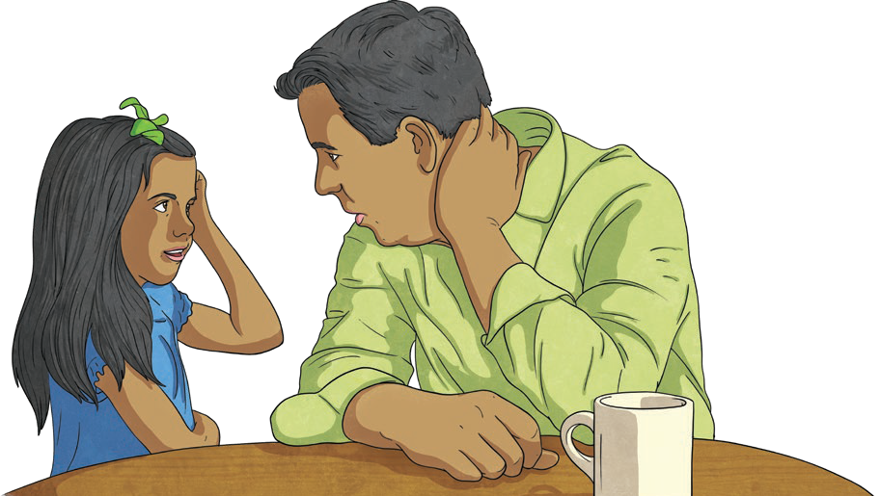
twinkl.com
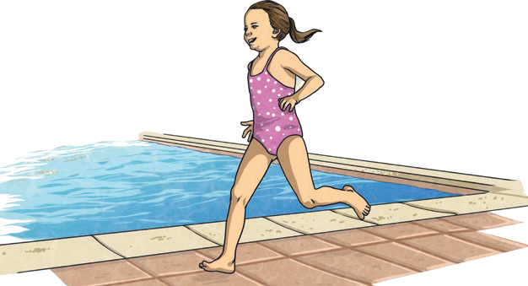
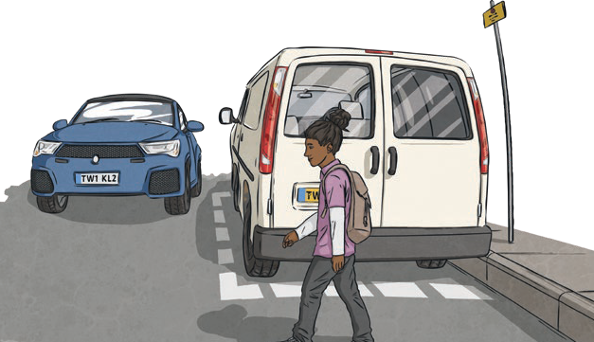
This resource is fully in line with the Learning Outcomes and Core Themes outlined in the PSHE Association Programme of Study.

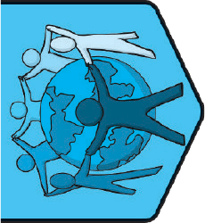
Relationships | VIPs
Key Vocabulary
support network: | A group of people we can rely on to provide practical and emotional help.
strategies: | Ways we can work through or manage something.
resolution: | A solution to a problem.
conflict: | An argument or disagreement between two or more people.
disagree: | When people express different opinions.
pressure: | A strong influence people feel to behave in a certain way.
influence: | Things that affect the choices and decisions we make.
ecosystem: | Our actions. The way we behave.
VIP(s): | Very Important Person(s).
confidential: | Something that someone is asking us to keep private.

Key Knowledge

Loving Relationships
People can be part of many different relationships. These might be friendships, relationships within families, romantic relationships, online friendships and also the relationship we have with ourselves. Different people may choose to be in different relationships and this must be respected. The way we feel love in the various relationships we are part of may feel different, but it is important we feel safe, secure and cared for. If any of our relationships make us feel uncomfortable emotions, it is important that we talk to someone in our support network for help.
PSHE and Citizenship | Relationships | VIPs

Processing Big Emotions
There are some emotions we may experience which could be particularly big or particularly uncomfortable. When this happens, it can help to have some calming strategies we know will help. These may include breathing slowly and deeply, sitting or lying in a relaxing position, practising mindfulness, listening to or playing music, squeezing a ball or toy, exercising or thinking positively.

Disagreeing Respectfully
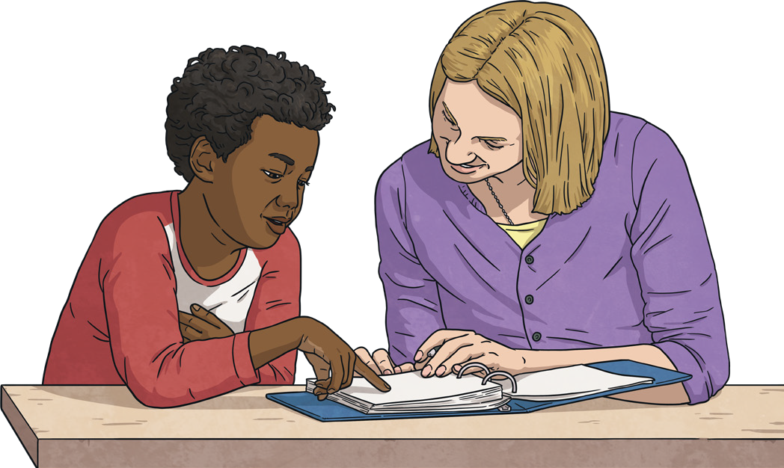
We are part of many different relationships and within these we will share our opinions with lots of different people. We do not need to always think the same as our VIPs, so our opinions on certain topics may be different. When we have an opinion that is different from someone else’s, we can share our ideas in a respectful way that acknowledges the other person’s view but makes our opinion clear too. We can do this by using kind words and a calm tone and in a way that shows respect for the views of others. It is important
to show each other respect, politeness and honesty while valuing the different opinions we each have.

Feeling Pressured
There are many influences on the choices we make and although these can be positive, sometimes we may feel pressured to make choices that make us feel uncomfortable. It is important we make our own decisions and do not feel pressured by others. If we experience pressure, it can help to remember the pressure we are feeling isn’t our fault, to think about how we can get out of the situation that is making us feel pressured, to trust our instincts about the situation we are in and if it feels wrong, get to a place we feel safe. It is very important to speak to a trusted adult to get help.
Unhealthy Relationships Although every relationship has ups and downs, most healthy relationships can be worked on and help the people in the relationship to feel good. If a relationship isn’t helping both people to feel good, the relationship may
be unhealthy. A relationship may be unhealthy if one person expects too
much from the other, if one person is in control of the relationship or of the other person, if someone is made to feel bad about themselves or if one person is jealous of the other. If we notice any relationship we are in, or one of our VIPs is in, is unhealthy, it is important to speak to a trusted adult and get help.

Secrets and Surprises
Sometimes we might be told something in confidence. This means
someone is asking us to keep a secret for them. If this is something

Key Learning Point Showing Love to Our VIPs
Healthy loving relationships should make people in them feel safe,
secure and cared for. We should feel respected and valued. There are many ways we can show our love to people we care about, and many ways people who care about us can show their love too. These include:

that we feel comfortable with, it is OK. Sometimes we might be asked to keep a secret that someone will soon find out, and when they do, that person will feel comfortable emotions. If anyone asks us to keep a secret that involves someone being hurt, upset or doing something they shouldn’t, it is important to speak to a trusted adult straight away to make sure everyone stays safe and happy. If any secrets we are asked to keep make us feel worried, anxious or uncomfortable emotions, it is important to speak to a trusted adult straight away.
  - giving each other our time;
  - valuing someone’s interests and passions;
  - showing patience;
  - showing kindness;
  - accepting each other’s point of view;
  - valuing our differences;
  - compromising when needed;
  - showing commitment and loyalty to the relationship;
  - being honest;
  - showing understanding.

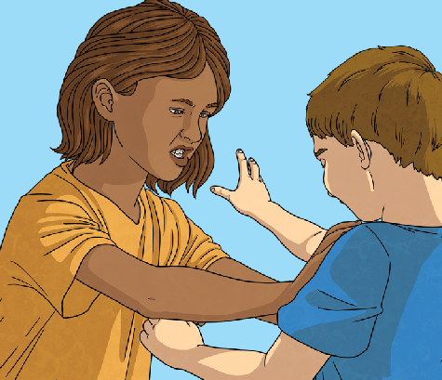
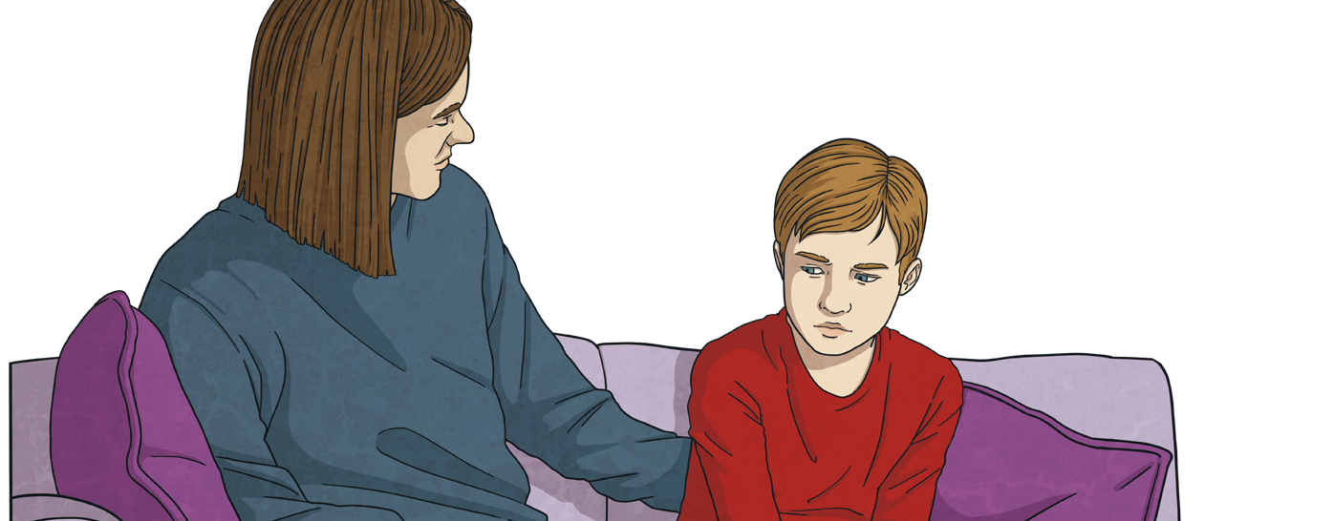
twinkl.com
To look at all the planning resources linked to the UKS2 One World unit click here
This resource is provided for informational and educational purposes only. You must ensure that an adequate risk assessment is carried out prior to using this resource. It is your responsibility to ensure that the information/activity this resource contains are safe and appropriate to use in your situation.

This resource is fully in line with the Learning Outcomes and Core Themes outlined in the PSHE Association Programme of Study.

twinkl.com
Disclaimer
This resource is provided for informational and educational purposes only and does not constitute mental health advice. If you require mental health advice, you should contact a suitably qualified professional. You should not rely on the material included within this resource and Twinkl does not accept any responsibility if you do.

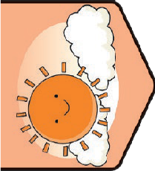
Health and Wellbeing | Think Positive
Key Vocabulary
feelings | Emotions we experience about things that are happening.
behaviour | Our actions. The way we behave.
cognitive | Thinking and other mental processes.
mindfulness | Focusing on the present and what we are feeling, seeing and doing right now.
opportunities | Chances to do things.
challenge | Something we may find tricky but that we can work to do well at.
resilience | Trying again and continuing to persevere when we find something difficult.
reaction | Our behaviour or feelings in response to something that happens.
growth mindset | The belief that we have the capacity to  improve our talents and abilities through our effort and actions.

Key Knowledge
Thoughts, Feelings and Behaviour
The thoughts we have can affect our feelings and our behaviour. This can have an impact on the people around us as well. Understanding whether our thoughts are helpful or unhelpful can help us to consider the reactions we may have to them, such as our feelings and behaviour. Turning unhelpful thoughts into helpful thoughts can have a positive effect on ourselves and others.
Positive Mental Attitude
If people experience unhelpful thoughts, they can use a worry doll or monster, share their worries with someone they trust, write them down in a thought journal or talk back to them. To help ourselves develop a
PSHE and Citizenship | Think Positive
positive mental attitude, we can eat a healthy balance of foods, get plenty of exercise, get enough sleep and drink lots of water. Doing things we enjoy can also help us to develop a positive mental attitude. This might include playing with a pet, seeing friends and family, playing games or getting outside in the fresh air. It can also help to laugh, help others and start the day with a positive thought.
Feelings and Emotions
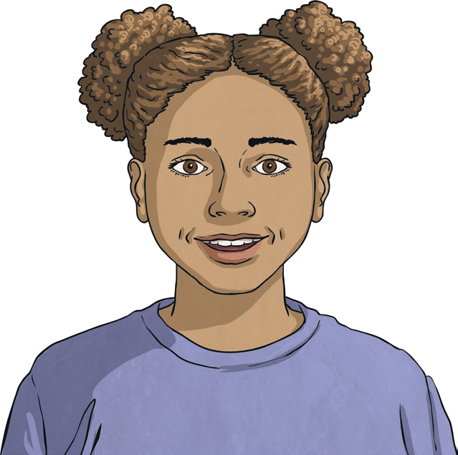
It is helpful to understand the many different feelings and emotions we
may experience. This can help us process them and talk about them with others. Some emotions are comfortable whereas some may be uncomfortable. If we are experiencing uncomfortable emotions, it can help to talk to a trusted adult and get help. It can also help to take some deep breaths,
count to ten, listen to music, spend time with friends, family or a pet, or talk to someone you trust about how you are feeling.
Making an Informed Choice
It is important we get as much information as we can if we are to make an informed choice. This might mean thinking carefully about what the ‘right’ thing to do is, asking for advice from people we trust, thinking about a similar decision we have had to make in the past, considering who will be affected by our decisions, how they will be affected and whether the decision is the safe choice.

twinkl.com
Using Mindfulness
Our minds have to process a lot of information. There are many sights, sounds, feelings, sensations, thoughts and decisions we have to work through all of the time. If we use mindfulness, we can be aware of our surroundings and consider our thoughts, feelings and the sensations our body is experiencing. Mindfulness helps us talk back to unhelpful thoughts, it can help us to form better relationships with those around us by improving our communication and listening skills, it can help us to feel grateful by focusing on what we have and it can provide a calm focused time in a busy day.
Facing a Challenge
There are lots of ways we can help ourselves when we face challenges. By thinking positively, we can support ourselves to achieve, such as by thinking about how proud we will feel when we have overcome the challenge, thinking about the qualities of ours the challenge will strengthen, observing others and learning from what goes well for them, trying different strategies, asking questions and researching, being patient with ourselves and celebrating the effort we have put in.
Key Learning Point:
Developing a Growth Mindset
Having a growth mindset means we believe that with a positive attitude towards our learning and with hard work, we can achieve our goals. To develop a growth mindset, we need to:
- ask questions to learn more;
- learn from the success of others;
- use feedback to improve;
- overcome obstacles;
- embrace new challenges;
- learn from mistakes;
- problem-solve;
- keep trying;
- show determination;
- believe in ourselves.
To look at all the planning resources linked to the UKS2 Think Positive unit, click here.
This resource is fully in line with the Learning Outcomes and Core Themes outlined in the PSHE Association Programme of Study.

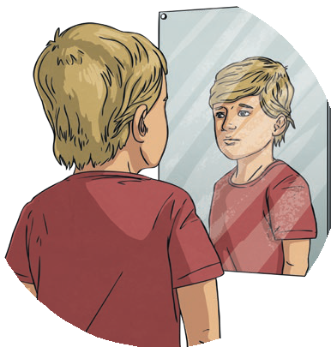
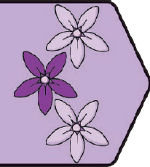
Key Vocabulary
unique: | The quality of being individual and unlike anything else.
opinion: | The way we feel and the ideas we share about certain issues.
belonging: | Feeling like we are part of a group or shared understanding.
respect: | A way of treating or thinking about someone that shows they are important and they are valued.
individuality: | Special features about us, who we are and the fact that we are special and unique.
feelings: | Emotions we experience about things that are happening.
emotions: | The way we feel about things that are happening.
uncomfortable: | Something we feel isn’t OK or that makes us feel unsettled.
comfortable: | Something that we feel is OK or that helps us to feel settled.
confidence: | Feeling good about ourselves or something we are doing.
setbacks: | When something doesn’t go as we had planned.
perceived failures: | When we feel that we have not done as well as we had hoped we would.
peer pressure: | The pressure people can feel to behave in a certain way because their friends or people they spend time with expect it.
tricky situations: | A situation which makes us feel uncomfortable or pressured to do something that we feel is not right.

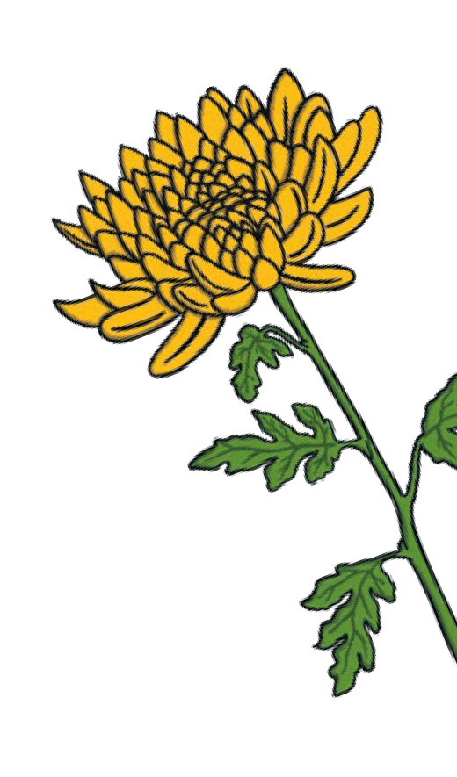
Relationships | Be Yourself
Key Knowledge

Being Ourselves
It is important to show self-respect by staying true to ourselves when we share our opinions and ideas. If we are among people who share a different view from ours, we may experience
pressure to say or behave in a certain way to fit in. However, sharing our own differing views and opinions in kind, respectful ways allows us to maintain our self-identity and demonstrate the ways we are all unique. This is part
of what makes the world
PSHE and Citizenship | Be Yourself
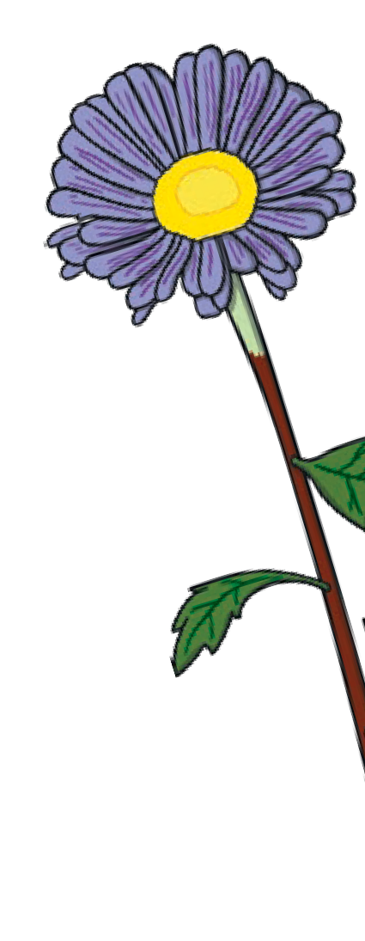
an exciting place and should be respected
and celebrated.

Sharing Our Feelings We each experience many different things each day and will feel differently from
others about these. Some of the things we experience will make us
feel comfortable emotions and some may make us feel uncomfortable emotions. By understanding what feelings we are experiencing, we can express these to other people. It is important to do this so we know how to help each other. This can also help to develop our positive, healthy relationships. In positive and healthy relationships, people listen to each other, care for each other, ask each other questions to learn more and think about what helps others. It is important to share how we are feeling with others to support our mental health and wellbeing.

Getting Support
We each experience a large range of emotions and some of these will be comfortable whereas some will be uncomfortable. To manage our feelings it is helpful if we can understand and name what we are feeling. To do this, we must be able to identify and pay attention
to our different emotions. It is important t how to get the support we need. This will o involve talking to people we care about and explaining how we are feeling. This empow us and supports our positive mental health and wellbeing.
hat we then know ften

ers

Confidence In Ourselves
Sometimes we might feel nervous, shy or worried about something. All these emotions are natural and normal. Everyone experiences them at some point. By recognising these feelings, we can understand how we can respond to them and get help from
people around us. To support ourselves in responding to these emotions, we can address our worries and concerns

Making It Right
We all make mistakes and deal with them differently. This is OK. When we make a mistake, it can help to acknowledge what has gone wrong and apologise or speak to people involved. This means we can process any uncomfortable emotions about the
situation rather than letting them build up and worry us more. This helps us to move forward positively. If we continue to experience uncomfortable emotions after the situation has been resolved, we may be experiencing unhelpful thoughts and these may affect our mental wellbeing. It is important to speak to a trusted adult if anything worries us.

Key Learning Point:
Positive and Healthy Relationships: Feeling a strong sense of self- identity and belief allows us to contribute to positive, healthy relationships. These are relationships where people are valued and respected for being themselves and differences are understood and valued. A positive, healthy relationship is one that has:

and challenge how important they are; we can focus on the positive outcome of a situation rather than the nerves
we are experiencing, and we can share our thoughts and feelings with those around us.

Making Good Choices
It is important to make choices that we are comfortable with and not to feel pressured in tricky situations. We can do this by identifying when we feel a situation makes us uncomfortable and doing what we feel is right. To do this, we might need to take ourselves out of the situation that makes us uncomfortable, be
assertive and explain what choice we are going to make or talk to a trusted adult.
- mutual respect;
- honesty;
- trust;
- loyalty;
- kindness;
- generosity;
- shared interests and experiences; and
- where people are encouraged
to be, and are able to be, the best they can.

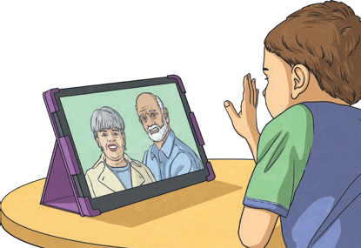
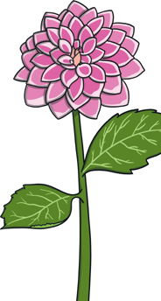
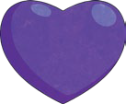
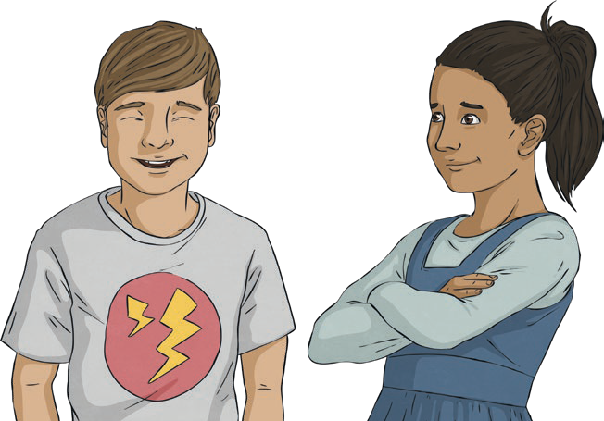
twinkl.com
Disclaimer: This resource is provided for informational and educational purposes only and does not constitute mental health advice. If you require mental health advice, you should contact a suitably qualified professional. You should not rely on the material included within this resource and Twinkl does not accept any responsibility if you do.
To look at all the planning resources linked to the UKS2 Be Yourself unit, click here

This resource is fully in line with the Learning Outcomes and Core Themes outlined in the PSHE Association Programme of Study.

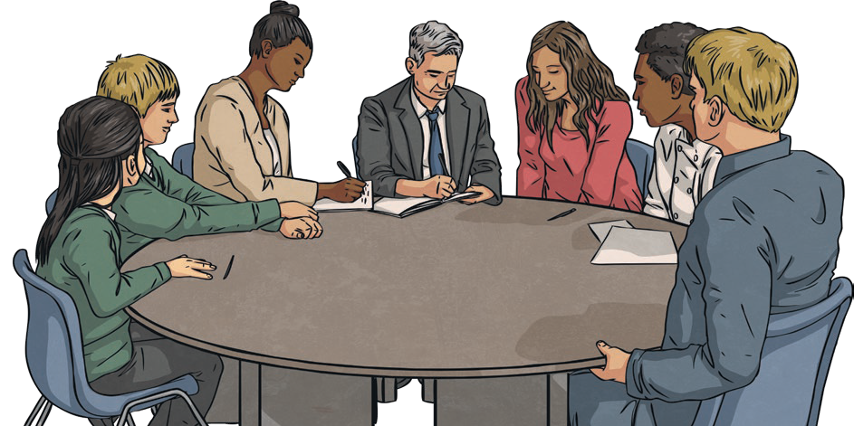
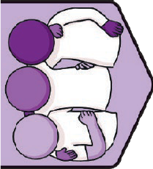
Key Vocabulary
attribute: | A quality or a feature of something.
successful: | When something is achieved or it is working well.
collaborate: | To work with others effectively.
contribute: | To provide something or help out to achieve a goal
respectful: | Treating someone in a way that shows they are important and valued.
hurtful: | A way of behaving that causes upset.
communication: | Ways of sharing our views with others including talking and writing messages.
compromise: | Finding a way of working together where two or more people adapt their behaviour, actions or choices.
sensitive: | Appreciating the feelings of others.
harassment: | Unwanted behaviour directed at someone that is upsetting or hurtful.
teasing: | When one person pokes fun at another.
trolling: | Posting unkind or upsetting information about or to someone.
excluding: | Deliberately leaving someone out.
bullying: | Behaviour intended to hurt or upset someone. There are many different types of bullying.

Relationships | TEAM | UKS2
Key Knowledge

Attributes of a Good Team
People work in teams in many different situations. This may be at work, when playing sports or in a class. Within a team there are lots of different people. We may be from different backgrounds, have
different skills or make different choices. These differences are part of what makes a team good because we can each bring different strengths to the task. While differences within a team make it strong, there are certain attributes all teams need to be successful. These include good communication, strong determination, focus, being adaptable and working hard.
PSHE and Citizenship | TEAM

Sharing Our Opinions Respectfully
Our uniqueness and individuality are part of what makes the world an exciting place. Because of the differences between us, we may have different opinions from people around us. It is important to
be able to share our views and express ourselves respectfully, even if we disagree with what is being said. We can do this by showing
active listening so it is clear we have heard and understood the other person’s opinion. We can clearly express our ideas too, using kind words and a calm voice.. This way our opinions are clear but we
are not expressing ourselves in a way that is hurtful to the feelings of others.

Working as a Team
Compromise and collaboration are two examples of teamwork skills. We may need to compromise if our teammates disagree on the way something should be done. If we compromise, we need to listen to each other, understand the different opinions within the team, share our views and find a decision that works. It is likely that the decision that is taken requires each member of the team to make small changes to what they want. When we collaborate with others, we will think about what strengths other team members have, listen to each other, share tasks and responsibilities and review what we have done.

Showing We Care
We can show we care for others in our team in lots of different ways. We can listen, show interest in things they care about, include them, respect them and the space they need, enjoy different activities together, value and talk with them about their feelings and tell them we care for them.
By doing this, we are able to be sensitive to the feelings of others. It is also important to care for ourselves. This way, we will have the energy and self-confidence to contribute to our team. Ways we can care for our bodies include keeping ourselves clean, exercising, eating a balance of different foods and getting enough sleep and water. It is also important to care for our mind by talking about our feelings, exercising, doing activities we enjoy, relaxing and spending time in nature.

Unkind Behaviour
As part of a team, it can help to be able to recognise unkind behaviour. This way, we can help if we see or experience this. Unkind behaviour includes harassment, teasing, trolling, excluding
others or bullying. These behaviours can affect others in many different ways, so it is important we do what we can to show it is not acceptable. If we experience this or notice it happening to anyone else, we can show kindness to others, include them in our conversations and games and understand that no one is more important than anyone else. If we are worried, it is important to speak to a trusted adult.

Shared Responsibilities
By contributing to shared responsibilities, team members will help their teams
to function successfully. Shared responsibilities include trying our best, looking after our resources and our environment, listening to and respecting each other, being polite and helpful and caring for our teammates.

Key Learning Point:
Helpful Team Behaviours: A successful team provides care and compassion for others, building a support network. This can support the wellbeing of ourselves and the people around us. These helpful behaviours include:
- Showing each other care and respect to develop strong relationships;
- Showing kindness to each other to help others feel secure and cared for;
- Respecting and valuing our differences and the contributions we each make;
- Listening to each other to
understand more.

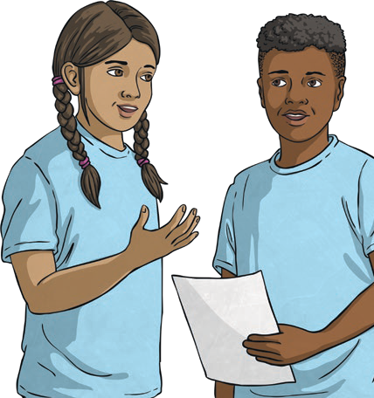
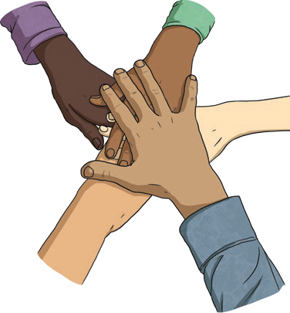
twinkl.com
To look at all the planning resources linked to the UKS2 TEAM unit, click here

This resource is fully in line with the Learning Outcomes and Core Themes outlined in the PSHE Association Programme of Study.

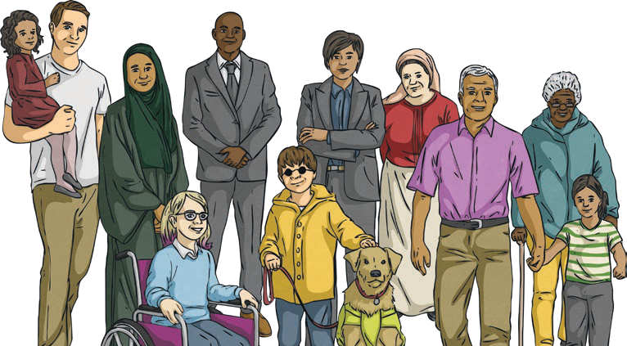
Living in the Wider World | Diverse Britain
Key Vocabulary
community | A group of people who live or work together in the same place, or have a shared interest  or experience.
ethnicity | Shared culture, customs, language or beliefs.
faith | A strong belief in something. To follow a religion.
identity | Special things about us that contribute to who we are. This could include our name, family, culture, interests, hobbies and the way we choose to express ourselves.
democracy | The belief that there is freedom and equality between all people and they should have a say in the way they are governed.
diverse society | A society which is made up of many different types of people.
responsibility | Tasks that we do to contribute or things we are in charge of.
prejudice | Having an opinion without reason or experience to justify it.
discrimination | Unfair treatment of a person or group based on who they are, where they are from or how they choose to live their life.
stereotyping | Assuming someone will behave in a certain way because of a certain characteristic. This could be based on the way they look, the way they speak, where they come from or their gender.

Key Knowledge

A Diverse Nation
We are lucky to live in a diverse society created from people of many ethnicities, faiths, cultures and
backgrounds. In a diverse society, it is important to show respect to others, whether they are similar to or different from ourselves. We can show respect by smiling and being friendly to others and asking questions to learn more. We all have a responsibility to make sure the rights of people around us and around the world are met.
PSHE and Citizenship | Diverse Britain

Our Community
Our communities are made up of people who share some similarities. These may be where they live, where they work, or something they share. It is very important to respect the differences between people in our communities as well. There are many ways we can contribute to our community and help to make it a happy, safe place for everyone. We can do this by respecting and embracing the differences between us, standing up for equality, showing kindness, consideration and helping others and thinking of their needs as well as our own. This way, we can share the responsibility to make sure everyone in our community has their rights respected and receives equal opportunity.

British Laws
local government | The organisation of politicians who are in charge of running the town or city. These politicians are voted for and elected.
national government | The group of politicians who make decisions about how the country should be run. These politicians are voted for and elected.
charity | An organisation which provides help and raises money for those in need.
voluntary organisation | An organisation formed of a group of people who volunteer to help a cause without being paid.

British laws are the rules by which society works. People keep the rules to help our communities and people within them stay happy and safe. British laws are made in parliament at Westminster and some are also discussed in the National Assembly for Wales, Scottish parliament and the Northern Ireland Assembly. Some laws apply
in the whole of the United Kingdom, while others only apply to one, two or three of the countries. People who live in the Channel
Islands are British citizens and the British parliament has the power to make laws for the Channel Islands but Acts of Parliament do
not automatically extend to them as, for the most part, they make their own laws.

Local Government
Local governments look after our communities by providing in areas such as education, transport, waste collection, recycling facilities and community centres. Within this, they help to ensure everyone has equal opportunities and access to everything they need and that people’s human rights are met and protected. We all have a responsibility to make sure no one suffers discrimination or prejudice, so they can live safely and happily in successful communities.

National Government
The national government is made up of the cabinet and the prime minister. They are elected to make important decisions about how the country works and enable us to live happy and successful lives. It is their job to make sure our human rights are met and that we can live without prejudice or discrimination.

Community Support
Charities and voluntary organisations work to make a positive contribution to our communities. They help people who are in need, as well as providing a purpose for those who would like to get involved and make a difference. Charities and volunteer groups work very hard to improve things for those who need help.
Key Learning Point: Active, Responsible Citizenship
By making positive contributions to our society, we
are being active, responsible citizens. This means we respect people around us
and promote and protect the human rights of everyone by ensuring we all have equal access to what we need to live safe, happy and fulfilling lives.

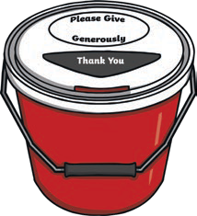
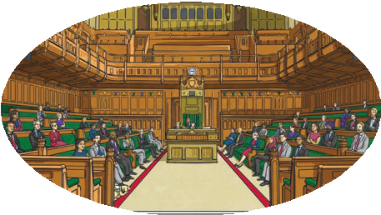
twinkl.com
To look at all the planning resources linked to the UKS2 Diverse Britain unit, click here.

This resource is fully in line with the Learning Outcomes and Core Themes outlined in the PSHE Association Programme of Study.

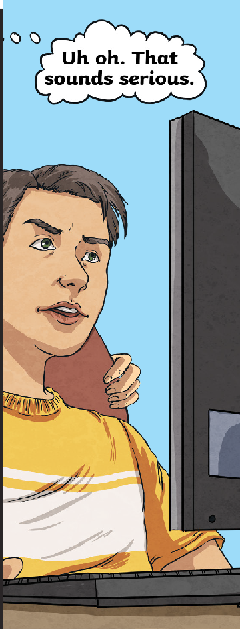
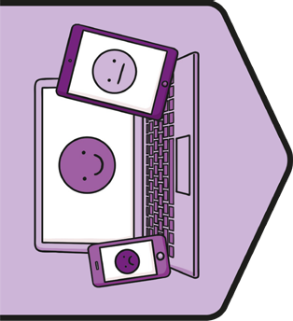
Key Vocabulary
digital wellbeing: | The way we interact with digital technology and look after ourselves and others as we use it.
respect: | A way of treating or thinking about someone that shows they are important and they are valued.
communication: | Ways of sharing our views with others including talking and writing messages.
fake news: | Untrue information presented as news.
bullying: | Behaviour intended to hurt or upset someone. There are many different types of bullying.
personal information: | Information that is about us. It can include our full name, our date of birth, our address, our telephone number and the name of our school. For adults, this also includes their bank details and place of work.
data: | Information collected for analysis or reference.
digital citizenship: | Behaving in a way that is respectful of ourselves and others in the digital communities we belong to.
social media: | Websites and applications where people can share images and comments and join online communities.
inappropriate: | Not suitable for the situation or person.
reliable: | Whether or not someone or something can be trusted.
reputable: | Something or someone that is respected and has a good reputation.

Relationships | Digital Wellbeing
Key Knowledge

Using the Internet
There are many ways we can use the Internet. By understanding how using our devices affects our feelings, thoughts and behaviour, we can develop positive digital
wellbeing. This means we can understand how we can use the Internet safely and responsibly in a way that works for us and protects our digital wellbeing and that of others as well. We can do this by keeping personal information private, not sharing photographs, using apps, games and videos that are appropriate for our age and that we have agreed with a trusted adult and by speaking to a trusted adult if anything worries us.
PSHE and Citizenship | Digital Wellbeing

Risks of Using the Internet While there are many benefits the Internet can bring from safe, responsible use, there
are also risks people need to be aware of. These include bullying, fake news, data sharing, inappropriate content, inappropriate relationships and worry or pressure that may be
felt. By understanding these risks, we can learn how to manage and avoid them and use the Internet safely and responsibly. If we are worried by anything we have seen or feel that something isn’t right, it is very important to talk to a trusted adult and get help. It may be necessary to record what has happened or what worries you, report problems to the site provider, or tell the police.

Online Relationships
There are many ways the Internet can help us to nurture and strengthen our relationships. This may be by video calling family members far away, messaging friends and emailing people we care about. It is important to remember that we should communicate online with the same respect we show people in person, and should expect this from others as well. Respectful online relationships show kindness and respect, respect privacy and personal boundaries, consider each other’s feelings, respect people for who they are, show trust and don’t pressure each other
to do things they are not comfortable with.

Using Social Media
Social media platforms offer benefits when used safely and responsibly, but can also provide risks. Some benefits include offering the opportunity to connect with people and avoid feelings of isolation, the ability to share ideas about things of interest, engaging with the wider world and exploring new topics, cultures and events. If we choose to use social media, it is important we do this safely and responsibly to avoid risks. These risks include disconnecting with the world around us if too much time is spent online, exposure to cyberbullying, exposure to inappropriate content and seeing or experiencing communication that does not respect the boundaries of others. To manage these risks, we can respect age restrictions, use privacy settings, show kindness online, never share information or pictures we wouldn’t want lots of people to see, balance time online with offline activities and always tell a trusted adult if anything worries or upsets us.

Online Bullying
Bullying behaviours online are called cyberbullying. This can come in many different forms and includes harassment, flaming, trolling, excluding others, outing, impersonation, denigration
and cyberstalking. All of these
behaviours have harmful and damaging effects on people involved and are unacceptable. It is important that we show kindness and respect in all communication online and report any bullying behaviour we experience or see. We can do this by talking to a trusted adult, recording what has happened, reporting it to the provider or, if necessary, telling the police.

Internet Reliability
There is lots of information on the Internet. Some of this information may not be true, so it can help us to protect the digital wellbeing of everyone if we are able to tell what is reliable and what isn’t. We can check how reliable Internet sites are by looking for the padlock symbol on the address bar, checking that websites end in .co.uk or .com, checking the publication date to see how recently it was written, using secure sites (these are ones where the URLs start with https), checking what we’ve read with a trusted adult and other offline reliable sources and using reputable websites we feel we can trust.

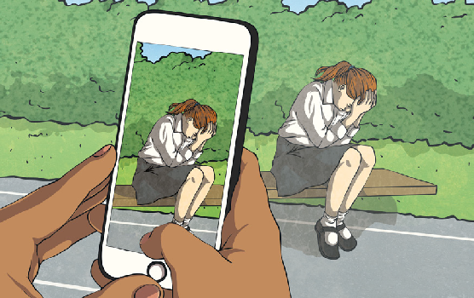
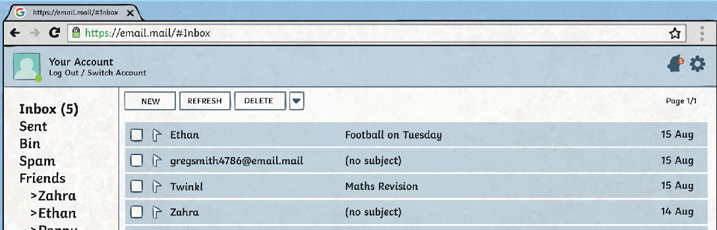
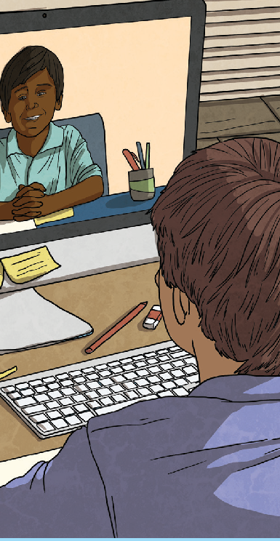
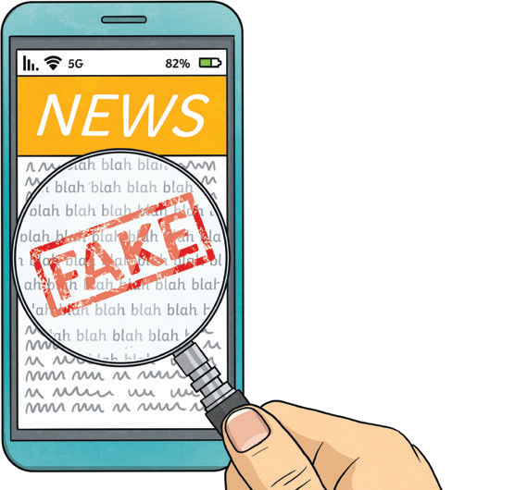
twinkl.com

This resource is fully in line with the Learning Outcomes and Core Themes outlined in the PSHE Association Programme of Study.

twinkl.com

Key Learning Point Staying Digitally Well
To help ourselves and others develop positive digital wellbeing, we can
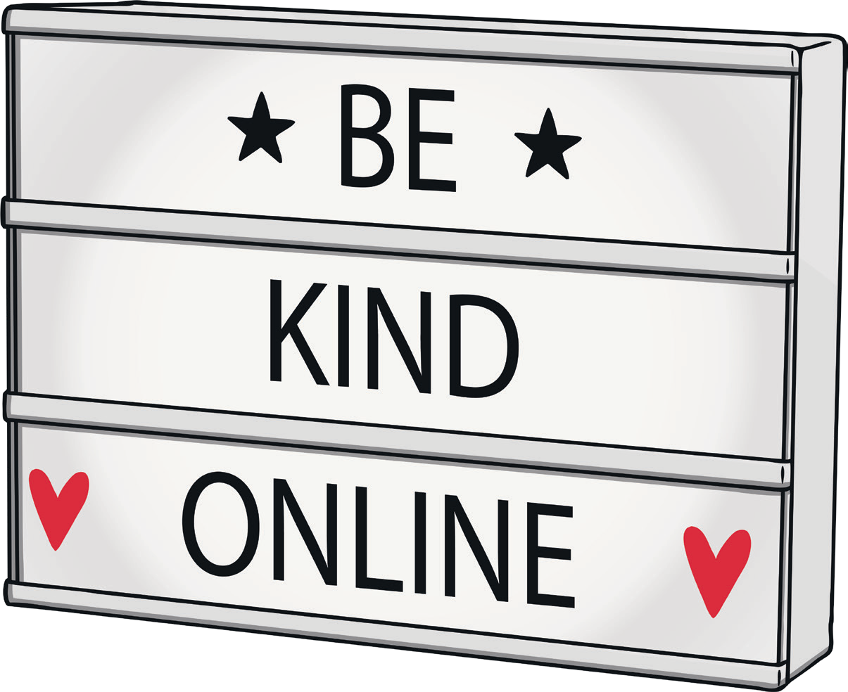
look after ourselves when using our devices and understand how to use the Internet in a safe and responsible way. We can:
- limit our screen time;
- get a balance of online and offline activities;
- treat people with kindness and respect online;
- only use games, apps or videos that are appropriate for our age;
- talk to a trusted adult if anything we see worries or frightens us;
- be honest and open about what we are doing;
- learn to know when our bodies and minds have had too much screen time.

To look at all the planning resources linked to the UKS2 One World unit click here
This resource/information is not intended to encourage social media use and we cannot accept any responsibility for pupils that sign up to social media sites after using this resource/information.
This resource is fully in line with the Learning Outcomes and Core Themes outlined in the PSHE Association Programme of Study.

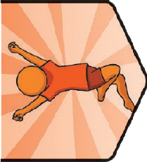
Key Knowledge
Key Vocabulary
autonomy: | The independence to make our own choices.
consent: | To give permission or agree to something.
respect: | A way of treating or thinking about someone that shows they are important and they are valued.
self-confidence: | Feeling comfortable with our own qualities,strengths and abilities.
choice: | Something we have the power to make when there is more than one possibility.
pressure: | A strong influence people feel to behave in a certain way.
inappropriate: | Not suitable for the situation or person.
drug: | A medicine or other substance which affects the body when taken. There are legal (allowed by law) and illegal (not allowed by law) drugs.
stereotype: | Assuming someone will behave in a certain way because of a certain  characteristic. This could be based on the way they look, the way they speak,  where they come from or their gender.
hygiene: | Keeping ourselves clean to stay  healthy and well.

Consent and Autonomy
We all have the power of consent and autonomy. This means we can choose what happens to our bodies and that other people need permission to touch us. Respecting ourselves means we know our bodies are precious and need to be protected from unwanted touch or harm. Other people have this right as well and can decide what happens to their bodies. It
is not OK to make anyone do something they are not comfortable doing. If anyone is worried about something that is happening that doesn’t feel right, it is important to explain the situation needs to stop and to speak to a trusted adult for help.
Exercise and Sleep
Physical activity has many benefits for our bodies and our minds. It can strengthen bones, muscles and the heart, boost immunity and energy levels, improve mood and help us to sleep better. It can also help our mental health by reducing stress, depression and anxiety levels, improving mood, brain power and self-esteem and improving social
PSHE and Citizenship | It’s My Body
connections. By making choices which help us to get enough exercise and sleep, we can help our bodies and minds feel healthy and well.
Looking After Our Bodies
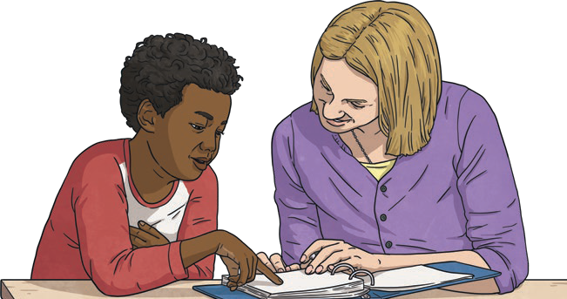
There are lots of ways we can take care of our bodies. Eating a balanced diet including a wide variety of food groups gives our body the vitamins and minerals it needs to stay healthy. Keeping ourselves clean by washing our bodies and our clothes helps us to feel fresh and hygienic. Eating breakfast gives us energy to start the day and eating foods rich in protein helps to maintain our energy levels. Looking after our teeth by brushing twice a day, flossing and visiting the dentist regularly helps maintain our oral health. Developing good bedtime routines
helps us to get enough sleep. Drinking enough water helps our bodies to stay hydrated and keeps our skin clear. Taking care in the sun by staying hydrated, sitting in the shade and covering up avoids heat and sun exposure.

twinkl.com
Key Knowledge
Harmful Substances
Substances people put into their bodies to have an effect are called drugs. Legal drugs include alcohol, tobacco, caffeine and medicines. It is important to understand the risks and rules associated with these substances so that people are able to make informed choices. It is also
important we remember it is our choice what we put into our body and that no one should make us feel pressured to do or try anything we don’t want to do or are not comfortable with.
Body Image
There are many influences around us that may affect how we see ourselves. Many of the images shown on adverts, the Internet, social media and magazines may have been altered to present an image of an unrealistic appearance. It is important to remember this
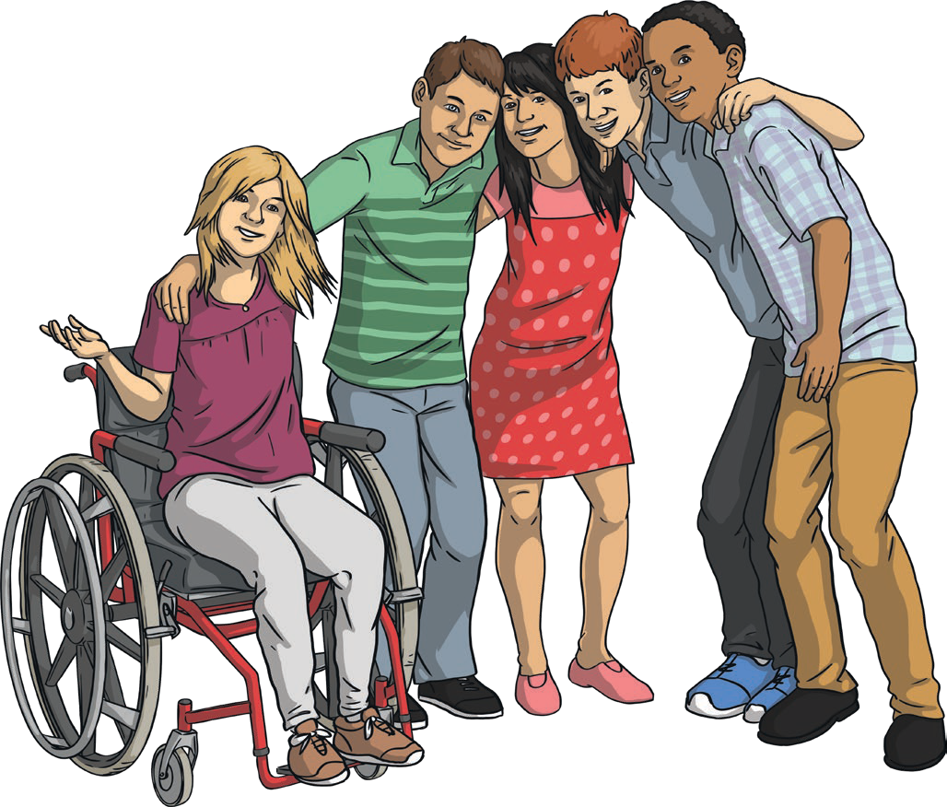
when reflecting on how we see ourselves and to make sure we value the positive qualities that we have rather than just focusing on what we look like. There are many ways we can look after our body to keep it healthy and strong and this can also help to inform our self-image.
Healthy Choices
There are lots of things we can do to keep our bodies and minds healthy and well. We can eat a balanced diet, avoid substances which would be harmful to us, drink plenty of water to stay hydrated, get enough exercise, enjoy a balance of activities,
stay safe when it is sunny by finding shade, covering up and drinking plenty of water and we can allow our minds time to be calm through relaxation
and mindfulness. It is important to make our own decisions about how we look after our bodies and not feel pressured to do anything we don’t feel is right.
Key Learning Point:
Proud to be Me
There are many choices we can make about our bodies and it’s important to remember that the decisions are ours to make. We should be able to choose options that make us feel comfortable and not be pressured by influences around us. By learning about healthy, balanced lifestyles, we can
make informed decisions that help us to stay healthy and well and feel good about ourselves.

Disclaimer
This resource is provided for informational and educational purposes only and does not constitute medical advice. If you require medical advice, you should contact a suitably qualified professional. You should not rely on the material included within this resource and Twinkl does not accept any responsibility if you do.

This resource is fully in line with the Learning Outcomes and Core Themes outlined in the PSHE Association Programme of Study
To look at all the planning resources linked to the UKS2 It’s My Body unit, click here

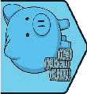
Key Knowledge
Key Vocabulary
investment: | A purchase or saving option that it is hoped will increase in value and therefore make money.
risk: | A possibility of danger or harm.
scamming: | Stealing the details on credit or debit cards with the intention of taking money.
phishing: | Trying to steal someone else’s personal information.
consumers: | People who buy goods or services.
value for money: | How much of a product people receive in relation to how much money they pay for it.
ethical spending: | Spending money or buying things in a way that has no negative impact on the environment or people involved in the making of the goods.
fair trade: | Trade in which fair prices are paid to the producer.
budget: | An amount of money that can be spent over a given period of time. A plan for how a certain amount of money will be spent over a  period of time.

Financial Risk
Taking a risk with money can mean investing it in something which may increase in value but also may decrease in value, meaning money is lost. Often, the larger the increase in value that is possible, the greater the risk may be. Therefore, there is the chance that while it is possible more money could be gained, more money could also be lost. Our money can have an impact on our wellbeing. If people feel worried that their money may be at risk, it can cause feelings of stress or worry.
Value for Money
There are lots of things that may influence people’s spending. Sometimes manufacturers use advertisements and advertising techniques to try
PSHE and Citizenship | Money Matters
to persuade people to spend money. This may include offering items that seem to be available for free when a certain amount is spent. By understanding how to establish how much something actually costs,
people can be critical consumers and make choices and decisions that are right for them.
Spending Choices
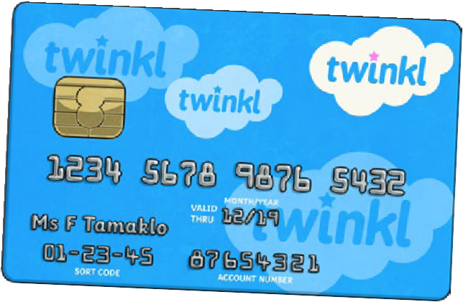
People consider different things when spending money. They may consider how expensive things are, the value they get for the money they are spending, or the ethics of their spending. Ethical spending means making choices which do not have a negative impact on the environment or on people involved in producing items. Some ways people can choose to make ethical choices are by avoiding single-use plastics, buying Fairtrade products, avoiding unnecessary packaging, choosing recycled materials when possible and recycling or reusing items no longer used. This can be achieved by taking reusable shopping bags when shopping and taking items no longer needed to charity shops. People’s spending choices, which are individual and what’s right for them, should be respected and viewed with kindness.

twinkl.com
Key Knowledge
Budgeting
Some people choose to make a budget as a helpful way of making sure money is available for all they need to buy. By planning spending activity for a certain amount of time, people can feel confident the available money can be spent on what is needed. It is important to remember that people’s spending is a personal decision and different people have different choices to make. Everyone is in a different financial position and the options available to us all will vary depending on how much money is available, what needs to be spent and how we feel about this. We should view the spending choices of different people with kindness and respect.
Money and Our Emotions
Money can have an impact on our emotional wellbeing. This is not because of how much or how little money people may have, but could be emotions caused by what people need to afford and spending decisions they need to make. People may feel stress or worry if they don’t know whether they will be able to afford what they need. Sometimes people borrow money to cover costs that need to be met.
Spending in the Wider World
Money can affect the environment we live in. Contributions to national and local government through income tax or council tax help to look after the environment and services within our local area. People may also choose to make decisions about spending which prioritise the environment. This might be by avoiding single-use plastics, excess packaging, using recycled materials, recycling their own unwanted items or looking for ways these can be reused, buying Fairtrade produce or by taking reusable bags when they go shopping. People may also decide not to prioritise this or may not feel they have the choice to do this. No spending decision is better than any other, and everyone needs to view the choices of others with kindness and respect.
Key Learning Point
Financial Confidence
What people spend money on is an individual choice. It depends on many things like how much money is available, what is needed at the time, what future costs might need to be considered and how money might affect people’s emotions. By having a clear understanding of our own available money, our financial choices, any risks there may be to our money (such as scamming, phishing, investment risk) and how these
can affect our emotions, we are in a better position to make choices that are right for us. No spending decision is better than any other, as people’s financial situations are all different. What is important is that we understand our own financial situation, the choices available and how these will affect our mental wellbeing.

Disclaimer
This resource is provided for informational and educational purposes only and does not constitute financial advice. If you require financial advice, you should contact a suitably qualified professional. You should not rely on the material included within this resource and Twinkl does not accept any responsibility if you do.

This resource is fully in line with the Learning Outcomes and Core Themes outlined in the PSHE Association Programme of Study
To look at all the planning resources linked to the UKS2 Money Matters unit, click here

Key Knowledge
Key Vocabulary
investment: | A purchase or saving option that it is hoped will increase in value and therefore make money.
risk: | A possibility of danger or harm.
scamming: | Stealing the details on credit or debit cards with the intention of taking money.
phishing: | Trying to steal someone else’s personal information.
consumers: | People who buy goods or services.
value for money: | How much of a product people receive in relation to how much money they pay for it.
ethical spending: | Spending money or buying things in a way that has no negative impact on the environment or people involved in the making of the goods.
fair trade: | Trade in which fair prices are paid to the producer.
budget: | An amount of money that can be spent over a given period of time. A plan for how a certain amount of money will be spent over a  period of time.

Financial Risk
Taking a risk with money can mean investing it in something which may increase in value but also may decrease in value, meaning money is lost. Often, the larger the increase in value that is possible, the greater the risk may be. Therefore, there is the chance that while it is possible more money could be gained, more money could also be lost. Our money can have an impact on our wellbeing. If people feel worried that their money may be at risk, it can cause feelings of stress or worry.
Value for Money
There are lots of things that may influence people’s spending. Sometimes manufacturers use advertisements and advertising techniques to try
PSHE and Citizenship | Money Matters
to persuade people to spend money. This may include offering items that seem to be available for free when a certain amount is spent. By understanding how to establish how much something actually costs,
people can be critical consumers and make choices and decisions that are right for them.
Spending Choices
People consider different things when spending money. They may consider how expensive things are, the value they get for the money they are spending, or the ethics of their spending. Ethical spending means making choices which do not have a negative impact on the environment or on people involved in producing items. Some ways people can choose to make ethical choices are by avoiding single-use plastics, buying Fairtrade products, avoiding unnecessary packaging, choosing recycled materials when possible and recycling or reusing items no longer used. This can be achieved by taking reusable shopping bags when shopping and taking items no longer needed to charity shops. People’s spending choices, which are individual and what’s right for them, should be respected and viewed with kindness.

twinkl.com
Key Knowledge
Budgeting
Some people choose to make a budget as a helpful way of making sure money is available for all they need to buy. By planning spending activity for a certain amount of time, people can feel confident the available money can be spent on what is needed. It is important to remember that people’s spending is a personal decision and different people have different choices to make. Everyone is in a different financial position and the options available to us all will vary depending on how much money is available, what needs to be spent and how we feel about this. We should view the spending choices of different people with kindness and respect.
Money and Our Emotions
Money can have an impact on our emotional wellbeing. This is not because of how much or how little money people may have, but could be emotions caused by what people need to afford and spending decisions they need to make. People may feel stress or worry if they don’t know whether they will be able to afford what they need. Sometimes people borrow money to cover costs that need to be met.
Spending in the Wider World
Money can affect the environment we live in. Contributions to national and local government through income tax or council tax help to look after the environment and services within our local area. People may also choose to make decisions about spending which prioritise the environment. This might be by avoiding single-use plastics, excess packaging, using recycled materials, recycling their own unwanted items or looking for ways these can be reused, buying Fairtrade produce or by taking reusable bags when they go shopping. People may also decide not to prioritise this or may not feel they have the choice to do this. No spending decision is better than any other, and everyone needs to view the choices of others with kindness and respect.
Key Learning Point
Financial Confidence
What people spend money on is an individual choice. It depends on many things like how much money is available, what is needed at the time, what future costs might need to be considered and how money might affect people’s emotions. By having a clear understanding of our own available money, our financial choices, any risks there may be to our money (such as scamming, phishing, investment risk) and how these
can affect our emotions, we are in a better position to make choices that are right for us. No spending decision is better than any other, as people’s financial situations are all different. What is important is that we understand our own financial situation, the choices available and how these will affect our mental wellbeing.

Disclaimer
This resource is provided for informational and educational purposes only and does not constitute financial advice. If you require financial advice, you should contact a suitably qualified professional. You should not rely on the material included within this resource and Twinkl does not accept any responsibility if you do.

This resource is fully in line with the Learning Outcomes and Core Themes outlined in the PSHE Association Programme of Study
To look at all the planning resources linked to the UKS2 Money Matters unit, click here

