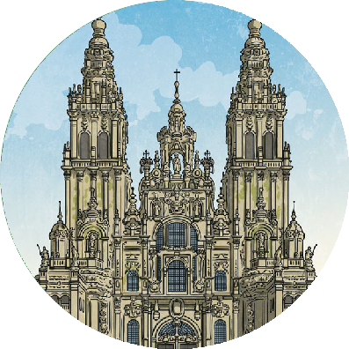
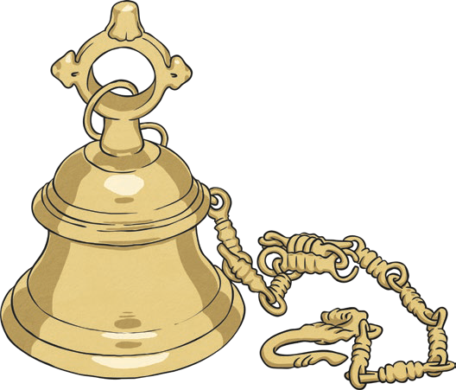
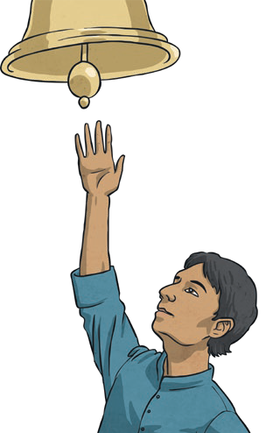
For religious believers, the aim of worship is to show that god has more worth than anything or anyone else.
Religious freedom is the right to chose what you believe and which religion to follow.
View more Worship planning resources.
visit twinkl.com
Key Vocabulary
worship | The feeling or act of showing respect, loyalty or love.
worth | Having a particular value.
Christians | Followers of the religion of Christianity.
Hindus | Followers of the religion of Hinduism.
puja | The Hindu act of worship.
gurdwara | A Sikh place of worship.
Sikhs | Followers of the religion of Sikhism.

Acts of Worship
Worship can take many forms:
- singing
- dancing
- praying
- helping others
- meditating
- giving
but religious believers believe that true worship comes from the heart.

Christianity | Hinduism | Sikhism
Christians believe that they should put God first. The first of the Ten Commandments (a list of rules revealed by God), said worship no other Gods but me. | Hindus ring a bell at the start of puja to tell the  gods that they are there. | Sikhs gather in the gurdwara to worship together. These gatherings include hymns, singing, prayers and meditation.
Christians come together to worship in church. | During puja, prayers are said and offerings are made. Puja can take place in the home or a temple. | The aim of Sikh worship is to give praise to god.  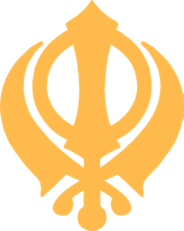

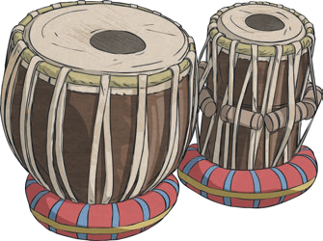
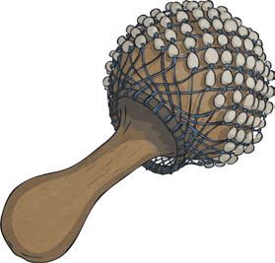
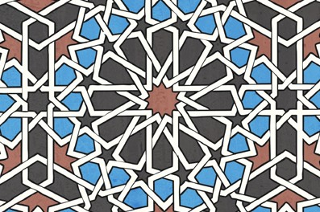
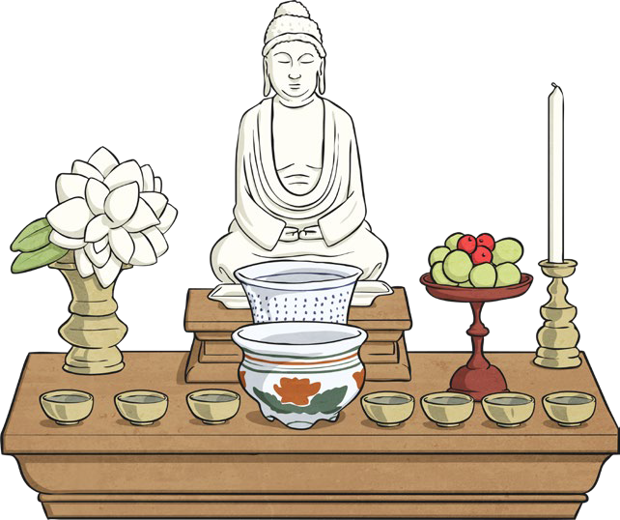
Music | Prayer | Art
Different religions use music in their worship.  Islam uses music for the call to prayer and the reciting of the Qur’an.  Christians and Hindus sing and use musical instruments in worship. Most of the service in a synagogue is chanted or sung. The reading of the Torah (the Jewish holy book) is chanted.  Buddhists also chant religious texts. | For religious believers, praying is a way of talking to god.  People pray in different ways:  - together;  - on their own;  - saying a known prayer;  - praying with their own words. A special prayer for Christians  is The Lord’s Prayer. A special prayer for Jews is the Shema. | Religious believers can use art as a form of worship. Artists represent through art, how their faith inspires them or their emotions about  religion. Prayer mats, statues and paintings are examples of religious art. In some religions, the shapes and colours chosen for art are symbolic.

Key Vocabulary
artefacts | A religious artefact is an object that has a special significance within  a religion.
call to prayer | This is sung five times a day to remind Muslims to pray.
Qur’an | The holy book of Islam.
Islam | One of the main world religions. Its followers are Muslims.
synagogue | The name of the building where Jews worship.
Buddhists | Followers of the religion of Buddhism.
Jews | Followers of the religion of Judaism.

Artefacts
Special artefacts can be found in many religions. They can be used as part of worship, or as a symbol of a person’s religion. They can also be used as a focus for personal
or group reflection. Religious artefacts are treated with respect by believers. There may be special rules about where they are stored or how they are treated.

View more Worship planning resources.
visit twinkl.com

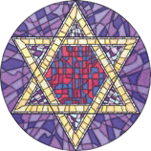
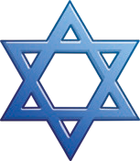
Forgiveness (noun) is the action of forgiving or being forgiven. To forgive (verb) is to stop feeling angry or resentful towards someone for an offence, flaw or mistake. Forgiving means to change the way you feel about something that has happened or been done to you.
What Is Forgiveness?
Jews and Christians believe that the Ten Commandments were rules given by God and that to break these rules is a sin.
Key Vocabulary
sin | A bad action. To go against rules given by God.
confess | To admit you have done something wrong.
repent | To feel sorry (and express how sorry you are) for something you have done wrong.
Ten Commandments | The ten most important laws, revealed by God, teaching people how to live their lives.
covenant | An agreement.
atonement | The act of putting things right when someone has done something wrong.

Jews | Teshuvah | Yom Kippur
Jewish people believe that they have a covenant with God. This covenant means that so long as they follow the Ten Commandments, God will look after them.  Jews believe that God will forgive those who repent. | Teshuvah is often used to talk about repentance in Judaism. Teshuvah means ‘return.’ Once you  confess your sins and ask for forgiveness, you can return to God’s path.  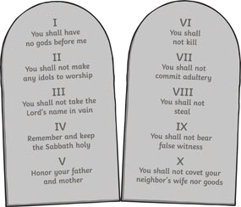 | Yom Kippur is the holiest day of the year for Jews. For ten days after the Jewish New Year (Rosh Hashanah), they pray, reflect and repent for their sins from the past year. The tenth day  is Yom Kippur, a day of atonement, where  Jews ask for forgiveness from God.

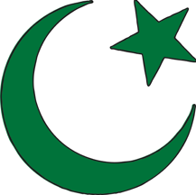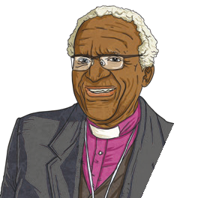
Buddhists use meditation to help them focus and forgive. Meditation can be done alone or in a group.
Religious, spiritual and world leaders teach about the importance of forgiveness. “You do not do evil to those who do evil to you, but you deal with them with forgiveness and kindness”. Prophet Muhammad (PBUH)
World Views
Archbishop Desmond Tutu taught about the importance of forgiveness
for a peaceful world. He taught that forgiving is not forgetting, but remembering. Remembering means you can learn from your mistakes.
Desmond Tutu
Buddhists read the Dhammapada, which contains the teachings of Buddha. It teaches them that forgiveness and love can overcome hate. Buddhists do not pray to Buddha or ask his forgiveness; instead they try to forgive themselves and others by following the Eightfold Path.
Buddhists
Key Vocabulary
Dhammapada | One of the Buddhist holy texts.
Eightfold Path | A set of eight instructions set out by Buddha to encourage people to follow the right path.
meditation | Taking the time to focus the mind on a thought or an object.
The Prophet Muhammad (PBUH) | The founder of Islam.
Archbishop Desmond Tutu | He was a Nobel Peace Prize winner and an important figure in the Anglican Church of South Africa.

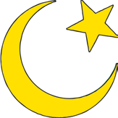
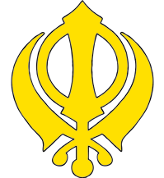
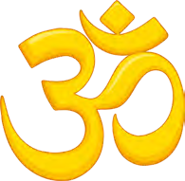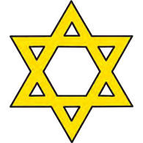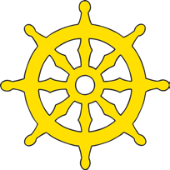
Religious Views About Peace
One of the important | Peace in Judaism also | The word Islam means
messages of Christianity | focuses on ideas like | submission to God. This has
is ‘Peace on earth’. | prosperity (for all, not | been important in creating
This was the message | just the rich), fertility | peace between individuals and
from the angels to | of crops, harmony and | nations. While most Muslims
the Shepherds when | general well-being. | are not pacifists, Muslims do
Jesus was born. |  | not believe in starting wars.
Peace is central to | Buddhism teaches that through meditation, you can let go of being self-centred  and live peacefully and generously with each other. | The founder of Sikhism was committed to non- violence. Sikhs promote  human rights and harmony and have been involved in charitable work for the poor and needy.
Hinduism. A key
teaching in Hinduism is
non-violence (ahimsa).
This has been used
to protest against
oppression in India.

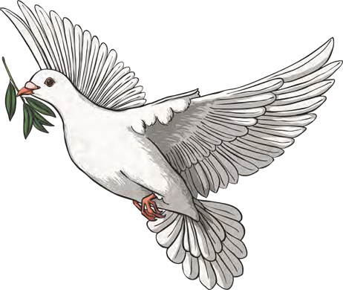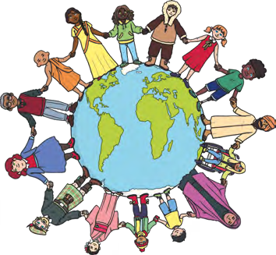
Key Vocabulary
peace | A state or period in which there is no war or war has ended. Freedom from disturbance;  tranquillity.
acts of peace | Actions that bring people closer to creating peace. These can  be big actions that involve lots of people and organisations or small ones that a single person can do.
conflict | Fights or wars.
non-violence | A commitment to resolving things peacefully.
pacifist | A person who does not believe in war or violence.

Peace can mean two different things. It could be a time period without any conflict or it could mean an amount of time where you are in a state of calm or quiet with no disturbances.
Peace is something that all governments and organisations aim for. Acts of peace are ways that this can be done – both as communities or as individuals.
Peace
Peace is a central theme in all religions and while there has been conflict in the name of religion, they are all committed to teaching peace as an important message.

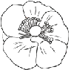
Inner Peace Techniques
Mindfulness is similar to Buddhist meditation. It involves being aware of the present moment and clearing your mind of distractions. It can be used to help mental health and find inner peace. | Meditation involves focusing your mind for a period of time. It can be done in silence or with chanting and can be for religious or  spiritual reasons or as a method of relaxation. | Prayer is often used to say sorry,  thank you or please.  It helps people focus and gain inner peace.
Tai Chi is a Chinese martial art. It concentrates on controlled body movements and breathing which helps bring inner peace. | Yoga is a Hindu practice and involves controlled breathing, specific  body positions and meditation. | 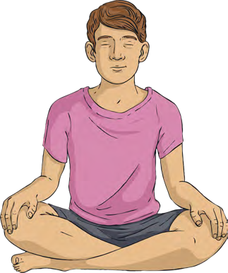

Key Vocabulary
inner peace | Being able to feel peace in yourself. Being in a state of inner peace is healthy and relaxing.
mindfulness | Used to help mental wellbeing and focuses on being present in the moment.
symbols of peace | Images that are linked to peace.
community cohesion | A group of people (for example a school, town or country) where everyone has a sense  of belonging and positive relationships are encouraged between everyone, regardless of their background.
fair trade | A system that focuses on people being paid fairly for their work. It is often  linked to food like chocolate and bananas.

Lots of western religions work alongside charities within the community to promote cohesion (a sense of togetherness). One way that this is done is through promoting fair trade. Symbols of peace are used worldwide to promote peace. Some are linked with religions and others aren’t but they share a powerful message of community cohesion for peace.
Community Cohesion
Western religions (Christianity, Judaism and Islam) focus on peace within their community. Eastern religions (Sikhism, Buddhism and Hinduism) all have a focus on inner peace.

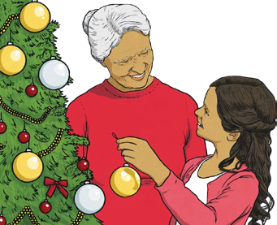


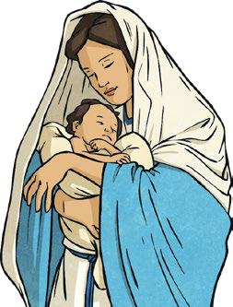
Jesus’ arrival on earth is important to Christians. They recognise Jesus as the Son of God and believe he was sent to earth to save humans from sin.
Christians celebrate Christmas every year and believe it is a time focused on love. They believe this as it celebrates the arrival of their Saviour, Jesus Christ. Christians believe that Jesus went on to die for their sins by sacrificing His life on the cross. Christians feel this shows God’s love for people and the world. They spend the Christmas period reflecting on God’s love and their love for each other. It is important to Christians to demonstrate acts of love at this time of year to show their gratitude to God.
Love
Key Vocabulary
Christmas | A Christian festival that celebrates the birth of Jesus Christ.
gratitude | Being thankful.
tradition | The passing on of ways of thinking, acting and/or  believing. There are lots of different traditions, ranging from those which impact a society (for example The King’s speech in the United Kingdom on Christmas Day) to traditions within a family or group of friends (for example going out for a meal on Christmas Eve).
love | There is more than one type of love. There is romantic love, love for a friend, love within a family, the love you have for yourself and the love you show to strangers.
associate | To link or connect.

Associations and Traditions
There are lots of different words, acts and ideas that  are associated with Christmas.  These might be objects such as hats and decorations or they might be acts such as  wrapping presents. | Christians believe that all acts of God associated with Christmas are connected to  love and God’s love  for people. | Christmas traditions  may include:  - Sending cards  - Giving gifts  - Singing carols  - Eating  Christmas dinner  - Decorating a tree

The ‘True Meaning of Christmas’
Christians celebrate Christmas each year. They believe that the ‘True Meaning of Christmas’  involves showing gratitude to God for what he did and remembering the birth of Jesus Christ, by worshipping him, giving gifts and thinking of the poor and less fortunate. | Christmas cards can be secular or Christian.  Christian cards show the true meaning  of Christmas by displaying important images from the Christmas story to remind Christians about why they celebrate Christmas. | Christmas carols often celebrate different parts of the birth story of Jesus. However, some are more focused on traditions associated with Christmas and are sung as general celebrations of the Christmas festival.

Key Vocabulary |  | Incarnation and Paradoxes | One of the ideas behind the ‘true meaning of Christmas’ is helping others. As a vulnerable baby, Jesus was forced to flee to Egypt to escape King Herod. This made him a refugee.  At Christmas, people often do charitable acts to help the vulnerable, including refugees.
incarnation | To become flesh. | Incarnation is an important idea in Christianity. It is all about how God became human in the form of Jesus and suffered as a human can do. Christians believe that God is an all-powerful creator and a pain bearer and that through his incarnation as Jesus, he was not a ‘big giant in the sky’, but a regular human with qualities found in all of us. God being an all-powerful creator and a vulnerable human is a paradox.
paradox | A contradictory idea.
carol | A type of religious song particularly associated with Christmastime.
commercialism | A focus on making money.
charity | Giving help to those who need it (often by raising or donating money or by volunteering).
vulnerable | Those who are in need of additional support, care or protection because of their age or a disability, or due to a risk of harm.
secular | Not connected with religion.
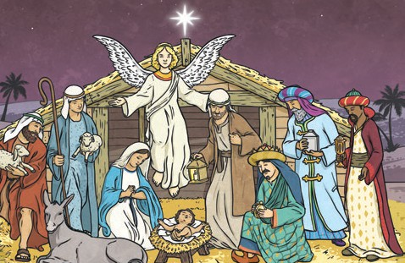
Some people argue that the ‘true meaning of Christmas’ is now lost and that Christmas has instead become victim to commercialism.
Other people disagree with this and say that the important messages of Christmas are still remembered.

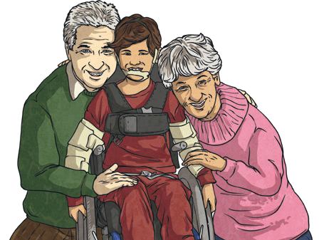
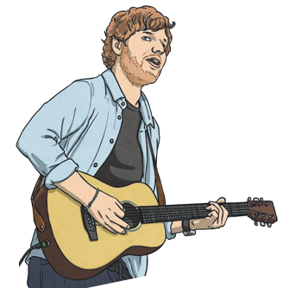
Many people make commitments to help them achieve their dreams and goals, such as athletes like Jessica Ennis-Hill (who committed to training regularly to achieve success in athletics) and musicians like Ed Sheeran (who rehearsed regularly and dedicated a lot of
time and energy to achieving success). You may have made a personal commitment to achieve a goal, such as giving up fizzy drinks or getting healthy by exercising.
Commitment is a promise to give your time and energy to something you believe in. A commitment doesn’t have to be religious. Commitments can be made to family, friendships, a healthy lifestyle, learning a skill or achieving a goal.
What Is Commitment?
Religious commitments can be made once a person reaches a certain age.
These commitments are special rituals people do when they come of age to show commitment to their faith.
Key Vocabulary
rituals | A religious service or ceremony where actions are performed in a set order.
Bar Mitzvah | Son of the commandments.
Torah | The Jewish holy book.
Bat Mitzvah | Daughter of the commandments.

Bar Mitzvah | Bat Mitzvah | Holy Communion
In the Jewish faith, once boys reach 13 years old, they become responsible for their actions. Boys must commit to learn to read the Torah in Hebrew as part of the ceremony.  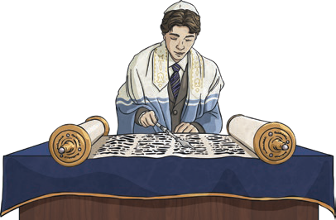 | When Jewish girls reach 12 years old, they become responsible for their actions. Girls must also recite the Torah in Hebrew and practise every day to  make sure they get it right.  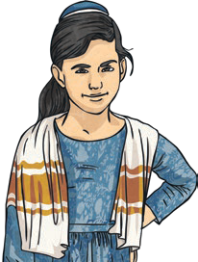 | For Catholics, the Holy Communion is the first commitment made independently. They must attend lessons to prepare. During the First Holy Communion, bread and wine are symbolic gifts.  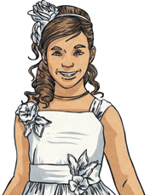

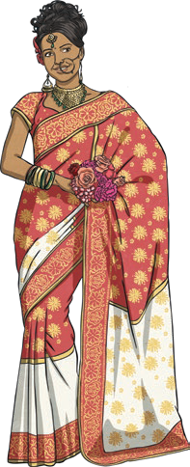
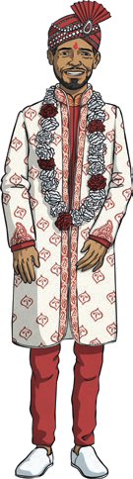
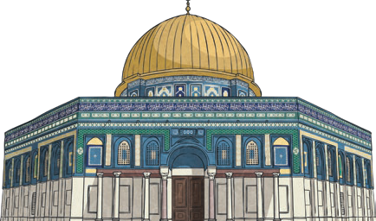
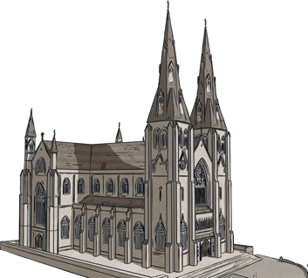
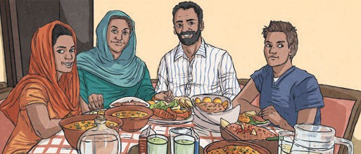
Fasting takes a lot of commitment and dedication. In Islam, Muslims follow sawm. During Ramadan, Muslims fast for the month. It reminds people of those who have to fast every day because they have no choice.
Key Vocabulary
sacrifice | giving up something which is valuable to you.
Lent | 40 days and nights when Christians prepare for Easter.
fasting | not eating or drinking anything during daylight hours.
sawm | the commitment of fasting for Muslims.
Ramadan | the ninth month of the Islamic calendar.
marriage | A legally recognised relationship between two people, who take part in an official ceremony and then usually live together.
duty | something we must do.

Sacrifice
Many people make sacrifices as a sign of commitment to their faith. Sacrifices can be made for your own good or for the good of someone else. Sacrifices could include giving up free time (or other activities) to go to Church every Sunday morning for Christians or to Mosque every Friday evening for Muslims. During Lent, Christians sacrifice something for 40 days and nights.

Marriage
Each wedding is | Religious beliefs can | In Hinduism, marriage is seen as a duty. There are many parts and rituals in a Hindu wedding, including the presentation of garlands, lighting of a sacred fire and walking seven steps. For each step taken, a special prayer is said.
different. Some are | affect the way people
held in places of | make commitments
worship and others | to each other. People
in a hotel or registry | with religious beliefs
office. Marriages | often feel that getting
link people together | married in their
for the rest of their | place of worship, in
lives but they also | front of their god, is
link families and communities. | very important.

There are many aspects of Judaism and Christianity that are the same in both religions:
Christianity originated from Judaism and Jesus was Jewish. Christianity as a religion, began after Jesus’ death. The Old Testament contains
24 books of the Jewish Tanakh (Jewish Holy Texts) and other, additional books.
Judeo-Christian
Genesis
Genesis is the first book of the Bible and the first book of the Torah (part of the Tanakh).
It contains the Judeo- Christian creation story.
Key Vocabulary
creation | The act or process of bringing something into existence.
creation story | A story that explains how the Earth and humans came into existence.
Judeo-Christian | Aspects of Judaism and Christianity that are grouped together because of similarities.
Old Testament | The first part of the Bible containing stories and writings from before the birth of Jesus.
Abrahamic religions | This is what Judaism, Christianity and Islam are collectively known as. They all trace  their common origin to Abraham.
Islamic | Relating to Islam, one of the world’s main religions.

Judeo-Christian Creation Story | Abrahamic Religions | The Islamic Creation Story
In this story, God created the world in six days. On the seventh day, God rested.  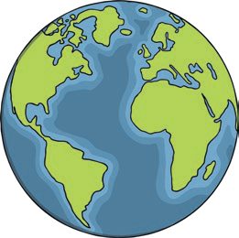 | The Abrahamic religions have these common beliefs:  God revealed himself to Abraham. There is only one God. Their holy books contain many of the same people, places and histories. | In this story, Allah created the world and the heavens, creatures, vegetation and man. There are similarities between the Islamic creation story and the Judeo-Christian one.  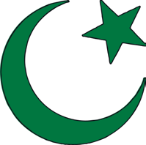

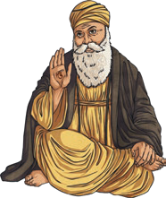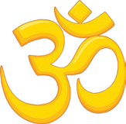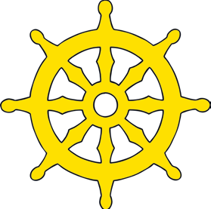
In one story of the creation of the universe, Vishnu commanded Brahma to create the world. Brahma created the heavens, earth and sky using a lotus flower. He then created animals, plants and trees and gave the animals the senses of touch, sound, movement and sight.
Hindu Creation Story
Buddhism
Buddhists do not believe in God, so there is no creation story
in Buddhism.
Key Vocabulary
Brahma | The first god in the Hindu Trimurti.
Trimurti | The three Hindu gods who are responsible for the creation, care and destruction of the world:  Brahma, Vishnu and Shiva.
Guru  Granth Sahib | The Sikh holy book.
Ex nihilo | The world is created from nothing.
Creation from chaos | The world is created by bringing order from disorder.
World parents | The world is created from a world parent or parents.
Emergence | Humans emerge from another world or are born into a  new world.
Earth-diver | Material is retrieved from under water and is used to create land.

Sikh Ideas About Creation | Non-Religious Creation Stories | The Five Types of Creation Story
In the Guru Granth Sahib, creation  is described, but there is no creation story as such.  There is no sequence of events. It does not  mention the time it took to create the world.  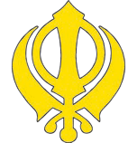 | There are many belief systems and societies that have their own stories and myths about creation. Some of these are written down, others are passed on through  an oral storytelling tradition. | There are five different types of creation stories and myths:  Ex nihilo  Creation from chaos World parents Emergence  Earth-diver  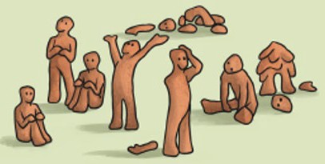

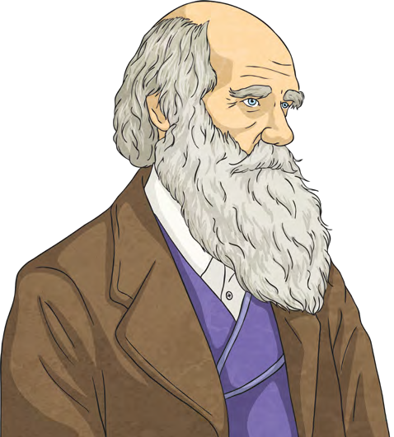
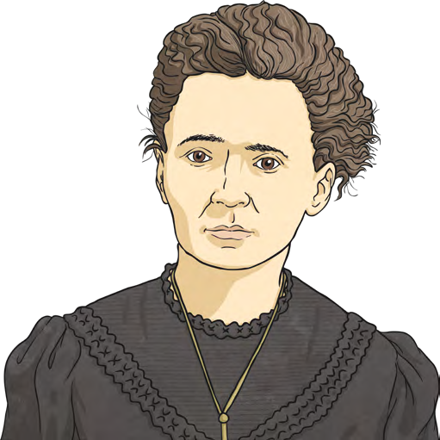
Main Beliefs of Humanism
Main Beliefs of Humanism
Non-Existence of Gods | Meaning of Life Humanists give their lives meaning by living good lives. They make good choices and take an interest in the world around them. | Science
Most Humanists are |  | Scientific investigations
atheists. They rely on |  | gather evidence to find
science and have found |  | the truth. Humanists
no evidence that a god |  | also use evidence to see
exists or ever existed. |  | what is true.
No Purpose to | Reason  Humanists believe decisions should not be made on emotions, but on reason, rationality and logic. | Ethical Decisions To live good lives, decisions must be  weighed up for their positive and negative consequences for all. Humanists believe there are no perfect decisions.
the Universe
They believe that the
universe was created by
chance, so there is no
purpose to the universe.

Key Vocabulary
Humanist | Someone who believes in the Humanism worldview.
Secular | Not connected with religious or spiritual matters.
Atheist | Someone with no belief in God or gods.
Worldview | Your ideas about life or the world.
Ethical | Someone who is honest and follows good moral practice.
Rationality | Thinking about things clearly, in a logical way, with decisions based on facts.

Humanists actively seek to live good lives without following a religion. Their moral values are based on human nature and life experiences. Humanists base their moral principles on reason, shared human values and respect for others. They believe people should work together to improve the quality of life for all. Thinkers such as Charles Darwin, Marie Curie and George Eliot have all influenced Humanism.
Non-Religious World View
Humanists don’t believe in a religion or a god.
In the past, some Humanists did believe in religion, but during the 19th and 20th centuries,
Humanists became more secular.


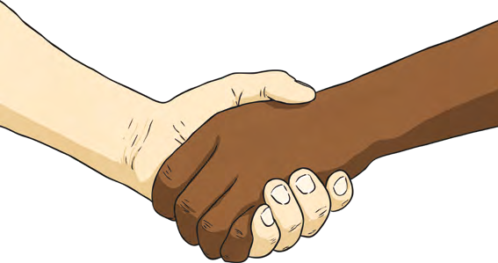
Key Vocabulary
BHA | The British Humanist Association (now operating as Humanists UK). Many Humanists in the UK are members of this association.

The Humanist symbol is called the Happy Human. It was designed by Dennis Barrington who won a competition organised by the BHA in 1965. The symbol was chosen as the design was simple. The symbol shows a human, but it could have be either a male or female. Within a few years, this symbol became the international symbol of Humanism. The symbol is still used, in a range of adapted forms, in the present day.
Humanism Symbols and Meanings
Humanists believe in a golden rule in life. This is to treat others how you would like to be treated.
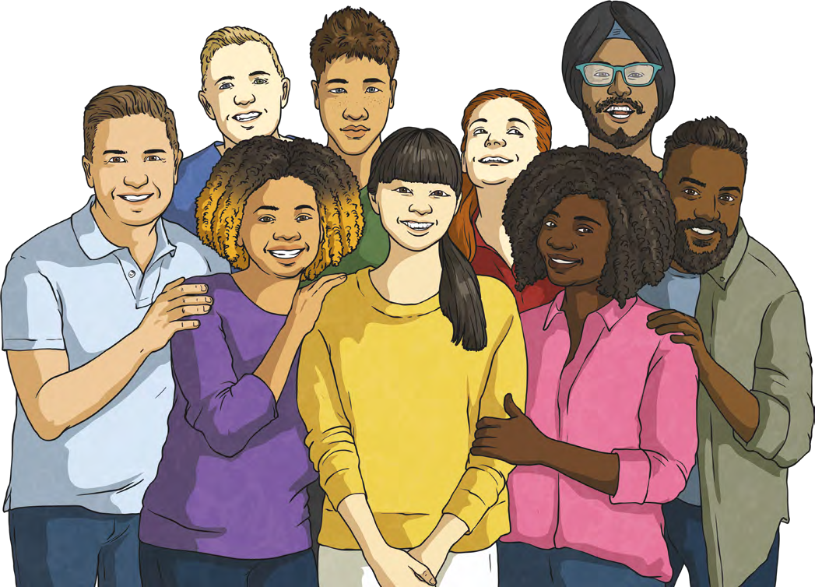
The British Humanist Association Values
Treating people with fairness and respect. | Respecting and promoting freedom, human rights and the law. Engaging | Cooperating with others to make good things happen, including with
 | in conversation and | those of different beliefs.
 | discussion with attention
 | to detail.
 |  | 
Celebrating human achievement, progress and potential. | Engaging in conversation and discussion with attention to detail  and evidence.

Key Vocabulary

Freedom

Moses

The right to speak, think and
act as you want. To be free from something undesirable. To not be imprisoned or enslaved.
A Jewish prophet. He is also an important prophet in a
number of other faiths, including
Christianity and Islam.
Moses wanted freedom for the Hebrews so that they could practice their religion freely.

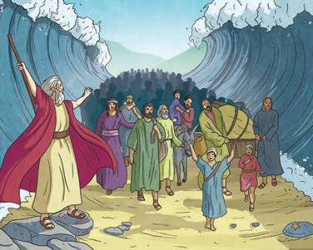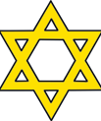
Hebrews

Ten Commandments

Eightfold Path

moksha

guru
Descendants of Abraham who practice Judaism.
Ten rules given by God for people to live by.
Judaism and Freedom
When Moses grew up, God asked him to lead the enslaved Hebrews out of Egypt to safety and freedom. The Pharaoh refused to free the Hebrews so God sent ten plagues to Egypt. Moses then led the Hebrews to find the promised land. Their journey was a difficult one but God provided them with food and shelter. After about three months of travelling, Moses and his people reached Mount Sinai, where God revealed the Ten Commandments to Moses.
Religion and Freedom
Buddhists believe that | Hindus believe that | Sikh gurus believe that
the most important | we should have no | people should have the
freedom is freedom from | restraints on freedom | freedom to choose their
suffering, which can be | of reason, thought, | beliefs and that freedom
found by following the | feeling and will and | comes from choosing to
Eightfold Path. | that this can be done | do the right thing.
 | through moksha.
Moksha can be achieved through knowledge, meditation, worship and
good deeds.
Christians believe that people should achieve their freedom in a way that respects others’ freedom too. |  | In Islam, Muslims believe  that God has given them free will to make good choices.

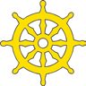
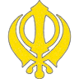
A set of eight instructions, set out by Buddha, to encourage people to follow the right path.
Freedom from the cycle of death and rebirth, so that a person can be at one with God.


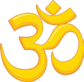

Spiritual teacher

The Universal Declaration of Human Rights is a law written to ensure freedom and equality for all.
It consists of thirty statements such as:
- We are all born free and equal.
- We all have the right to life and to live in freedom
and safety.
- No person has the right to enslave another.
- We are all equal before the law.
- We have the right to believe in what we believe.
Judaism and Freedom
World Religions and Justice There are many
stories about justice from different world religions. These help believers think about what is reasonable and what is fair. The ideas about justice sometimes vary from story to story.
Key Vocabulary
justice | Being fair and reasonable.
human rights | The basic rights and freedoms that belong to every person in the world.
non-violent action | Steps taken to achieve changes,  without using violence.
independence | For a country to be able to rule itself, rather than be under the rule of another.
campaign | Work towards a particular goal.
Catholic | A member of the Roman Catholic faith.
Protestant | A member of the Western Christian churches.
strike | To refuse to work as a form of protest.
boycott | To protest by refusing to have dealings with a country, organisation or person.
apartheid | A system of discriminating on the grounds of race.

Nelson Mandela | Mahatma Gandhi | Martin Luther King Jr
Nelson Mandela was a Christian, who was jailed for protesting about the unfair treatment of Black  people in South Africa. He supported non- violent action, such as strikes and boycotts. Not long after he was released from prison, apartheid ended. | Mahatma Gandhi led peaceful demonstrations in India for equal  rights and for India to gain independence.  Gandhi was a practising Hindu. Gandhi made  a distinction between just and unjust laws in his fight for Indian  Independence. He stated that where laws were unjust, it was acceptable not to follow them. | Martin Luther King Jr was a Christian, who believed that Jesus’ teachings about ‘love thy neighbour as yourself’ meant that we should  all be treated equally. He campaigned for equal rights for Black and White people peacefully. John Hume, an Irish Catholic was inspired by Martin Luther King Jr to campaign for equal rights between Catholics and Protestants.

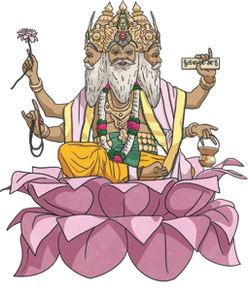
Humanists believe that people should use empathy. This means that people should think about the feelings of other people and animals and consider the effect that our own actions can have on them. They believe that we all have the responsibility to act in this way.
These are the values that are important to Humanists:
- Be honest.
- Use your mind.
- Look after the environment.
- Do to other people what you would like them to do to you.
What Matters Most to Humanists?
The ultimate aim of Hinduism is to leave the cycle of rebirth and become one with the god Brahma.This is called Moksha.
Through samsara and good karma in life, eventually, Hindus believe you can leave samsara and become one with the god Brahma.
What Matters Most to Hindus?
Key Vocabulary
values | Beliefs about what is right and wrong and what is important in life.
morals | Standards of good behaviour.
empathy | The ability to understand another person’s feelings.
Dharma | In Hinduism, Dharma means duty, religion, virtue and morality. It is a central part of a Hindu’s daily life.
Karma | Describes the belief that the good and bad things happening to you are a result of your good and bad actions in this and previous lives.
Samsara | Hindus believe in reincarnation. They believe that your soul has a cycle of lives in succession, with the soul being reborn over and over again.
Moksha | Moksha links to the Hindu belief in reincarnation. Reincarnation is the belief that life is a cycle of birth, life, death and rebirth. When a person dies, they are then reborn as another living thing. This cycle can go on for thousands of lifetimes.

View more What Matters Most? planning resources.
visit twinkl.com

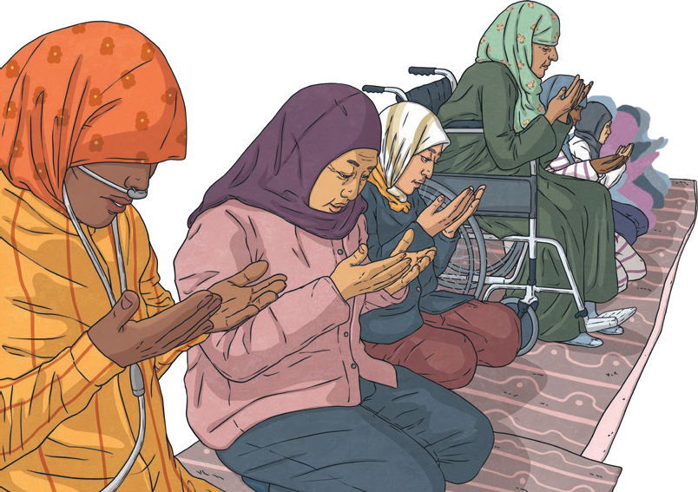
View more What Matters Most? planning resources.
visit twinkl.com
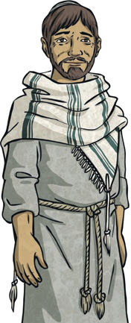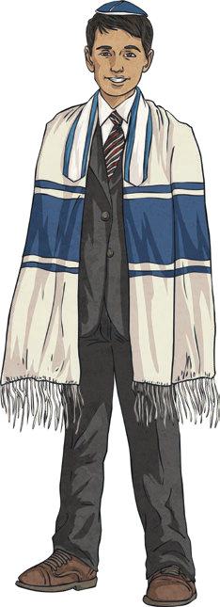
Key Vocabulary
Shabbat | The holy days of the week in Judaism which begin on a Friday and end after Saturday.
Orthodox  Judaism | The original and traditional form of Judaism.
Reform Judaism | A form of Judaism from the 1880s that allows people to follow Judaism in a different way.
Shahada | This is the First Pillar of Islam. Shahada is the main belief of all Muslim people and it is a declaration of their faith.

The first and most important Pillar of Islam is Shahada. The Shahada states a Muslim’s belief in the one Allah. The belief that there is one Allah is central to Islam.The Shahada is a Muslim’s statement of their faith. By saying these words every day in their prayers, Muslims are reminded that there is only one God, Allah.
What Matters Most to Muslims?
As with most world faiths, worship is an important part within the Jewish faith. Jewish people practise their faith by worshipping both at home and at the synagogue (their place of worship). The Torah, the Jewish holy book, is also important to Jewish people as it is the word of God. Shabbat is a
special time of the week when worship and other traditions matter very much.
What Matters Most to Jewish People?
Christians believe that by living by the Christian values given by Jesus, they can make good choices in life. Living by these values enables Christians to believe that they will have a place in heaven with Jesus when they die as they will have lived a good life that helped others as well as themselves.
What Matters Most to Christians?

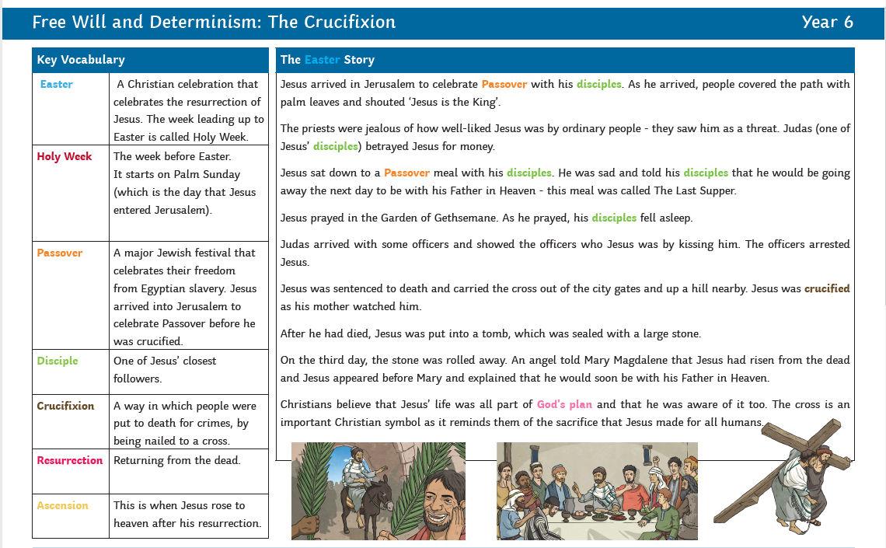

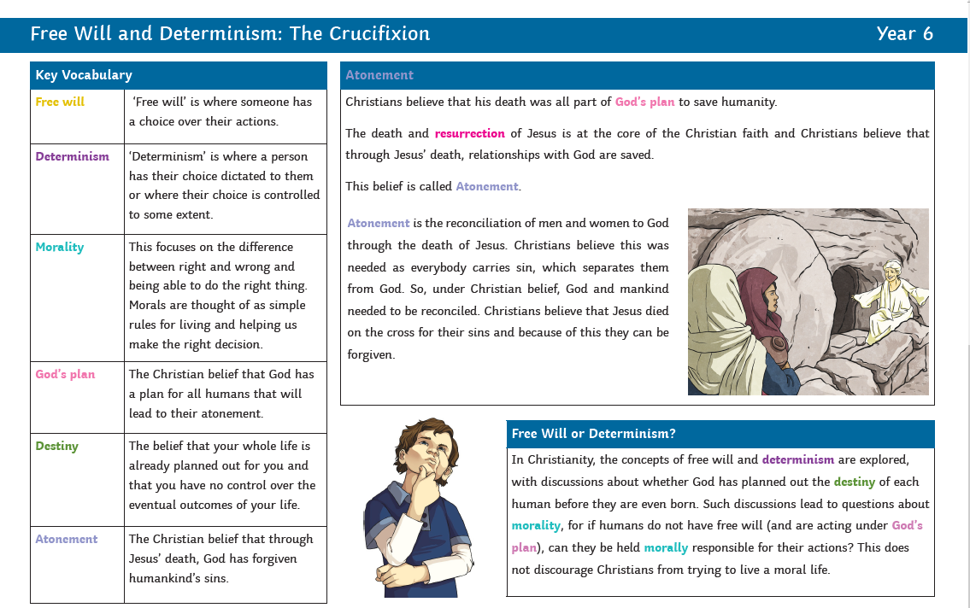

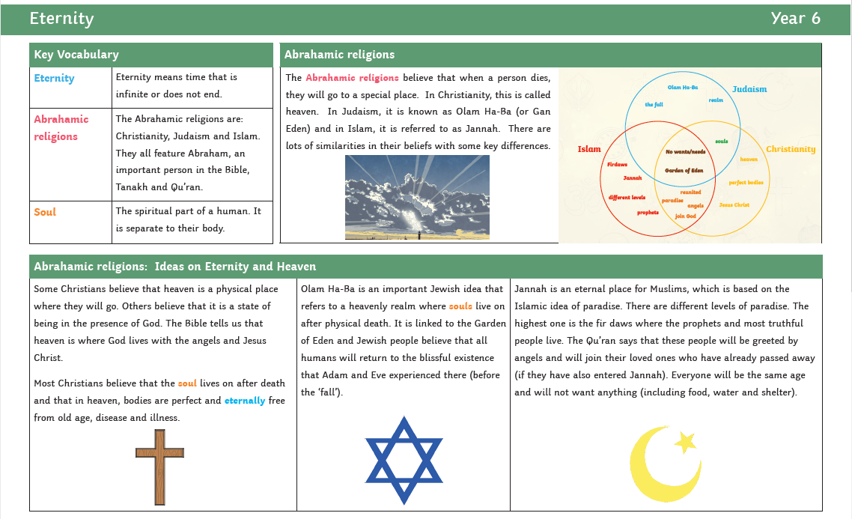
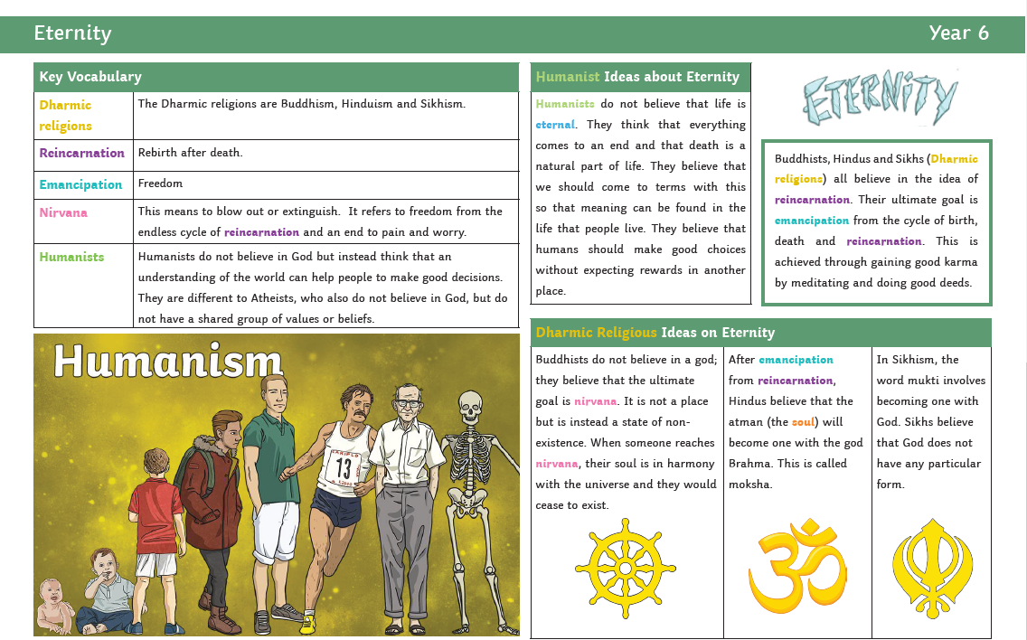
Progression of Skills
 | UKS2
Beliefs and teachings (from various religions) | Children can explain how beliefs and teachings can make contributions to the lives of individuals and communities. Children can compare the key beliefs and teachings of various religions, using appropriate language and vocabulary and demonstrating respect and tolerance.  Children can:  - recognise and explain how some teachings and beliefs are shared between religions;  - explain how religious beliefs can shape the lives of individuals and contribute to society.
Rituals, ceremonies and lifestyles (from various religions) | Children look further at the concepts of belonging, identity and meaning. They understand how certain features of religion make a difference to individuals and communities. Children also explore the rituals and ceremonies which mark important points in life. Moving on from LKS2, children will have the opportunity to explore non-religious ways of life.  Children can:  - explain practices and lifestyles associated with belonging to a faith;  - explain practices and lifestyles associated with belonging to a non-religious community;  - compare lifestyles of different faiths and give reasons why some people within the same faith choose to adopt different lifestyles;  - show an understanding of the role of a spiritual leader.
How beliefs are expressed | Children continue to explore the expression of beliefs through books, scriptures, art and any other important means of communication, as in LKS2. Children then move on to exploring a range of beliefs, symbols and actions so they can understand different ways of life and expressing meaning. Children can explain meaning of religious stories, sources of wisdom and the traditions from which they come.  Children can:  - explore religious symbolism in literature and the arts;  - explain some of the different ways individuals show their beliefs;  - share their opinion or express their own belief with respect and tolerance for others.
Time to reflect and personal growth | Children continue to develop their understanding how an appreciation of religion plays an important role in the lives of some people. They make links to expressing identity and belonging, and notice and respond sensitively to different views. Children can then discuss and apply their own and others’ ideas about ethical questions, including ideas about what is right and wrong and what is just and fair.  Children can:  - recognise and express feelings about their identities and beliefs;  - explain their own opinions about tricky concepts and tricky questions that have no universally agreed answers;  explain why their answers may be different from someone else’s and respond sensitively.
Values (in your own life and others lives) | Children continue to develop their appreciation of the ways in which people’s values are an important aspect of their lives. They make links to responsibility and citizenship.  Children begin to understand the concept of shared values and how a community can use shared values. Moving on from their previous learning, children begin to strengthen their capacity for moral judgements.  Children can:  - explain why individuals and communities may have similar and differing values;  - show an awareness of morals, question morals and demonstrate an ability to make choices, understanding the consequences;  express their own values while respecting the values of others.

