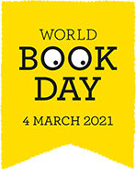
World Book Day Activity Week
EYFS/KS1
Get Creating! | Design and make your favourite book character competition  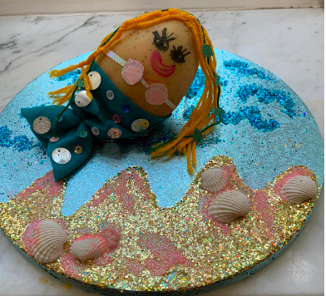  You can choose to create this how you wish, you could make your character out of fruit and vegetables; lego; playdough; craft materials or you may have an idea of your own. Be as creative as you like!  Send pictures of your designs to your class teacher by Monday 8th March. The winner from each key stage will be announced on Friday 12th March and will receive a book token to spend on their favourites books.  Click on the link below to get some inspiration on a few ideas you could use for your character!  https://www.worldbookday.com/fun-craft-favourite-characters/ | 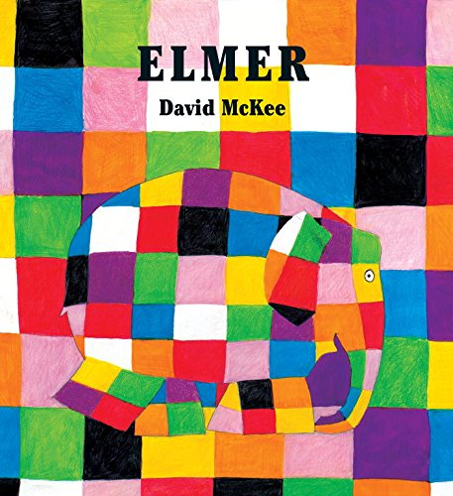  Make your own Elmer  Listen to the story of Elmer read by the author David Mckee  Elmer the Patchwork Elephant  Then create your own Elmer character out milk bottles.  https://www.worldbookday.com/wp-content/uploads/2018/05/Elmer-Milk-Bottle-Craft-Activity.pdf |  | Create a monster lunch  Inspired by gloopy, gunky picture books Spider Sandwiches, Dragon Jelly and Monster Max’s Shark Spaghetti, by Claire Freedman and Sue Hendra.  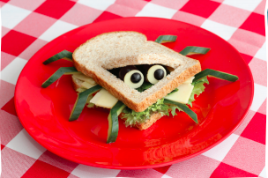  https://www.worldbookday.com/wp-content/uploads/2017/11/Nursery-Cooking-Monster-Max-Scarey-Recipes.pdf
Share a Story  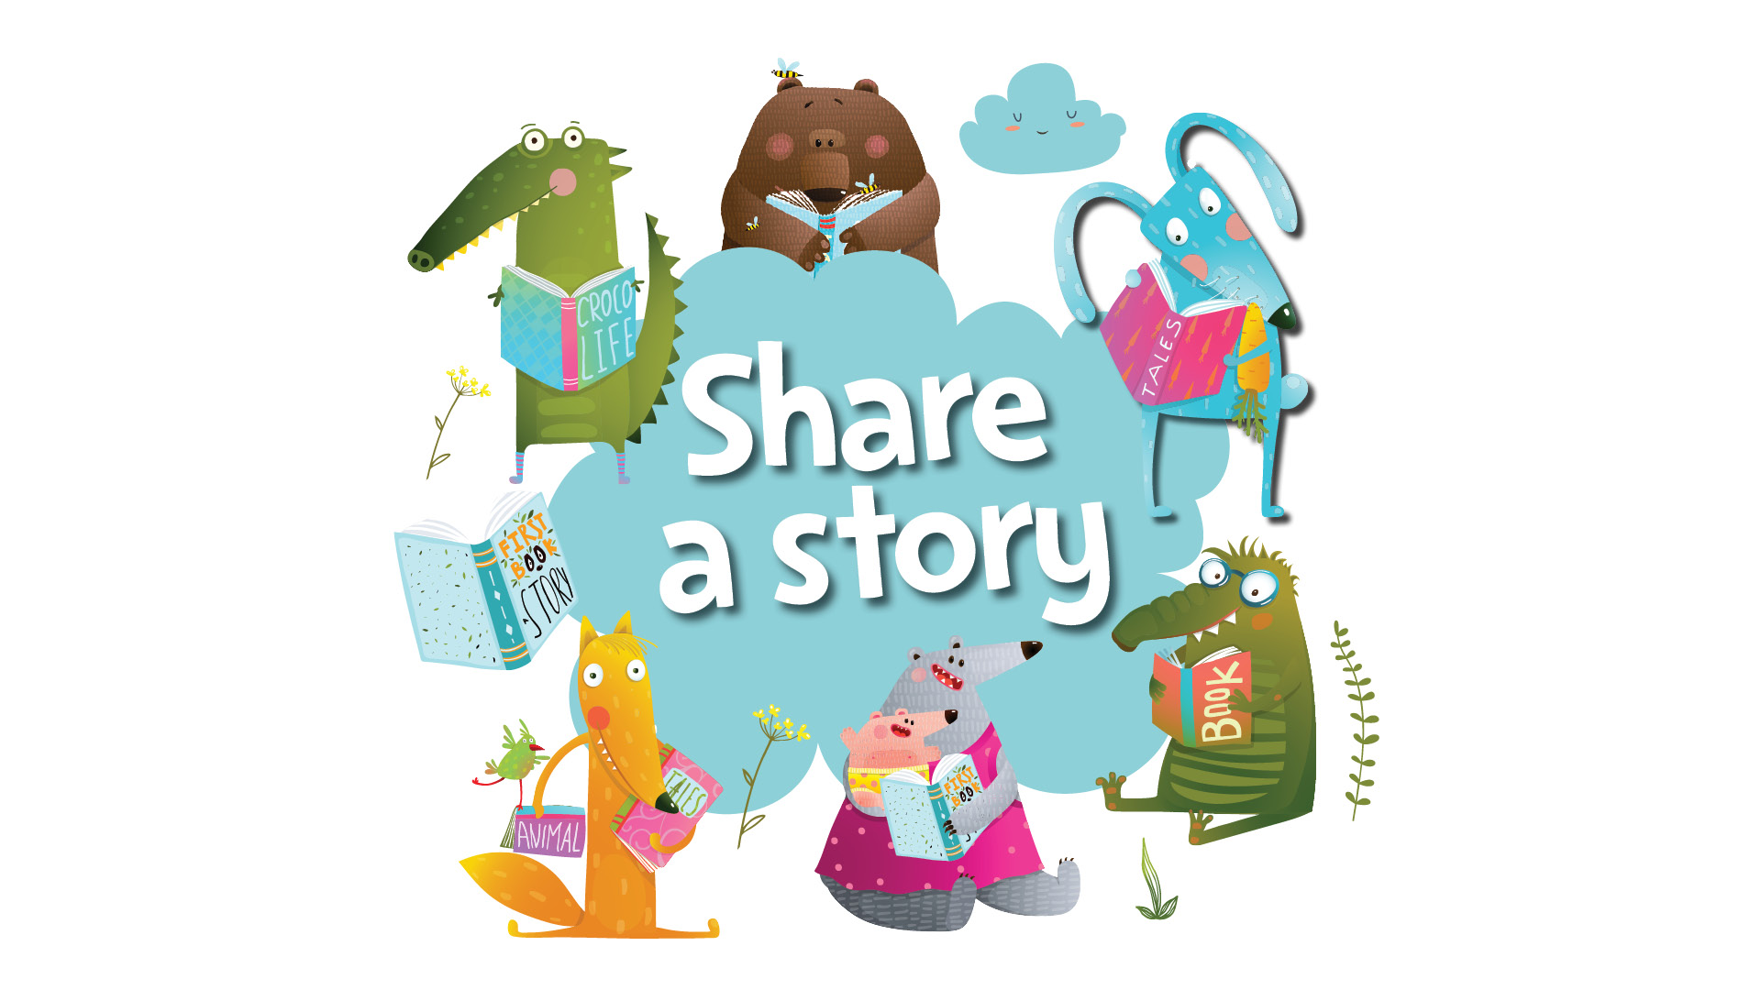 | Share a Story (live events)  Share a story with your whole family by listening to one or more of the stories in Share a Story Corner. After you have listened to the story, download the fun activities for each book.  https://www.worldbookday.com/share-a-story-corner/ | Listen to an Audio Book  Listen to an audio book with your family or on your own. Click on the link below to find a range of different stories from various genres.  https://www.worldbookday.com/world-of-stories/#fiction |  |  | Make a reading tent  Make a reading tent in a room in your house. This could be your bedroom or if your parents allow, in your living rom for the whole family to enjoy. Place a selection of your favourite teddies and books inside and read your favourite stories with your whole family.
Be an Author | Paint or draw your favourite book character  Draw or paint the character you have chosen to dress up as this week.  Challenge: Write the character’s name and a short description of your character.  What does your character look like?  What colour hair/eyes?  What does your character like/dislike doing?  Who are your character’s best friends? | Create a puppet theatre.  Create finger puppets of your favourite characters and retell the story using your characters.  Get your parents to film you and upload to your class blog or email to your class teacher. | Design a book cover for the theatre production you have watched.  Make sure your design is eye-catching so you capture the reader’s attention! |  | Write/draw a book review of your favourite book.  You can either draw a picture of your favourite book to encourage you friends to want to read it or write a review using the template below.  https://www.worldbookday.com/wp-content/uploads/2018/01/Share-A-Story-Book-Review-Template.pdf | Through the Keyhole  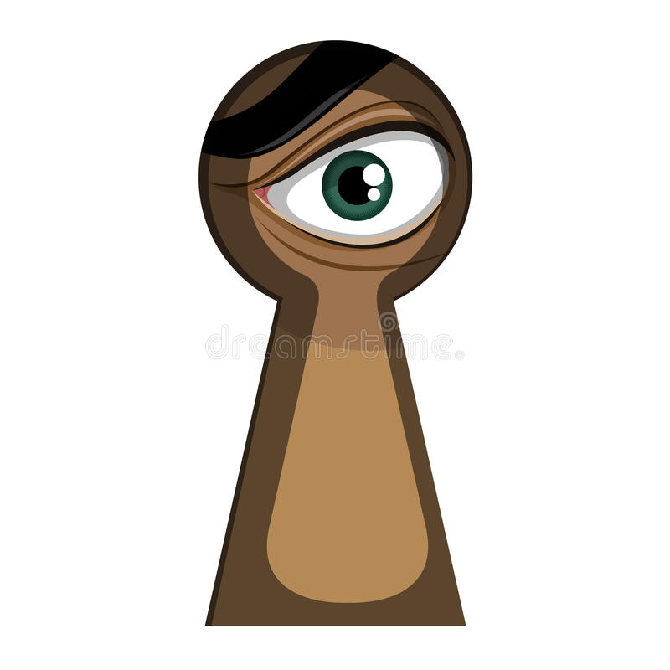  Imagine you are looking through a keyhole at a scene from your favourite book. Draw what you see. Make sue you include the setting and the characters.  As a challenge, add labels to your drawings using words and phrases from the story.

