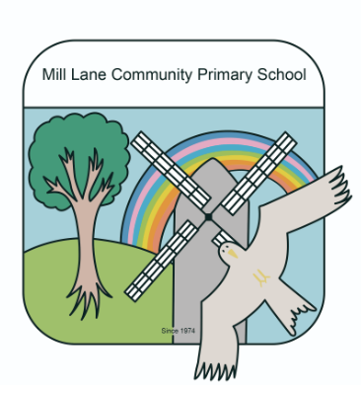
Year 4 Autumn Term 2023 Homework Menu
Dig for Victory! (WW2)
This is your Dig for Victory topic homework menu. On it, you will find a variety of different tasks to complete as homework activities. You can choose from any of the activities and, this term, we have a ‘Wild Card,’ which means that for one of the tasks you will be able to produce anything you like – as long as it has something to do with our topic. As there are more activities than needed, you do not have to do every task. Choose carefully! All homework tasks are open-ended, so you will not be restricted to completing them in a certain way. Try to include a range of writing, art and practical activities throughout the term.
Please complete at least 3 pieces over the term. I have included fortnightly hand in dates below to help you keep on track, but you can hand in topic homework at any time during the term. Remember to ask a member of staff if you are struggling with any aspect of your homework, or if you need specific resources to help you.
Choice 1  Make a timeline of the events of the Second World War. | Choice 2  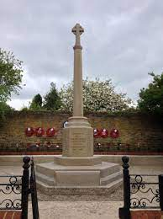  Visit the Chinnor War memorial. What does it tell you about those killed in the War?  Talk to older members of your family about their experiences or of memories that have been passed down to them about WW2. | Choice 3  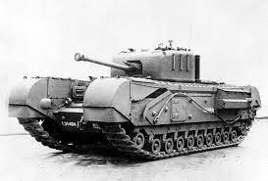  Draw and label a plane or tank from the Second World War – You could even make a model. | Choice 4    Create a propaganda poster. | Choice 5  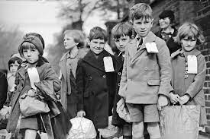  Find out where children were evacuated from and to in Britain. Show this on a map.
Choice 6    Write a newspaper report about a significant event during WW2. | Choice 7    Write your name using Morse Code. Could you write a message? | Choice 8  Make do and mend: Create a toy using only re cycled materials.  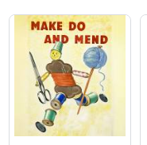 | Choice 9  Find out about rationing. Bake or cook a wartime recipe.  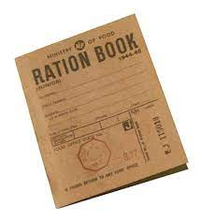 | Choice 10  WW2 Wild Card  For this piece of homework, you can produce anything of your choice. Remember that it does have to link to our Dig for Victory topic in some way!
Homework Due Dates:
Friday 10th November, Friday 24th November, Friday 8th December.

