**Communication, language and literacy**

**Writing:**

* Play scripts based on Street Child
* Diary entries of their character from their play

**Guided Reading:**

* Street Child by Berlie Doherty – VIPERS

**MFL:**

|  |
| --- |
|  |
|  |
|  |

**Mathematical Development**

**Maths:**

* **Unit and non-unit equivalent fractions**
* **Converting between mixed numbers and improper fractions**
* **Compare and order fractions**
* **Multiplying fractions by integers**

**KIRF Focus:**

* **I can identify prime numbers up to 50**

**Physical Development**

**PE:** This Basketball unit will teach the class the skills players need to play both defensively and offensively. The children will learn how to dribble and pass the ball using a range of different techniques. Defensively, they will develop their skills of marking including man-to-man marking. Offensively, they will learn how to get free from a defender, how to shield the ball and the skill of pivoting. They will also learn some of the rules of the game and to play as part of a team in a mini-tournament, putting their newly developed skills into practise. Evaluating their own performance will round off the unit.

**Personal, social and emotional development**

**PSHE:**

This unit is inspired by the idea that we are all individuals and that it is important to ‘be yourself’. It aims to encourage the children to develop a positive view of themselves and enable them to recognise the importance of being proud of their individuality.

**RE:**

In this Worship unit, children will focus on aspects of worship across different faiths. They will explore what worship is, what it means to religious believers and how believers worship differently. Children will consider different forms of worship; through music, art and objects.

**Knowledge and Understanding of the World**

**History:**

* The Victorians
  + Queen Victoria
  + Industrial Revolution and inventions
  + Medicine
  + Children

**Geography:**

* The British Empire

**Year 5 Topic Overview**

**Autumn Terms 3 and 4 2024**

**The Victorians**

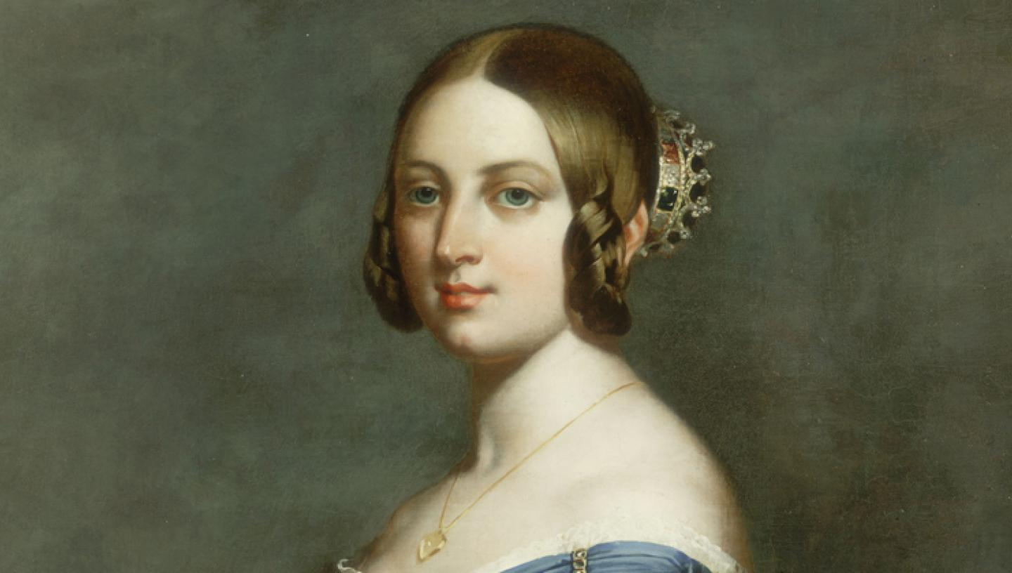

**Creative Development**

**Art:** Plants and flowers – drawing and making 3D sculptures.

**DT:** Building bridges, learning about the different building techniques and how to strengthen them.

**Music:** to listen and appraise the song ‘Make You Feel My Love’ by Adele and develop skills and knowledge of rhythm, pitch, tempo and pulse.

**SScientific Development**

Science: Living things and their habitats

* How plants reproduce – sexual and asexual
* Metamorphosis
* Life cycles of different organisms
* Classification and identification
* Fieldwork

ICT: Systems and searching

* How information is transferred between devices
* Input, output, real life examples
* Search engines, how the World Wide Web workd