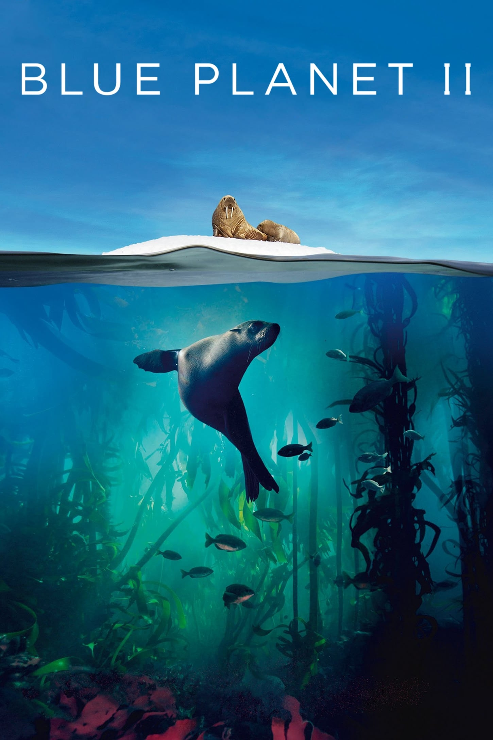

**Creative Development**

**Art:** The children will create their own clay fish by joining 2 thumb pots together using the scratch and slip method. They will add texture and colour to their work. They will also create abstract fish in the style of Vincent Scarpace.

**DT:** The children will design and make sea creature soft toys using 3 stitches (running, stitch, back stitch and blanket stitch)

**Music:**

* The children will learn and innovate verses for a grime-inspired anti-bullying rap;
* They will also learn a selection of traditional sea-shanties and compose accompaniments for them, along with a sea-soundscape.

**Physical Development**

**PE:**

* **Netball**
* **Tennis**

**Personal, Social and Emotional Development**

**PSHE: (VIPS)** The children will look at how friendships are formed and maintained, the qualities of a good friend and strategies for coping with disagreements. **PSHE: (One World)** The children will reflect on what they can do to help make the world a fairer place.

**RE: (Christianity)** The children will learn about the key aspects of the Christian faith. They will find out where Christianity originated, about special places and key festivals in Christian life and the main beliefs held by Christians. **RE: (Food and Fasting)** the children will explore the role food plays within religions, including lent and Ramadan as well as how food is also used within religions for celebrations.

**Scientific Development**

**Science:**

* States of matter (The Water Cycle)
* Living things and their habitats

(Grouping and Classifying animals and environmental change)

* Animals, including humans (Food Chains)

**ICT:** Using spreadsheets / Logo control

**Year 4 Topic Overview**

**Spring Term 2024**

**Blue Planet**

**Knowledge and Understanding of the World**

**History:** The children will learn about Jacques Cousteau’s impact on our knowledge of what is in the ocean and the history of ocean exploration.

**Geography:** The children will learn about the seas and oceans of the world, the Great Barrier Reef and the impact of environmental issues.

**Mathematical Development**

**Maths:**

* Multiplication and Division
* Fractions
* Decimals
* Time
* Length, area and perimeter

**KIRF Focus:** Multiplication and Division Facts for the 7- and 12-times tables.

Where appropriate, links will be used in maths to enhance learning in our Blue Planet topic, including: measurement (sea depths) and venn diagrams to classify sea creatures.

**Communication, Language and Literacy**

**Writing:** Using the stimulus of ‘The Song of the Dolphin Boy’ By Elizabeth Laird the children will focus on narrative writing, explanation texts, non-chronological reports and persuasive writing.

**Reading:** Using the Literacy Shed Vipers Year 4 will be reading ‘The Last Bear’ By Hannah Gold.

**MFL: French (Where in the World?)**

|  |
| --- |
|  |
|  |
|  |

The children will learn specific key vocabulary related to countries/continents and animals.

**SScientific Development**

**Science:** Over the term Year 4 will be learning about Forces and Magnets, creating their own compasses, understanding what friction, push and pull forces and the role of gravity.

**ICT:**