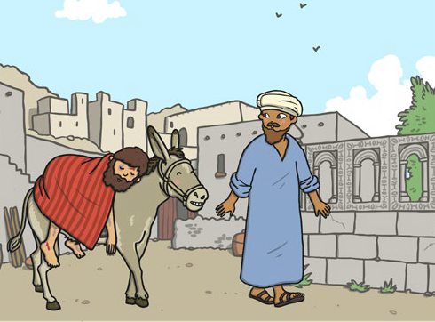
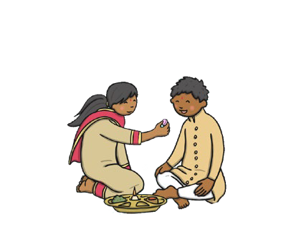
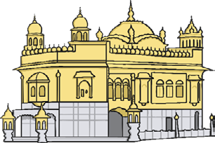
Key Vocabulary
Raksha Bandan | A Hindu festival (usually celebrated in August) that celebrates the love between brothers and sisters.
Gurdwara | A special building for Sikhs and they go there to worship.
langar | A free kitchen found inside a gurdwara.
langar hall | The place inside a gurdwara where people can sit together and eat a free meal.
Samaritan | At the time, this was a person from a place called Samaria. Now, it is a person who helps other people.
Bible | A special book for Christians. It has lots of stories and lessons which help Christians lead their lives.
Levite | A person who worked in a temple in Jerusalem.

Raksha Bandhan (Hinduism)
In the Raksha Bandhan festival, sisters tie a Rakhi (bracelet) around their brother’s wrist. The Rakhi means protection from evil. After this, the sisters say a prayer and put a mark (called a tilak) on their brother’s
forehead. The brothers then make a promise to look after their sisters.

Langar (Sikhi)
Each gurdwara has a langar and a langar hall. The langar meal is vegetarian so that people from all religions are able to eat it. This is because Sikhs believe everyone is equal and should be treated the same. Everyone takes it in turns to
prepare, cook and serve the meal, then clear up afterwards.

The Good Samaritan (Christianity)
The Good Samaritan is a Bible story told by Jesus. It tells us to be kind to others, regardless of who they are.
One day a Jewish man went for a walk. Along the way, two bandits stole his belongings and clothes, beat him up and left him by the side of the road.
A priest and a Levite walked past him and both of these people ignored the dying man.
A Samaritan walked along the road and saw the dying man. Samaritans and Jews did not usually get along at the time but the Samaritan helped the man. He gave him the cloak from his back, put the man on his donkey and took him to an inn. He bought expensive supplies to heal the man and paid for him to stay at the inn while he got better.

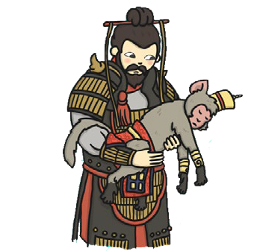
The Monkey King (Buddhism)
Key Vocabulary
The Prophet Muhammad (Peace Be Upon Him) | The founder of Islam.  He is seen by Muslims as God’s messenger.
prophet | A person who is thought to be a direct messenger from god.
sacrifice | Giving up something important. This often benefits others.
consequence | Things that happen as a result of something that somebody says or does. Consequences can be good or bad.

A long time ago, a monkey king lived in a forest full of fruit (including mangoes). He ordered his monkeys to pick and hide the mangoes so nobody else could have them. However, the biggest and juiciest mango stayed hidden. That night, a strong wind shook the mango loose. It fell into a river and was swept to another land, where a human king took a bite of it. He wanted more so he took his men to the forest.
All the monkeys were asleep in the mango tree, apart from one. She ran to the other monkeys to wake them, but she was followed. The king announced that the mango tree was his now and anyone in it would be killed. The monkey king said he would protect his tribe, which made the human king angry. He ordered his men to kill the monkeys. To escape, the monkeys had to cross a river by using their king’s back as a bridge. The monkey king was in pain and dying. The human king saw this sacrifice and was touched. He ordered his soldiers to help the monkey king down. The human king promised to become a good and kind ruler. A consequence of this was that all creatures were allowed to share in the forest fruit.
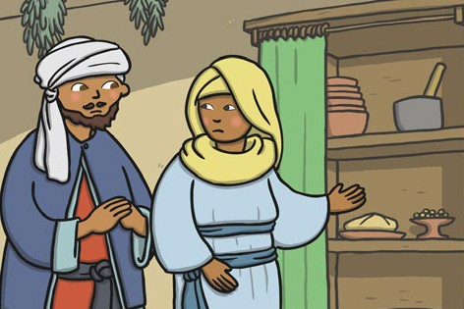
Be My Guest (Islam)
The Prophet Muhammad (Peace Be Upon Him) asked Abu Talha (one of his close friends) to take a poor and hungry man home and to feed and look after him.Abu Talha went home and told his wife what the Prophet Muhammad (PBUH) had asked him to do. His wife told him that they only had enough food for their children. They sent their children to bed and made a meal for the visitor using the food they had. To save the visitor from feeling sad, they turned down the lamp so that he couldn’t see that their plates did not have any food on them. Abu Talha and his wife made a sacrifice. They did not eat and put the needs of the poor man ahead of their own.

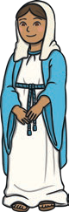
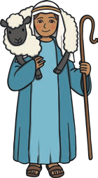
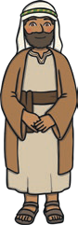
The Nativity Story
Key Vocabulary
Christmas | Christmas is the time when Christians remember and celebrate the birth of Jesus, the son of God.
Christmas Day | Christmas Day is celebrated by Christians all over the world on 25th December every year. It is a special holiday when most offices, shops and all schools are closed.
Nativity | A play that tells the story of the birth of Jesus.

The Angel Gabriel visited Mary and told her she was going to have a baby called Jesus and that he would be God’s son.
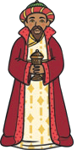
Mary and Joseph had to travel to Bethlehem. A kind innkeeper in Bethlehem let Mary and Joseph stay in his stable for the night and Jesus was born there.

An angel appeared to some shepherds and told them that the son of God had been born in Bethlehem. The shepherds walked to Bethlehem to visit the baby Jesus.
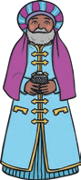
Some Wise Men saw a star in the sky and knew that it meant a king had been born. They followed the star. They went past the palace of King Herod who asked the men to tell him where the baby was. The Wise Men found baby Jesus but they received a message from God warning them not to tell Herod so they didn’t.
Herod began to search for Jesus. He ordered that all baby boys in Bethlehem be killed. However, after a warning in a dream, Mary and Joseph travelled to Egypt with Jesus and he was safe.
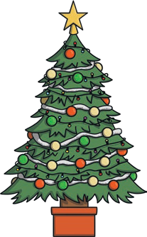
The story of the birth of Jesus is very important to Christians. Many believe he was a gift from God.
People celebrate Christmas in lots of different ways and these include acting out a nativity, carol singing, putting up and decorating Christmas trees and hanging wreaths. Many families get together for a special meal on Christmas Day.
Many Christians give gifts at Christmas to show their love for one another. After his birth, the Wise Men gave Jesus special gifts of gold, frankincense and myrrh. They were the kinds of gifts given to kings at that time.
They were very valuable and were probably the first Christmas presents.
Christmas Traditions

Key Vocabulary
Eid Al-Fitr | Eid Al-Fitr is a special festival which celebrates the end of Ramadan. It lasts for three days.
Eid Mubarak | ‘Have a blessed Eid.’
fasting | Fasting is a period of time when you do not eat or drink.
Qur’an | The Muslim holy book.
Ramadan | A holy month for many Muslims. It is often marked by fasting.
Zakat Al-Fitr | A type of charity which many Muslims give either during Ramadan or Eid Al-Fitr.

Ramadan
Ramadan is a very special time for many Muslims. It celebrates the time when the Qur’an was revealed to the Prophet Muhammad (Peace Be Upon Him). It is celebrated at a different time every year because Islam uses a lunar calendar, which is based on the cycles of the moon.
During Ramadan, many Muslims fast during daylight hours. Often, they go to the mosque to read the Qur’an.
Many Muslims fast during Ramadan because it reminds them of people in the world who have less than they do.
People who are young, elderly or ill don’t have to fast.
Muslims will often have a meal called Suhur before sunrise and another called Iftar after sunset.
Zakat Al-Fitr is often given at this time. Many Muslims give food or money to help those in need.

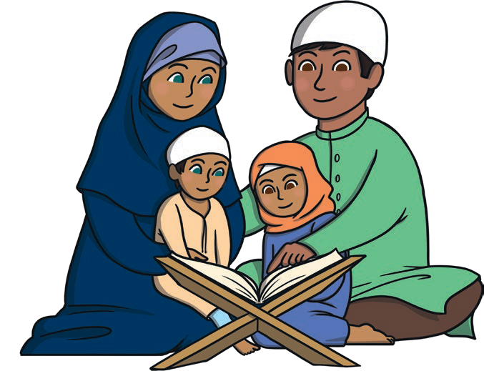
Eid Al-Fitr is the time when many Muslims celebrate the end of Ramadan. It lasts for three days and is a very special time.
During Eid Al-Fitr, Muslims may give thanks to Allah (God) for giving them the strength to fast during Ramadan.
It is also a time for many Muslims to think about others.
Eid Al-Fitr is celebrated in lots of different ways. Many families go to the mosque to pray. Gifts are often given and are usually opened after the morning prayer and people can exchange cards that say ‘Eid Mubarak!’
Eid Al-Fitr

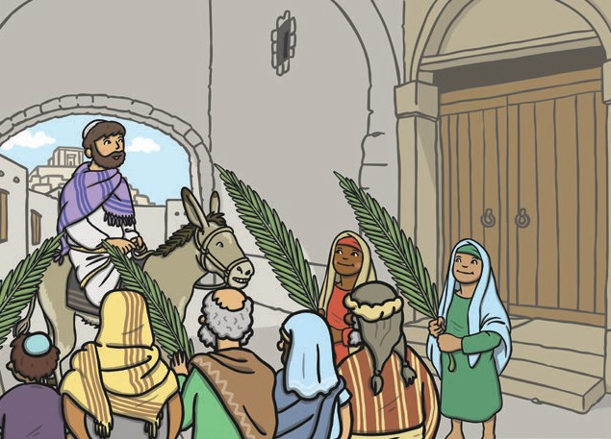
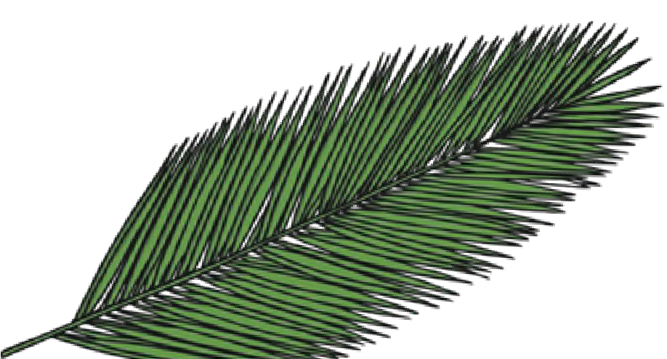
Holy Week is the week leading up to Easter. The Easter story is very
important to Christians as it reminds them of Jesus’ death and celebrates his resurrection. There are four important days during Holy Week: Palm Sunday, Maundy Thursday,
Good Friday and Easter Sunday.
Holy Week
Key Vocabulary
Easter | The oldest and most important Christian festival.
Christians | People who follow the religion of Christianity.
Jesus | The son of God.
resurrection | When Jesus came back to life.
disciples | The twelve followers of Jesus.
symbolise | When something stands for something else.
betray | To be unfaithful or break a promise to someone.
Holy Communion | A special service in church, where Christians share bread and wine.

Palm Sunday | Maundy Thursday | The Last Supper
Palm Sunday marks the start of Holy Week. Christians remember when Jesus rode into Jerusalem on a donkey and was welcomed by people waving palm leaves and placing them on the ground in front  of him. Palm leaves symbolise goodness and well-being. | On Maundy Thursday, the story of the Last Supper is remembered. ‘Maundy’ comes from a word that means command. At his last supper, Jesus told his disciples to love one another. Jesus knew that this would be his last supper and that one of his disciples (Judas), would  betray him. | During the Last Supper, Jesus shared some bread and wine with his disciples. Jesus said the bread was his body and the wine was his blood.  During Holy Communion, Christians re-enact this special moment from the Last Supper.  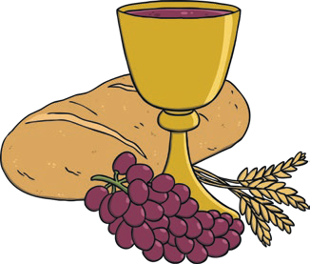

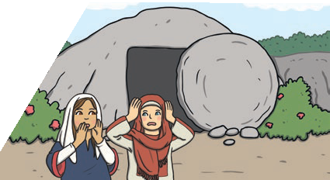
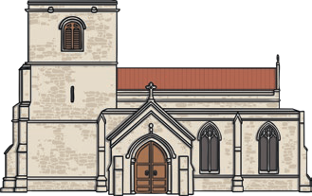

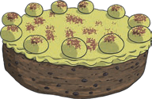
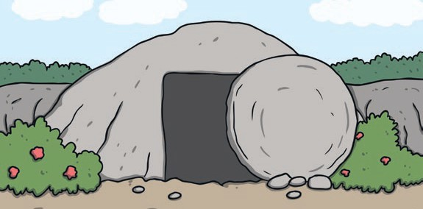
Some of Jesus’ friends went to visit his tomb on the Sunday after he died. They were surprised to find it empty. After his resurrection Jesus visited his disciples before going up to heaven to live with God.
A Surprise
Many Christians go to
church at Easter. Parts of the Bible are read and special hymns are sung. Hot cross buns are eaten. The cross reminds people that Jesus died on the cross. Many Christians send Easter cards. Simnel cake is eaten. It is a fruit cake with eleven marzipan balls on the top. These represent all of
the disciples except Judas. Eggs are painted and chocolate eggs are given. The eggs symbolise new life and are the same shape as the rock that was rolled in front of Jesus’ tomb.
Easter Traditions
On Easter Sunday, Christians celebrate Jesus’ resurrection. The resurrection of Jesus gives Christians the promise of eternal life in heaven.
On Good Friday, Christians remember the day that Jesus was crucified. Leaders in Jerusalem were jealous that people listened to Jesus and so they had him crucified.
Christians believe it is ‘good’, because Jesus showed great love and died for the sins of others. When he died, his body was put in a stone tomb.
Good Friday
Key Vocabulary
crucified | Put to death on a cross.
sins | Bad actions.
tomb | A place cut into rock or underground, where the dead are buried.
eternal | Lasting forever.
heaven | Christians believe this is where God lives and where good people go after death.
bible | The Christian holy book.
hymns | Religious songs.

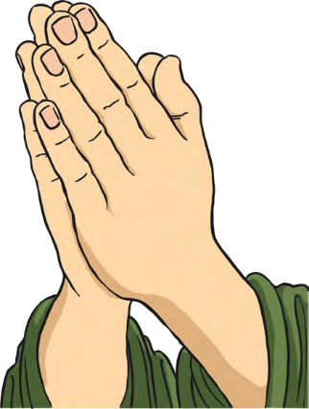
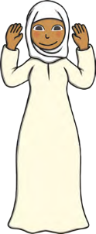
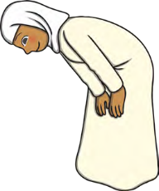
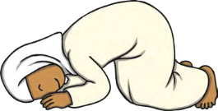
A ritual often includes certain things:
- repetition of actions or words
- special objects used in a particular way
- a special order in which things are done
- a focus or theme, perhaps praying to God
Rituals are used by people in religion to help them remember things, to help them focus on God (or an important idea from their religion) and as part of praying to, or worshipping, their god.
Rituals
Sudjood
Ruku
Niyyat
Prayer (salat) is an important part of the Islamic faith. Salat should be performed five times every day. These times are at dawn, midday, late in the afternoon, after sunset and in the dark of the night. Salat is often performed in a mosque but it can be done anywhere. Muslims may use a prayer mat. Muslims make sure that they are facing Mecca when they are praying. When Muslims pray, they perform sets of movements and gestures.
These include starting the prayer by standing up, raising their hands to their ears and saying, ‘Allahu Akbar’ (which means ‘God is great’). This is called Niyyat.Other actions include Ruku, dropping into a prayer position with their hands on their knees, looking at their feet and saying the prayer words.Sudjood is another action. In this, Muslims kneel with their hands, feet and
face towards the ground and say the prayer words.
Salat
Key Vocabulary
ritual | A ritual is similar to a ceremony. In a ritual, a series of things is done in a special order. Rituals are sometimes done every week, or every day, or at special times.  They often have religious or spiritual significance.
salat | One of the Five Pillars of Islam (the ‘rules’ that  Muslims follow to live a good life). It is a type of prayer that should be performed five times every day.
mosque | A Muslim place of worship.
Mecca | A holy city in Saudi Arabia.
gesture | A movement of the body. A gesture could involve moving any part of your body including your hands or head. It is a way of communicating without talking.

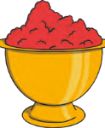
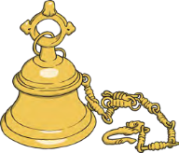
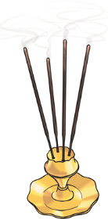
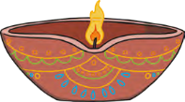
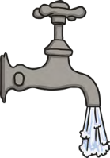
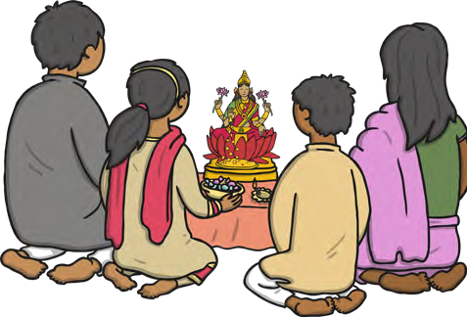
Key Vocabulary |  | Puja
punja | A type of worship (used in Hinduism) featuring prayer to a god. | Hindu worship is called puja. It can be performed at home or in a Hindu temple. It is often performed at a shrine.  Before performing the ritual prayer of puja, Hindus remove their shoes to show respect for God. They chant prayers (mantras) and they give offerings to the murtis such as fruit, water and flowers. This is to show their love and respect for the gods, just as a host would want to offer food and drink to a visitor. When the puja has finished, Hindus share and eat the food. They believe this food is blessed after it has been offered to the deities.This blessed food is known as ‘prashad’. ‘Aum’ is chanted during puja, incense is burned to make the air pure, a bell is rung and red dots are placed on the foreheads of the worshippers and of the murtis. A diva lamp is lit and the murtis are offered a drink of water from a spoon. Hindus believe that they feel closer to their gods when they speak to them using all of their senses. All  the senses are used during the ritual of puja.
Shrine | A holy space for worshipping. It often includes a picture of the thing being worshipped.
murtis | Special images that represent a Hindu god.
Holy Communion | A ritual that some Christians take part in to remember Jesus, his death and how it meant that Christians were saved from sin.
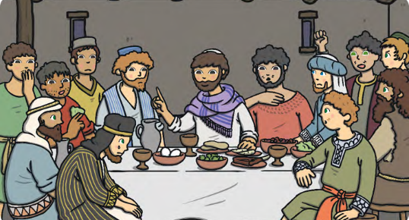
Christians believe that Jesus is the Son of God. They believe he came to earth and lived as a real human being. Christians believe that Jesus died on a cross and that his death meant that all the bad things (sins) that humans did could be forgiven. They believe that he knew he was going to die. Before he died, he had a last meal with his closest friends, who were called his disciples. It was called the Last Supper. During this meal, he shared bread and wine with his closest followers. He said the bread was his body and the wine was his blood. During services, Christians may perform a ritual known as the Holy Communion. They eat a small piece of bread and take a sip of wine or grape juice. Prayers are read out during Holy Communion.
They help Christians remember Jesus, the importance of the Last Supper and his sacrifice.
Holy Communion

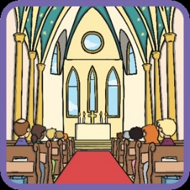
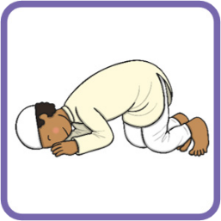
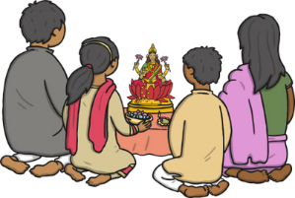
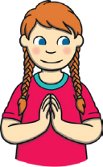
A place of worship is a special place within a religion where believers may go to:
- pray
- worship their god or gods
- learn about their religion
- spend time together as a community
Many places of worship have special rules for people to follow as a way of showing respect.
What Is a Place of Worship?
Communities often come together in these special places to spend time together or hold events. Many people mark important occasions
in their lives at places of worship, e.g. weddings, baptisms, coming of age ceremonies and invitations into the faith.
Why Are Places of Worship Important?
What Is Worship?
Worship involves showing love or respect to something or someone. People who belong to a religion often worship a god or gods. Worship can happen in many different ways. Some religious believers show their respect and love by looking at a picture of their god and giving special gifts to it. Other people pray or talk to their god while they worship.
Key Vocabulary
murtis | Images of gods. Hindus use them in their worship. They are often colourful and bright.
yantras | Drawings of the universe made with special colours and shapes.
karma | Consequences caused by people’s actions.
bimah | A raised platform where the Torah is placed when read.
ark | A special place where the Torah is kept. It is often on the main wall of the synagogue.
font | These can be different shapes and sizes but all fonts hold water. This water is used for baptism, a special Christian ceremony.
Holy Communion | A special ceremony, involving bread and wine, which helps Christians to remember Jesus.

Hinduism and Mandirs
Hindus believe in a supreme god called Brahma. They also believe that people live more than one life and that if they have done good things in this life, karma will mean that they will have a good next life.
The Hindu place of worship is called a mandir, or Hindu temple. Not all Mandirs look the same but there are certain parts of the buildings that have special meaning. For example, the towers of a mandir remind Hindus that their spirits will reach heaven. Inside a mandir, you will find murtis. You might also find yantras.
The Jewish place of worship is called a synagogue. Most people in a synagogue cover their heads. Men wear a special cap called a kippah. The Jewish special book is called the Torah. It is sometimes placed on the bimah or kept safe in the ark.
An important set of rules in the Torah is the Ten Commandments, which Jewish people believe God gave to Moses. They try to keep all Ten Commandments throughout their lives.
Judaism and Synagogues
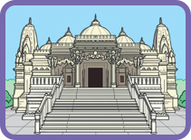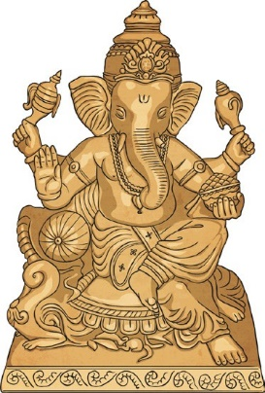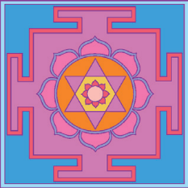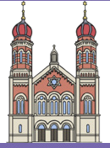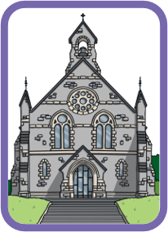
Christians believe in just one god. They believe that God created the world and all people. The special place of worship for Christians is called a church. Churches are often in the shape of a cross, as this is an important symbol for Christians.
Inside a church, you will find a copy of the Christian holy book, the Bible. This is often placed on a lectern. There will also be an altar (where Holy Communion takes place) and a font.
Christianity and Churches

Key Vocabulary
Which Communities Might I Belong to?
My family  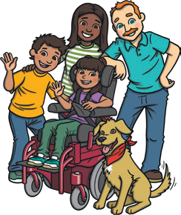 | My school  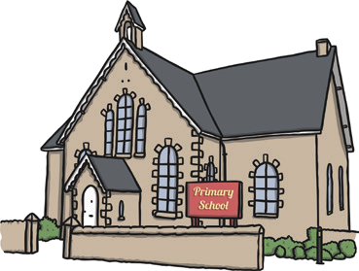 | My class  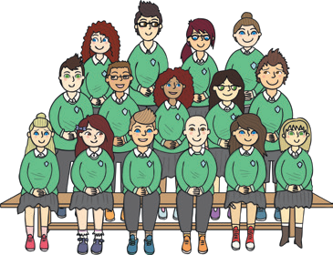 | A club  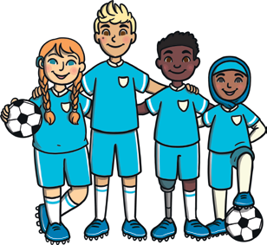

To belong is to be in a place or a

belong

community

identity

religion

role

symbol
group where you feel safe, secure and valued.
A community is a group of people living or working together or who have shared interests.
Christianity | Judaism | Islam
A religion based on the teachings of Jesus Christ. The belief that Jesus is the Son of God and he died to forgive human sin. Followers are  called Christians. | A religion with one God, who revealed Himself through prophets such  as Abraham and Moses. The world’s oldest religion.  Followers are called  Jewish people. | A religion centring around The Qur’an as the word of Allah.  This was revealed to the Prophet Muhammad (PBUH). Followers  are called Muslims.

A person’s identity is the qualities, likes and dislikes that make them who they are.
A system of faith or worship linked to one or many gods.
A role is a part that a person can play. In a family, this might be the position that you hold e.g. son, daughter, sister or brother.
Key Religious Text
The Bible  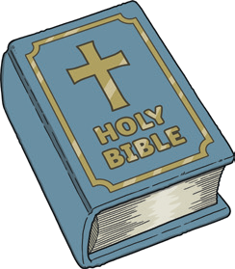 | The Torah  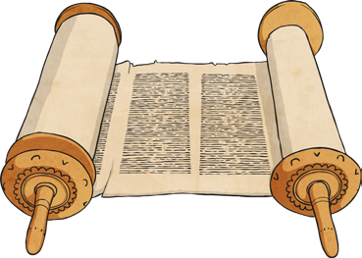 | The Qur’an  

A symbol is something that stands for something else. An object with an underlying meaning.

Churches, mosques and synagogues are all places to pray, sing and hold celebrations such as weddings.
What Do Religious People Do in Their
Places of Worship?
Christian Festivals | Jewish Festivals | Islamic Festivals
Christmas | Rosh Hashanah | Eid Al-Fitr
This festival celebrates the birth of Jesus Christ. | The Jewish new year festival. | A joyful festival celebrating the end of a month of fasting.
Easter | Shavuot | Laylat Al-Qadr
This festival celebrates Jesus dying on a cross and rising from the dead three days later. | A festival celebrating God giving the words of  the Torah to Moses. | A festival remembering Allah delivering the words of the Qur’an to the Prophet  Muhammad (PBUH).

Key Vocabulary
The Muslim ceremony that takes place to welcome a
Aqiqah
church mosque

Shabbat
new baby into the Islamic community.
The Christian place of worship.
The Muslim place of worship.
The Jewish day of rest, taking place each Friday evening until Saturday evening.
Key Religious Symbols
Christianity - Cross  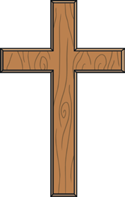 | Judaism - Star of David | Islam -  Star and Crescent

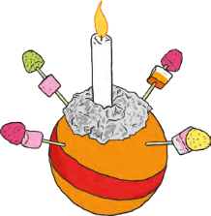
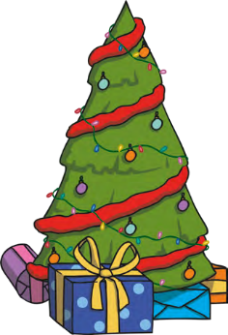
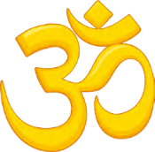
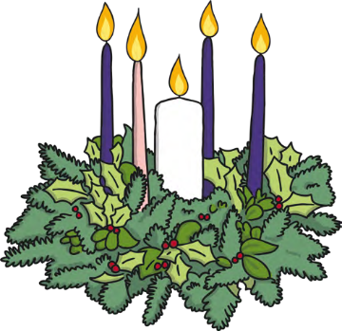

Christians use lights to help them celebrate Christmas. There are many types
of lights, e.g candles, tree lights and hanging light decorations. A star is often placed on top of the Christmas tree, as a reminder of the star that led the Three Wise Men to Bethlehem.

Many churches and schools hold
Christingle services. A Christingle is an orange decorated with a red ribbon, sweets and a candle.
The lit candle represents Jesus as the ‘light of the world.’

Diwali is celebrated by Hindus and Sikhs in October or November. It is the start of the Hindu new year and lasts for five days. The word ‘Diwali’ comes from a word that means ‘lighted row of lamps’.
Diwali
Christingle
Christmas
Advent is the start of the Christian year. It is when
Christians start to prepare for Christmas. Churches display an advent crown or wreath. These usually contain five candles, which remind Christians
about the light of God coming into the world through the birth of Jesus Christ.
Advent
Light is important to Christians, as they believe Jesus to be the ‘light of the world’, bringing light and hope to people, even in times of darkness.
Key Vocabulary
Advent | The four weeks leading up to Christmas (starting on the nearest Sunday to 30th November).
Christians | Followers of the religion of Christianity.
Christmas | The Christian festival that celebrates the birth of Jesus. Christmas Day is celebrated on 25th December.
Jesus | The founder of Christianity, believed by Christians to be the son of God.
Bethlehem | The place of Jesus’ birth.
celebrate | To take part in enjoyable activities  for a particular occasion.
Diwali | The Hindu festival of light.
Hindu | Followers of the religion of Hinduism.


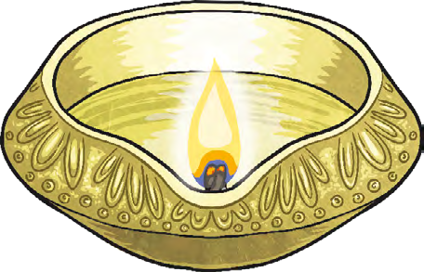
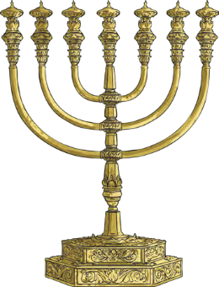
Key Vocabulary |  |  | Diwali |  |  | Fireworks are set off during Diwali celebrations.
exile | To be made to stay away  from home. |  | Diwali celebrates the victory of good over evil and light over darkness. At Diwali, some Hindus remember the story of Rama and Sita returning from exile, where their way home was lit by  lamps. Hindus light diva lamps at Diwali to welcome Lakshmi into their homes. |  |  | Fireworks are set off during Diwali celebrations.
victory | A win against the enemy. |  |  |  |  | Fireworks are set off during Diwali celebrations.
evil | Very bad. |  |  |  |  | Fireworks are set off during Diwali celebrations.
diva | A small oil lamp (usually made from clay). |  |  |  |  | Fireworks are set off during Diwali celebrations.
Lakshmi | The Hindu goddess of wealth.
Lakshmi | The Hindu goddess of wealth. |  | Hanukkah | The Hanukkah Menorah | Celebrating Hanukkah
Hanukkah | The Jewish festival of light (also known as Chanukah).
Hanukkah | The Jewish festival of light (also known as Chanukah). |  | Hanukkah celebrates one of the greatest miracles in Jewish history. After their temples were destroyed by the King’s army, the Jews found a tiny amount of oil at the temple in Jerusalem to light a menorah. The menorah had seven branches. It kept burning for eight days  and nights - a miracle! | A Hanukkah menorah has nine branches, not seven. The branch in the middle, holds the candle that is used to light the others.  On each night of Hanukkah, a branch of the menorah is lit as  a reminder that God is with you, even during difficult times. | Jewish people eat oil-based foods during Hanukkah. The festival begins in December or late November. Presents and coins are given and a game called Dreidel is played.
Jewish | Relating to the religion of Judaism (or the followers of that religion).
miracle | An amazing event that happened, but cannot be explained.
menorah | A special candlestick used in Jewish worship.

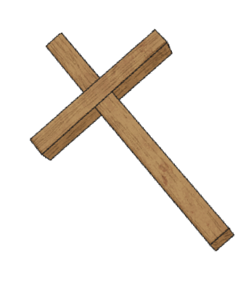
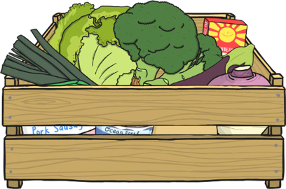
Nature and God
Year 2
During harvest time Christians thank God for helping them to grow the food that they have collected. A Harvest Festival is held at churches (and sometimes in school) where produce is donated and then given to those in need.
Harvest
On the seventh day, God rested. Sunday is seen by Christians as the seventh day of the week and is a day for rest and reflection - this
often includes going to church.

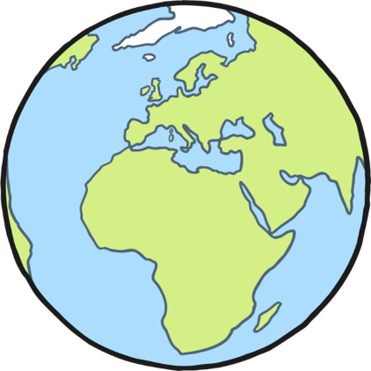
Key Vocabulary
Creation story | The Creation story is what the Bible says about how the world was created by God.
create | Creating something means making it.
reflection | Reflection is where you think carefully about something that has happened.
harvest | Harvesting is the process of collecting in crops. Harvest time is the period of time which it takes to gather in all the crops.
produce | Produce is a word used to describe food that has been grown and harvested.

On the first day, God made light (“day”) and dark (“night”).
On the second day, God made the sky.
On the third day, God created the land and the seas. He also created plants and trees.
On the fourth day, God created the sun, the moon and the stars.
On the fifth day, God created birds and sea creatures.
On the sixth day, God created animals to fill the earth. God also created humans to enjoy and care for all that He had made.
On the seventh day, God rested.
The Creation Story

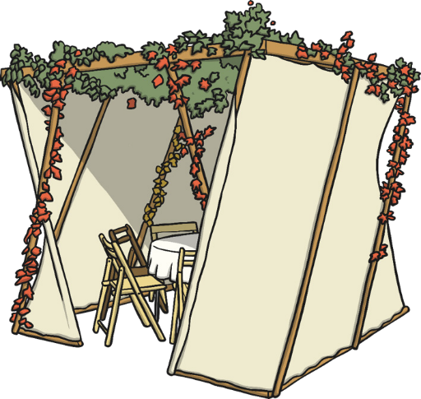
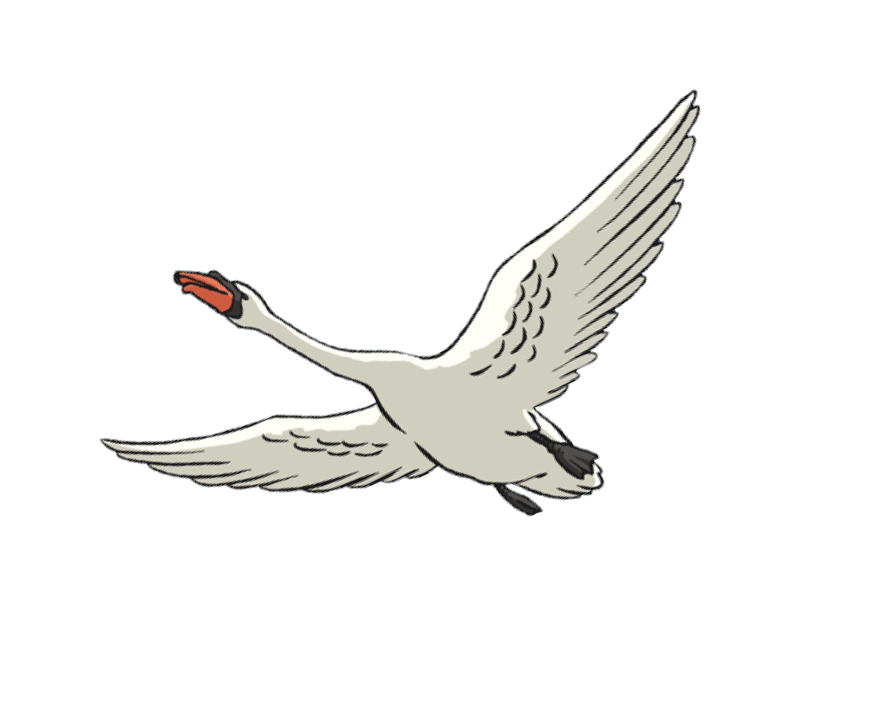
Nature and God
Year 2
Sukkot
Every year, many Jewish families celebrate Sukkot by building and living in a sukkah for a week. They try to eat all their meals inside it and also invite their family and friends to eat in it too. This is to help them remember when God freed them from slavery and they wandered in the desert for forty years. On the seventh day of Sukkot, Jews visit the synagogue to give thanks to God for looking after them.
Key Vocabulary
Sukkot | A Jewish festival that celebrates God  looking after the Jews when they lived in the desert.
sukkah | A hut where Jews lived during their years of living in the desert.
synagogue | A Jewish place of worship.
Prince Siddhartha | The real name of the Buddha, a religious teacher who lived many years ago in India. He founded the Buddhist religion.
Prophet Muhammad  (peace be upon him) | The founder of the religion of Islam. Muslims believe that Allah sent messages to him which then  formed their holy book  - the Qu’ran.

Protecting Nature in Different Religions
In some religions, there are stories that make you think about how you help other people and animals in your everyday lives.
Prince Siddhartha and the Swan tells the story of the Buddha, who was always kind to animals. When he saw an injured swan, the Buddha nursed the swan back to health and released it into the wild. | The Boy Who Threw Stones at Trees tells the story of a young boy who threw stones at a date tree to get the fruit  to fall off so he could eat it. This was damaging the tree and when he was caught, the Prophet Muhammad (peace be upon him) taught him about the importance of caring for plants too.

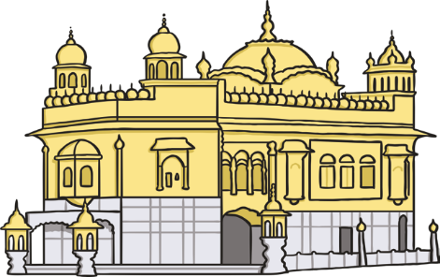
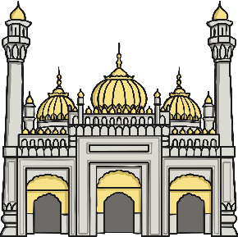
A gurdwara has
four doors to show that people from all corners of the world are welcome. Any place that has a Guru Granth Sahib (the Sikh holy book) can be called a gurdwara. Everyone who enters covers their head to show respect. People also take off their shoes and wash their hands. The holy book is found in the main hall (the Darbar Sahib). Near this is the langar. This is a large kitchen where free vegetarian meals are made. Sikhs help each other prepare the food and when they eat it, they sit on the floor to show they are equal.
Visiting a Gurdwara
People should wear clothes that cover their arms and legs when they visit. Shoes are taken off when you enter. Pictures of humans and animals are not allowed in mosques. Instead, you might see patterns on the wall. People clean themselves in the ablutions area before praying. Mosques have prayer rooms. The main prayer room is called the musallah. Prayer mats are used for praying.
Muslims all face towards Mecca when they are praying. Usually men and women pray in different spaces. They can use prayer beads to help them focus.
Visiting a Mosque
Key Vocabulary
worship | To act in a way that shows great respect and/or love for someone.
place  of worship | A building or space where people worship. They may go to pray alone or worship with others. They might go for an important ceremony.
mosque | A Muslim place of worship.
gurdwara | A Sikh place of worship.
Mecca | A city in Saudi Arabia. It is the most holy place in the world for Muslims.
ablutions area | This is where people go to thoroughly wash before praying or touching the holy book, the Qur’an.

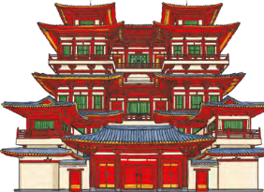
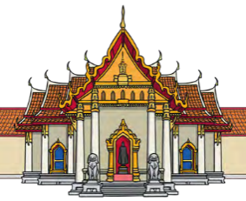
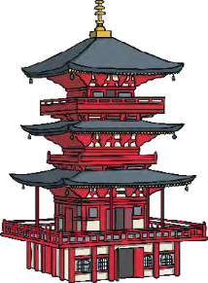
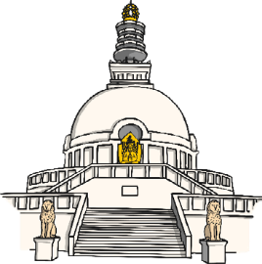
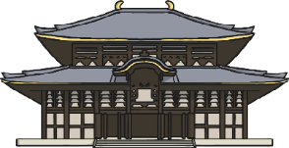
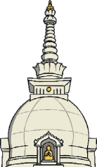

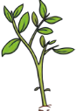

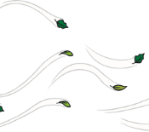

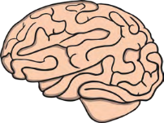
Every Buddhist
temple has at least one statue or image
of Buddha so that Buddhists can thank
him for his teachings and show him respect. Buddhist temples do not all look the same from the outside. Each temple is designed
to symbolise the five elements. The earth is represented by the square base of the temple. Wisdom is shown by the pinnacle at the very top. The spire represents fire. The crescent of a temple represents air and the dome represents water. Inside the temple, you might see incense burning, prayer wheels and the Three Jewels.
People often meditate there. They use malas and
mantras to help them. You might also see monks and nuns.
Visiting a Buddhist Temple
Buddhists do not believe in God. The Buddha was not a god but was a special person. He was born as Siddhartha Gautama. He was known as the Buddha after he became enlightened.
Buddhists do not pray to Buddha like people of other religions would pray to God. Buddhists believe that the universe is made up of five main things (the five elements). These are earth, air, fire, water and wisdom.
Buddhist beliefs
Key Vocabulary
Buddhist temple | A Buddhist place of worship.
enlightenment | In Buddhism, this means finding out the truth about life.
Buddha | The title given to Siddhartha Gautama, the founder of Buddhism.
Malas | Beads which help Buddhists keep count of their mantras and also help to focus the mind.
mantra | Sounds or words that are repeated hundreds of times over to help concentration.
Three Jewels | Symbols of the three most important things to Buddhists - Buddha, his teachings and Buddhist people.

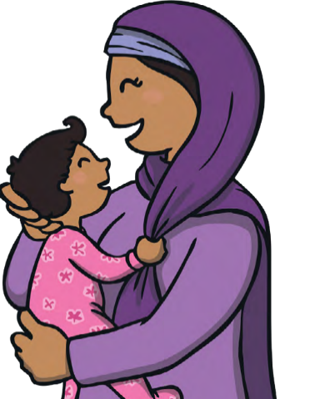
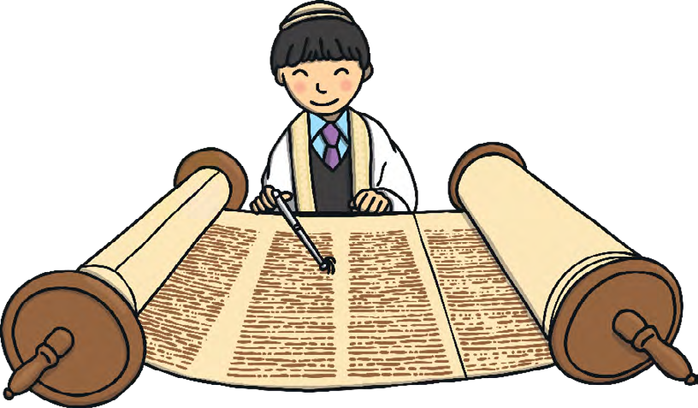
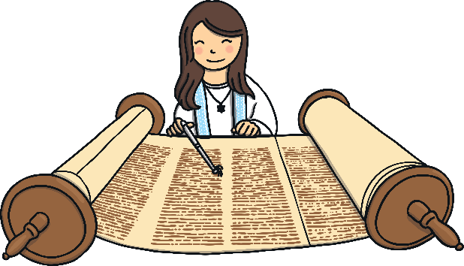
There are lots of different
ways to welcome a new baby. A Muslim ceremony for this is called Aqiqah and is where the baby is introduced to family and friends and a meal is shared to thank Allah (God) for giving them a child. Prayers are said for the baby. The baby has their hair cut or shaved off. The removed hair is weighed and then its weight in silver or gold is given to charity.
Aqiqah
Key Vocabulary
ceremony | An important event. Ceremonies are held on special occasions and usually celebrate or remember something important. Lots of religions have special ceremonies for different events.  Some ceremonies are similar in different religions (such as  weddings), but some ceremonies are unique or special to one particular religion.
Bar Mitzvah | This means ‘Son of the Commandment’. A Jewish boy becomes a Bar Mitzvah when he is thirteen years old.
Bat Mitzvah | This means ‘Daughter of the Commandment’. A Jewish girl becomes a Bat Mitzvah when she is twelve years old.
Torah | The Jewish holy book.
rite  of passage | This is part of growing up.

When Jewish boys and girls reach a certain age, | Bar and Bat Mitzvahs
they become responsible for their actions and must follow Jewish rules.
Many families celebrate this with a special ceremony. This is a Bar Mitzvah for boys and a Bat Mitzvah for girls. Becoming a Bar Mitzvah or Bat Mitzvah is a ‘rite of passage’. Young Jewish people spend a lot of time preparing for these ceremonies. They read the Torah and learn about their faith. The ceremonies have some differences for boys and girls but both boys and girls usually speak about the important things they have learned about. After the ceremonies, many families have a party or celebration.

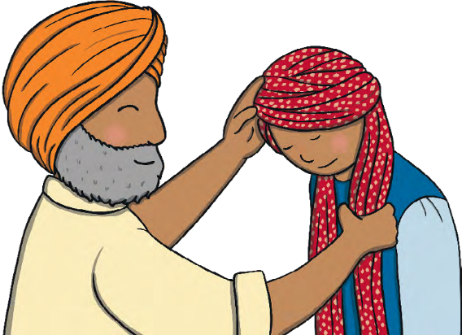
Key Vocabulary
Dastar Bandi Sikhs believe that hair is a gift from God. It shouldn’t be cut and it should be kept very clean. It should be covered in public and in religious buildings. Men wear a dastar to protect their hair and to show others that they are Sikhs. During the Dastar Bandi, a boy will sit in front of the Guru Granth Sahib (the Sikh holy book) and an elder will tie the turban on his head. Afterwards, he will be prayed for and he may receive gifts. Often people eat and celebrate together afterwards.
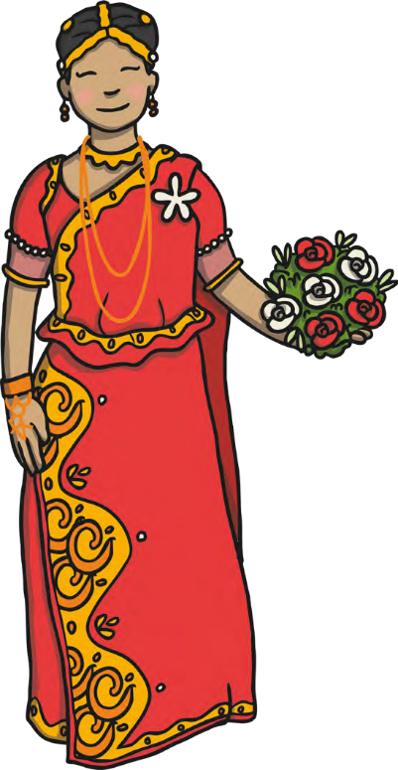
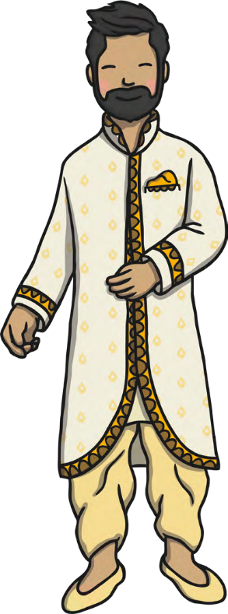
dastar | The name of a turban worn by men in the Sikh religion. It covers the head. It covers a man’s hair and protects it from getting tangled or dirty.
Dastar Bandi | A Dastar Bandi is a turban-tying ceremony where a Sikh boy starts wearing a dastar.
wedding | A ceremony, and the celebrations before and after this, when two people get married to one another.
sari | A traditional type of clothing. It is a long piece of fabric that is draped around the body.
safa | A wedding turban.

Hindu weddings
are often very big celebrations. Lots of people attend and the celebrations can even last more than one day! The bride wears beautiful silk clothing that is often embroidered with
detailed designs and jewels; she might wear a sari. The groom often wears a jewelled safa. At the wedding venue, a mark is put on the foreheads of the groom and his family with red kum-kum powder. This marks the start of the two families being joined together. One important part of the ceremony is when the bride and groom walk around the sacred fire. They take seven steps and say prayers. This is called Saptapadi.
A Hindu Wedding

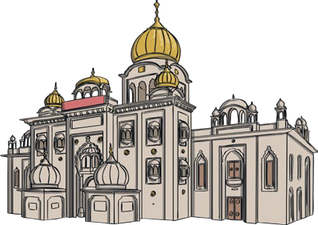
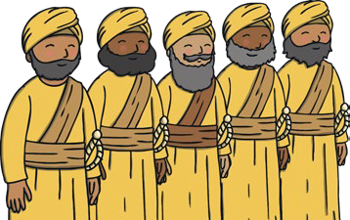
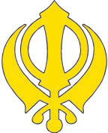
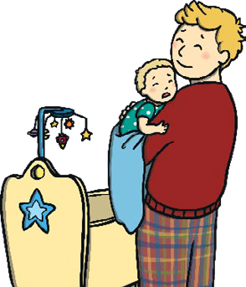
During Vaisakhi, Sikhs remember the story of the Panj Pyare and how they gave up their everyday lives to follow Sikhi. The Panj Pyare represent the following: kindness, justice, organisation, courage and majesty.
Naam Karan is a Sikh
baby naming ceremony. The baby is welcomed into the Sikh faith. Naam Karan takes place in a gurdwara. The Sikh holy book (the Guru Granth Sahib Ji) is opened at random. The first letter of the first word on that page is chosen to be the first letter of the baby’s name. Once the name has
been chosen, everybody cheers. For their second name, girls are called Kaur (princess) and boys are called Singh (lion).
Naam Karan
Vaisakhi
Vaisakhi began as a harvest festival and the founding of the religion.
Beginnings can often be a time of excitement and happiness and a time to celebrate. Endings are often a time to remember and reflect and can sometimes be sad.
Beginnings and Endings
Key Vocabulary
beginning | The start of something new.
celebrate | To take part in an enjoyable activities for a special occasion.
ending | The end or final part of something.
reflect | To think carefully about.
Vaisakhi | The Sikh Harvest celebration.
founding | The beginning or start of something.
Sikh | People who follow the religion of Sikhi.
Panj Pyare | The first members of Sikhi. Also known as the Beloved Five.
justice | Fairness.
gurdwara | A Sikh place of worship.

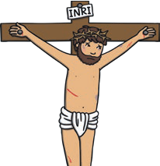

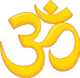

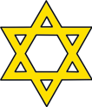
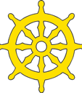
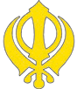
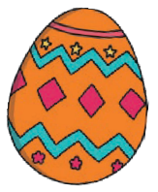
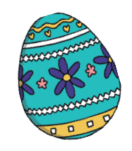
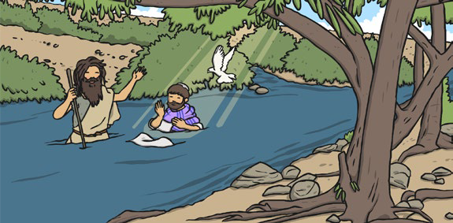
Christians celebrate Easter to remember the story in the Bible of Jesus’ crucifixion and resurrection. Christians believe that Jesus died so that everyone’s sins could be forgiven.
Easter
An ending can also be a beginning. The end of Jesus’ life was the beginning of hope and new life for Christians. Other beginning and ending ceremonies are celebrated by different religions, such as Bar/Bat Mitzvah and weddings.
Endings
At Easter time, Christians go
to church, send cards and give Easter eggs. Easter eggs symbolise the new life, as a Christian, that God
promises to those that believe in him.
Celebrating Easter
Christians are often baptised as a baby, when they are given their
name, but they can also be baptised as an older child or an adult. Gifts are often given at baptisms.
John the Baptist baptised Jesus in the River Jordan. When Jesus came up from under the water, the sun came out and a dove flew down.
Jesus heard God’s voice say, “This is my son. I love him and I am pleased with him.” Water is used in baptism and symbolises a person’s sins being washed away and the beginning of
their journey of faith as a Christian.
Jesus’ Baptism
Key Vocabulary
baptism | A ceremony welcoming a person into the Christian church.
symbolises | When something stands for something else.
sins | Christians believe that sins are wrong actions, that are not what God would want a person to do.
Christian | People who follow the religion of Christianity.
resurrection | When Jesus came back to life after death.
crucifixion | When Jesus was put to death on a cross.
Bar/  Bat Mitzvah | A Jewish celebration for the beginning of adulthood.

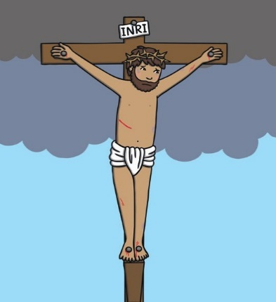

Key Vocabulary charity
Christian disciple Gospel
Holy Trinity parable
permanent
The cross is the most important symbol of Christianity. It represents the sacrifice made by Jesus when he was crucified.
Who Is God?

Christians believe that God is the creator of the universe, including the heavens and the Earth. They believe that God is all-powerful and forgiving. He sent Jesus Christ, His son, to die for the forgiveness of human sin.

The Holy Trinity
God the Father | God the Son | God the Spirit
God the Father refers | God the Son refers to | The Holy Spirit refers to
to God being loving, | Jesus Christ, who came to | God’s power in action
kind and forgiving | Earth as a man. Although | and the impact of His
and watching over all | Jesus is the Son of God, | force. It is not a person,
living creatures. Many | he is also God in human | but a divine force that,
Christians will say the | form. Christians believe | Christians believe,
‘Our Father’ prayer to | that Jesus died for the | created the universe and
thank God. | forgiveness of human sin. | everything in it.

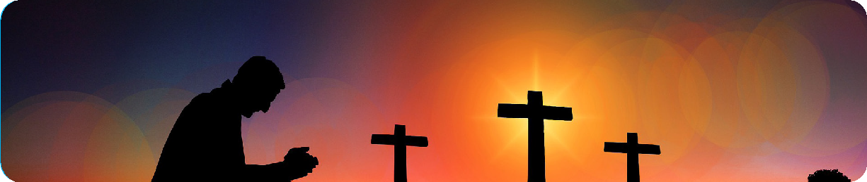
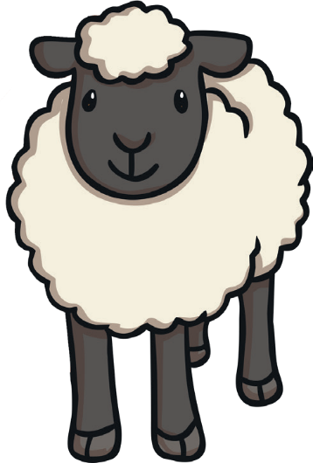
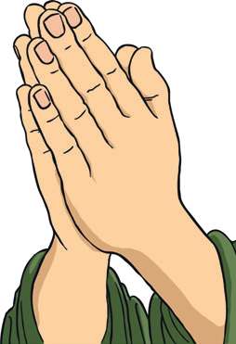
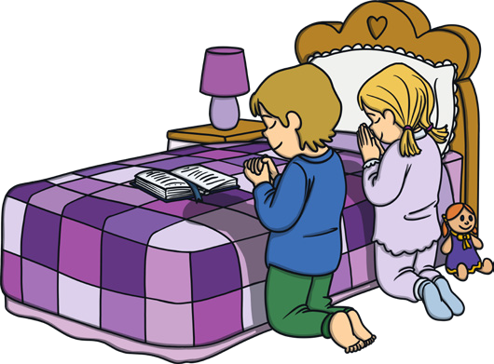
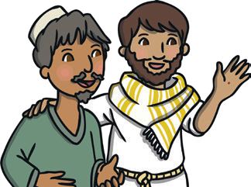
The Parables of Jesus
Jesus told parables to explain his teachings.
The Parable of the Good Samaritan
teaches people to love their neighbour.
The Parable of the Lost Sheep teaches that God loves everybody, no matter what they may have done.
The Teachings of Jesus
Jesus taught about the goodness of God. | Jesus taught how to be kind.  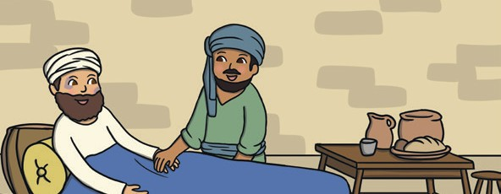 | Jesus taught about God’s forgiveness.  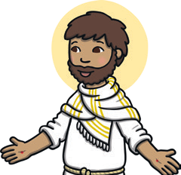

How Do Christians Show Their Faith?
Worship: honouring and giving thanks to God. | Sharing the message: spreading the message of God’s love. | Putting Jesus’ teachings into action: showing kindness and love to others.

Key Vocabulary prayer
sin

worship

Progression of Skills
 | End of KS1
How beliefs are expressed | Children explore a range of sources of wisdom and the traditions from which they come. They can suggest some meanings to religious stories. Children begin to recognise different symbols and how they express a community’s way of life.  Children can:  - name religious symbols and the meaning of them;  - learn the name of important religious stories;  - retell religious stories and suggest meanings in the story.
Beliefs and teachings (from various religions) | Children begin to recall and name different beliefs and main festivals associated with religions. Children can recognise different religious symbols, their relevance for individuals and how they feature in festivals.  Children can:  - describe the main beliefs of a religion;  - describe the main festivals of a religion.
Rituals, ceremonies and lifestyles (from various religions) | Children begin to explore daily practices and rituals of religions, identifying religious practices and recognising that some are featured in more than one religion. Children begin to reflect on their own experiences of attending ceremonies.  Children can:  - recognise, name and describe religious artefacts, places and practices;  - explain religious rituals and ceremonies and the meaning of them, including their own experiences of them;  - observe when practices and rituals are featured in more than one religion or lifestyle.
Time to reflect and personal growth | Children look at how an appreciation of religion plays an important role in the lives of some people. They make links to expressing identity and belonging and what is important to them.  Children can:  - identify things that are important in their lives;  - ask questions about the puzzling aspects of life;  - understand that there are similarities and differences between people.
Values (in your own life and others lives) | Children look at and appreciate how many people’s values are an important aspect of their lives. Children look at religious stories to understand actions and consequences. Children begin to make connections to their own lives, looking at their own actions and consequences and choices they can make.  Children can:  - look at how values affect a community and individuals;  - explain how actions can affect other people;  - understand that they have their own choices to make and begin to understand the concept of morals.

