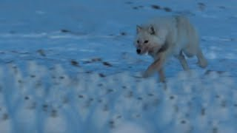
Arctic Wolf Hunts – KS1 Comprehension
https://www.youtube.com/watch?v=UQKC5pZ0FG8

- Which adjective is used to describe the wolves at the start of this clip? Tick one.
- Long.
- Scary.
- Ugly.
- Hungry.
- Which of the following is a source of food for the Arctic Wolf. Tick one.
- Snow.
- Potatoes.
- Arctic Hares.
- The night.
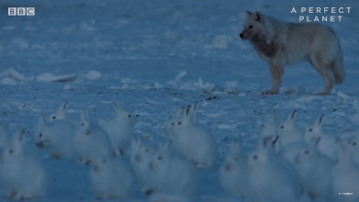
- Pause at 16 seconds. How does this image make you feel? Explain your answer.
This image makes me feel ____________________ because ______________
_______________________________________________________________.
- True or False – the Arctic Hares are in groups of ten? _____________________________________________.
- Why have the Arctic Hares gathered into large groups?
The Arctic Hares are in large groups because ___________________________________________________.
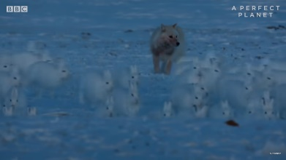
- Pause at 49 seconds. How do you think the hares are feeling here? Explain your answer.
I think the hares feel ____________________ because ___________________
_______________________________________________________________.
- Sir David Attenborough says one Arctic Hare, “Is not much of a meal.” What does he mean?
I think this phrase means ___________________________________________________________________.
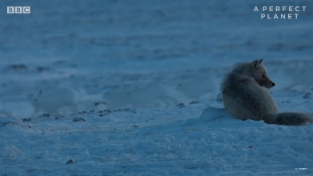
- Pause at 1.15. How do you think the Arctic Wolf feels here? Explain your answer.
I think the wolf feel ____________________ because ___________________
_______________________________________________________________.
- Tick a box to show whether each statement is true or false.
 | True | False
These animals live in the Arctic.
The hares live alone.
One hare makes for an excellent meal for an Arctic Wolf.
The wolf fails to catch a hare.
- Having watched this clip, which featured animal do you like the most? Explain your answer.
I really like the _____________________ because _______________________________________________
________________________________________________________________________________________.

EXT: We are going to have a go at drawing our own wolves using this awesome YouTube draw-along video - https://www.youtube.com/watch?v=GKbcXAacc9A

Answers
- Hungry.
- Arctic Hares.
- Various possible answers to discuss – scared the wolf might eat the hares/excited about what might happen next/nervous about the hunt/etc…
- False – they are in groups in their hundreds.
- It helps to keep them safe.
- Various possible answers to discuss – scared because they are being chased/tired from running away/etc…
- One Arctic Hare won’t fill up a hungry wolf and give it a good meal.
- Various possible answers to discuss – sad/hungry/etc… because it was unable to catch a hare.
- True
False
False
True
- Various possible explanations for choice to discuss.

