Optional Writing Template Lesson 15
How to train your dragon – Writing the build-up scene

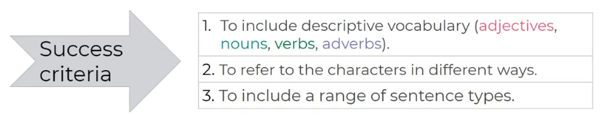
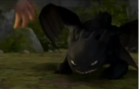
Toothless backed away and growled
___________________________________________
___________________________________________
___________________________________________
________________________________________________________________________________________________________________________________________________________________________________________________________________________________________________________________________________________________________________________________________________________________________________________________________________________________________________________________
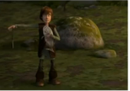
Hiccup drops his knife
___________________________________________
___________________________________________
___________________________________________
________________________________________________________________________________________________________________________________________________________________________________________________________________________________________________________________________________________________________________________________________________________________________________________________________________________________________________________________

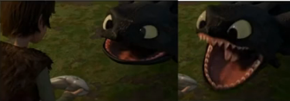
Toothless approached with his mouth open and revealed his teeth
___________________________________________________________________
________________________________________________________________________________________________________________________________________________________________________________________________________________________________________________________________________________________________________________________________________________________________________________________________________________________________________________________________
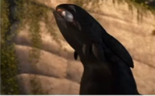
Toothless devoured the fish _______________________________________
_______________________________________
_______________________________________
________________________________________________________________________________________________________________________________________________________________________________________________________________________________________________________________________________________________________________________________________________________________________________________________________________________________________________________________

